New home for Morriston centre named after inspirational nurse Jill Rowe
Friday, 9 November 2018
A specialist centre at Morriston Hospital named after an inspirational nurse is set to expand after moving to a new home.

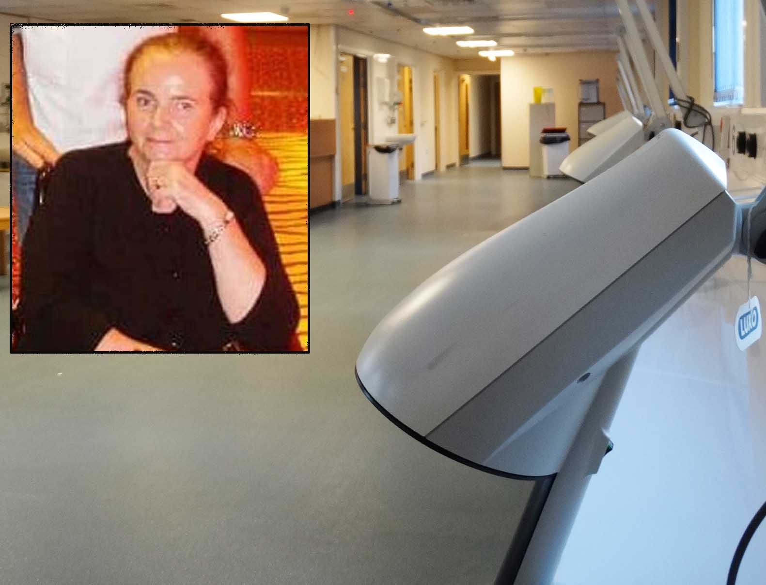
The Jill Rowe Neurology Ambulatory Unit is a treatment and day investigation unit for people with neurological disorders including multiple sclerosis, Parkinson’s disease and epilepsy.

Left: the late Jill Rowe (inset). Main pic: ready to be fitted out – the new unit is more spacious than the old and has the potential to accommodate more patients and extra consultation rooms
It opened three years ago and carries out investigations such as lumbar punctures, scans and cognitive assessments, as well as treatments.
However, there have been occasions when Morriston Hospital has been so busy that the unit – located off Gower Ward – has been needed instead for bed space for seriously unwell inpatients.
Now, after months of planning, the unit is transferring to a new location which means that should no longer happen.
And the move to the former renal annexe will make more space available to provide expanded facilities for patients.
Morriston Hospital Service Manager for Medicine, David West, said: “There have been occasional issues when the hospital has been extremely busy and the existing unit has been required for very unwell patients.

“This new unit will alleviate that situation. It is separate from the main hospital and will be used solely for neurology, whereas previously it was sharing the area with a ward.

“There will be much more space. It has the capacity for up to four consultation rooms, which is double what we have at the moment.
“It has the potential to increase our infusion capacity from four patients to 12. We also hope to provide a space for the MS Society to use in future.”

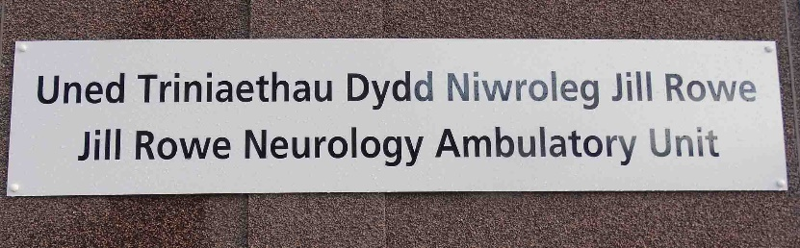
The unit honours the memory of Jill Rowe, a senior sister who was a member of the team that established Morriston’s Cardiac Centre before becoming service manager for cardiac and neuro services.
Jill, herself an MS patient, died in 2011. The unit bearing her name was officially opened in the summer of 2015.
Its new home, located opposite the entrance to the Welsh Centre for Burns and Plastic Surgery, becomes operational on Monday (Nov 12).
The building has been redecorated and equipment and fittings from the existing unit will be transferred across this weekend.

Mr West added: “The building is wheelchair accessible and there is patient-only parking outside, as well as an ambulance drop-off area.”

Source: Abertawe Bro Morgannwg University Health Board

