New venue for memorial service for loved and lost babies
Tuesday, 6 November 2018
Growing numbers of families are coming together every year to remember their loved and lost babies.
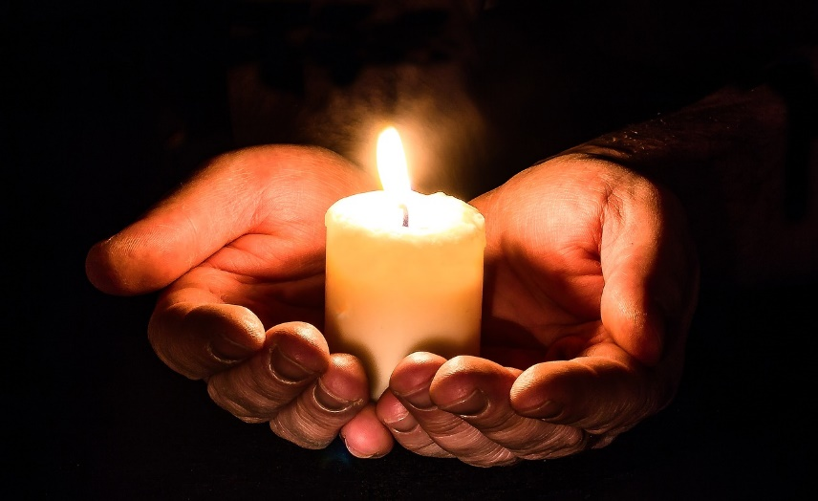
Such is the interest in an annual remembrance service organised by ABM University Health Board that it has had to move to a larger venue.

The service will now be held in St Mary’s Church, St Mary’s Square, Swansea, at 2.30pm on Sunday, December 2.

Singleton Hospital Chapel has hosted it in previous years.

The service is open to anyone who has experienced the loss of a baby.

It will be officiated by the Reverend Canon Ian Rees and will include prayers, readings, the lighting of candles, reflection and the Maesteg Gleeman Male Voice Choir.

Specialist Bereavement Midwife at Singleton Hospital Christie-Ann Lang said: “The service invites anyone who has experienced the loss of a baby to offer support and reflection in sharing the memories of their child.

“If you would like to attend the service it will be a time to spend with others who have experienced the loss of a child alongside professionals who may have provided care and support to yourself and your family.”
- For any inquiries please contact Christie-Ann Lang on 07766466896 or Christie-Ann.Lang@wales.nhs.uk

Source: Abertawe Bro Morgannwg University Health Board

