Pharmacies offer a convenient alternative for the flu jab
Monday, 12 November 2018
Did you know you can get the flu jab at your local pharmacy? Why not pop in and get protected at a time that suits you.

Flu can kill or leave you seriously ill and you are particularly at risk if you have a long-term health condition.

That is the stark warning from a pharmacist as those with diabetes, asthma, heart disease and other chronic illnesses are urged to get the vaccine.

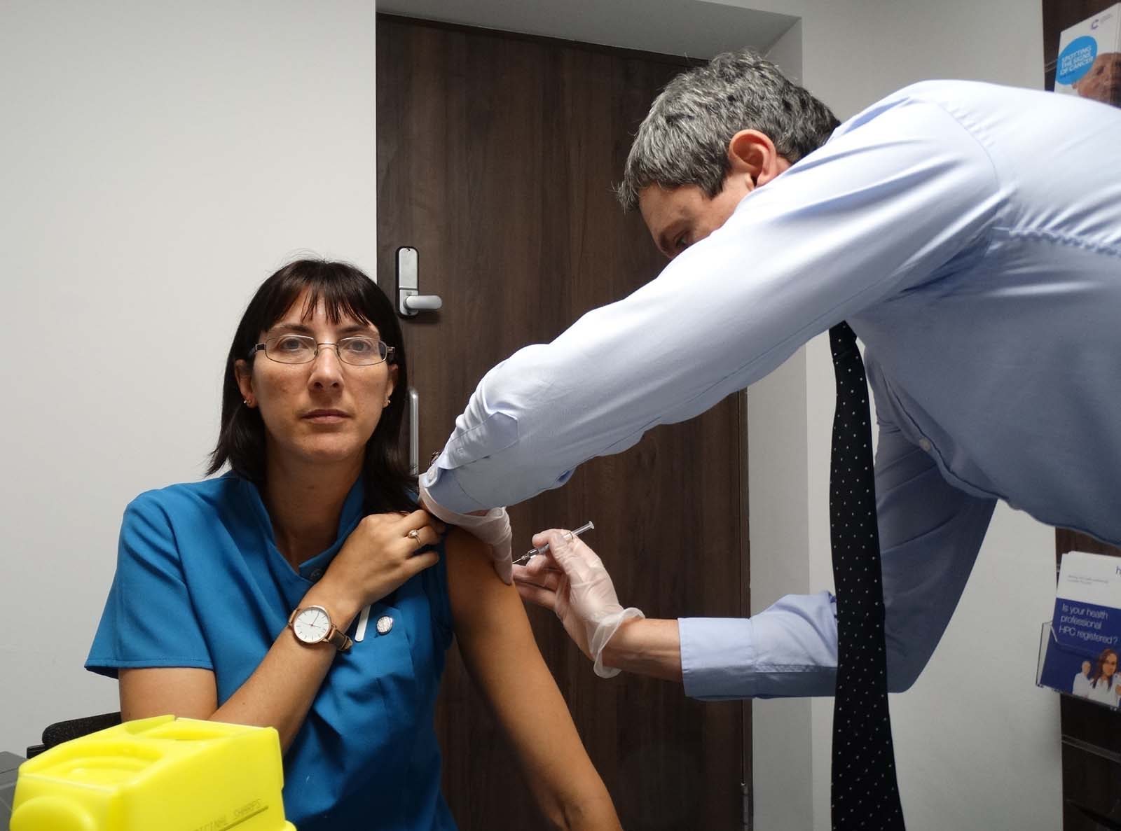
Pharmacist Alwyn Fortune of Sheppards in Kenfig Hill, near Bridgend, said: “Flu can kill. Flu can lead to chest infections and pneumonia.

“So if patients have been vaccinated against the flu, when they are exposed to the virus the antibodies are already there to be able to fight it off so they either won’t get the flu or have a lesser dose.”

Left: Pharmacist Alwyn Fortune vaccinates Leanne Hewer

He is among the many community pharmacists who have been trained to give the vaccine, which is available free on the NHS to those with long-term conditions and their carers.

He said: “If patients can’t get to the GPs for a particular time they can come to the pharmacy. What we try to do here is vaccinate patients as they come in. It may be the case that they have to wait a few minutes while we check a few prescriptions, but we try to do patients immediately.

“It gives patients who might be working another option where they can drop in at the end of their working day, during their lunchtime or at a time convenient to them.”

Among those who have taken advantage of the free NHS jab at the pharmacy are staff members Leanne Hewer, 36, from Kenfig Hill, and Anita Lloyd, 51, from Cefn Cribwr.

Leanne takes medication for arthritis, which reduces her immune system, so getting the vaccination is vital.

“I would be quite ill as my immune system is quite low so I need it to help prevent me catching the flu. I have never had a reaction to the vaccine,” she said.

Anita added: “I have the flu vaccine so that, number one, I’m not off work and won’t be able to carry out my job. But also because I am a carer and I don’t want to carry it home to my husband who has a heart condition and if he gets it then it could be devastating for him like many patients with heart conditions.”

Conditions that put people more at risk of complications from flu include diabetes, heart, liver and kidney disease, mini stroke and respiratory problems.


People with chronic chest conditions like Chronic Obstructive Pulmonary Disease (COPD) and moderate to severe asthma, for example, are around seven times more likely to die from flu than people without a health condition.

People whose spleen doesn’t work properly, adults who are very overweight (have a BMI of 40 or more) and people who have a suppressed immune system due to disease or treatment – such as cancer patients – are also more vulnerable to the effects of flu and should have the vaccine.

Last year around half the people in Wales aged six months to 64 years who were eligible for a free NHS flu vaccination due to a long-term condition missed out on it.

Right: Pharmacist Alwyn Fortune, Leanne Hewer and Anita Lloyd

https://www.youtube.com/watch?v=dUTUamgq16k

Source: Abertawe Bro Morgannwg University Health Board

