Take a tip from Pippa - don’t let flu slow you down this winter
Friday, 6 October 2017
Little Pippa Elliott has a very good reason for wanting to stay well this winter.
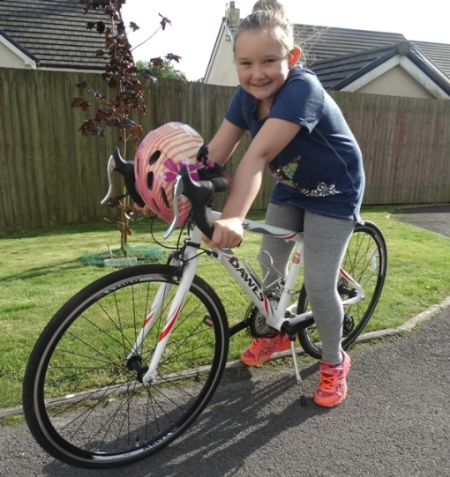
“If I was ill I wouldn’t be able to go cycling,” said the seven-year-old Nottage Primary School pupil (right).

Already a keen cyclist and the proud owner of a 14-speed drop handle bar racing bike Pippa is dedicated to her favourite hobby.

She knows if she is poorly she won’t be able to join her dad Jason on their regular bike rides.

And one of the best ways of keeping Pippa healthy this winter is by having her flu vaccination – delivered by school nurses using a nasal spray.

“I remember having it last year and I don’t mind it all – and it means I get a sticker,” said Pippa, who has just started Year Three.

Her mum Jude, who received her flu jab while pregnant with both Pippa and her seven-month-old brother Phineas, is grateful for the protection the vaccination provides.

“I don’t understand why anyone wouldn’t have the vaccination. It may not be pleasant but having flu is far worse,” said Jude, from North Cornelly.

The nasal spray flu vaccine not only helps protect children against flu, it also means the infection will be less able to spread from them to their family, carers and the wider population.

Children spread flu because they generally don't use tissues or wash their hands properly.

The vaccination is a vital way of protecting youngsters against flu this winter and is being offered at surgeries to children aged 2 and 3 and those 4-year- olds who are not in school. Pupils in Reception & Years 1, 2, 3 and 4 will be given the vaccination in school.

Vaccinating children also means others who might be vulnerable to flu, such as babies, the elderly, mums-to-be and people with serious long-term illnesses are put at less risk of catching it.

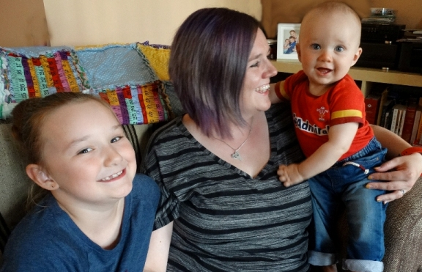
Although very common and considered by some to be nothing major, flu can actually be very dangerous and put lives at risk especially if you are very young, pregnant, over 65 years of age or over 6 months of age and have an existing illness or health condition such as asthma, diabetes, heart disease

Contact your GPs surgery to arrange an appointment or go to www.abm.wales.nhs.uk/flu

Pippa with her mum Jude and baby brother Phineas.

Source: Abertawe Bro Morgannwg University Health Board

