Singleton GP establishes dedicated children's ward in Sierra Leone
Tuesday, 30 October 2018
A doctor is back home in Swansea after spending the last year as the go-to medic for helping sick children in the Kono district of Sierra Leone.
Michael Bryant, from Singleton Hospital’s acute GP unit, and his wife Bethany have successfully established a dedicated children’s ward in the medically deprived African country.
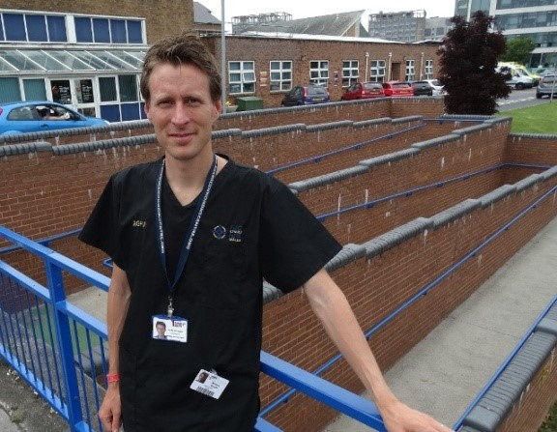
Left: Michael Bryant at Singleton Hospital

They have introduced oxygen and transfusion systems to the ward, which has helped to save lives.

And as the only GP in the district, Michael has mentored local health staff, successfully establishing a strong team prepared to treat patients and manage the systems as well as possible once he and Bethany had left.

The ward at Adama Martha Memorial Community Health Centre initially lacked necessities such as water, heating, electric and oxygen. This proved challenging, resulting in the need for making hard-hitting decisions quickly.

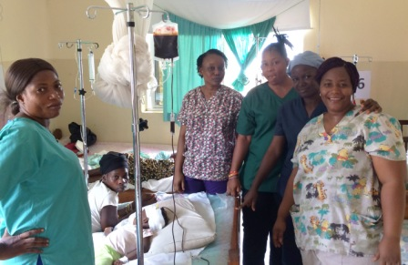
Right: Health staff and patients at the children’s ward at Sierra Leonne

Michael had previous experience working in Sierra Leone during the Ebola outbreak. But, he said: “This was even harder as we were six hours upcountry from the capital.

“The hardest thing was constantly having to think on my feet and come up with solutions for desperately sick babies very quickly.

“Often we would admit patients through the day, then realise we had four babies all needing oxygen. We would need to share the oxygen between them all, it was tough deciding who needed it most.
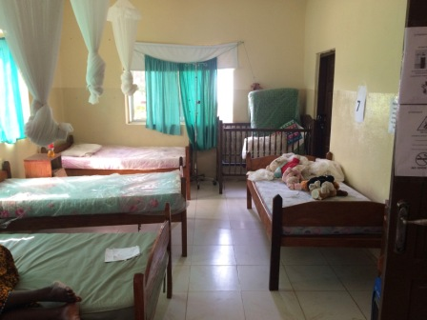
“I remember several times when the power would go out in the middle of the night and we would have a baby with breathing difficulty, and try to manage with a phone torch looking around for equipment and oxygen tubing.

“We always made sure the basic resources we had were as well organised as possible. We were constantly tired from overwork and stress.”

Thanks to the Pennies from Heaven scheme and generous donors, Michael was able to place a high quality oxygen system, transfusion system and acquire a solid supply chain of medication, reducing the number of deaths that would typically occur.

Pennies from Heaven allows employees of ABMU Health board to donate a tiny part of their earnings to a charitable fund, to help essential lifesaving paediatric work in sub-Saharan African countries.

The mortality rate during their time at the centre between September 2017 and June 2018 was just two per cent, less than half the national average.

Michael said: “The oxygen system came online in October. The main limitation was the lack of electrical power so we had to transport cylinders from an oxygen plant so that when the power went out the supply kept going.

“In addition, the transfusion system meant we could do a lot of transfusions in the centre particularly for the high numbers of sickle cell patients and children with severe malaria through the rainy season.”

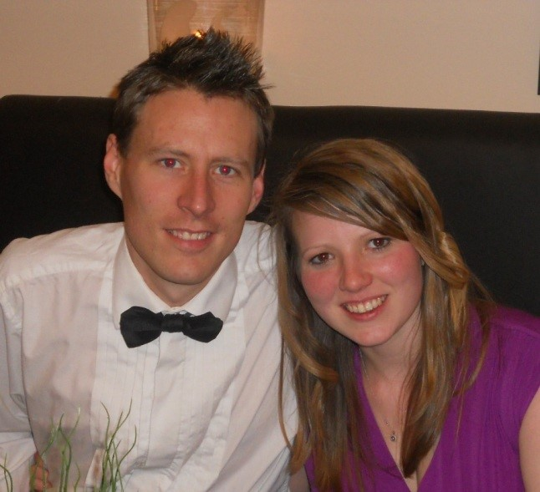
Michael said the mentoring and training of staff was key to ensuring a strong local team knew how to use the systems sufficiently when he and Bethany returned to Swansea.

Right: Michael and wife Bethany

He said: “By the time we left, we could give oxygen to neonates, unwell children and the operating theatre simultaneously, and most of the staff know how to use the system.

“Being able to give blood to toddlers who would otherwise die from severe malaria is a wonderful breakthrough and meant we had very few deaths.”

During their time at the Adama Martha Memorial Community Health Centre, the new children’s ward grew gradually from four beds to 10.

“It was amazing to watch the ward grow gradually from four, to six, to eight and then a 10-bed capacity – and see the children get better and discharged.”

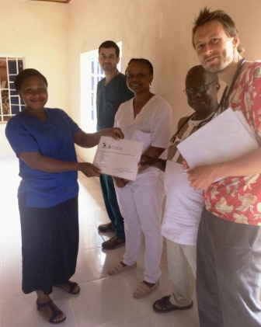
Health staff completed Emergency Triage Assessment and Treatment (ETAT) training, an approved set of guidelines relating to treating unwell children in resource-poor settings.

Michael added: “We will never forget giving certificates to all the staff who completed their ETAT training, as well as a huge range of topics, we were so proud of them.

Right: Michael presenting the staff with their certificates

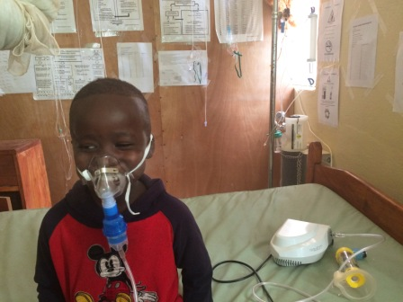
“It was incredibly rewarding to see them get good at monitoring the sick patients, as well as managing convulsions calmly, which gave us a great sense of achievement.

“I hope to continue the good work in West Africa through our health board. There is a lot of interest in a similar project at a hospital in Liberia which I hope to start in the New Year.”

Source: Abertawe Bro Morgannwg University Health Board

