Big flavours and high calories on nursing home menus to combat malnutrition
Friday, 1 September 2017
Food and drink that’s high in calories as well as flavour is being put on the menu in nursing homes to help residents stave off malnutrition.
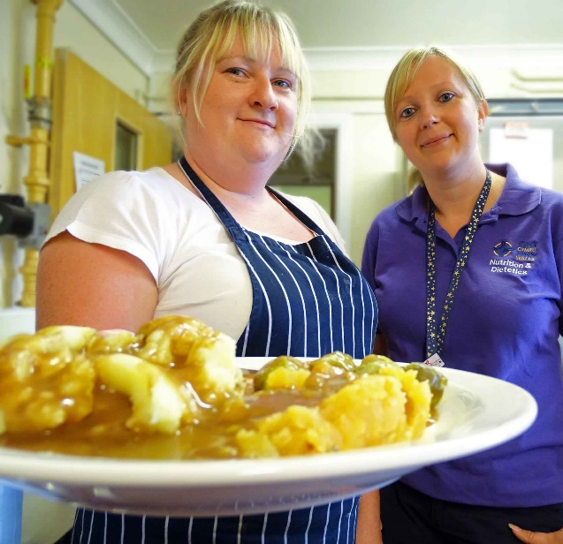
A pilot project that started in three homes in Neath Port Talbot earlier this year was so successful it has now expanded into Swansea and Bridgend.
Jo Betty (right) with Swn Y Mor Care Centre catering manager Victoria Kingdom
ABMU lead community dietitian for nursing homes, Jo Betty, is leading a team of three dietetic assistant practitioners (DAPs) on the project.
They are working with nursing homes across the ABMU area to prevent malnutrition occurring in the first place.
But they are also training staff to spot the signs of malnutrition early, and providing them with rapid access to dietitians should the need arise.
Malnutrition is a problem in nursing homes nationally – not because of failings with the food but because residents have smaller appetites, or conditions like dementia which affect eating.
Dietitians usually work in nursing homes only after a referral from a GP or specialist service such as speech and language therapy.
The malnutrition management project takes a proactive approach by improving the nutrition of the entire home rather than individual residents.
Staff can now also call in the team directly if needed, rather than wait for a GP referral – freeing doctors to see other patients and reducing delays.
Dietetic assistant practitioners are trained in health promotion. They can clinically review patients in nursing homes, checking medical charts for appropriate prescribing.
The three DAPs on Jo’s team – Rhian Wilyeo (Neath Port Talbot), Rhiannon Edwards (Bridgend) and Rhiannon Parker (Swansea) – are also able to train nursing home staff as part of the malnutrition management project.

This training focuses on two main areas. One involves using a screening tool to monitor residents’ weight to pick up signs of malnutrition early so the appropriate action can be taken.
The other covers maximising the nutritional value of meals, snacks and drinks – and how to use alternatives to food supplements which are expensive but often unappealing to residents.
Here the DAPs provide advice in line with the Food First principles, which include encouraging small, frequent meals and snacks, and fortifying food and drink with high calorie ingredients.
Jo said: “For example, if you cook a shepherd’s pie, make sure the mashed potato is fortified with butter, cream or cheese.
“We also encourage eating little and often. Residents may have had three meals previously but they can no longer eat big portions.
“So they get smaller meals, but topped up with nourishing snacks and drinks.
“They may not manage eight Rich Tea biscuits but if you gave them half a scone with cream and jam it’s the equivalent calories.
“Or instead of giving them a cup of tea you could give them a hot chocolate with cream and a Flake.
“We’re mindful of things like diabetes control and heart disease.
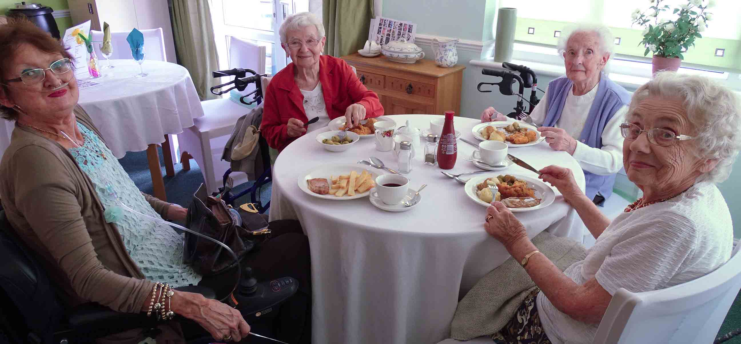
“But if someone is malnourished, if they’re wasting away and losing muscle strength, they will quickly lose independence and have issues with skin integrity and infection risk.”
Swn Y Mor Care Centre residents (l-r) Susan Morgan, Valmai Williams, Grace Jones and Hazel Owen pictured enjoying their lunch

The project started in January in three Neath Port Talbot nursing homes but now covers 10, including some in Bridgend and Swansea. Ultimately the aim is to include all homes across the health board area.
When they first go into a home, the DAPs review medication charts to see how many residents have food supplements – then provide alternatives where appropriate.
Jo said: “Many residents prefer normal food to supplements. They’re more likely to eat half a scone than they are to sit there with a drink they’re not fussed on and are likely to waste.
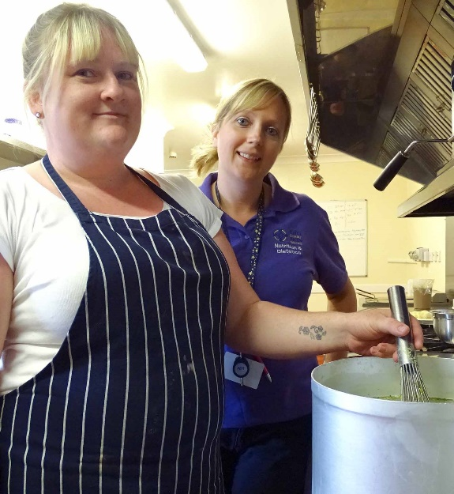
“We are already saving around £100 a day by reducing supplements just in the homes we have reached so far.”
Swn Y Mor Care Centre at Aberavon Beach was one of the first to get involved, working with DAP Rhian Wilyeo.
Manager Sharon Williams said: “We were using a lot of supplements which people won’t drink because they don’t find them very tasty.
“We were actually wasting them. Now using a fortified diet has improved their dietary intake.
“We’ve had training, we’ve had definite steps to go through. But if that fails we now have direct access to the dietetics team.
“We no longer have to wait for a GP referral, which can cause delays.”
Rhian has also provided advice to relatives about the best snacks to bring in for residents.
Sharon added: “It’s breaking down barriers. There’s no us and them, it’s a real partnership. And there’s only one person who will benefit from this – the patient.”
Although other health boards employ DAPs, their role within ABMU’s managing malnutrition service is unique.
This has led to the Bevan Commission selecting Jo as an Innovation Examplar – part of a Wales-wide programme supporting NHS staff leading projects that will improve patient care.
“It will be really nice to work with other people who are developing their own projects – sharing good practice and good ideas,” Jo said.

Source: Abertawe Bro Morgannwg University Health Board

