Charity bike ride team saddle up for sepsis at Morriston Hospital
Friday, 1 September 2017
An epic charity bike ride set off today from Morriston Hospital where a lifesaving campaign is really picking up speed.

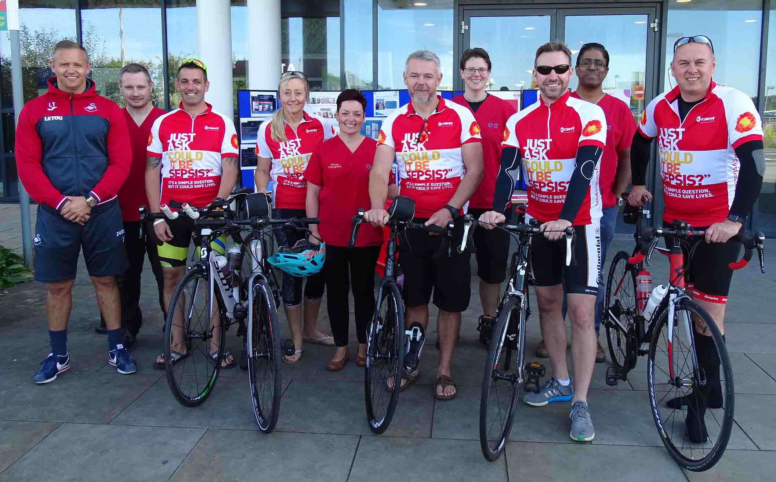
Last year the hospital’s Emergency Department launched the campaign, which promotes early identification and treatment of sepsis.

Swansea City FC club ambassador Lee Trundle and Morriston Hospital staff join riders (l-r) Kevin Stephens, Tracy Owen, Neil Owen, Terence Canning and Darren Ware for the Cycle 4 Sepsis launch

Known as the silent killer, sepsis is when the body’s response to infection injures its own organs – which can lead to shock, organ failure and death.

Since last November, the ED sepsis team have held a series of drop-in awareness sessions for all staff.

They have also updated the existing sepsis screening tool, making it more accurate and in-depth, yet easier to use.

The awareness campaign is now being rolled out to 10 wards in Morriston Hospital, with a growing number of sepsis champions recruited to promote the work within their own area of work.

Through the campaign, the ED team have forged a close relationship with the UK Sepsis Trust, in particular its Welsh Executive Director, Terence Canning.

Every year the charity hosts the Cycle 4 Sepsis bike ride, which sees teams set off from various locations around the UK, converging on Birmingham where the charity is based.

It was because of the close links between the hospital and the trust that the South Wales cycling team chose Morriston as their starting point.

Morriston’s sepsis clinical lead Dr Rangaswamy Mothukuri invited Terence Canning to the first drop-in session last year.

Terence, who lost his brother to sepsis in 2012, said: “The plan was for me to stay for an hour or two but I ended up staying seven hours. We’ve successfully repeated that three times.

“I am really happy to be associated with the hospital and I love the idea of the red shirts for the sepsis champions and the visibility of sepsis awareness.

“My role with the charity is to raise awareness and these guys are doing a brilliant job.

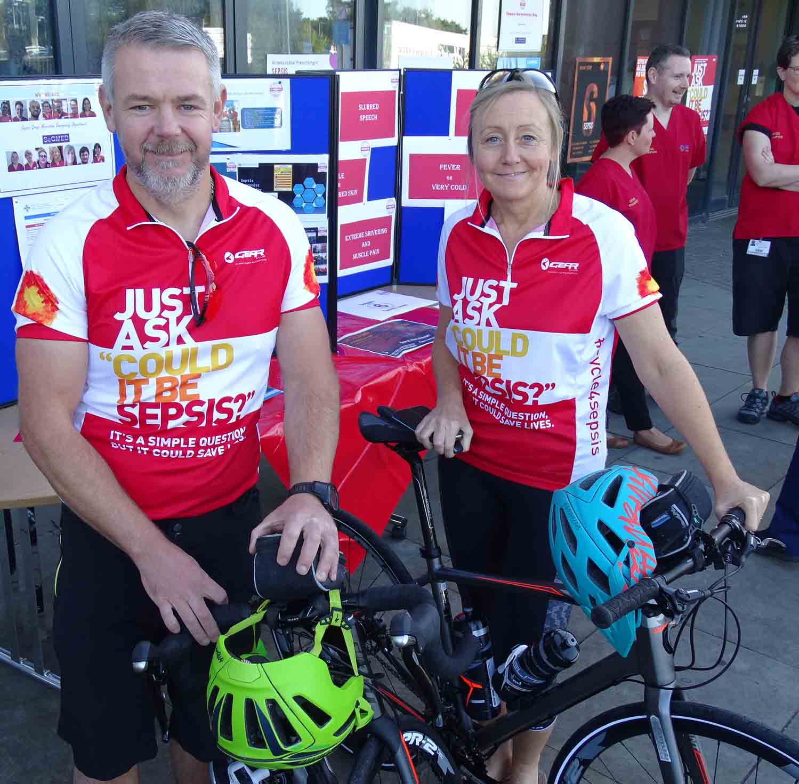
“Morriston was a really appropriate place to start our Cycle 4 Sepsis ride this year, to showcase the work they do here.”

One of the cyclists is Tracy Owen, an advanced critical care practitioner in Morriston’s intensive therapy unit.

Right: Neil and Tracy Owen

Tracy, who is cycling with husband Neil, said: “I came to one of the open days and I was so moved by some of the stories I heard that I decided to do the ride.

“That was in July and I asked Neil if he would train me and he agreed - we do a lot of mountain biking but I hadn’t been on a road bike for 20 years.”

The ride set out this morning and continues until Sunday when all the cyclists will arrive in Birmingham. Its launch coincides with the start of international Sepsis Awareness Month.

Dr Mothukuri said the team wanted to use Morriston as the starting point in recognition of the important work the hospital had undertaken.

He added: “We are leading the way in the fight against sepsis and raising awareness and today’s event will help promote that further.”

Swans legend and club ambassador Lee Trundle helped get today’s ride under way. He will also launch the Sepsis 6k run which takes place along Swansea seafront on Sunday, 10th September.

Places are still available for the run, which the ED team are organising and which will set out from Blackpill Lido on Mumbles Road at 10.15am.

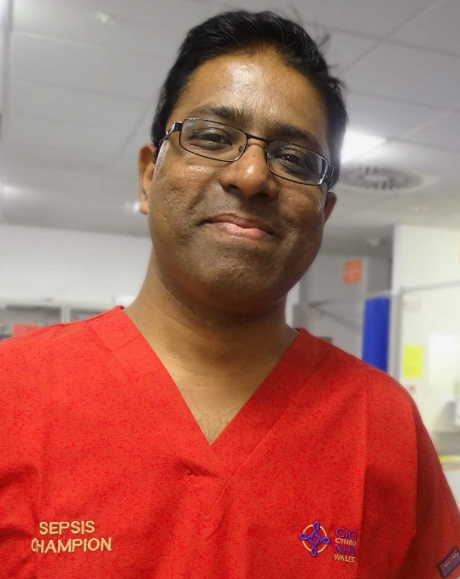
It is open to everyone, including children, and people are welcome to walk if they can’t run the course.

Dr Mothukuri (left), who will be running on the day, said: “The money raised will go to the Morriston ED Sepsis Fund.

“This will be used for education, equipment and supporting further sepsis awareness both within the hospital and in the community.”

You can donate to the Morriston ED Sepsis Fund here: www.justgiving.com/fundraising/segmedsepsis6krun2017

Everyone taking part in the Sepsis 6k run will have to register, which you can do here: www.eventbrite.co.uk/e/sepsis-6k-tickets-36365914429
Source: Abertawe Bro Morgannwg University Health Board

