Choir hitting high notes for special care baby unit
Thursday, 21 September 2017
Bridgend-based choir Maternal Harmony used their annual summer concert to raise funds for Princess of Wales Hospital’s special care baby unit.

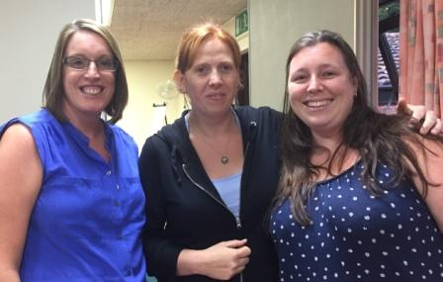
The concert raised £750 and is set to be used for a much-needed reclining chair for the unit.

Choir member Joanne Braddock suggested the choir raised money for SCBU as she had personal experience of the excellent care the unit provides for babies, new parents and their families.

(l-r) SCBU nurses Rhian Nolan and Tanya Johnson with Joanne Braddock.

Joanne said: “My daughter Ella was born 11 weeks early and during our time on SCBU, I got to witness the day-to-day running of the unit. I got to see different scans of Ella’s heart and brain and different procedures carried out using amazing technology.

“What I remember the most is the fantastic work of all the staff involved, from the paediatric consultants, the ward sisters, staff nurses, nursery nurses and even the secretary. Every single one of them work day and night to save and protect the lives of the most precious little human beings.

“When the opportunity arose to suggest a charity to support, there was never going to be anyone other than SCBU at the top of my list.”

Joanne added: “Their dedication and enthusiasm is second to none and they not only care for babies, but they take pretty good care of mum and dad too!”

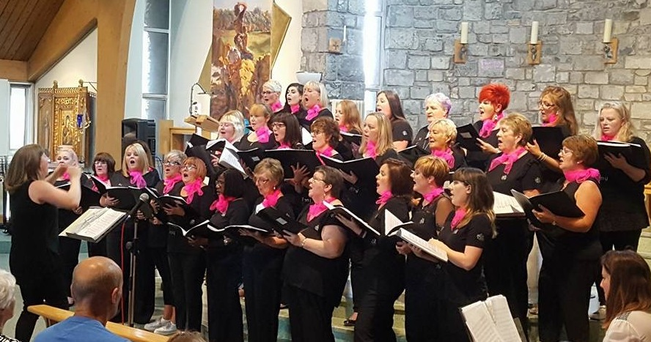
The choir was originally set up by the Perinatal Response and Management Service (PRAMS) at Princess of Wales Hospital and was aimed at women with postnatal depression.

Now the choir welcomes those with other mental health issues, their family members or anyone who would just like to support the cause.

Special care nurses Tanya Johnson and Rhian Nolan received the cheque on behalf of the unit during a choir rehearsal.

Rhian said: “Maternal Harmony wants the money to be spent on something to benefit mums while they are on the unit and we have a number of things we are looking to purchase. One of the items is a comfortable reclining chair so that the mums can be relaxed while having skin-to-skin cuddles with their babies. This allows babies to be out of their incubators for longer, which has mood-boosting benefits for mum and is excellent for brain growth in babies.”

Maternal Harmony is always on the hunt for new recruits. It holds rehearsals every Thursday from 7pm to 9pm in the Communal Residences Hall at Princess of Wales Hospital.

Source: Abertawe Bro Morgannwg University Health Board

