Don't take chances this winter, stay healthy with help from flu vaccination
Monday, 25 September 2017
As the nights draw in and the temperature falls most of us are looking forward to a healthy happy autumn. But the flu season is almost here so don’t forget to take action to make sure you stay well this winter.

Although flu is common that doesn’t mean it isn’t dangerous, especially to anyone who has other underlying health issues.

Now health experts at ABMU Health Board are reminding everyone who could be at risk to make sure they get protected by having their flu vaccination.
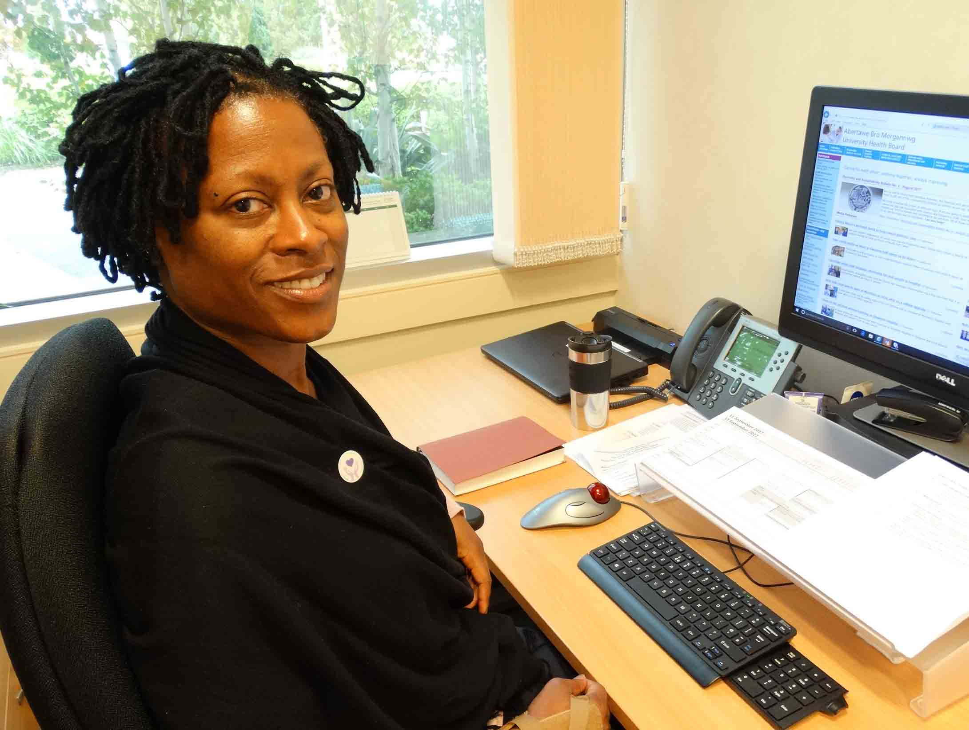
They are appealing to those who are very young, over 65, pregnant or over six months old with an existing illness or health condition such as asthma, diabetes or heart disease to have their free flu vaccination.

ABMU’s Director of Public Health Dr Sandra Husbands (left) said: “Flu really is serious. For most it may just leave you feeling awful for a few days but for people who have got underlying conditions it can be a lot more dangerous and even life-threatening.

“For example, if you’ve got asthma and then contract flu you could end up being admitted to hospital.”

Figures for last year reveal 671 people in Wales were treated in hospital for flu-related illnesses – 74 of them were admitted to intensive care.

Dr Husbands said flu is highly infectious and can spread very easily from person to person.

“Getting the vaccination is a simple way that you can help to keep our community safer.”

Last year more than 130,000 people in Swansea, Neath Port Talbot and Bridgend had their flu vaccination, including more than 8,000 members of ABMU staff.

“We are particularly keen on encouraging everybody who works in health care or hospitals to make sure they have their vaccination,” she said.

Dr Husbands explained that those who don’t have the jab are not only putting their own health at risk, but also jeopardising the health of others.
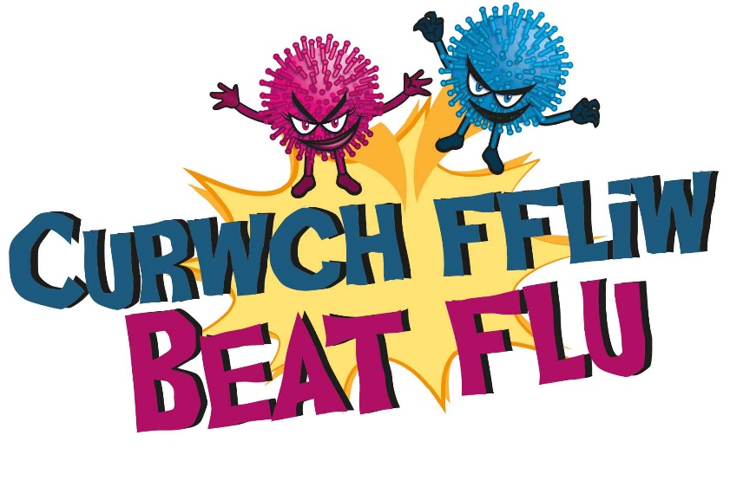
“Working in healthcare means they will come into contact with a lot of people and many of these may already be quite ill or their health may be compromised.

“At a time when there is lot more pressure on our NHS services we want everyone to do all they can to avoid catching or spreading flu.
“That’s why we recommend health and social care workers have the vaccination to keep themselves healthy, to keep their patients healthy and to keep their colleagues healthy.”

She spoke out to reassure people about the safety of the vaccine.

“There are no real side effects. You may feel a little achy but it’s just a reaction to the injection. This is usually short-lived and not serious.

“It’s not a dose of flu, there is no active virus in the vaccine. The vaccination acts as a little kick start to your immune system, a call to action which marshals your immune system ready to fight infection.”

She emphasised that having the jab was the best protection available against such an unpredictable and unpleasant illness, even if you are fit and healthy.

“Unlike other conditions the flu virus is very changeable. This means the people who make the vaccines have to work very hard every year to catch up and produce the most effective vaccine for each winter.

“That is the main reason we can never have a vaccine that is 100 per cent effective. However having it will definitely be better than having no vaccine at all.”

Dr Husbands said she makes sure she and her family are all safely vaccinated every year.

“The jab is an awful lot less unpleasant and more short-lived than flu and the earlier someone has their vaccination the longer they will be protected,” she added.

She also emphasised how important it was for mums-to-be to be vaccinated as their immune system is reduced during pregnancy.

Catching flu can lead to complications such as their baby being born prematurely or having a low birth weight as well as increasing the chances of having a stillborn baby.

“In pregnancy, women – rather like older people and young children – are more likely to have a severe flu, they wouldn’t be able to bounce back in the same way as if they weren’t pregnant.”

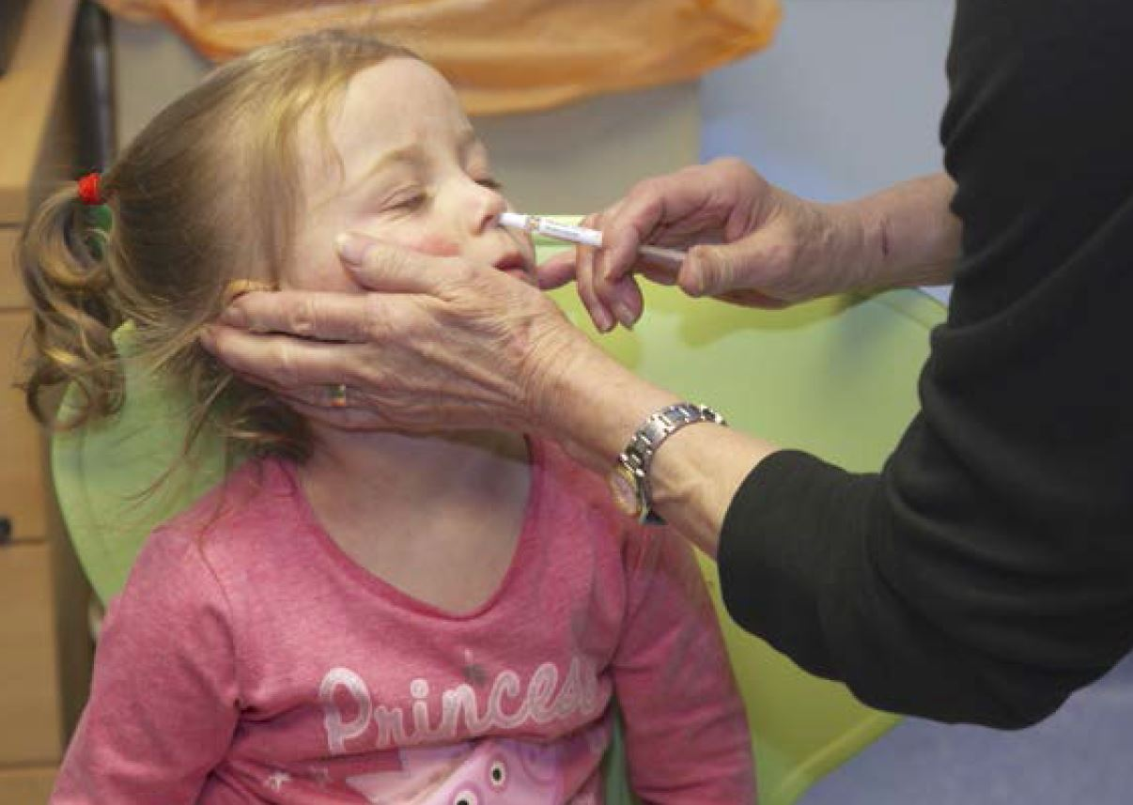
She said the vaccine wouldn’t harm the unborn baby and would lead to the mum producing antibodies which provide early protection for her baby too.

Dr Husbands emphasised that children were one of the key groups that need to be vaccinated.

Those aged 2 and 3 by 31st August 2017 and 4 years old but not in school will receive the vaccine by nasal spray at their GPs while children in Reception and Years 1, 2, 3 and 4 will be able to take advantage of vaccination sessions being held at their school by ABMU’s school nurses.

The vaccine is going to be available this week and GP surgeries will be running flu clinics so find out when and book yourself in.

You should also contact your GP surgery to arrange your free flu jab if you are a carer, immunosuppressed or living with someone who is, a morbidly obese adult with a BMI of over 40, or in long-stay residential care.

She added: “Obviously there are other measures that can help prevent the spread of flu – washing hands, covering the nose and mouth while sneezing – but having the vaccination is the best way of reducing your risk of getting it.

“Flu is nasty, flu can be very, very serious, flu can kill – that’s why I would encourage everyone to make sure they are protected and have the vaccination.”
For more flu-busting information log on to www.abm.wales.nhs.uk/flu

Source: Abertawe Bro Morgannwg University Health Board

