Experts’ warning on the sales technique that is hitting our health
Friday, 8 September 2017
Fast food restaurants and cafes who routinely offer customers extra portions of unhealthy food and drinks are helping to fuel our obesity crisis say experts.

The public health team in ABMU has spoken out to warn shoppers about the tactic known as upselling which sees shoppers encouraged to buy more than they had intended – often for a temptingly small price.

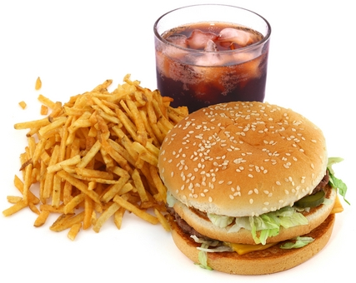
They are echoing calls from the Royal Society for Public Health which says the marketing ploy is having a negative effect on our waistlines and our future health.

It has released a new poll of more than 2,000 UK adults which reveals eight of 10 people experience upselling every week.

This ranges from diners being offered the chance to buy a larger portion for a small supplement to customers being encouraged to add sugary cakes or biscuits to their original drinks order.

Staff working at chain eateries are trained to make the offer but health leaders are concerned people don’t always realise they are being manipulated into eating more than they intended – especially if they think they are getting a bargain.

ABMU consultant in public health Jennifer Davies said: “Marketers know exactly how to use behavioural science to get you to part with your money. This is all about profits and also how to create loyalty to a brand through thinking you’re getting something of value.”

She said it was important for customers in shops, cafes and restaurants to recognise that the firms’ motivation for these tempting offers was mostly financial.

“The emphasis is on getting you to part with your money, possibly without realising it.

“When thinking about unhealthy food and drinks in particular, the research is clear that if you buy it or have it in front of you, you are most likely going to eat and drink most, if not, all of it,” she said.

Jennifer said that she would like to see healthier food and drinks being offered as an alternative to the larger portions.

She added: “The first step is for customers to be aware and prepared so that as this practice becomes more common they are ready to make the right choice for them.”

The research reveals that young people are particularly susceptible to promotional techniques such as upselling.

Public Health lead for health visiting in ABMU Jane O’Kane added: “It can be really challenging for parents to make healthy choices for their children.

“This is particularly so when they are faced with high-profile adverts for food and drinks that potentially have an impact on children’s health, especially considering our high local rates of tooth decay and childhood obesity.”

She said this dilemma was made worse for parents as these super-size deals often mean healthy foods more expensive than the unhealthy options.

Source: Abertawe Bro Morgannwg University Health Board

