FaceTime offers sign language alternative for deaf people in hospital
Thursday, 14 September 2017
Deaf people in hospital could soon be having sign language interpretation via a live FaceTime link if an interpreter cannot be there in person.

ABMU has carried out a successful FaceTime trial using iPads to provide real-time signing for deaf people whose first language is British Sign Language and who are receiving care in hospital.

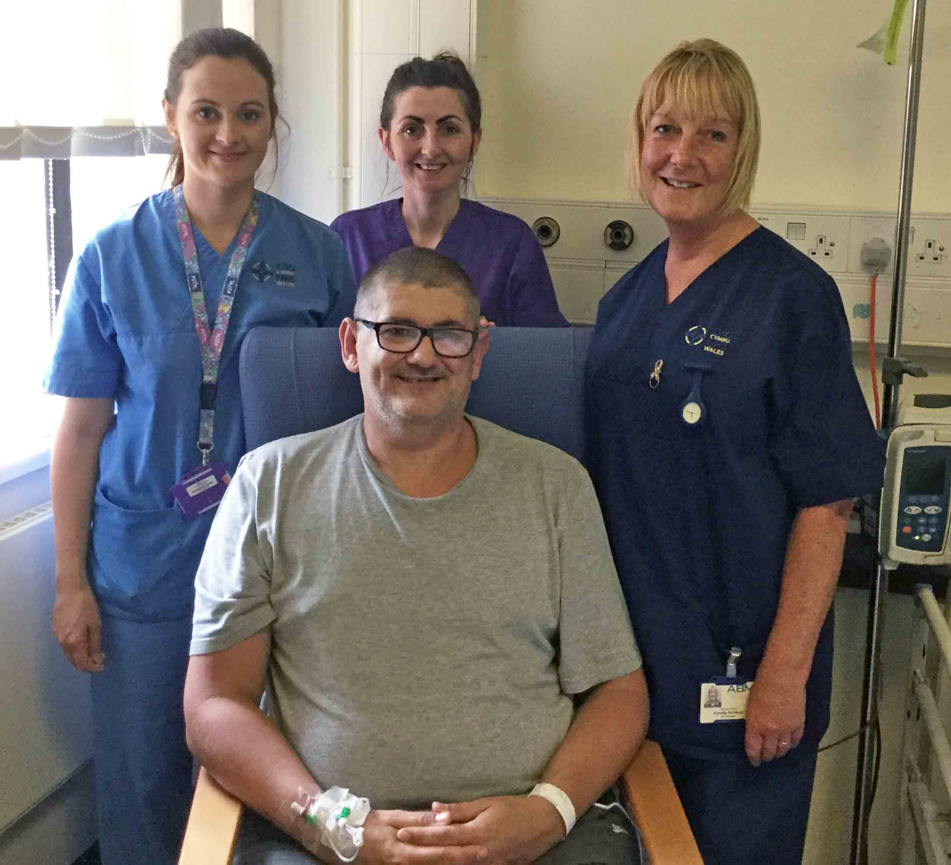
It was put to the test by 51-year-old Darren Tobin from Port Talbot, who was having hip replacement surgery.

Patient Darren Tobin is pictured on Ward 9 with (l-r) staff nurse Nicola Stocker, student nurse Carly Rees and ward manager Annette Riddoch

Mr Tobin said: “I did have a few concerns about having the interpretation through an iPad rather than having an interpreter present.

“But I was very happy with the way it went. It was very straightforward and the care I received was excellent.”

The FaceTime trial was developed as part of ABMU’s wider mobilisation project, which involves using new technology to improve contact between the health board, staff and patients.

It is now being fine-tuned. When it is eventually made more widely available it will not replace face-to-face interpretation but will instead be an extension of the existing service.

When signing is required, ABMU contacts the Wales Council for Deaf People, which arranges for an interpreter to be present.

However, there are times when, through unforeseen circumstances such as illness or bad weather, or when patients need urgent or emergency care, they are unable to attend.

Also, if they are required on the ward after a patient has had surgery, they may have a long wait while the doctors do their rounds and are only actually needed for a relatively short time.

This not only uses up their time when they could be providing a service elsewhere, but means unnecessary expense for the health board which pays them according to how long they have been there.

IT senior project manager Jonathan Fellows developed the FaceTime service with mobilisation engineers Dan Lewis, Kristoff Geil and Rich Brown.

Jonathan said: “We were always going to use an iPad for the pilot but we looked at several apps before deciding on FaceTime.

“It’s free, it’s integrated into the iPad, it’s completely secure and end-to-end encrypted.

“It’s not stored on a server so there were no issues with patient confidentiality.”

Mr Tobin first used the new FaceTime service during a pre-assessment clinic in Neath Port Talbot Hospital, and again when he had surgery at Princess of Wales Hospital in Bridgend.

During the pre-assessment, an interpreter was present elsewhere in the hospital in case there were any problems. The engineering team were also there but were not required as the trial went without a hitch.

Engineers were also present while Mr Tobin was in Ward 9 at Princess of Wales before and after surgery. This time the interpreter was off-site – and again the FaceTime link worked perfectly.

Ward 9 manager Annette Riddoch said: “It was really good. I was very happy with the way it went.

“It was great that were able to communicate when needed with Mr Tobin throughout his stay with us.”
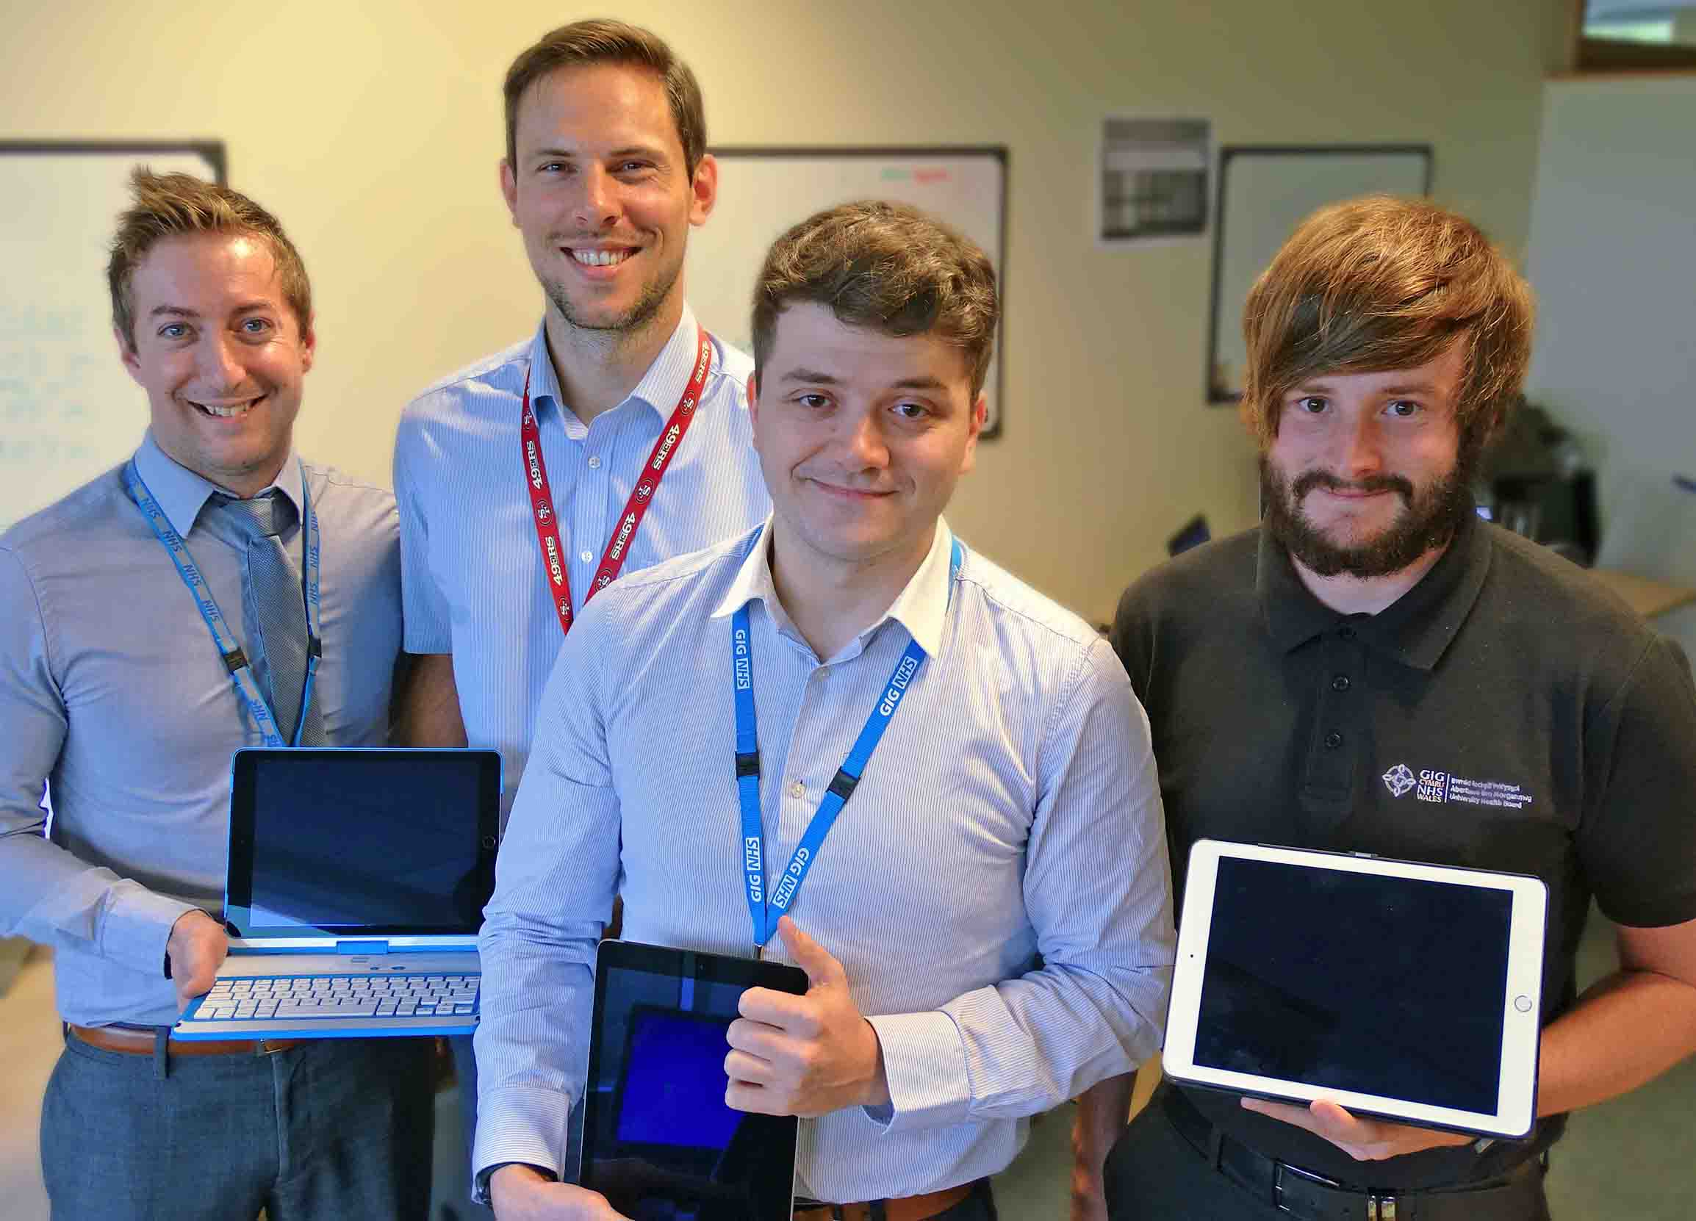
Mr Tobin added: “The interpreter was fantastic. When the nurse and doctor were explaining about the hip replacement it was all very clear and easy to understand.”

Pictured are IT senior project manager Jonathan Fellows (second left) with (l-r) mobilisation engineers Kristoff Geil, Rich Brown and Dan Lewis with iPads used in the FaceTime project

Jonathan said the engineering team was also very happy with the trial but they wanted to do some additional work to see if there was any way of making further improvements such as in-video text boxes.

“It definitely improves patient care by adding flexibility to our ability to offer interpretation.”

Wales Council for Deaf People operations manager Louise McGrath said the FaceTime service was not intended to replace traditional face-to-face British Sign Language interpretation but was a valuable resource.

“It will allow the health board to ensure deaf service users receive appropriate and timely communication support at point of need.

“It is intended for use in emergency situations or in other situations such as if an interpreter becomes unavailable on the day of the appointment, or ward rounds where it makes sense not to book an interpreter.

“This additional provision makes the service an effective and cost efficient means of ensuring the health board reinforces its commitment to the deaf community.”

Source: Abertawe Bro Morgannwg University Health Board

