Fiancee’s fundraising challenge in memory of tragic tank blast soldier
Friday, 29 September 2017
The grieving fiancée of a soldier killed in a tank training exercise in Pembrokeshire has raised money to say thanks to the team who tried to save his life.
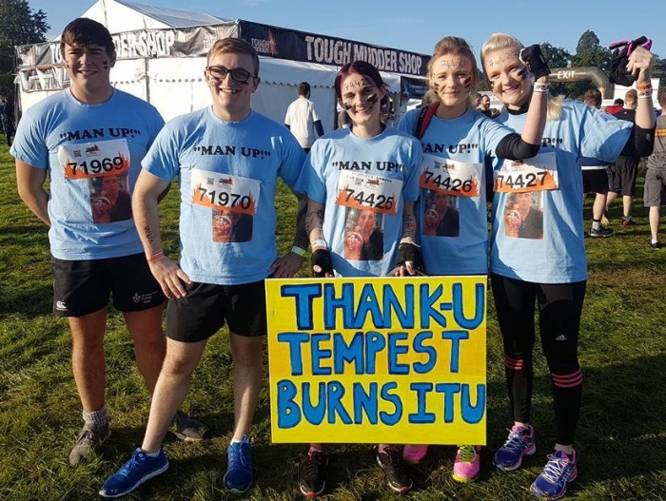
Jill McBride took part in a Tough Mudder endurance obstacle race and collected almost £2,000 for Tempest Burns ITU at the Welsh Centre for Burns and Plastic Surgery at Morriston Hospital.

Jill McBride (second from right) with her team-mates before taking on the Tough Mudder.

Corporal Matthew Hatfield was taken to the hospital when he was seriously wounded after an explosion in his tank during an exercise at the Castlemartin range in June. He died at the hospital with his family and Jill by his side.

Matthew was one of two members of the Royal Tank Regiment, based in Wiltshire, killed in the accident, another two were seriously injured.

After the tragedy Jill, who is a theatre nurse at Salisbury Hospital, was determined to do something positive in 27-year-old Matthew’s memory.

She said: “I really can’t thank the staff on the ward enough for their help, for looking after Matthew and for allowing us to be with him in his last moments.

“I wanted to do everything I could to show how grateful and how blessed we were to have had such super doctors, nurses, theatre staff and others involved in looking after him.”

Jill said Matthew used to help her to keep fit and since his death she hadn’t been doing much training but she was determined to make it round the muddy 12-mile course at Crawley. Littered with a string of obstacles, the challenge aimed at testing mental as well as physical strength.

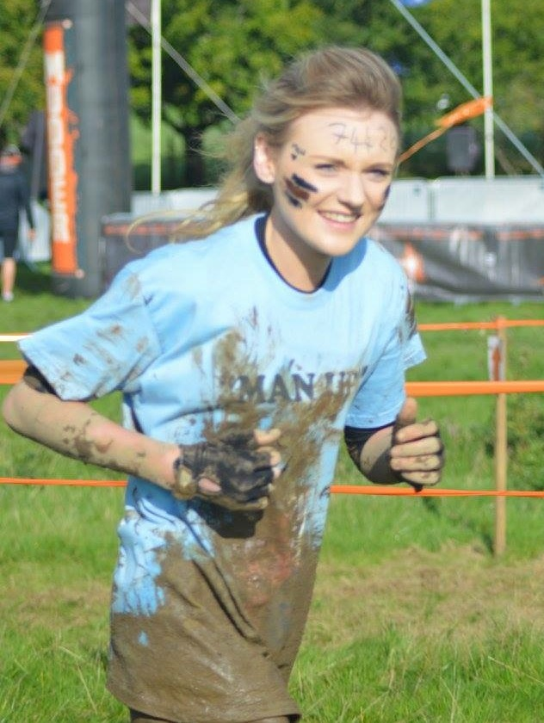
“It was horrible,” said Jill, 24, who was joined on the course by a team of family and friends.

“But we did it all for Matthew and every pain and ache was worth it. Matthew would be so proud.”

She ended up raising far more than her £1,000 goal and the figure currently stands at £1,900 and is still going up.

Lead nurse at the Welsh Centre for Burns and Plastic Surgery Clare Baker said: “We are very grateful for this wonderful donation to Tempest Ward and we would like to thank Jill for taking part in the challenge to raise the money.

“We pride ourselves on the care that we give our patients so the money will be used for training so our staff can maintain and improve the standard of care we give all patients who attend the burns centre.”

Jill is now hoping to return to the burns centre to be reunited with the staff who cared for Matthew and to formally hand over the donation.


“When I decided to do the race I just hoped it would give us a chance to show a fraction of how thankful we are to them. I am so overwhelmed at how much we have raised.”

Jill’s fundraising page is still open and anyone who would like to add to her total can go https://www.justgiving.com/fundraising/jill-mcbride

Jill McBride with her fiancé Matthew Hatfield who inspired her fundraising.

Source: Abertawe Bro Morgannwg University Health Board

