Former Mayor’s personal quest to help cancer patients’ care
Friday, 15 September 2017
Her own family’s experience of cancer care was the inspiration when Sheila Penry chose a charity to support during her year as Mayor of Neath Port Talbot.

Now she has visited Y Rhosyn, the palliative care unit at Neath Port Talbot Hospital, to hand over a cheque for £10,000 collected during months of successful fundraising.

Councillor Penry lost her daughter Helen Culpan to cancer in August 2011 aged just 40.

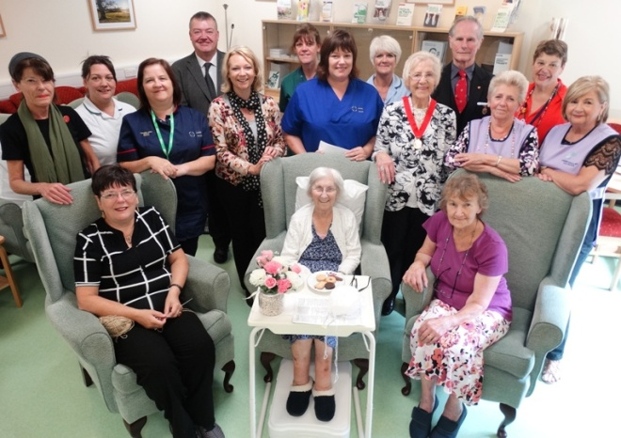
She said the treatment Helen received during her final illness had left a lasting impression and her year in office had given her a chance to do something to repay it.

Past Mayor of Neath Port Talbot Sheila Penry and her consort Glen Clarke (standing fifth and fourth from right) with senior management, complimentary therapist, CISS counsellor, volunteers, occupational therapy assistants, health care support workers and patients.

“My experience made me determined to do all I could to try to help people with cancer in this area.

"Helen had wonderful care and I understand the difference that that can make to patients and their families. It gives me great pleasure to present this donation,” she said.

Mum-of two Helen passed away a day before she had been due to be admitted to Morriston Hospital’s Ty Olwen and some of the money raised will go towards services at the Swansea hospice.

Councillor Penry and Glen Clarke, who was her consort from May 2016 to May 2017, visited Y Rhosyn in its new location in what was formerly the hospital’s Elderly Day Unit.

Clinical nurse specialist Kate Tucker explained the change of venue was aimed at improving the available services and surroundings for patients with specialist palliative care needs.

Y Rhosyn provides day care and therapies including complimentary therapy, fatigue management, relaxation therapy and counselling. It also hosts a specialist palliative care outpatient clinic and sees patients in the community and in the hospital.
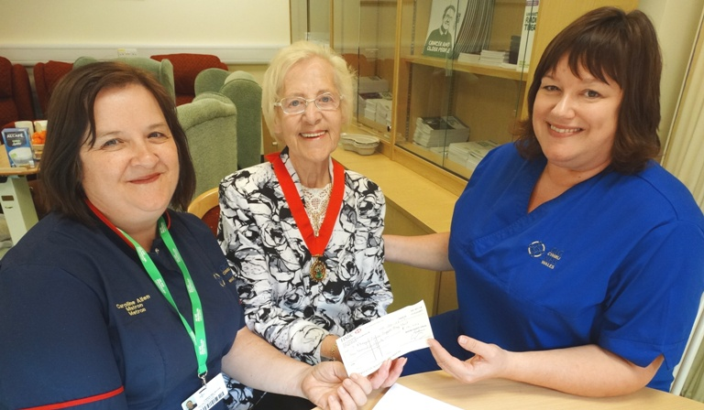
​
Former Mayor of Neath Port Talbot Sheila Penry (centre) with Macmilllan palliative care matron Caroline Allen (left) and Kate Tucker, clinical nurse specialist Y Rhosyn.

Kate said: “We really are a one-stop shop for our patients and we intend to use this money to make our new home here more comfortable and less clinical for them.

“This donation is a tremendous boost for our team’s work and it will enable us to do things even better.

“We are so grateful to Councillor Penry and the people of Neath Port Talbot for thinking of us and our patients.”

After handing over the money, Councillor Penry chatted to staff and patients and also explained just why the unit and the work of cancer services in ABMU were so dear to her heart.

“Helen was originally diagnosed with cancer when she was nine. She recovered but we were warned it might come back aggressively when she was older.

“When she was 40 her kidneys started to fail and within 10 days she had passed away,” said Councillor Penry, who has another daughter, Helen’s twin sister Alison, now a senior hospital sister in Southampton.

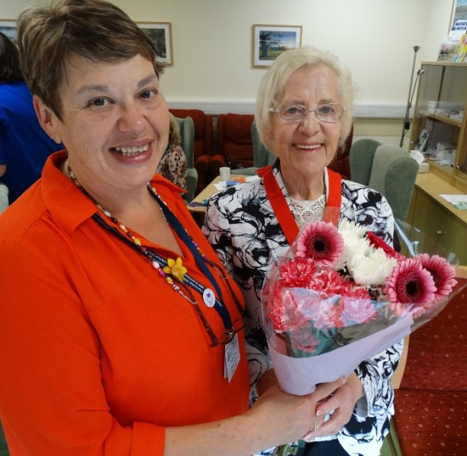
“I had wonderful support from the people of Neath Port Talbot for my appeal so I want them to be able to benefit which is why I wanted to help Y Rhosyn.”

Y Rhosyn office coordinator Bella Tudor presents Sheila Penry with flowers during her visit to the unit.

During her visit she also brought a donation of teddy bears for staff to sell in the run-up to Christmas to raise further funds.

In addition to this £10,000 boost, Councillor Penry is set to present an additional £3,000 from her final Mayor’s Appeal total of £13,700 for Alzheimer’s patients at Tonna Hospital. The remainder will go to St Joseph’s Church in Hillside, Neath and to St John Ambulance.

“I am grateful for the kindness and hard work of all those people who supported my Mayor’s Appeal throughout the year.

“There are too many to mention by name but I had donations from a wide variety of groups and individuals and I would like to thank them from the bottom of my heart for all their effort,” she said.

Councillor Penry’s support for Y Rhosyn is set to continue – she now plans to launch a series charity Sunday lunches at the Castle Hotel in Neath with all proceeds going to help the unit.

Source: Abertawe Bro Morgannwg University Health Board

