Get your body mapped and take 3D pics at Swansea Science Festival
Monday, 4 September 2017
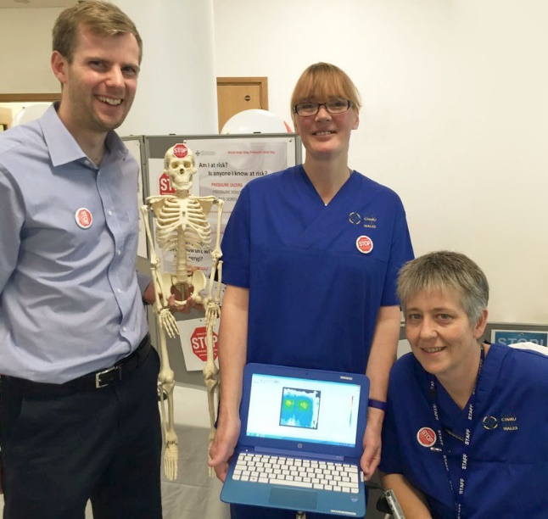
Visitors to this weekend’s Swansea Science Festival can have their body mapped to highlight the risk of pressure ulcers.

With guidance from a team of ABMU experts they can also take 3D images of pressure wounds and explore an interactive module to learn more about a problem that can have a huge impact on people’s lives.

Principal clinical scientist Dr Mark Bowtell with senior clinical nurse specialist Sue Flavin (centre) and tissue viability nurse Julie Evans

Swansea Science Festival takes place in the National Waterfront Museum from Friday to Sunday this week (September 8th-10th).

Representatives of ABMU’s Pressure Ulcer Prevention and Intervention Service (PUPIS) and Tissue Viability Service will present a drop-in workshop in the museum’s Vivian Room on Friday from 4pm-6pm.

The skin is the body’s largest organ and is also the easiest to damage.

Every year in Wales, thousands of people living at home develop damage from prolonged pressure on their skin. This damage can be difficult to heal and lead to the risk of infection.

ABMU specialists are pioneering the use of technology to reduce this risk and improve the care for people with pressure damage to their body.

Innovations include developments in 3D photography and the creation of a new pressure ulcer app.

Head of rehabilitation engineering Dr Lorna Tasker said: “This will be an opportunity for members of the public to come along and see how we are using technology to prevent and manage pressure ulcers.

“They will be able to pressure map their body on a seat, using a computerised mat to show where they may be at risk from pressure ulcers.

“They can also take 3D photographs of artificial wounds, and explore an interactive learning module with games and quizzes.

“The aim is to increase awareness of pressure ulcers because people often don’t realise what they can do to prevent them.”

Swansea Science Festival is hosted by Swansea University in partnership with the National Waterfront Museum.

Source: Abertawe Bro Morgannwg University Health Board

