Hospital team honoured for mentoring work with student nurses
Thursday, 21 September 2017
The guidance and support it offers to nursing students has earned the mentoring team at Princess of Wales Hospital’s Day Surgery Unit a top award.

The team was honoured with an Excellence Award at this year’s annual Mentor Conference held by the University of South Wales after being nominated by a grateful BSc Nursing student.

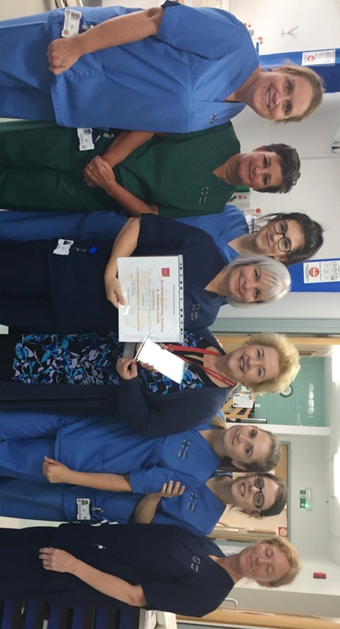
Ward manager Fran Hipkiss and the nursing team at the unit consistently receives good feedback for the support it provides to students.

Ward manager Fran Hipkiss (centre with certificate) and practice education facilitator Helen O’Mahoney with members of the team at the hospital.

Fran said: “As a department, we strive hard to provide a unique and supportive learning environment for students.

“Each and every team member is motivated to encourage students to reach their full potential by assisting and supporting their individual needs.

“This, in itself, develops students’ confidence and skills which promotes learning for both the student and the mentor.

“Having a student can be challenging at times for the mentor - and co-workers - but the reward is seeing the future nurses developing.”

Mentoring is a regular role of nurses across ABMU, explained practice education facilitator Majella Kavanagh.

She said: “The role is varied and much appreciated as without our committed mentors the next generation of nurses simply wouldn’t exist.

“Staff undertake their mentorship preparation module once they have been qualified for 12 months and completed their preceptorship period.

“Mentoring experiences are generally very positive and can be recorded by individuals and used within the Nursing and Midwifery Council revalidation process so the relationship is beneficial to both parties.”

The mentorship preparation module is available in-house at Princess of Wales Hospital and at Swansea University. Payment is not required but study time must be made available in accordance with NMC guidance.

Further information is available from Helen.Omahoney@wales.nhs.uk and Simon.cassidy@wales.nhs.uk

Source: Abertawe Bro Morgannwg University Health Board

