Madge retires after 45 years dedicated to neonatal care at Singleton
Tuesday, 5 September 2017
When a neighbour told Madge Williams she had found her the perfect job she never dreamed she would still be doing it 45 years later.

Now neonatal nurse Madge has finally said goodbye to her colleagues at Singleton Hospital after caring for thousands of newborns and their families since 1972.

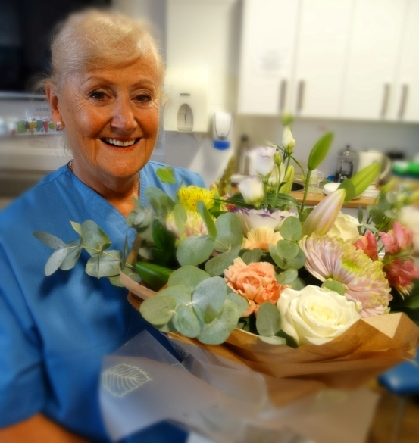
Madge, from the Swansea Valley, actually started her nursing career 51 years ago and after training at Mount Pleasant Hospital took up her first post on the wards at Morriston Hospital.

She said until then she had never considered switching to neonatal care.

“I had given up work to have my first baby and a neighbour who was a midwife, came round one day and said ‘Madge, I’ve got you a job’.

“My son was only four months old so I just laughed but she said was serious and that I couldn’t turn it down. ‘Madge, you can work any day you want, any hours you want, they are absolutely desperate for staff.’

“I had never done neonates before but she said not to worry and to take the job and that’s how it started here at Singleton.”

The 66-year-old says she has enjoyed her career enormously but felt after working part-time for the past few years, it was the right time to step aside.

“I am now nursing the children of babies I helped look after!

“Although many aspects of our work have changed enormously over the years, the days are as hectic as ever but I just put my babies first, like I have always done.”

When Madge began her job the neonatal ward saw fewer premature newborns.

“It was totally different then, it wasn’t such a specialised role as it is now. The main difference is babies born earlier now have a better chance of surviving. Technology and modern equipment has changed the job entirely.

“When I first started there were no ventilators at all, then we progressed to what was called a Gregory box which was put around the baby’s head and provided oxygen. The service has really developed over the years.”
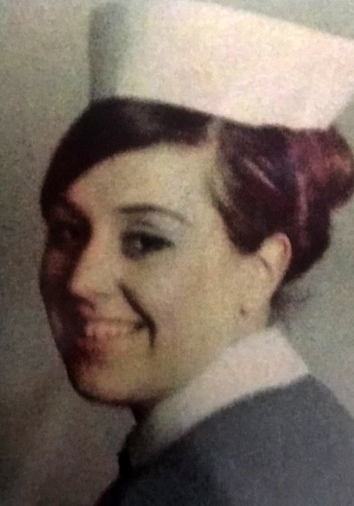
Neonatal nurse Madge Williams at the start of her career.

However despite the advances some things never change she says, including the anxiety felt by her tiny patients’ families.

“I always tell parents to take things second to second, minute to minute, and to remember every hour is precious.”

Over the past 45 years, besides building relationships with families, Madge has played a key role in training and supporting the next generation of neonatal nurses.

“All through my career I have always been part of a very close knit group – there are 11 of us here have worked together for 30 years - we’ve helped each other, looked after each other.

‘It’s a tough job but the team work makes such a difference, we all trust each other. I have made friends for life.

“I have always tried to show the same care and consideration to my colleagues as I would to the families,” she said.

And many of those friends and colleagues came along to wish her well and join her for a celebration at the neonatal unit on the day of her final shift.

“This ward is unique in every way – we are touching families’ lives and I have been privileged to work here,” she added.

Mum-of-two Madge, who also has two grandchildren, is now looking forward to having more time to devote to her many interests including spending time with her partner Peter, helping with her son Martyn’s pork business and looking after her two horses.

She is also a keen gardener and enjoys decorating and sewing.
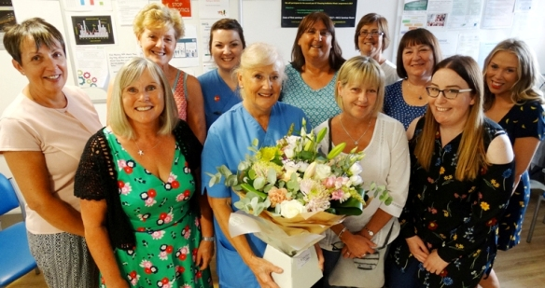
Neonatal nurse Madge Williams with some of her colleagues at Singleton Hospital’s neonatal intensive care unit who helped her mark her retirement.

“I have a very full life but what I will miss most are my friends – my colleagues have made my career and what a wonderful career I have had. How fortunate I have been to work with such fantastic people.”

Matron for neonatal services Helen James said: “On behalf of the neonatal team we would like to thank Madge for the hard work she has provided for the neonatal service over the years.

“Madge is an exceptional nurse who has provided excellent care to our babies, working closely with their families.

“Retirement is a new and exciting chapter in Madge’s life and we wish her all the best.”

Source: Abertawe Bro Morgannwg University Health Board

