Neonatal project wins top Welsh health award
Friday, 22 September 2017
An initiative by ABMU staff to improve the way antibiotics are used to treat newborn babies has earned a prestigious NHS Wales Award at the tenth anniversary of the ceremony.
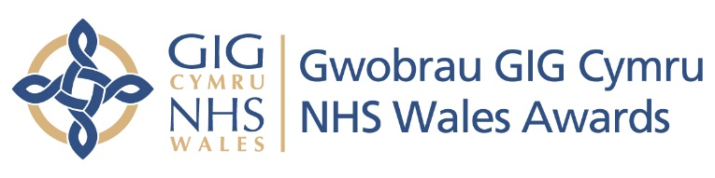

Work on the Managing Antibiotics Wisely project won the Improving Quality Using Improving Quality Together Methodology Award at the event held in Cardiff last night.

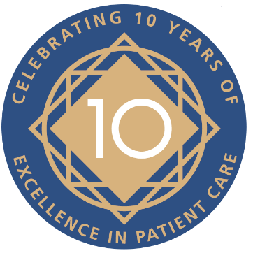
The project, led by consultant neonatologist Dr Sujoy Banerjee, involves reducing the use of antibiotics in babies at Singleton Hospital’s neonatal unit, without adversely affecting outcomes. In fact, reducing inappropriate antibiotic use may improve health outcomes in babies for life.

The project has seen a 43 per cent reduction in antibiotic use – double the original target and sustained over 12 months – with the unit recording one of its lowest death and serious illness rates of recent years.

Three other ABMU projects missed out on awards after being shortlisted by judges.

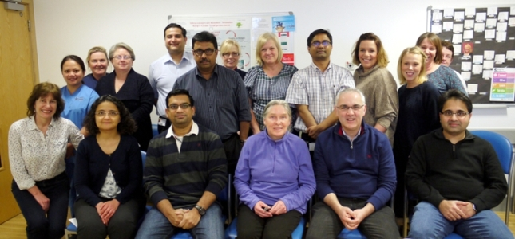
The ABMU team behind the Managing Antibiotics Wisely project including Dr Sujoy Banerjee (standing, fifth from left).

The team behind improvements to pulmonary rehabilitation services and work to use a low FODMAP diet as effective treatment for IBS were finalists in the Improving Health and Wellbeing and Reducing Inequalities category.

An initiative at Tonna Hospital to create an enhanced therapeutic environment for patients to reduce aggression and improve staff morale was among the runners-up in the Improving Patient Safety category.

ABMU’s Interim Chief Executive Alex Howells said: “Congratulations and well done to everybody involved in this project. I am delighted to see the judges recognise their innovative and important work.
“To have four ABMU projects reach the final stages of such prestigious awards really was a great achievement and I am very proud of all the hard work that has gone into each of them. It shows how our colleagues are always looking for ways to improve the care we give our patients.”
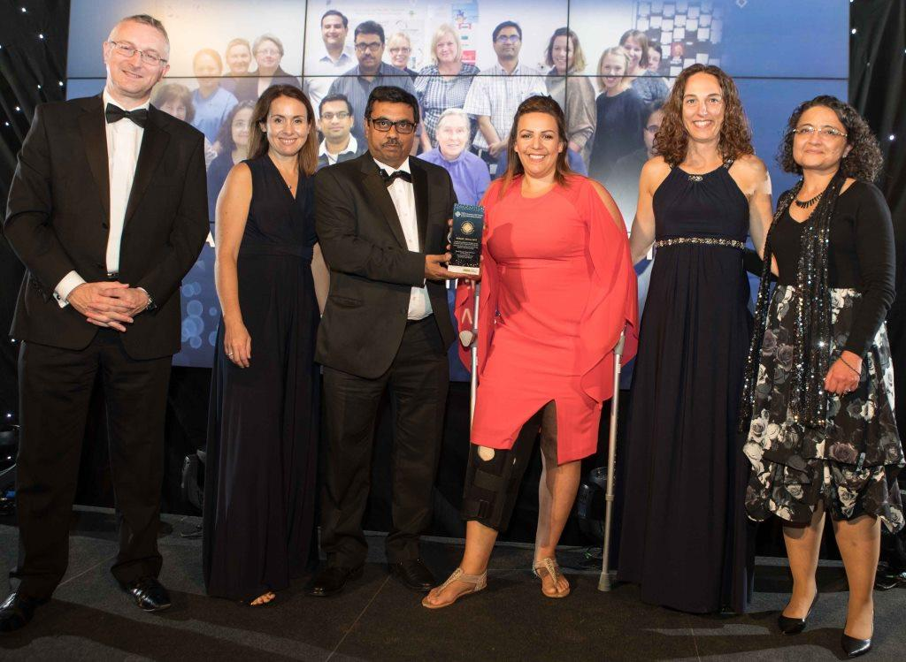
Pictured at the ceremony are (from left) NHS Wales Chief Executive Andrew Goodall, Joanna Webb, Sujoy Banerjee, Gemma Davies, Vanessa Makri and Maha Mansour.

The NHS Wales Awards were launched in 2008 to celebrate the 60th anniversary of the NHS and recognise and promote good practice across Wales.

Entries were received from a range of organisations, revealing a high standard of innovative and diverse work that is transforming patient care across Wales.

Cabinet Secretary for Health Vaughan Gething, who attended last night’s ceremony in Cardiff, said: “The NHS Wales Awards are a national showcase for excellence and celebrate best practice in improving patient care across Wales.

“It’s a great opportunity to learn from each other and recognise the inspiring innovation of our NHS staff.

“Every finalist should be proud to be shortlisted for an award. It’s encouraging to see such passion and dedication to improving services provided across Wales.”

To read more about all of the winners visit www.nhswalesawards.wales.nhs.uk.

Source: Abertawe Bro Morgannwg University Health Board

