New-look renal unit to open at Morriston in 2018 after £5.8 million upgrade
Wednesday, 13 September 2017
A new-look renal unit providing state-of-the-art facilities will be unveiled at Morriston Hospital next year after a £5.8 million upgrade.
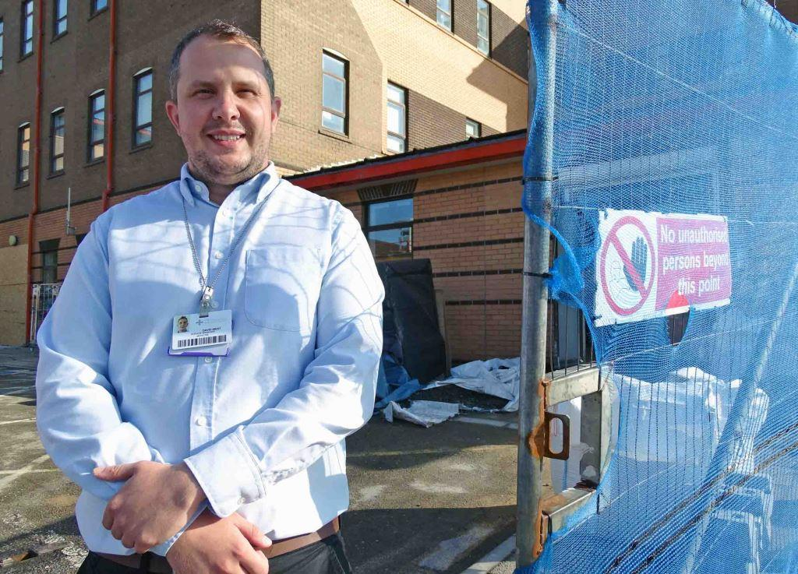
Work is well under way and due to be finished in spring 2018, transforming care for thousands of patients from across the South West Wales region.

Left: David West outside the renal unit where a £5.8 million refurbishment is now under way

Morriston’s local and regional renal dialysis unit, renal outpatient department and renal day case and self-care service are all being improved.

The refurbishment – funded by the Welsh Government – includes direct access from the wards into the dialysis units.

There will also be more cubicles, more bed space and more outpatient consulting rooms, along with a new main entrance.

Medicine service manager David West said: “This redevelopment has been in the planning for some time.

“The unit has been there for many years and had become outdated. It was quite dark and the layout was not ideal.

“But following the refurbishment it will provide a much brighter, airier and more attractive environment for patients and staff.”

The Morriston unit provides care for people with kidney disease across South, Mid and West Wales from Fishguard to Bridgend in the south and from Tywyn to Llanidloes in the north.

However, it had insufficient cubicles and the bed spaces were too small.

Following the refurbishment it will provide 19 dialysis stations and a modernised procedure room. The number of cubicles in the renal ward will increase from three to seven and dedicated facilities will be provided for barrier nursing and for bariatric (high weight) patients.

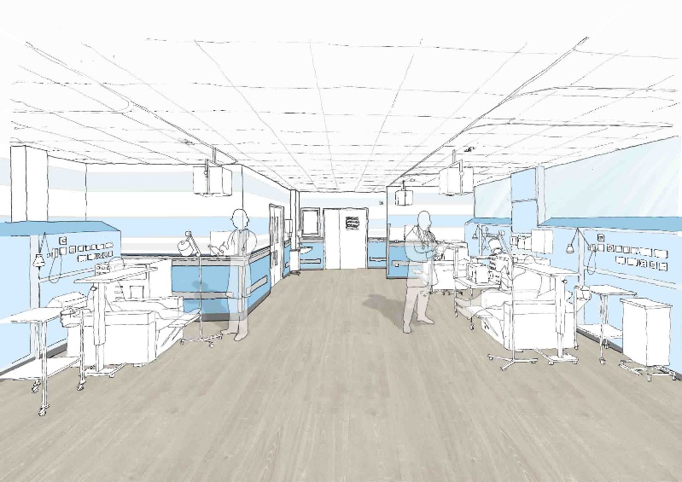
The day case unit will have one cubicle, three trolley spaces and six chairs. Along with the new renal pharmacy it provide a one-stop service for outpatients and day patients who need multiple interventions and tests or medications.

Meanwhile, the number of consulting rooms in the outpatient suite will increase from four to six.

There will also been a self-care training area for patients.

Right: Artist's impressions of the new-look renal unit

Mr West said alternative provision had been made within Morriston Hospital so patient care could continue uninterrupted while the refurbishment, due to be completed next May, took place.

“We handed the unit over to the contractors in June and they are making good progress. They have demolished the internal walls and are changing the layout completely.

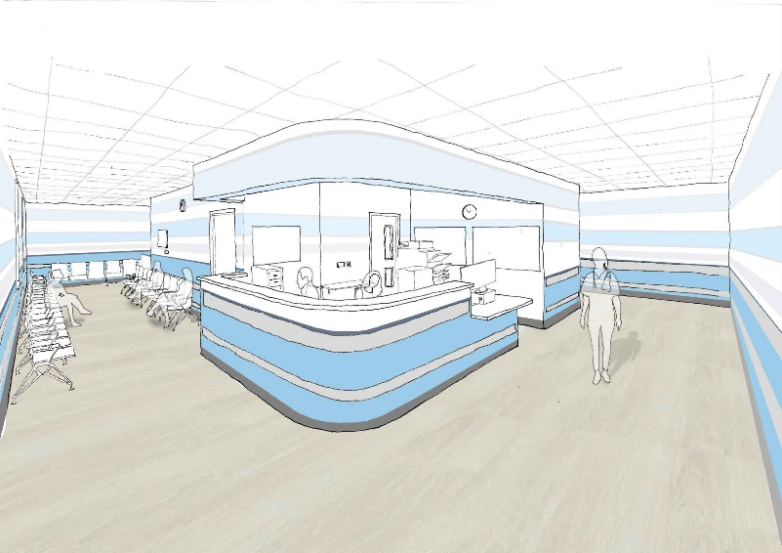
“The refurbishment includes new facilities – new chairs, new equipment, and new televisions for patients as they are in the dialysis chairs for hours at a time.

“The renal unit is being brought up to modern standard and everything is going to be state of the art.”

The upgrade follows the opening of the new renal annex within Morriston Hospital’s £60 million main entrance and outpatients department in late 2015. This provides additional dialysis machines and other services.

Source: Abertawe Bro Morgannwg University Health Board

