Tough test sees staff raise £2,500 for cardiac patients
Wednesday, 6 September 2017
A team of intrepid colleagues from Morriston Hospital made a splash by taking on a gruelling 10-mile obstacle course to help ABMU cardiac patients.

The 27-strong group completed the Tough Mudder challenge at Badminton which sees participants tackling a route littered with more than 20 obstacles including monkey bars and mud crawls and a slide into iced water.
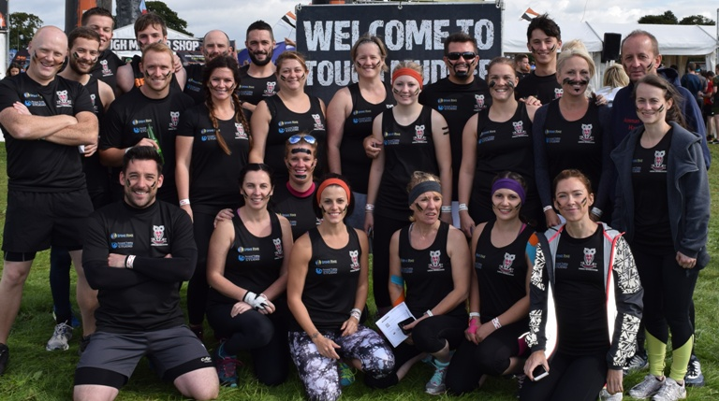
But their journey towards raising more than £2,500 was not without a few casualties, according to radiographer Caroline Hurley.

The team before they headed out on the Tough Mudder course.

She said: “The majority of us got around with minor scrapes and bruises but two of our team ended up with shoulder dislocations. As a whole, though it was very successful and a fun day.

“I would definitely do it again - although I'm not sure all my team mates would agree!”

She was joined on the challenge by fellow radiology staff along with colleagues from the cardiac cath labs and the Spine Fine Chiropractic Clinic in Cross Hands.

The money they raised will go towards the cardiac rehabilitation service which is used to help patients as they recover from a heart attack or heart disease - like Caroline's own dad.

She said: “Last October my father needed a coronary angiogram, then a coronary artery bypass. The care he had was absolutely fantastic and he saw huge benefits from attending the cardiac rehabilitation clinic after his surgery.

"We chose to raise money for our local rehabilitation centres because many of us who took part have had family members or friends who have received treatment for heart disease and were helped by cardiac rehabilitation.

“Also we see first-hand the importance of cardiac rehabilitation for our patients post surgery or cardiac procedures. It is an invaluable service to patients.”

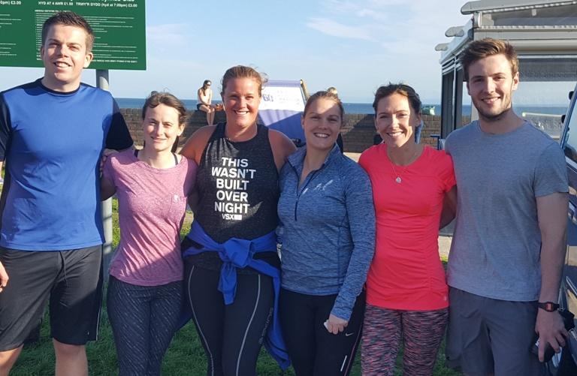
Morriston cardiac physiologists Gavin Wells and Claire Warren, radiographers Rachel Ford and Caroline Hurley, cardiac cath lab nurse Melissa Madden and radiographer Matt Davies during their training for the Tough Mudder.

Cardiac rehab is primarily offered to people who have undergone bypass surgery or coronary angioplasty or have stable angina, heart failure, cardiomyopathy and other heart disease.

It aims to help people manage their condition and regain confidence in returning to exercise, work and normal day-to-day activities after their surgery or illness.

Caroline added: “As this year marks the 20th anniversary of the Cardiac Centre at Morriston Hospital I felt it was fitting to raise some money as a thank-you for the care my father had received.

"The centre covers the whole of West Wales from Bridgend to Aberystwyth, but once the patients have had their procedures or surgery they are then cared for in their local area, which is why we are supporting both cardiac rehabilitation at both Morriston and West Wales General Hospital in Carmarthen.

“We are very grateful for the support we have already received and any sponsorship towards this vital service is very much appreciated.”

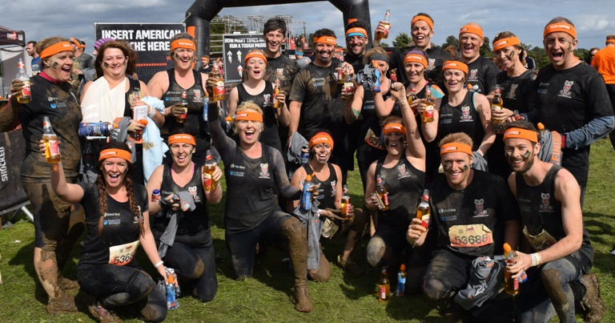
Although their fundraising page is now closed Caroline is hoping to add to the total and says it is still possible to make a donation at Morriston’s cath lab and radiology and cardiac rehab departments.

The team after they finished their challenge.

