ABMU celebrates its brightest and best young doctors
Friday, 14 September 2018
A celebration of the brightest and best young doctors working for ABMU has taken place at Morriston Hospital.
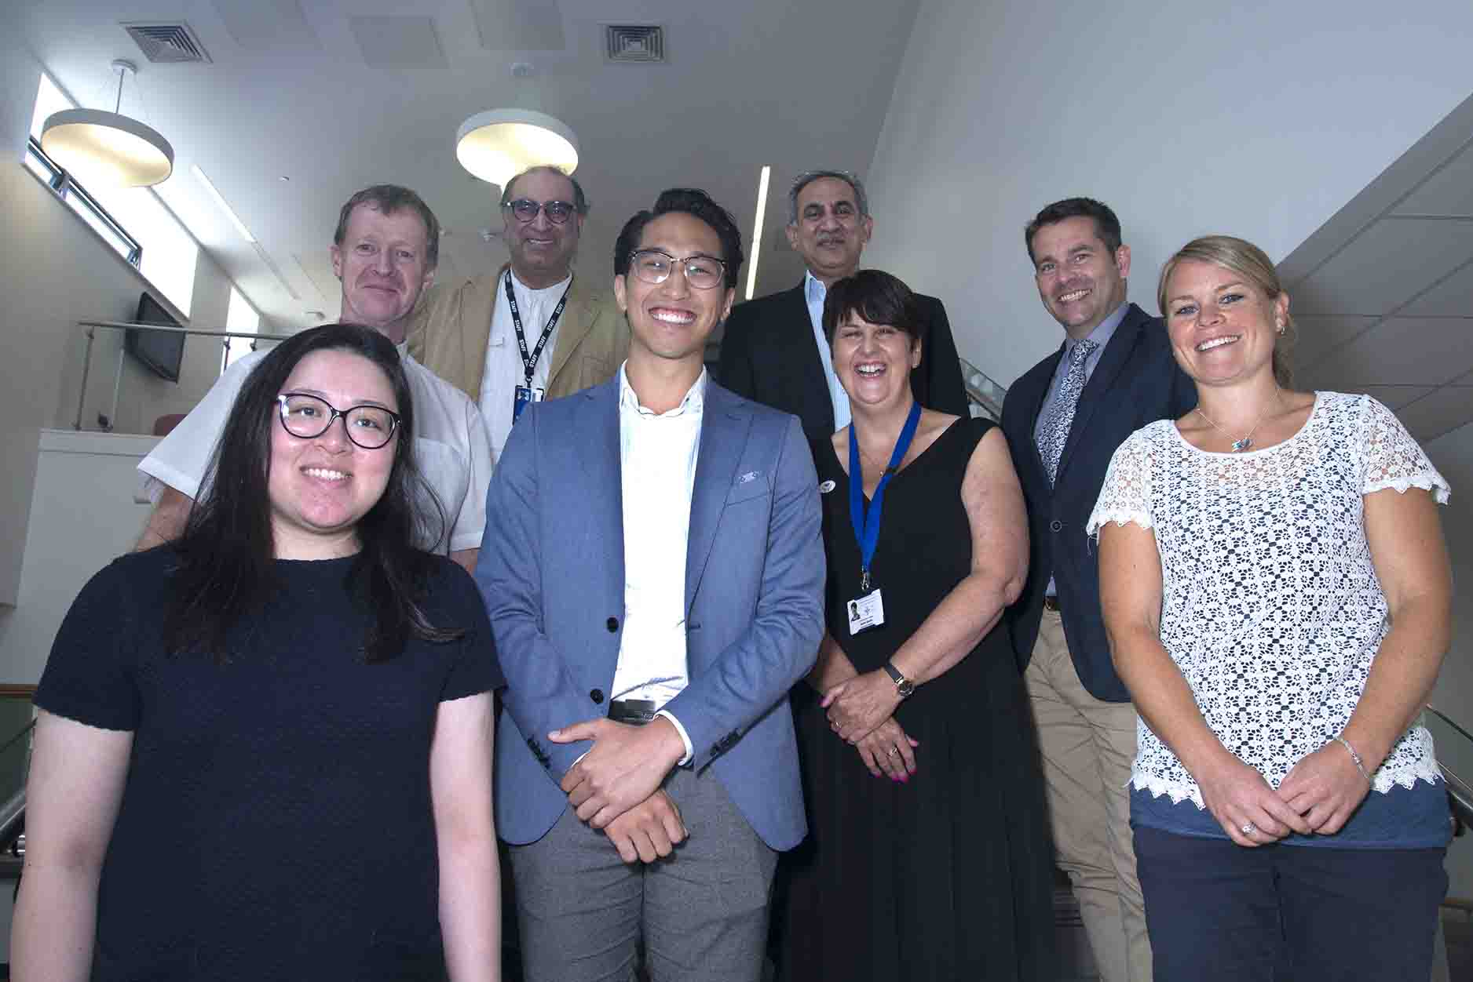
Every year the health board honours the top doctors of tomorrow for the contributions they are making to patients today.

And every year the list of candidates is so strong that selecting the winners is always a tough decision for the judging panel.

L-r: Alethea Tang, joint winner, Junior Trainee Award; Paul Jones, Swansea University Medical School; ABMU Interim Executive Medical Director Pushpinder Mangat; Martin Van, joint winner, Junior Trainee Award; Amol Pandit, faculty lead for trainees; ABMU non-officer member Jackie Davies; Nick Wilson Jones, faculty lead for trainees; and Catrin Williams, Senior Trainee award winner.

This year was no exception, but after much deliberation the panel announced the 2018 winners were:

Foundation Trainee – Dr Alex Evans, Morriston.
Junior Trainee – (joint winners) Dr Martin Van and Dr Alethea Tang, Morriston.
Senior Trainee – Dr Catrin Williams, Morriston.

The ABMU Best Trainee Awards celebrate excellence among junior doctors, highlighting their contribution to service delivery, quality improvement and education.

The awards, now in their eighth year, were originally launched by Dr Umakant Dave to reward the best Morriston Hospital trainees.

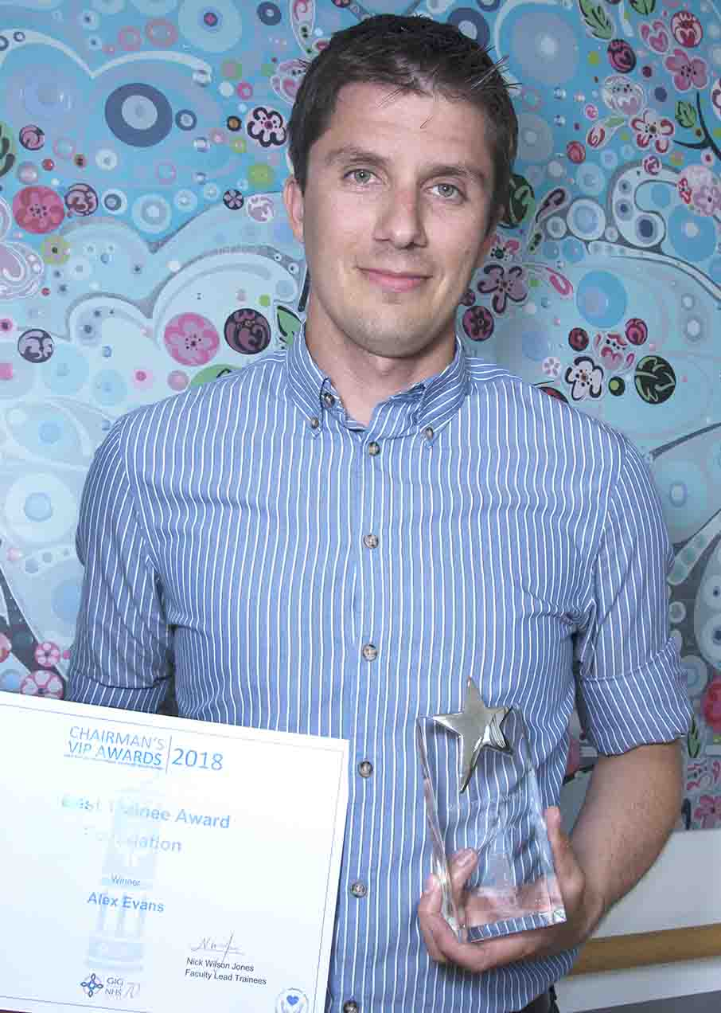
However, over the years they have gone from strength to strength and been expanded to include entries from across the health board.

Right: Foundation Trainee award winner Alex Evans

The judging panel comprised ABMU Interim Executive Medical Director and Responsible Officer Pushpinder Mangat; non-officer member Jackie Davies; faculty leads for trainees Nick Wilson Jones and Amol Pandit, and Paul Jones of Swansea University Medical School.

Consultant paediatric plastic and reconstructive surgeon Nick Wilson Jones said: “It was an inspiring and humbling day.

“All too often we hear negative comments about the NHS but this was a celebration of excellence and hard work.

“The standard this year was incredibly high. Shortlisting and then choosing the eventual winners proved incredibly difficult because there was such calibre.”

Every year, members of staff are invited to put doctors forward for the awards. All nominated trainees then have to provide structured references from two clinical supervisors and one non-medical member of staff.

A shortlisting panel from ABMU’s education faculty reduce the nominations down to three candidates in each of the three categories.

They then have to present to the judges and take part in a question and answer session.

This year the shortlisted candidates for each category were:
Foundation: Alex Evans; Nia Jones; Michael Nangalia; Rob Slade (there were four instead of three as the shortlisting panel were unable to separate them).
Junior: Martin Van; Alethea Tang; Owen Vale.
Senior: Samantha Cox; Catrin Williams; James Warbrick Smith.

Nick Wilson Jones added: “Every nominated candidate should feel very proud and the health board should be very proud of them.”

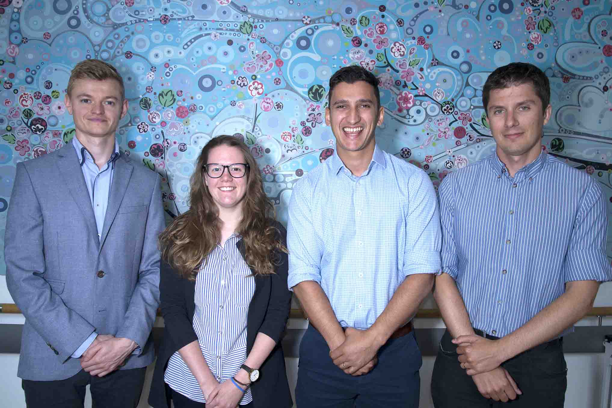

Above: Nominees for the Foundation Trainees Award

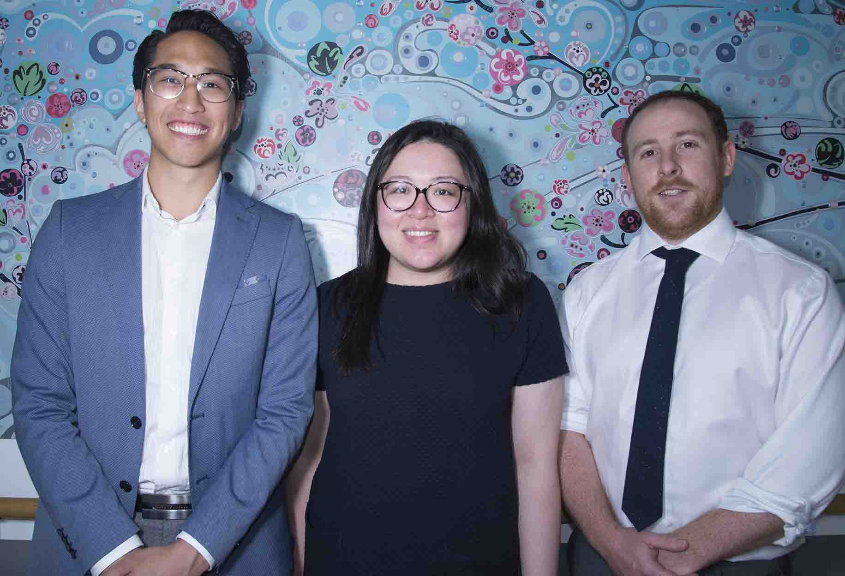

Above: Nominees for the Junior Trainee award

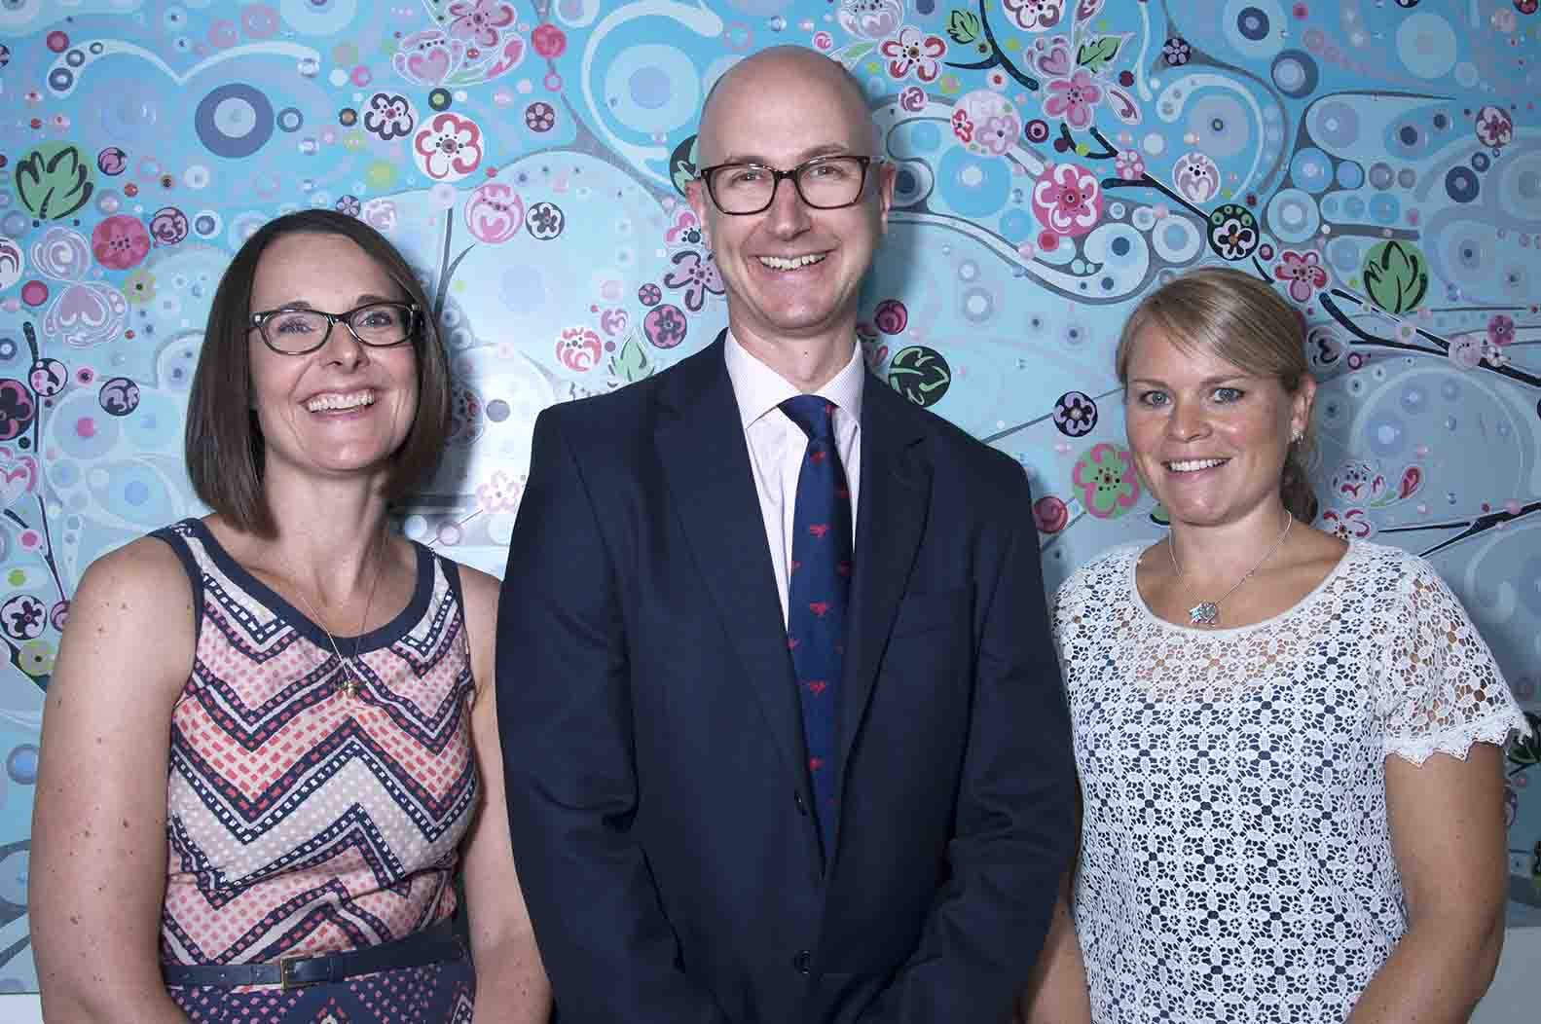

Above: Nominees for the Senior Trainee award

Source: Abertawe Bro Morgannwg University Health Board

