Dr Richard Evans appointed ABMU's Medical Director
Wednesday, 5 September 2018
ABMU Chairman Andrew Davies and CEO Tracy Myhill are delighted to announce to colleagues the successful appointment to the post of Medical Director.
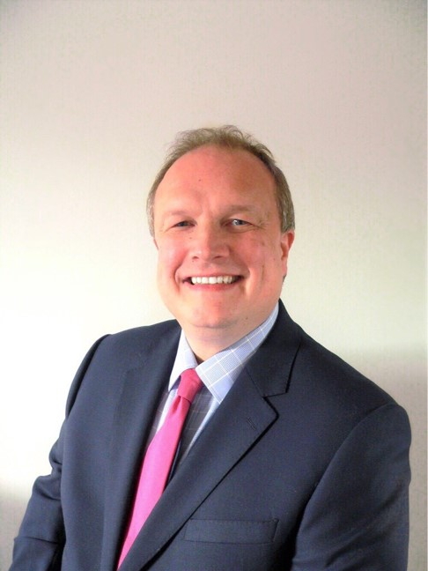
We have secured an excellent candidate in Dr Richard Evans who is currently Clinical Board Director for Medicine and a practicing hospital consultant specialising in Infectious Diseases and General (Internal) Medicine at Cardiff and Vale University Health Board.
He has more than 12 years’ experience in senior leadership roles in the NHS and brings with him extensive knowledge of leading complex clinical services.
Richard (pictured left) qualified from the University of Wales College of Medicine and undertook his specialist training in Wales and the USA, completing a Research Fellowship at Harvard Medical School and a Clinical Fellowship programme at Massachusetts General Hospital in Boston.

Richard is also a graduate of the Institute of Healthcare Improvement’s Improvement Advisor programme.

Richard said: “It’s a privilege to be appointed as the new Medical Director at ABMU and I am looking forward to joining the team. I am particularly looking forward to meeting patients, families, and staff, and to hear from them all how we can deliver further improvements in the services we provide and to the lives and health of the communities we serve.

“The strong relationship with Swansea University and our close collaboration with neighbouring health boards and partners are a formidable combined force to shape the future of healthcare in the region.

“My focus is to continuously improve the quality of the services we provide to achieve the best possible outcomes for the population. The challenge is significant, but the opportunity is enormous, and I am very excited at the prospect of what the future holds.”

Tracy Myhill Chief Executive Officer said: “I am very much looking forward to Richard joining my Executive Management Team in this significant role welcoming him with the Chairman to our Board. I am very grateful to Dr Push Mangat who has been acting into this role in the interim and wish Push every success in his new role as Medical Director at HEIW. I would like to thank Dr Alastair Roeves for his on-going support as he acts into the Medical Directors role between Push leaving and Richard joining us.”

Andrew Davies, Chairman, said, “I am delighted to welcome Richard to the ABMU Board and Executive Team. He brings a great deal of clinical and management experience to his new role, and will be joining us at an exciting time for the Health Board which is looking to build on the progress we have made over the last few years.”

Len Richards CEO at Cardiff and Vale Health Board said: “We are delighted for Richard on his appointment as Executive Medical Director at ABMU. His grounding as Medicine Clinical Board will stand him in good stead in the new position. I would like to thank Richard for all of his commitment and drive in order to effect significant changes to the Medicine Clinical Board Director and in particular his work with the Emergency Unit, which is the largest and busiest in Wales. I look forward to continuing the work with work with Richard and his other Executive Team colleagues on taking forward our shared agenda of specialist services.”
Source: Abertawe Bro Morgannwg University Health Board

