Eco-therapy helping to improve mental health of patients
Wednesday, 26 September 2018
The Early Interventions in Psychosis (EIP) team at Abertawe Bro Morgannwg University Health Board have been working with the Down to Earth Project to benefit their service users.
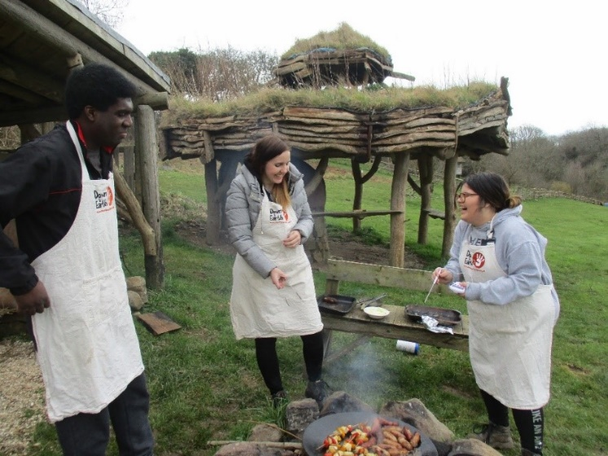
The non-profit organisation based in the Gower Peninsula, believe that relationship centred and meaningful outdoor experiences have the potential to change people’s lives.
On a weekly basis, two members of the EIP team accompany service users to their eco-therapy sessions, as a means of helping them overcome a main barrier of engagement.
The sessions vary from woodwork to gardening, cooking, river and sea swimming and woodland management, with a focus on team work, education and empowerment.
Their involvement in the project was recently featured in the first edition of the Early Intervention in Psychosis Network newsletter.
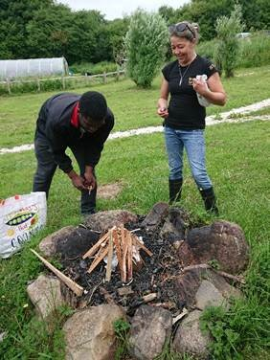
Bronya James, who wrote the article featured, is an EIP Practitioner at ABMU Health Board.
She said: “We have found that our service users have wanted to participate in work, educational or social activities but have lacked the confidence or motivation to do so.”
The team looked for a service that would help the young people work towards their goals, but without putting them in overwhelming situations, which may have contributed to a further decline in confidence or mental health.
“We found that those service users involved consistently improved in confidence and well-being.

“The activities were educational and through these activities the service users have also obtained accreditations, which has given them a confidence boost too.

“Attending the activities alongside the service users has also helped us as staff to develop a therapeutic relationship with themin non-clinical setting, as well as being good fun.

“The initial eco-therapy programme provided by the Down to Earth Project was hugely successful, and our team and service users look forward to the next programme”.
Source: Abertawe Bro Morgannwg University Health Board

