Life changing courses supporting those with long-term health conditions
Thursday, 13 September 2018
A mum from Neath who went on a course to learn how to cope with chronic pain is now helping others - by becoming a tutor on the very same course.

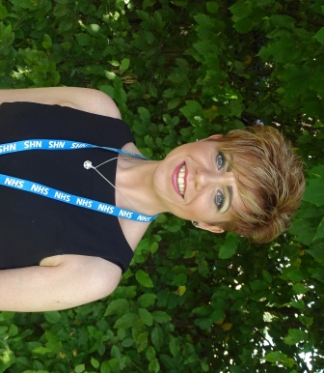
Angela Funning (left) spent three years in a wheelchair because of fibromyalgia and hypermobility.

She said: "I was in so much pain.

"Looking back I was so depressed. I was dependent on both my husband and my son for pretty much everything."

Then she attended a chronic pain self-management course run by Education Patients Programme (EPP) Cymru.

EPP provides a number of self-management courses and health and wellbeing workshops for people with a health condition or caring for someone with one.

The courses are based across the ABMU Health Board area, including Remploy Swansea and Bridgend and Cimla Health and Social Care Centre in Neath.

EPP also offers health and well-being courses and self-management courses for anyone who is or has been a carer.

Most of the courses are led by volunteer tutors, who themselves have experience of living with a long-term health condition, and have gained the confidence to take responsibility for their own care.

The chronic pain self-management course helped Angela develop the skills to coordinate all the things needed to manage her health and keep her active.

Angela, who worked as a healthcare support worker for 22 years, made steady progress across the six-week programme, and in time became less and less dependent on her family for her own wellbeing.

She has since progressed further, and has been without her wheelhair for two years now.

"I am no longer in a wheelchair or using any walking aids, although there are good days and there are bad days. I tire easy.

Eighteen months ago, Angela joined EPP Cymru as a volunteer tutor.

She now tutors the chronic pain self-management course, which she strongly believes helped to change the way she lives her life.

"I was so inspired by the learning techniques of the course - and with my nursing background, I wanted to get back into helping others and passing on what I've learnt.

"Even if one person walks away from one of the sessions I tutor having learnt just one thing, then I've done my job.

"I want to reassure people that they too can come out on the other side, and If I can do that, that's everything".

Full tutor training is provided and volunteer tutors have access to local EPP coordinators for help and support and are also given ongoing training and updates.

As a volunteer tutor, Angela is supported by Natalie Harris, who is a EPP Coordinator at Cimla Health and Social Care Centre.
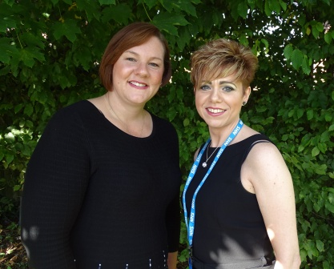
Natalie (pictured left with Angela) said: "As well as supporting tutors and coordinating the courses, I am a tutor myself.

"I have seen so many lives transformed through this course which is incredible. People have come away feeling as though they have gained control of their condition and it is no longer controlling them.

"They come away feeling more confident, and people have continued to form friendships".

To enquire about accessing any of these Self-Management courses, please contact Education Patients Programme (EPP) Cymru on 01639 684528 or email Natalie.Harris3@wales.nhs.uk

Source: Abertawe Bro Morgannwg University Health Board

