Morriston Physio achieves world ranking in power lifting
Thursday, 27 September 2018
A physiotherapy assistant at Morriston Hospital has achieved a top three world ranking at the World Power Lifting Championships.
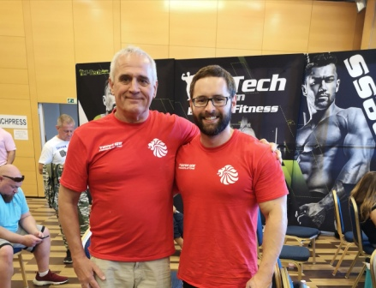
Cieron Browning represented Great Britain on Wednesday 19th September in Hungary, where he secured third place.

Left: Cieron Browning (right) with his father (left) at the World Championships.

The 28 year old from Neath has been a part of the cardiothoracic team at Morriston Hospital for five months, balancing his work with training and also as a sports massage student at Afan College.

He said: “My life is organised around my training. I train five days a week sometimes both morning and evening, with up to eight sessions at my local gym in Pontardawe”.

He was inspired to start powerlifting following his success at two strongest man competitions, where he achieved two top three titles in 2017.

And, despite only powerlifting since January this year, he achieved third place in the Global Powerlifting Committee (GPC) Welsh powerlifting qualifier in the under 90kg category.
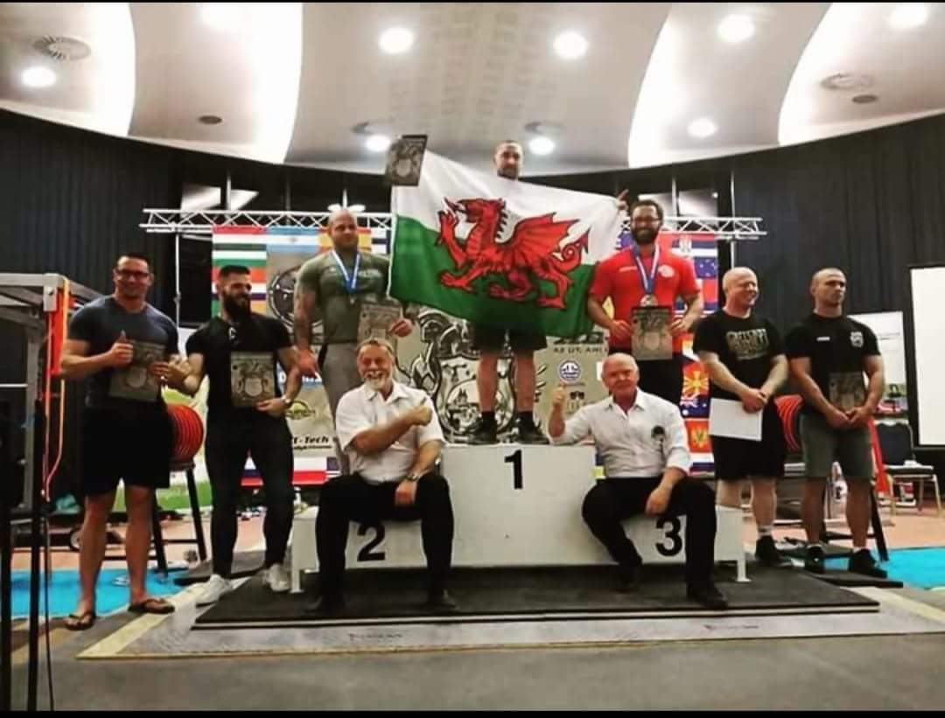
He said: “My father originally introduced me to training which made me catch the bug for lifting.

“Placement of the Great Britain Team was received in July, so extra focus and emphasis has been from that day.

“I was so happy to be chosen to compete for GB and I have put my all into it.

“Although I would have liked to have been able to lift more, and I feel like I can still improve - I am happy that I managed to come third and the hard work has paid off.

“My next competition will be for the Welsh GPC Powerlifting under 90kg title next year, roughly around May 2019”.

Source: Abertawe Bro Morgannwg University Health Board

