Nathan's rap charts his journey back from the brink
Thursday, 27 September 2018
Eighteen-year-old Nathan Davies almost died from a severe brain injury - now he's written and performed a rap telling the story of his hospital journey.

With video

“I got hit with a boom boom pow and then I went down…then I met the don and the game was on, learning to walk, learning to talk, singing some songs you just can’t go wrong.”

These are some of the lyrics from a rap written and performed by an 18-year-old who suffered such a severe brain injury that medics warned his family that he might die.

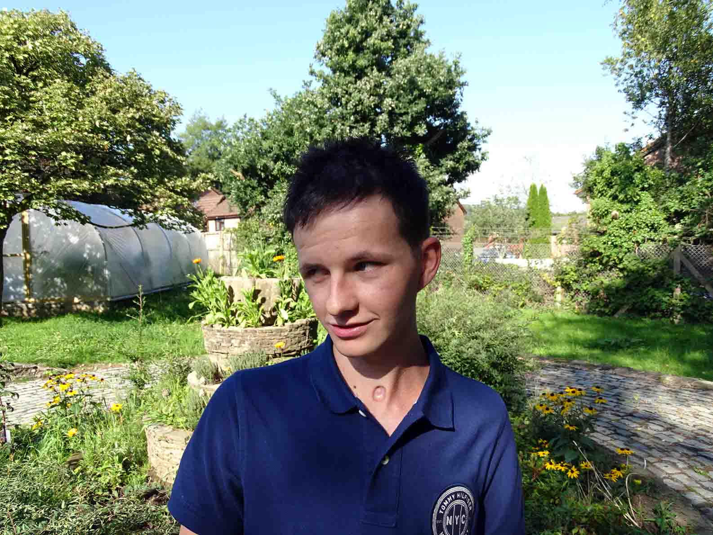
But despite being in a coma for a fortnight and in hospital for 18 months after he suffered a brain haemorrhage during a boxing match, Nathan Davies from North Cornelly, near Bridgend, is battling back.

Pictured left: Nathan Davies in the garden of the Traumatic Brain Injury Service at Morriston Hospital, Swansea

He has revealed how music and the Traumatic Brain Injury Service (TBIS) at Morriston Hospital in Swansea has supported him on every step of his journey.

He said: “Music gave me the ability to express myself. My rap, Nathan’s Journey, is about what happened and what I have been through.”

Jo Humphreys, a music therapist with the charity Nordoff Robbins which works in partnership with ABMU Health Board, first met Nathan on the neuro-rehabilitation ward at Neath Port Talbot Hospital when he was bed bound, unable to do anything for himself and only able to talk or sing in a whisper.

She said: “Initially Nathan was in isolation so he didn’t have a lot of company. I was able to go in with my sterilised guitar and my gloves and apron and we would have a little session at his bedside. We would enjoy making up songs together.

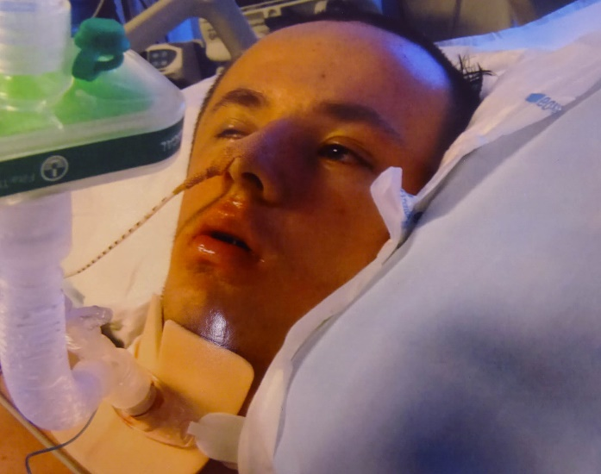
Pictured right: Nathan Davies in intensive care

“At that time Nathan was having a lot of things done to him, but in music, he was able to take the lead. At every stage of his rehab, music could meet him where he was – and celebrate how far he’d come.”

A fan of rapper Eminem and a wide variety of music, Nathan has continued working with Jo at TBIS following his discharge from hospital.

Using cymbals and even the arm of a wheelchair, Nathan has accompanied Jo on percussion while she plays the keyboard, a practice which has helped him develop his co-ordination and concentration skills.

And, having progressed onto the djembe drum, keyboard and rapping, Nathan is now ensuring fellow patients benefit from music therapy and the other innovative rehabilitation activities on offer at TBIS, which include gardening and exercise classes in conjunction with Swansea City FC.

Ahead of his 18th birthday in May, Nathan and his carer Paul Amphlett asked friends not to buy presents but to put donations into buckets during his party at Kenfig Hill RFC.

They raised £70 to support services at TBIS, where Nathan is continuing his rehabilitation.

Now able to walk again, Nathan has produced the rap with Jo’s help to chart the story of his hospital journey and also improve his speech and memory.

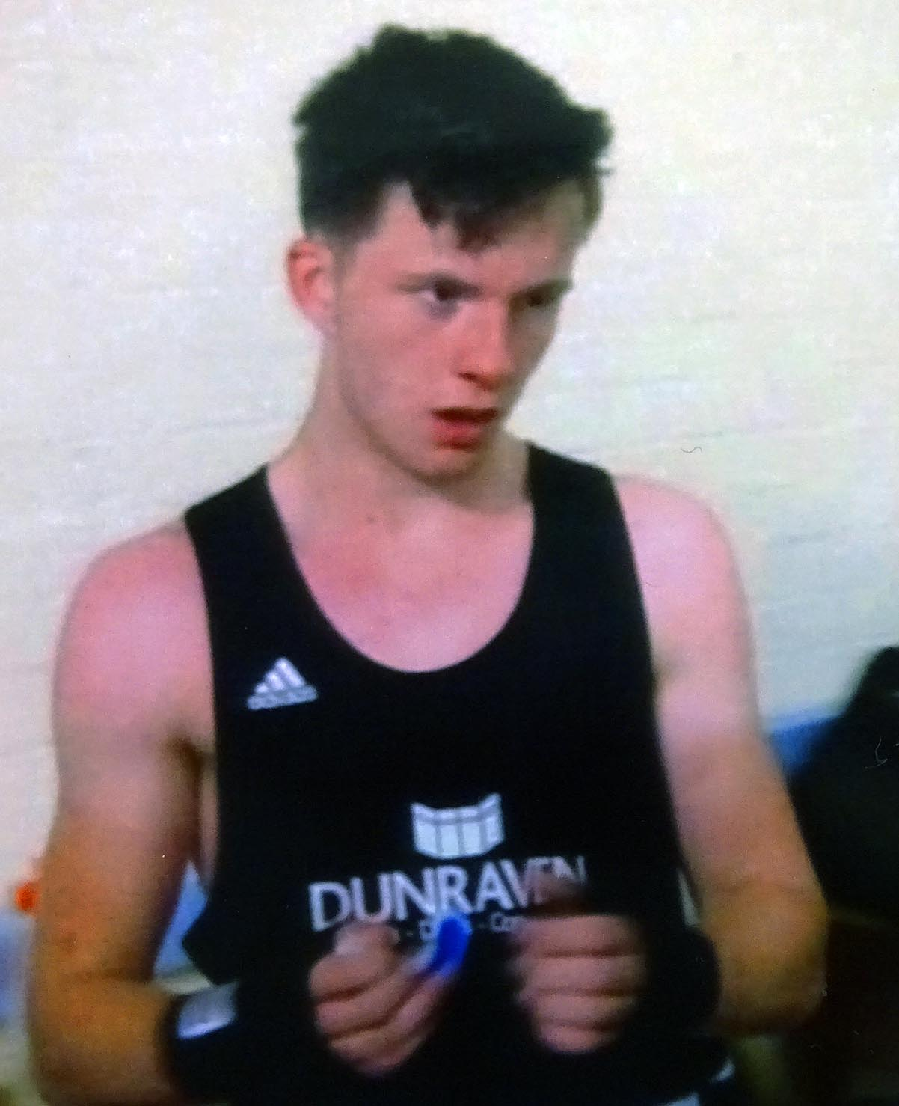
Pictured left: Nathan before he suffered his head injury

In the lyrics Nathan, a member of the Porthcawl and Pyle Pumas boxing club, describes how he collapsed in the last round of a bout in Bargoed two years ago and was rushed to the Royal Gwent Hospital in Newport before being transferred to intensive care in the University Hospital of Wales in Cardiff.

Here, he was placed in an induced coma while his brain swelled.

During this time his mum and dad Alison and Martin Davies, nan Sheila Carey and other family members keeping a bedside vigil were told twice by doctors that he was so ill they feared he would die.

“But there’s no getting rid of me,” said Nathan, who also uses the rap lyrics to recount his frustration during his lengthy hospital stay – “getting told no when I wanted to go” – and his optimism for the future – “seeing how it goes I suppose, taking it one day at a time and hope it all goes fine”.

Nathan said: “I have a very positive attitude: I can and I will. I always have that in my head.
“I hope to get to college to do car maintenance in the future. I was meant to be doing that now, but it all went a bit ‘Pete Tong’ (wrong).”

Jo, who is already planning a follow up to the rap with Nathan, added: “Nathan’s decision to donate all the fundraising he did at his 18th birthday party was incredibly touching for us as a service because it means we can carry on delivering rehab to people in a range of innovative ways.

“I wasn’t surprised because I have got to know Nathan over the last couple of years and I know he’s such a generous and positive person, I knew he’d want to help other people.”

Paul Amphlett, Nathan’s carer, said: “I have been a carer for 10 years now and I have never met anyone like Nathan who is happy every morning.

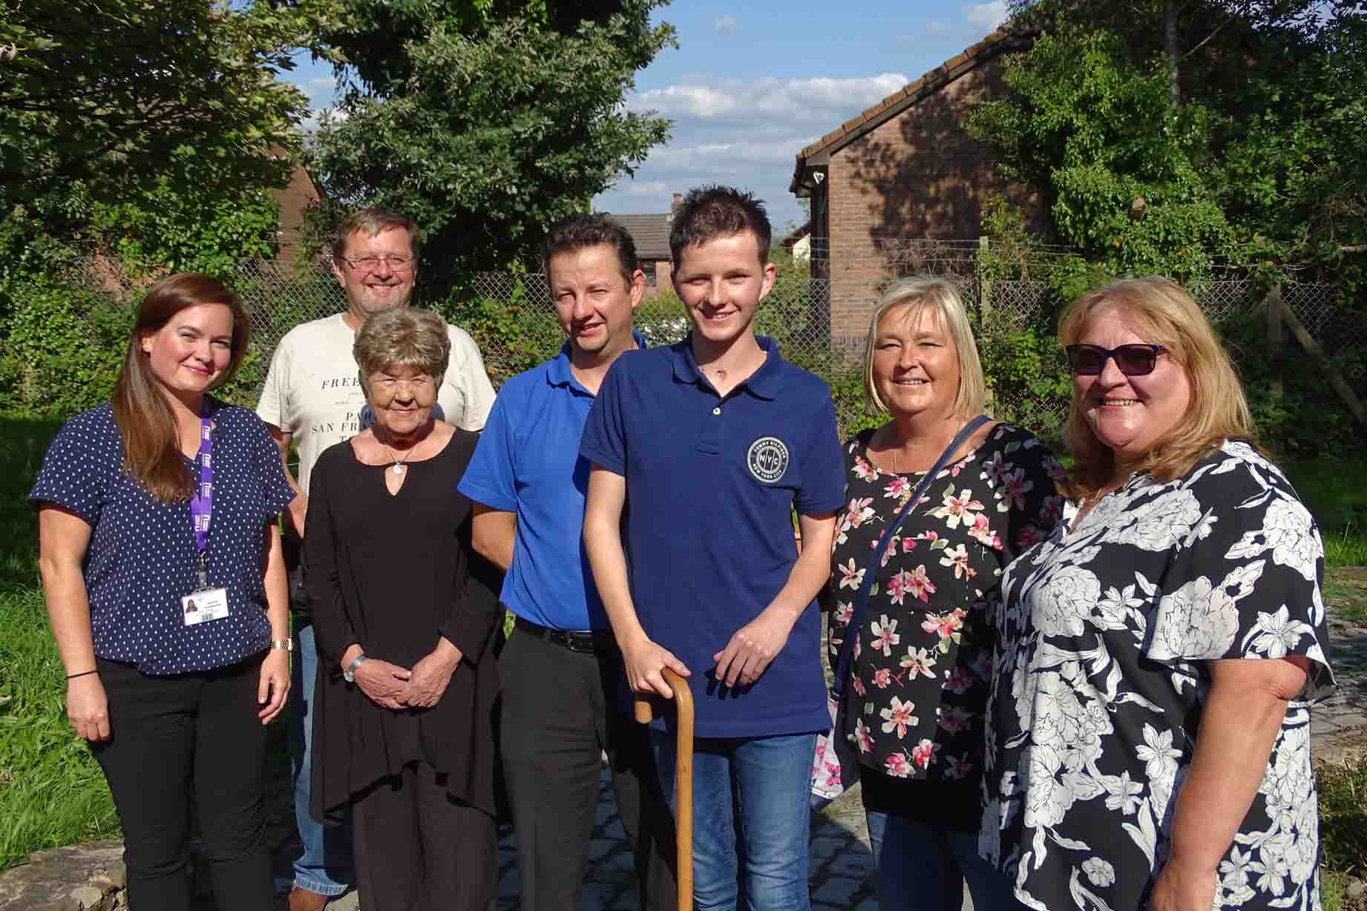
“He’s remarkable, especially after all that has happened to him. I have never known someone as positive.”

Pictured right: Music therapist Jo Humphreys, Nathan’s carer Paul Amphlett, Nathan’s nan Sheila Carey, dad Martin Davies, Nathan Davies, mum Alison Davies and Clinical Nurse Specialist Carole Saunders of TBIS

Nathan’s rap lyrics in full:
I got hit with a boom boom pow
Then I went down
Down to the Royal Gwent
Then over to the Heath I went
Then from the Heath to Neath I went
Then I met the don and the game was on
Learning to walk, learning to talk
Singing some songs, just can’t go wrong
Playing on the Wii
Adele, Lyndon and me

I would always win
They would have to take it on the chin
Getting told no when I wanted to go
Now I’m gone and I’m writing this song

When I was home I dropped my phone
Being out with my mates just feels great
I had a party when I turned 18
All the boys came – nobody was mean

My dad was dancing which was quite embarrassing
I wanted to stop him so I did
Seeing how it goes I suppose
Taking it one day at a time
And hope it all goes fine
This is the story of my hospital journey

Source: Abertawe Bro Morgannwg University Health Board

