Patient urges others to follow her lead and Choose Well
Monday, 10 September 2018
A patient left with deep wounds as the result of an accident at home has praised staff in the Minor Injury Unit at Neath Port Talbot Hospital.

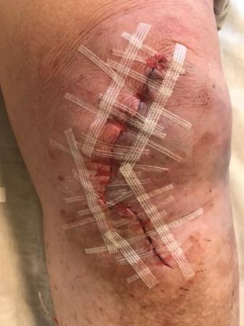
Leonora Matthews, 74, from North Cornelly, near Bridgend, was left with wide cuts to her left knee and left elbow after tripping over the vacuum cleaner.

Her daughter Ceris drove her to the Minor Injury Unit (MIU) where Leonora was seen after a 15-minute wait.

She received treatment and was discharged less than an hour and a half later.

The pair are now urging others to choose well when they need medical assistance as a trip to the Emergency Department may not be necessary.

“The cut on my knee (pictured left) was so bad I didn’t think they’d be able to pull it together,” said Leonora, who was also treated in the MIU after breaking bones in her foot and wrist in two previous incidents.

“But the person who treated me was very patient, very gentle, didn’t hurt me and pulled it all together and stuck it with wound closure strips.

“I am very happy with the service there.
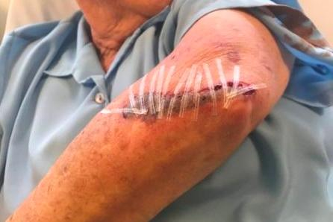
“I think some people don’t know about it or realise they can go there.”

Leonora is recovering well at home.

Pictured right is the injury to Leonora’s elbow following treatment

The MIU is open between 7.30am and 11pm, seven days a week, to treat adults and children over the age of one who have had an accident within the last couple of weeks.

Patients are treated by very experienced, specially-trained emergency nurse practitioners, triage nurses and health care support workers.

The MIU can treat a variety of ailments including sprains, strains, fractures and dislocations of the shoulder, fingers and toes, minor burns, head or face injuries without a loss of consciousness in the last 24 hours, bites and stings.

Susan Jones, head of operational services at Neath Port Talbot Hospital, said: “We are glad to hear Mrs Matthews is recovering. We are also pleased to hear she was happy with the service she received in the MIU.

“Our team of skilled staff are able to deal with a wide range of issues and waits are often shorter in the MIU than they would be in an emergency department, although we must stress waiting times will increase during busy periods.

“I would urge everyone else to follow the Choose Well advice when they need medical help and consider attending the MIU when it is appropriate.”

Director of Nursing and Patient Experience Gareth Howells said: “I’d like to praise the staff in the MIU for their commitment and kindness.

“Leonora’s case is a great example of how our highly-skilled nursing staff are able to deal with this type of injury and other non life-threatening issues in a highly-efficient manner.

“I’d like to remind people of the various services which are available when an A&E visit is non-essential and urge them to follow our Choose Well guidance."

You can find more Choose Well advice on our website

Source: Abertawe Bro Morgannwg University Health Board

