Sepsis - do you know the symptoms?
Thursday, 13 September 2018
Sepsis is very serious - are you aware of the symptoms?
It may be World Sepsis Day on 13th September, but staff at Morriston Hospital's Emergency Department are working to raise awareness all year round.
In 2016 they set up a working group called SeGMED with a mission to improve the recognition and management of sepsis in our health board, and also raise public awareness.
Sepsis project support officer Michael Brown-Thompson said:
“We have a long road ahead of us but we couldn’t have achieved what we have done to date if it wasn’t for the hard work and dedication of the sepsis team and the hospital as a whole.
“We thank everyone for their support and look forward to what the future will bring with sepsis awareness in Wales.”
Sepsis occurs when the body’s response to infection injures its own organs. This can lead to shock, organ failure and death, especially if it is not recognised and treated early.
Very often it is caused by common bacteria which people come into contact with every day without any adverse effects.
Early detection and treatment is the key to preventing deterioration. But identification can be difficult because the symptoms often resemble other, less serious conditions.
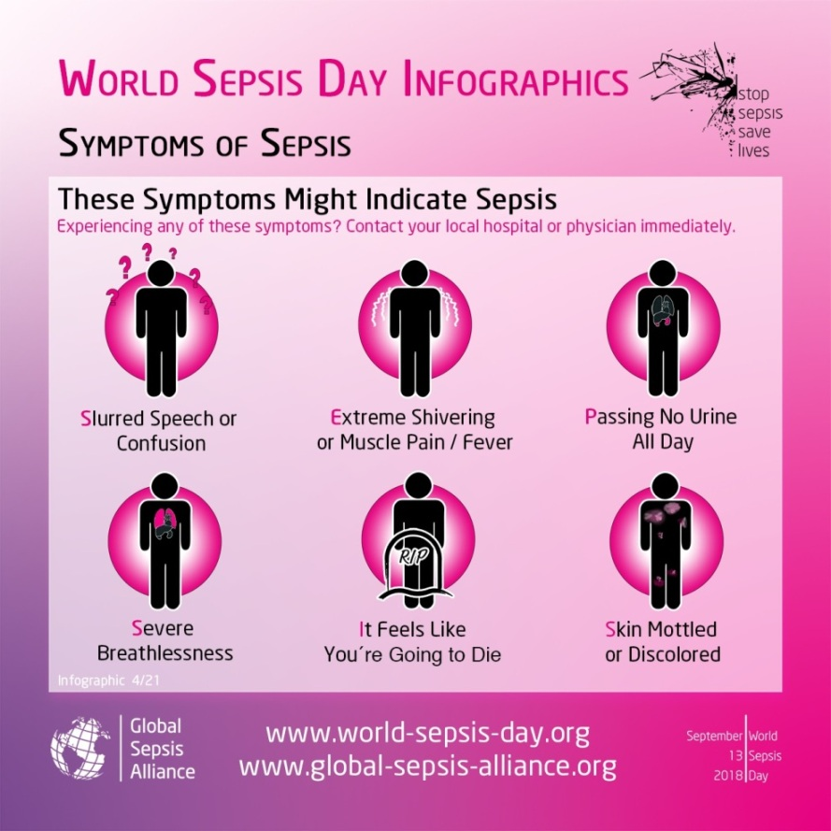
As part of their campaign, the SeGMED team have updated the existing sepsis screening tool using the latest research and data, making it more accurate and in-depth, yet easier to use.
They have also hosted a series of open days to promote early treatment and management of sepsis among staff.
Meanwhile, the hospital’s sepsis champions are actively supporting the campaign and helping to spread the word about how important early detection is in treating the condition.
Last year the team organised the Swansea Sepsis 6k run. It was named after the half-dozen interventions clinicians can use – collectively known as the Sepsis Six – including antibiotics and fluids.
That raised £8,000, with the fund receiving donations from various people and companies, including TK Maxx which gave £1,500.
This year's event, organised by SeGMED and Unison, will take place on Sunday, 30th September. It will set out from the Blackpill Lido at 12.30pm, with registration starting at 10.45am.

Source: Abertawe Bro Morgannwg University Health Board

