Swansea nurse rewarded for exceptional contribution with national award
Wednesday, 12 September 2018
A paediatric nurse named a winner at the 2018 WellChild Awards picked up her prize at a star-studded bash in London where she met newly-wed royals Harry and Meghan.
Geraldine Phillips a paediatric diabetes specialist nurse who has worked within the department of child health at Morriston Hospital in Swansea for more than two decades, was chosen from hundreds of nominations across the UK as the Most Inspirational Nurse.
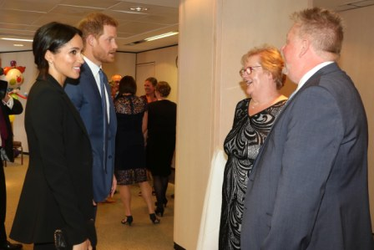
The awards not only celebrate the courage of children coping with serious illnesses or complex conditions, but also honour the dedication of professionals who go the extra mile to help sick children and their families.

Dr Chris Bidder nominated Geraldine for the award.

He said: “Geraldine is a dedicated nurse who goes above and beyond what is required of her. She is a sympathetic key worker for children and families from the day of diagnosis until the time they are adults. Children and families place their trust in the support she provides for them.

“She selflessly goes the extra mile and will respond to patient phone calls outside of working hours at evenings and weekends to ensure families feel safe and cared for.”

Geraldine began in post as a single-handed nurse covering a large clinic population, but quickly helped establish a support group for families, including organising and participating in an annual activities weekend at an outdoor pursuits centre.

The residential weekend is an innovative service in Wales that helps the children meet other young people with diabetes, learn new skills and develop confidence and independence – something that Colleague Dr Chris describes as a testament to Geraldine's resourcefulness and tenacity that it continues two decades later.

“As a colleague Geraldine has been a teacher, mentor and friend and her unstinting commitment to her patients is inspiring and humbling. She is consistently patient, kind and full of good humour and is a pleasure to work with.”
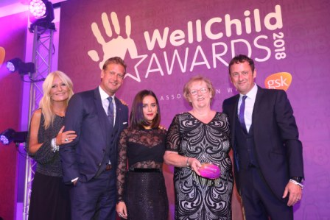
The awards are run by WellChild, the national charity for seriously ill children and have been supported for many years by patron HRH The Duke of Sussex, who attended this year’s ceremony on September 4 at the Royal Lancaster Hotel with HRH The Duchess of Sussex.
“First, let me congratulate all of those nominated tonight. Every one of you is truly amazing. You have shown all of us what it means to be a champion – whether for yourself, your family, your community, or someone in need.

“The stories that we’ve all just heard - of resilience, strength of spirit, and the power of working together –were without doubt, incredibly moving and motivating. They really sum up what WellChild is all about – giving families the best chance to care for their children at home, and supporting them through the reality of all that that entails.

“I would also like to pay tribute to the devoted nurses and volunteers across the UK who help give children and young people living with serious illness or exceptional health needs - a chance to be cared for at home instead of hospital.”

Source: Abertawe Bro Morgannwg University Health Board

