Team takes on 48-hour medical stretch challenge
Tuesday, 18 September 2018
Twelve colleagues from the Emergency Department at the Princess of Wales Hospital in Bridgend put their talents to the test at this year's Exercise Medical Stretch.

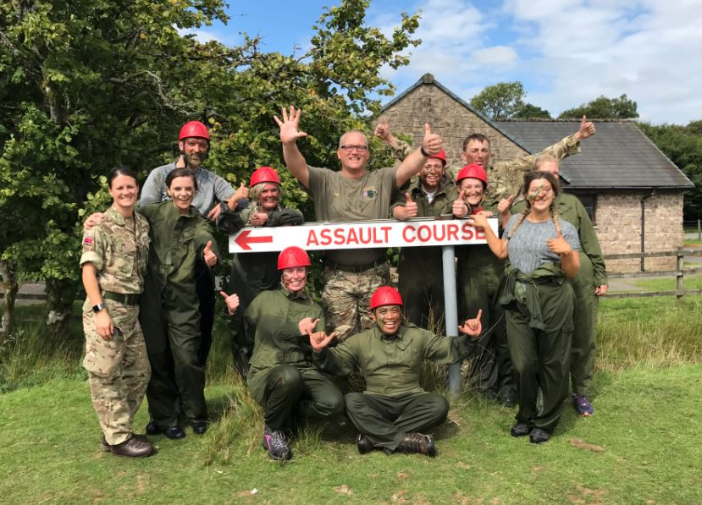
The annual challenge, run by 203 (Welsh) Field Hospital, brings together teams from all over NHS Wales for a series of tasks and challenges.

The weekend aims to give the participants a chance to develop a range of skills, including teamwork, problem solving and leadership, which they can bring into the workplace.

Several members of ABM University Health Board are members of the 203, and served with distinction on multiple tours of Iraq and Afghanistan.

Lead Nurse for Emergency and Acute Medicine, Mark Cadman said: “Although tough, the personal accomplishments made the weekend worthwhile.”

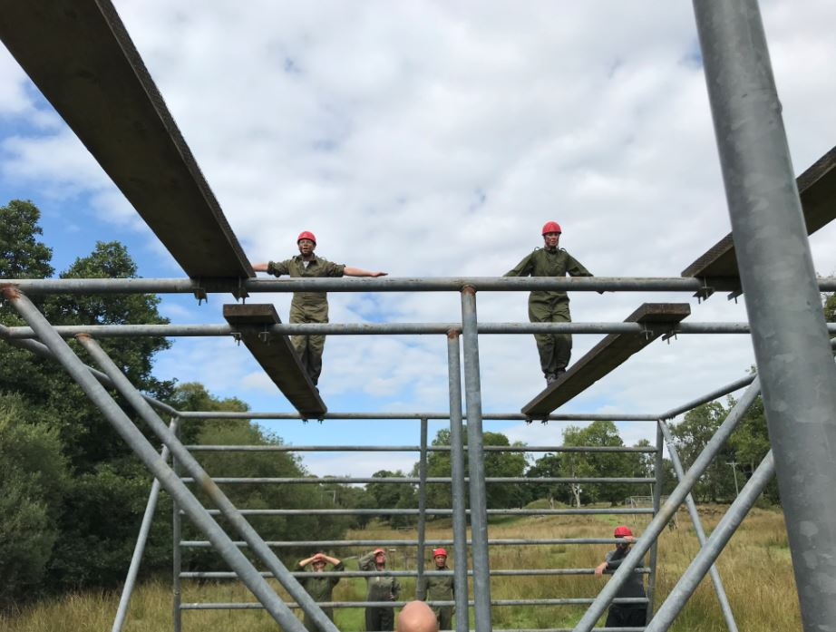
The activities were based around problem solving strategies and some physical activities including an assault course on the final day. The team also had to walk an average of 2km between the different activities.

“Each team member did the Health Board so proud and were visited on the exercise out by our Chief Executive Tracy Myhill acting in her role as honorary colonel for 203!” he added.

Source: Abertawe Bro Morgannwg University Health Board

