Team takes on the Swansea Bay 10k to help cancer patients
Wednesday, 12 September 2018
A team of ABMU Health Board staff and their families will be lacing up their running shoes to take part in the Swansea Bay 10K to raise money for Golau Cancer Foundation.
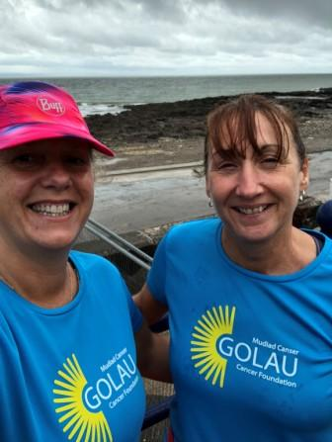
Twenty-Five people will form ‘Team Golau’ on Sunday, September 16, in a bid to raise as much money as possible.

The Golau Cancer Foundation supports the South West Wales Cancer Centre in Singleton Hospital, Swansea – the second largest non-surgical cancer centre in Wales.

Sian Morgan, fund manager at Golau said: “It’s down to the generosity of our supporters and work colleagues that we are able to continue raising vital funds to support patients and their families”.

The foundation raises funds for radiotherapy, chemotherapy, ward 12, the Cancer Institute/Research and the hostel for travelling patients. The money also supports patient care and comfort, specialist equipment and specialist training for medical and health care staff.

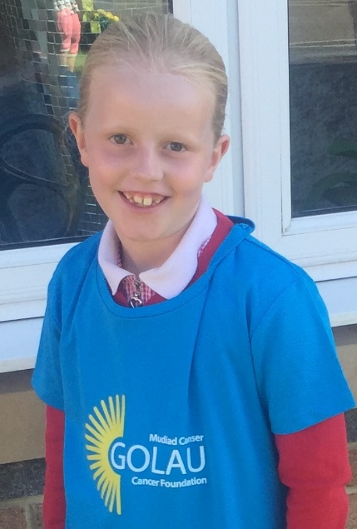
“Our vision is to help to improve the experience for patients affected by cancer, by raising funds to ensure care is the very best it can be, putting patients at the heart of everything we do,” said Sian.

Some of the team members preparing for the event are as young as four years old, including Sian’s nieces Holly and Lucy, who will compete in the junior race.

Sian added: “We are so proud of every single member of Team Golau, who have given up their time to participate to raise money for us. We would like to wish them all the very best for Sunday and hope they have the best time!

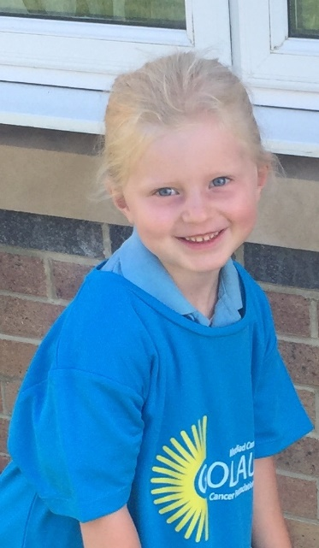
“We would also like to thank all our supporters who continuously help us achieve this and raise awareness of the work of Golau Cancer Foundation. Without your support, we would not possibly be able to provide the support that we do”.

Source: Abertawe Bro Morgannwg University Health Board

