Tiny baby thrives thanks to ‘first class’ service
Tuesday, 25 September 2018
Weighing just 3lb 10oz when she was born, Rosie Cornelius’ mum admits “she was skin and bone”.

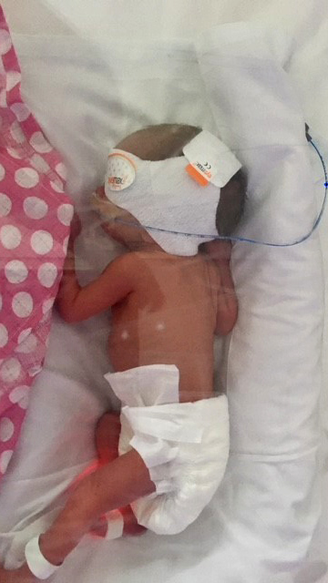
Rosie’s legs were so thin the family nicknamed her Twiggy.

As she had stopped growing at 32 weeks she was born via Caesarean section at 35 weeks at Swansea’s Singleton Hospital.

“It was a pretty traumatic time,” admits her mum Fay Cornelius, 34.

"She was really like a little dolly. We called her Twiggy because her legs were skin and bone.

Pictured left: Rosie in the neonatal intensive care unit

“They think there was something with the umbilical cord. It was really thin and it was wrapped around her neck twice when she was born.”

As Fay’s first child Emmie had been born a normal weight, Rosie’s birth and subsequent care in the neonatal intensive care unit was a stressful time for the whole family.
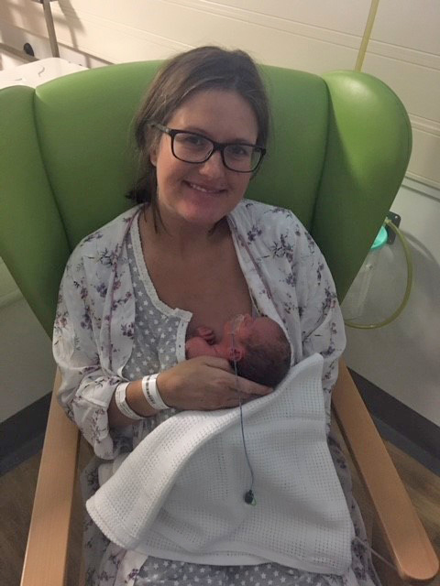
Right: Fay Cornelius with Rosie

But Fay said the “first class service” and support provided by staff eased their tension and allowed Rosie to thrive.

She has just celebrated her first birthday and lives with her family, including dad Tom and sister Emmie, three, in West Cross, Swansea.

It’s why, together with her cousin Rhian Waygood, Fay has raised £4,500 to help the Swansea unit support future premature babies and their families.

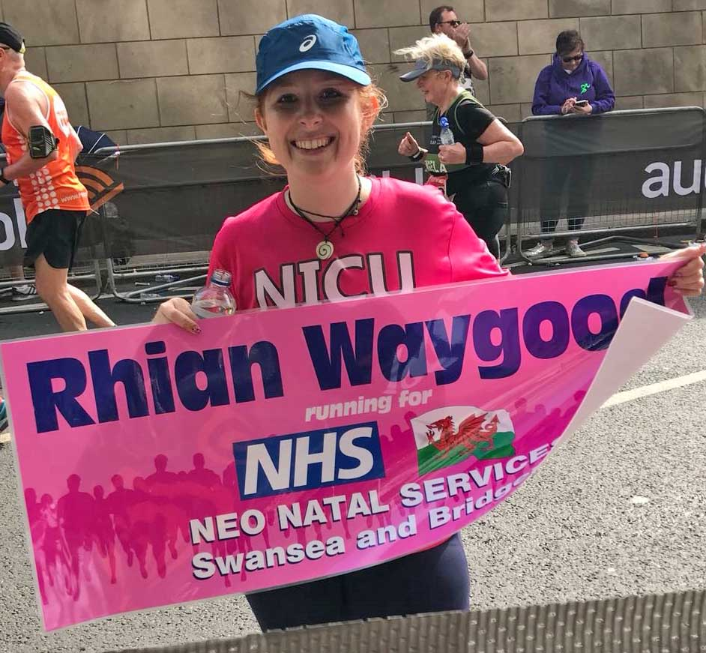
Rhian ran the London Marathon (left) and Fay organised a fundraising event at Mumbles Cricket Club.

“The staff were so supportive whilst we were in NICU. I stayed in hospital for the full three weeks and they were our friends and family all at the same time. They did everything possible to make you feel comfortable,” said Fay.

“It was a first class service. It’s a stressful thing to happen in the first place, but the whole team, nurses and doctors, made it so much easier.

“I didn’t want to go home because I was breastfeeding Rosie and the neo natal team found me a room to stay in to make sure I could be near her.

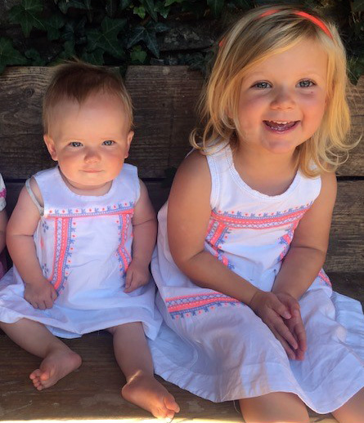
“I ended up breastfeeding Rosie for the best part of a year and I don’t think I would have been able to do that if I hadn’t had that support from the beginning. I think that is why she has thrived because after what she went through I wanted to make sure she had the best.

Right: Rosie, left, and sister Emmie

“She is fine now, she is slightly smaller. She is walking now she is one.

“She is hitting most milestones, but is still under the hospital care.

“The staff there were unbelievable, so supportive and went the extra mile and we really wanted to support them.”

Consultant neonatologist Dr Joanna Webb said: “We are extremely grateful to Fay, Tom and Rosie’s extended family for their support.

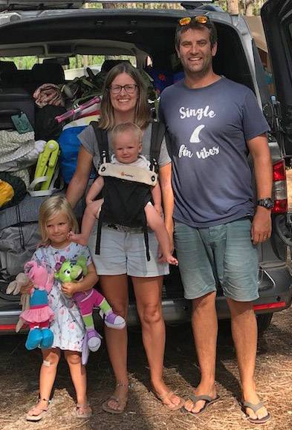
“Rosie did very well considering her very small size at birth and it was thanks to Fay’s commitment, and with the initial nursing staff support, that she thrived brilliantly and continued breastfeeding for so long.

Left: Emmie Cornelius, Fay, Rosie and Tom.

“The money raised will go towards education and training and support for other families experiencing similar difficulties with their baby unexpectedly admitted to the neonatal intensive care unit here in Singleton Hospital”.

Source: Abertawe Bro Morgannwg University Health Board

