Vaughan Gething guest at World Sepsis Day event in Morriston Hospital
Friday, 14 September 2018
Cabinet Secretary for Health and Social Services Vaughan Gething joined staff at Morriston Hospital at a special event marking World Sepsis Day.
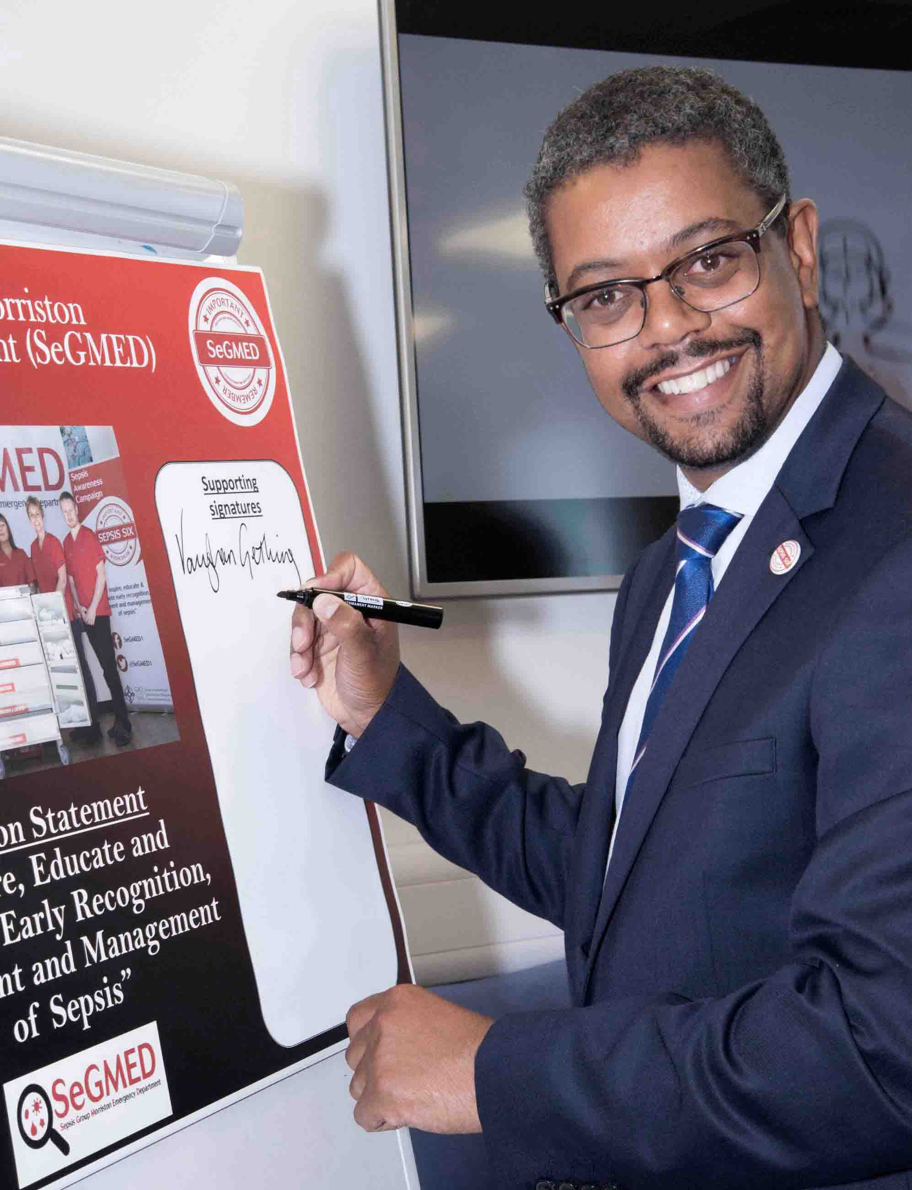
The awareness and education event was the latest to be organised and hosted by the hospital's SeGMED group.

Mr Gething provided the opening address and presented an award for the best sepsis poster.
First prize winner was Confidence Obianuju Okorie from general medicine, with the renal team from Cardigan Ward the runners-up.

There were several guests speakers throughout the day as well as a talk by Morriston’s sepsis clinical lead Dr Rangaswamy Mothukuri.

Dr Mothukuri said: “The World Sepsis Day event was a huge success.

“We had the privilege of having the Cabinet Secretary present and he spoke of all the work that has been ongoing and how far NHS has come in its 70 years.

“He was very keen and interested to speak to the staff members and the speakers, and very supportive of the work that is being done at Morriston Hospital.

“The talks from all the speakers were very well received and although very emotional, there were a lot of take home messages for the staff present.

“I also presented a session on sepsis cases for staff which was very well received and which will be a regular feature in future awareness days.”

Sepsis, known as the silent killer, occurs when the body’s response to infection injures its own organs. This can lead to shock, organ failure and death, especially if it is not recognised and treated early.

Very often it is caused by common bacteria which people come into contact with every day without any adverse effects.

Early detection and treatment is the key to preventing deterioration. But identification can be difficult because the symptoms often resemble other, less serious conditions.

In 2016, Morriston ED staff set up a working group with the aim of improving the recognition and management of sepsis in ABMU, and raising public awareness of sepsis across Wales.

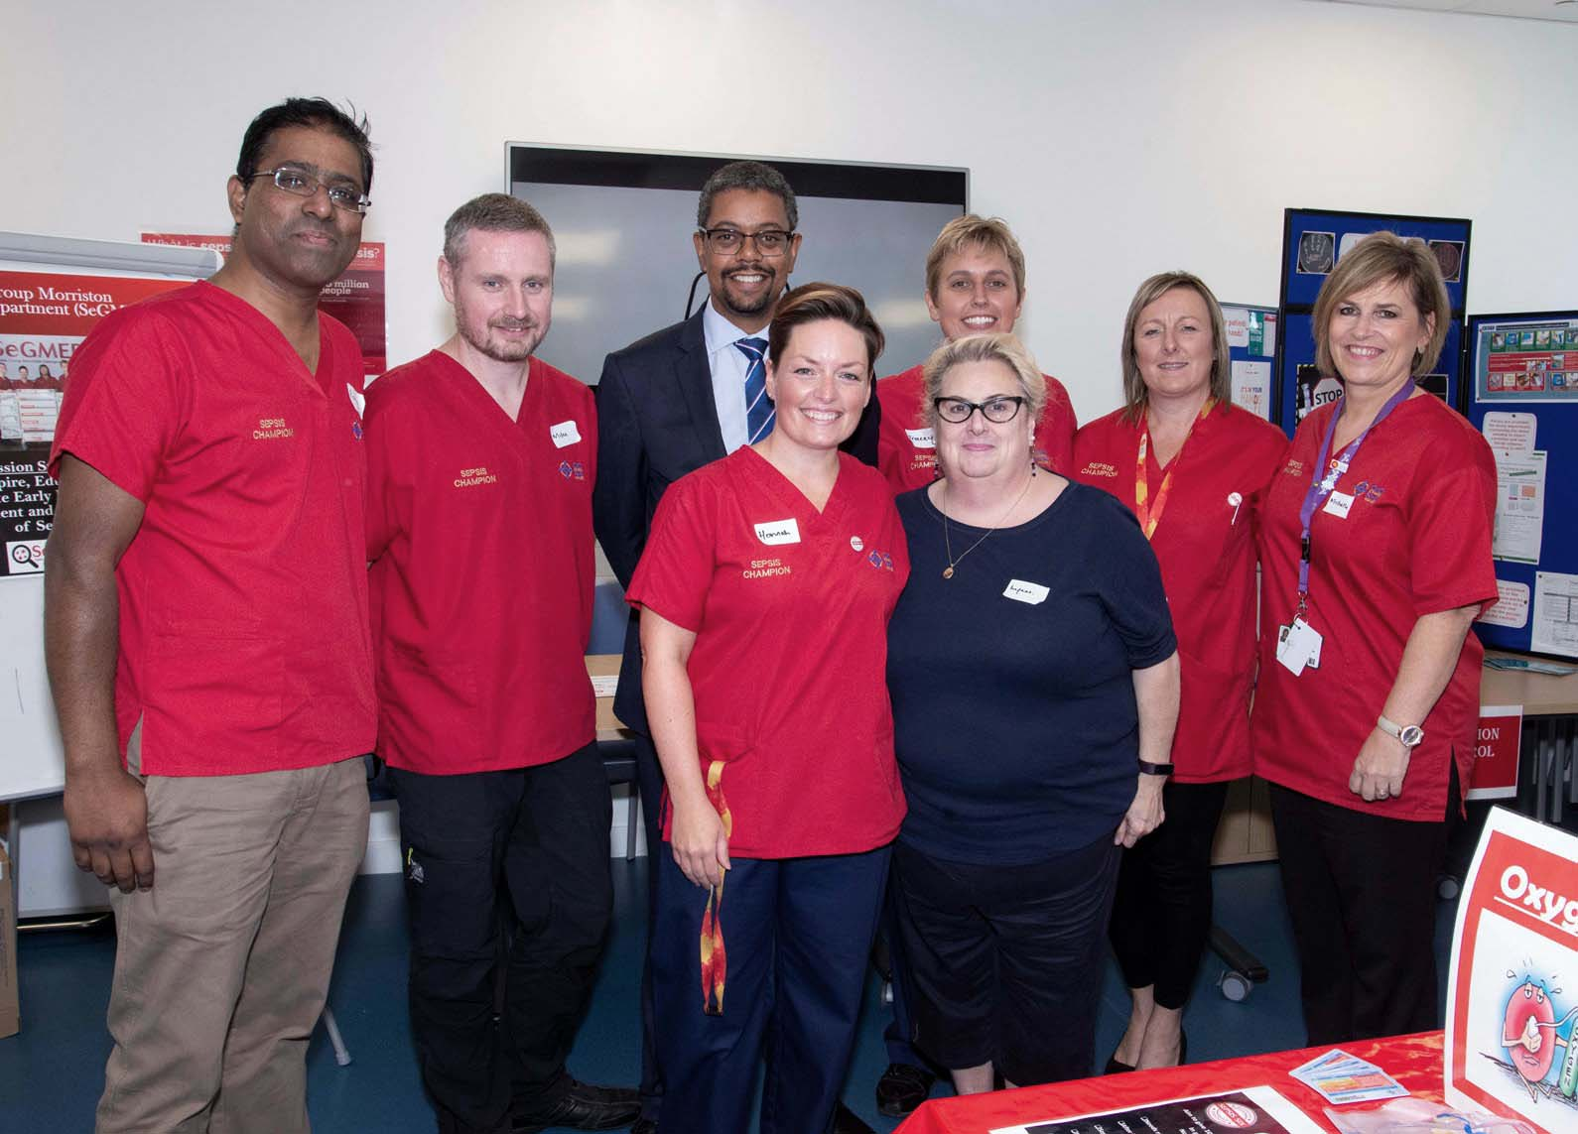
Since then, SeGMED (Sepsis Group Morriston ED) have updated the existing sepsis screening tool using the latest research and data, making it more accurate and in-depth, yet easier to use.

Mr Gething pictured with some of the SeGMED team including Dr Rangaswamy Mothukuri, far left of photo

They have also recruited sepsis champions throughout the hospital who are actively supporting the campaign and helping to spread the word about how important early detection is in treating the condition.

The team also organises the annual Sepsis 6K run, which this year will take place on Swansea seafront on Sunday, 30th September.

Organised by SeGMED and Unison, it will set out from the Blackpill Lido at 12.30pm, with registration starting at 10.45am.

You can find out more about that in our earlier press release here.

Source: Abertawe Bro Morgannwg University Health Board

