


Auditory

Perception

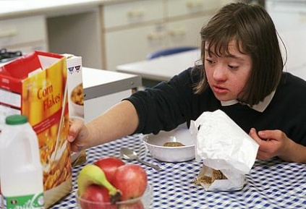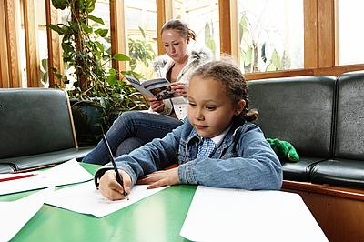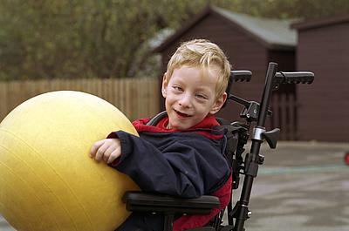
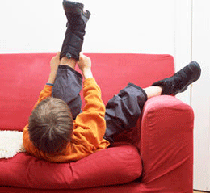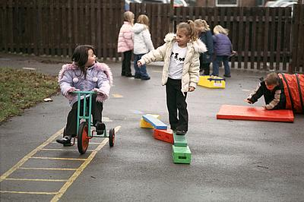

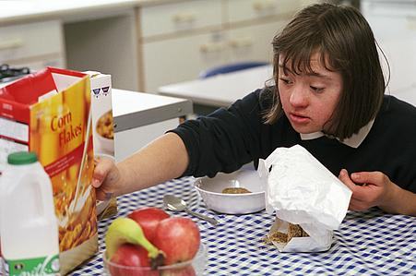
Community Paediatric Occupational Therapy Department
www.abm.wales.nhs.uk/childrensdevelopment

Introduction
Auditory perception is the ability to organise and interpret what is heard through the ear. It can be separated into three different sections:
- Auditory Discrimination
- Auditory Figure ground discrimination
- Auditory Memory

Auditory Discrimination is the ability to distinguish between sounds that are different and to work out where that sound is coming from. Difficulties can be seen when:
- Child has difficulty identifying the source of a sound and may turn the wrong way when he is called.
- Child has difficulty distinguishing between different sounds.
- Similar words are confused.
- The child has difficulty with rhyming words.
- Child is a 'daydreamer' and unable to focus on spoken words.

Auditory Figure Ground Discrimination is the ability to concentrate on one sound whilst filtering out or ignoring all other sounds. Difficulties can be seen when:
- Child is easily distracted by sound from any source.
- Child is unable to attend to a single voice whilst blocking out background noises.
- Child cannot direct his attention to precise sounds in the environment.
- Child finds it difficult to sit still and attend.
- Child often stares at speaker in order to 'speech read'.
- Child may respond to questions that are not directed toward him.

Auditory Memory is the ability to remember sounds and what they mean. Difficulties can be seen when:
- Child has difficulty following a sequence of directions.
- Child has difficulty getting a message right.
- Child has difficulty finding the right words when speaking.
- Child has difficulty recording class notes.
- Child cannot process information quickly or accurately.
- Child appears not to listen.

Helpful strategies

- Only speak to the child when they are facing you and looking at you.
- Give simple instructions. Don’t use too many words.
- Speak loudly and clearly to these children at all times.
- Start with one instruction and increase as the child is able to retain more information.

- Ask the child to repeat the instruction to you.
- Reduce extraneous noise OR wait until it has gone before giving instructions. (Do not expect a child with these difficulties to concentrate when there is a lot of noise going on outside the classroom)
- Give written instructions as well as verbal ones.

Activities
- Clapping games.
Ask the child to clap the syllables of his name. When they can do this, say other names to ‘clap out’. Progress to clapping out a favourite rhyme or song.

- I- spy but use the sound of the word.

- Beginning & ending game
Ask the child to say a word that begins with the last sound of a word you have just said. E.g. you say book, the child says kite. You say toad; the child says door and so on.

- Opposites.
You say a sentence and the child has to say it again using an opposite for one of the words.
E.g. the boy went to the zoo. (girl or came from)

- Bell game
Have the child sit in the middle of a room with a blindfold on. Move around the child and ring a bell occasionally. Ask the child to point to where the bell is.

- Hide the timer.
Set a timer to go off in a minute and hide it in a room. Ask the child to listen for the alarm and find the timer when it goes off.

- What can you hear?
Ask the child to sit very still with their eyes closed. Ask them to say what they can hear and where it seems to be coming from.

- Match the sound.
Using containers such as film canisters, make 4 or more pairs of containers. Put different things in each set. E.g. salt, flour, pebbles, gravel, peas, rice etc. Ask the child to shake, listen and find the pairs.
- Sound Tree
Draw a tree on a large piece of paper and various pictures of object that begin with the two sounds. Ask the child to paste all the pictures that begin with ‘b’ onto the tree.

- Listen for the word
Tell the child that they should only follow an instruction if they hear a certain word in the sentence. Start with their name.

- Musical chair
Have two pieces of music playing; one all the time (quietly) and one that stops and starts (The child should be familiar with this one) Ask the child to walk around and only when the song he knows stops should he sit down.

- I went to market……
Start the game and say ‘I went to market and bought an apple’. The child must remember and repeat what you said and add something of his own. This continues until someone leaves something out.

- Word Recall
Think of a subject and ask the child to tell you all the words they can think of that relate.

- Listen to a story
Read the child a short story and ask him to draw a picture, showing one of the following: -
- The main character
- The part he liked best
- The funniest/saddest part

Reference: Sensory systems: Auditory perception: Rachel Camm & Imogen Fisher, 2004

Editorial Board: Awaiting approval
Publication Date: 21.05.2015
Version:
Review Date:
Author: Paediatric Occupational Therapy

