

Warm Up Activities Prior to Handwriting

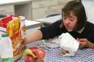
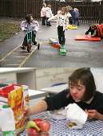
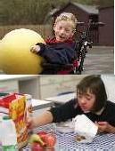
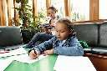
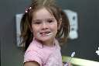
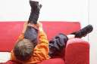
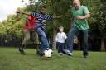
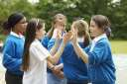

AIM:
To warm up the joints in preparation for hand writing

DESCRIPTION:

The receptors in our joints and skin provide us with information of where we are in space. This information helps to guide us on how to complete movements, enabling actions to be smooth and coordinated.

INSTRUCTION:
Pupils are advised to complete these activities for 1 minute prior to all handwriting activities. Choose at least 3 of the activities to do daily.

ACTIVITY | EXPLANATION
1. Table Push Downs | Pupil to stand in front of table with palms flat on desk. Push down onto desk for 10 seconds.
2. Prayer Position | Pupil to hold palms together in ‘prayer position’. Push hands together 10 times.
3. Chair Raises | Pupil to place their hands either side of the chair then push with their arms to lift their bottom off the chair. Gradually increase repetitions up to a total of 12.

4. Hand Pulls | Pupil to link finger tips together then attempt to pull them apart (see below) For count of 10 seconds.
5. Wall Push-Ups | Pupils to face wall at arms length, stretch out arms place hands flat on wall, shoulders level keeping body straight bend arms until nose touches wall – extend arms until body is upright again. Repeat 10 times.
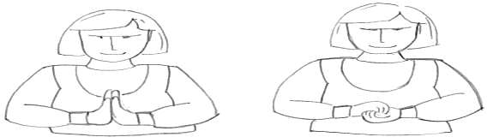
Prayer Position ← Hand Pulls →

Hand and Finger Activities

- Brush hands

- “Piano”: use both hands, tap fingertips on table and/or imitate sequence

- “Spider Push-ups”: use both hands, spread fingers apart and match thumb and fingertips together, then “push” in and out.

- Clapping games: e.g hand pile up or ‘pat-a- cake’

- Write with paper over a textured surface such as embossed plastic or sandpaper. A 2B pencil is very useful as it will provide a visual cue for pressure going darker or lighter.

- Squeeze “stress ball” or a squash ball with heavy pressure, then light pressure to sense or feel the different pressures.

- Squeeze the ball with whole hand then each finger with thumb.

