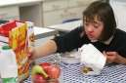
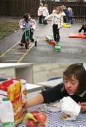
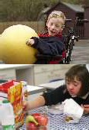








‘Picky’ Eating

Community Paediatric Occupational Therapy Department

Introduction

The term ‘fussy eater’ is often used to describe children with a range of aversions or preferences towards foods. This term isn’t always helpful as can belittle the challenges some children and their families face on a daily basis.
This information leaflet aims to provide you with some strategies to try with your child. It is important to note that these strategies will not work overnight and require time and patience.



Behavioural strategies for meal times

If you are worried about your child’s food intake, it may be useful to keep a food diary. This will allow you to monitor
- the foods they eat
- the amount eaten
- the time of day when they eat it
- and who was there when they ate.
It may also be useful to note other factors e.g. distractions (was the TV on?), where were they (school/ home/ restaurant), did they use a particular plate?

It is also very important to rule out if there is a medical reason for them not eating / taking a restricted diet e.g. do they have a sore throat? Do they have chewing / swallowing difficulties? If you are unsure, make an appointment with their G.P.

Sensory Considerations

We all have sensory systems that take in and process information differently and we can have difficulties in more than area. Everyone has preferences but sensory difficulties can get in the way of you and your child’s day to day life.

Vision | There is a common saying- you eat with your eyes! We look at the shape, colour and presentation of our food.
  (Visual) | What looks appealing to you, may not to another person. Some like a plate full of colour whilst others find that overwhelming and prefer more neutral or ‘beige’ coloured foods. Presenting your child with a bowl of spaghetti may look like a bowl of worms to them!
Touch    (Tactile) | Food touches our hands and face. We feel the food on our skin and moving around our mouths as we chew. This sense tells us the texture and temperature of the food.  Some children dislike having food touching their skin and some textures can make them gag. Some prefer crunchy or hard foods and unable to tolerate smooth and wet textures.
Smell | Some smells can be very appealing to some, e.g. fresh bread but the same smell

  (Olfactory) | can be unpleasant to others.  Some children find the smells of food so off putting that they may need to sit and eat in a separate room.
Taste    (Gustatory) | Foods can have a variety of flavours- sweet, savory, salty, sour, bitter etc. Again, some can be overpowering for some people, whilst others will seek it, e.g. spicy foods.
Hearing    (Auditory) | We hear how the food sounds when we are eating it. Is it loud, crunchy? Are others eating loudly? Is the school canteen loud and overwhelming?
Body Awareness  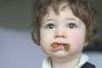  (Proprioception) | We need to be able to judge the force we are using when biting and chewing our foods. We also need to know when our mouths are full or empty.
Balance    (Vestibular) | We need to keep ourselves in a good position for eating with our head upright.

It is important to remember that none of the sensory systems work alone, they all work together. You can have processing difficulties in more than one area.

Telling your child to “eat something because it tastes nice”, “don’t be silly, it’s not too hot”, “no that doesn’t feel like worms!” will not help in these situations as their system is processing differently to yours. What they are eating needs to be ‘just right’ in terms of taste, smell, texture and so forth for them. Foods outside of the ‘just right’ can feel uncomfortable for your child to eat.

Rigidity and sameness

Some children enjoy routine and sameness in their daily lives and this can include food and meal times. Children may only like foods presented in a certain way, specific brands of foods, to eat at certain times and places. Changes to these can be a factor in children refusing to eat foods they previously ate.

Investigation

Looking back to the behaviours around meal times, the first step is to find out what, when, where and how your child will/ won’t eat certain foods. Consider the sensory factors such as textures, temperature, smells and colours. You can usually start to form an idea of what textures etc. your child likes or dislikes. For example, if you recognize that texture is an issue, you can introduce new foods in the preferred way, e.g. a new vegetable can be pureed if chunky textures aren’t liked, or traditionally hot foods can be served at room temperature.

Introduction and Exposure

Whilst you are clearly concerned about your child’s diet and food intake, try to remain calm and not too controlling. Successful meal time experiences come from children having control or at least feeling in control, whereas battling over this can often make matters worse.

There is a temptation to offer new foods every day to your child in the hope that you’ll find something they accept. It is more

beneficial to expose your child to new foods in a gradual manner. Similarly, parents sometimes offer lots of choices for new foods at the same time, hoping for success, however, this can be overwhelming for children.




Using a gradual approach will help your child become desensitised to the smell, look and feel of a new food. Choosing new foods that fit within what your child likes in terms of sensory qualities, e.g. textures will give you a greater chance of success. For example, if your child likes chicken nuggets, try them with breaded chicken, if they will only eat a certain brand of pizza or pasta, try them with a new one. Start this process with foods that have a good ‘sensory fit’.

Consider how your child might best accept a new food in their space. A small plate or bowl near when your child sits can be a starting point. Increase your child’s exposure to new foods by:


- Put the new food on the table

- Put the new food on their plate

- Encourage them touch it

- Encourage them to lick the food

- Encourage them to hold the food in their mouth

- Encourage them to swallow the food

Sometimes a child can tolerate a new food item on their plate with the understanding that they don’t have to eat it. Repeatedly try offering the same food item once or twice a day with meals, with no expectation. This strategy combined with other family members (particularly siblings) showing enjoyment when eating the food can encourage your child to try tasting it. You may need to try the same food for two or three weeks.

Whilst adding small amounts of vegetables ‘hidden’ in sauces can sometimes go unnoticed and ‘work’, children do not want to be tricked. If or when a child realises the additional ingredient to their foods, they may then become suspicious of all foods. This strategy probably works best when the sensory characteristic the child is focusing on is the ‘look’ of the food. If a child is more sensitive to the smell, taste or texture of a food, it may be harder to make ‘additions’ because they are usually easier for the child to detect. Be cautious when using this strategy. Do let your child try sauces with their food, if this helps them to accept and tolerate new foods.


Problems with eating and feeding can sometimes dominate family life. You can be overwhelmed by these issues when they are severe and so closely linked to health and development. Mealtime usually occurs three times a day and families can’t always eat at home which adds to the stress.

Ruling out underlying medical conditions and behavioural issues are important. After these are addressed, families can begin to tackle the environmental factors by working to desensitise their child to new foods with a non- controlling structured plan.

Desensitisation

This strategy can work well with your child but like all strategies, this does take time. Gradually introducing foods can help your child become desensitised to the smell, look and textures of an unfamiliar food.

- Start with a food that has the best chance of suiting your child’s taste and sensory preferences.

- This may involve the food being paced on a plate next to theirs for several meal times.

- Move the food to their plate with no expectation or pressure to eat it.

- Family members to try the food and show enjoyment. With this gradual introduction, this may allow your child to eventually try the new food.



Involvement with Meal Preparation

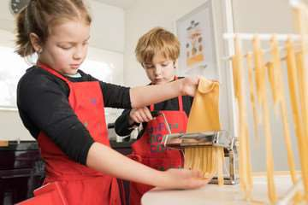
Allow and encourage your child to help with meal preparation at a level that is accessible to them. They will be more likely to taste something that they’ve helped to make.

Involve them as much as they are able with finding things to make, selecting ingredients,
shopping, even growing vegetables and fruits in the garden (if you have one).

Give your child a sense of control – give them a choice between foods, e.g. chicken or fish, pasta or rice, potato or chips. Stick to two choices to avoid overwhelming them. This could also involve making a weekly meal plan and using pictures to show what each meal will be.

Attitude

Having a positive attitude is really important when introducing new foods. You may feel frustrated having already tried foods, or anxious about your child’s eating patterns but it is important that your child feels positivity rather than negativity. Try your best to be patient and let your child feel in control of what they will/ won’t eat (within

reason!). Pressure and arguing over foods are likely to only make the situation worse.

- Try to make meal times fun and not confrontational.

- If your child struggles with the social ‘chit chat’ of mealtimes, try putting on some music / an audio book.

- Remember, try and keep the pressure off. The goal isn’t eating when you are exploring new foods, just play, and if your child happens to eat it - bonus!

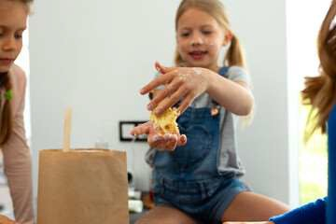

Expectations

- Let your child play with their food.

- Outline what behaviours are unacceptable, such as throwing the whole plate of food on the floor, but what they can do is, feel the texture of the food with their fingers.

- This process helps your child explore the food with their tactile/touch sense before they use their sense of taste.

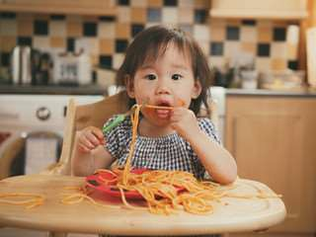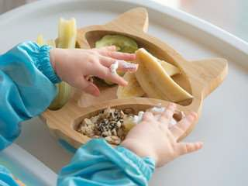

Presentation

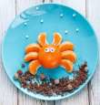
- Be creative. A so-called ‘picky eater’ may be more willing to eat ‘rocks and trees’ than meatballs and broccoli.

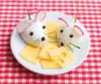


- Fun arrangements on a plate may encourage your child to taste something new.

Conclusion

- Look at your child’s eating environment, do they need a distraction such as music? Does your child need a puppet / favourite character to help them model eating?

- Would it help to place a mirror in front of them to see where their mouth is?

- During eating, do not present all foods at once. Instead, present them one at a time.

- After eating, praise your child for whatever success they had. If there was none, always be positive and say “nice trying!”

- Use rewards e.g. if your child tries a new food, reward them with their favourite food, use reward charts so they can see their success.

- ‘Social Stories’ can be useful to explain to your child, why we need different types of foods to stay healthy and fit.

- Hopefully you will find some that work for you and your child. Remember some new foods need to be tried around 20 times before a liking for it can be developed.



Information adapted from https://www.nhsggc.org.uk/kids

