

Swansea Bay University Health Board
Eye Health Needs Assessment
1 April 2025

Executive Summary
To support the eye care needs of communities, in 2024 Welsh Government imposed a duty on Local Health Boards to conduct an eye health needs assessment every three years to ascertain the needs on the public in terms of eye care provision in both primary and secondary care. ¹
Higher levels of clinical services identified by the local eye care needs assessments will be delivered on a cluster level to bolster this provision. Taken together, the needs assessment combined with delivery on a cluster footprint will ensure that local population needs will be fully considered and delivered against.
This eye health needs assessment is prepared in accordance with Legislative Direction ¹ relates to all of Welsh General Ophthalmic Services (WGOS) 1–5 provided under arrangements made by Local Health Boards and includes:
(a) an assessment and summary of the provision of WGOS 1–5;
(b) an assessment and summary of the demand for WGOS 1–5;
(c) proposals for further ophthalmic services that may be needed to meet demand for those services;
(d) an outline of the prevalence and impact of vision impairment in each Local Health Board’s area, including the aetiology, risk factors, demographics and public health and other consequences of vision impairment;
(e) an analysis of the information provided by all data sources;
(f) a map that identifies the premises at which any or all of WGOS 1–5 are provided in each Local Health Board’s area.
In preparing this eye health needs assessment, each Local Health Board
(a) has regarded, in so far as it is practicable to do so, the following matters—
(i) the demography of its area,
(ii) any different needs of different localities within its area,
(iii) the ophthalmic services provided under arrangements with any neighbouring Local Health Board which affect the need for ophthalmic services in its area,
(iv) any other NHS services provided in or outside its area (which are not covered by sub-paragraph (iii)) which affect the need for ophthalmic services in its area,
(v) any relevant information provided to the Local Health Board either under the Legislative Directions or the 2023 Regulations, and
(b) has taken into account the likely future needs having regard to changes to the number of people in its area who will require any or all of WGOS 1–5.

1.0 Introduction

1.1 Our population’s eye health
Wales spans an area of approximately 20,700 km² and has a population of roughly 3.1 million. It is served by seven distinct local health boards (LHBs). The boundaries of these LHBs vary significantly in size, from less than 500 km² for Cardiff & Vale University LHB to over 6,000 km² for Betsi Cadwaladr University LHB. The populations within these LHBs also differ, with Powys Teaching LHB housing around 134,500 residents and Betsi Cadwaladr University LHB accommodating approximately 692,000. The more urban and post-industrial regions represented by Aneurin Bevan, Cardiff & Vale University, Cwm Taf Morgannwg, and Swansea Bay University LHBs account for 60% of Wales’ population, yet only cover 17% of its land area. In contrast, Powys Teaching, Betsi Cadwaladr University, and Hywel Dda LHBs are largely composed of rural areas.
In the UK (population circa 68.27 million), ² approximately 1.93 million individuals are estimated to be living with vision impairment or blindness caused by conditions such as age-related macular degeneration (AMD), cataracts, diabetic eye disease, glaucoma, and uncorrected refractive errors. ³
Vision impairment can significantly diminish quality of life by hindering a person's ability to carry out daily tasks, restricting mobility, and affecting independence. ⁴⁻⁶ Additionally, individuals of working age with vision impairment are less likely to be employed compared to their sighted counterparts. ^{7,8} These challenges can further limit a person's ability to engage with the world, leading to social isolation and feelings of loneliness.
Unsurprisingly, vision impairment imposes a substantial socioeconomic burden, ⁹ which was estimated at £15.8 billion in the UK in 2013.³
Wales is projected to see an ageing population over the next two decades, leading to a higher prevalence of age-related eye diseases. From 2023 to 2033, the number of individuals aged over 80 is expected to rise by 16.0%, and by 2043, this increase will reach 56%. By 2033, the anticipated changes in incidence and prevalence for various conditions are as follows: ¹⁰By 2033, the anticipated changes in incidence and prevalence for various conditions are as follows: ¹⁰
- Cataracts: incidence is expected to rise by 11% (see Fig. 5), with prevalence increasing by 12.5%
- Glaucoma: incidence is projected to increase by 11.7%, and prevalence by 13%
- Retinal diseases: incidence is anticipated to grow by 13%, with prevalence increasing by 12.6%

1.2 NHS Wales
NHS Wales is the public funded National Health Service of Wales providing healthcare to some 3 million people who live in the country. The Welsh Government sets the health care strategy and NHS in Wales delivers that strategy and services via the seven Local Health Boards, three NHS Trusts and two Special Health Authorities. The NHS has 5 core principles, ¹¹
- Putting quality and safety above all else,
- Integrating improvement into everyday working,
- Focusing on prevention, health improvement and inequality,
- Working in true partnerships and
- Valuing all that work for the NHS.
Key strategic drivers for NHS Wales include:
- The Well-being of Future Generations (Wales) Act 2015 ¹²
The Well-being of Future Generations (Wales) Act 2015 invites collaboration across services and sectors and with the individual to improve wellbeing and reduce demand on services.
Optometry Contract reform embedded collaboration of services and sectors. Optometrists and dispensing Opticians work closely with patients and other health care professionals to improve eye health and general health, ensuring preventative advice is given to improve wellbeing and reduce demand on secondary care.
- A Healthier Wales ¹³
This policy encourages a more holistic approach to health and social care and supports the use of community-based services rather than secondary care where appropriate. The quadruple aim outlines the use of a motivated workforce, the higher value of care being provided, the improved population health and wellbeing, and the improved quality and increased access to care.
- Future Approach for optometry services ¹⁴
This transformation paper outlines the expectations of the Welsh Government for the delivery of eye care services over the next decade. To inform this approach, considerations have been made based on past and present experiences, as well as an analysis of current population access, demand, treatments, technologies, and outcomes.

1.3 Wales General Ophthalmic Services
Wales General Ophthalmic Services (WGOS) were introduced on 20 October 2023, with unification of the service architecture, governance and evaluation across Wales to provide care closer to home and ensure that people only attend hospital eye services when required. WGOS is a Primary Care Optometry service delivered from both fixed location premises in the community and closer to/in homes via mobile practices. WGOS is a tiered Service comprising of the following:
- WGOS 1: eye examinations and patient management plan.
- WGOS 2: made up of three bands:
  - Band 1 – Acute eye care and referrals for examination from another healthcare professional.
  - Band 2 - Further examinations following WGOS 1 to inform or prevent a referral.
  - Band 3 - Follow up examinations to WGOS 2 Band 1 and Cataract Post-operative Assessments.
- WGOS 3:
  - Assessments for those with low vision and providing low vision aids where appropriate, as well as holistically supporting the patient and providing rehabilitative support.
  - Certification of Vision Impairment for patients whose leading cause of vision loss is Dry Age-Related Macular Degeneration
- WGOS 4: examinations for patients who would previously have been referred to/or managed in the Hospital Eye Service (HES) instead remain in primary care for further enhanced assessment as part of an agreed referral refinement or monitoring pathway for patients:
  - with or with suspected medical retina conditions
  - with or with suspected glaucoma or ocular hypertension; and
  - who are at risk of retinopathy due to taking hydroxychloroquine or chloroquine
- WGOS 5: examinations in primary care for acute eye conditions that require management by an independent prescriber optometrist to reduce the need for onward referrals to Hospital Eye Services.
- NHS Optical vouchers: financial support for the provision of spectacles or contact lenses to patients in eligible categories determined by Welsh Government.

1.4 Welsh Index Multiple Deprivation
The Welsh Index of Multiple Deprivation (WIMD) is the Welsh Government’s official measure of relative deprivation for small areas in Wales. It identifies areas with the highest concentrations of several different types of deprivation. Deprivation is the lack of access to opportunities and resources, which we might expect in our society. WIMD ranks all small areas in Wales from 1 (most deprived) to 1,909 (least deprived). It is a National Statistic produced by statisticians at the Welsh Government. Small areas are Census geographies called Lower-layer Super Output Areas (LSOAs). ¹⁵
The full index is updated every 4 to 5 years. The most recent index was published in 2019. There are numerous indicators that feed into WIMD. Some of these are updated annually (when possible), some periodically, some only for the overall WIMD update and some only when census data becomes available.
The Welsh Index of Multiple Deprivation statistics look at:
- Income Deprivation
- Employment
- Health
- Education
- Access to Services
- Housing
- Community Safety
- Physical Environment
The health domain measures a lack of good health. The indicators are:
- People with a GP-recorded diagnosis of a Chronic condition (indirectly age-sex standardised)
- People with a GP-recorded diagnosis of a Mental health condition (indirectly age-sex standardised)
- Cancer Incidence (indirectly age-sex standardised)
- Limiting Long-Term Illness (indirectly age-sex standardised)
- Premature Death Rate (death of those under the age of 75)
- Children aged 4-5 who are obese
- Low Birth Weight, single births (live births less than 2.5kg)
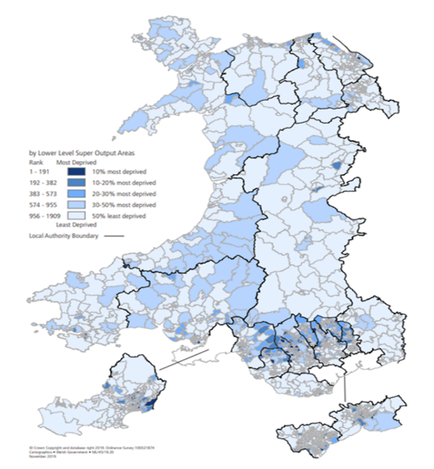
The indicators above are age-sex standardised to adjust for the expected prevalence of disease within the underlying population. This allows the index to identify areas where health deprivation exists beyond the effect of age and sex.
The association between deprivation and health is clearly apparent across Wales especially in the post-industrial valley communities in South Wales. Here poorer health outcomes are significantly worse than Wales as a whole.

2.0 Swansea Bay University Health Board
2.1 Our Population
Swansea Bay University Health Board (SBUHB) serves a population of 390,949 across Neath Port Talbot and Swansea. For Swansea, the total population is 248,051 and for Neath Port Talbot it is 142,898.
From predicted population estimates, the trend indicates a steady rise between 2018 and 2028. Over this period, variant population prediction estimates are as low as 396, 200 and high variant population prediction are 414,700 for the whole of the Swansea Bay area.
The main projected trends in Swansea, focussing on the first ten years, are outlined below:
- The projections point to higher growth in the number of males (+4,800 or 3.9%) compared to females (+3,100 or 2.5%) over ten years. The projections also suggest there will be more males than females in Swansea from 2020 onwards, reaching 50.3% by 2028.
- The number of working age people (aged 16-64) is projected to increase by 3,000 (+1.9%) by 2028; but proportionately below growth in the whole population (+3.2%)
- By 2028, the number of people aged 65 and over is projected to increase by around 5,100 (+10.5%) to 53,100. This is mainly due to continued improvements in mortality rates (reflected in people living longer) and the ageing forward of some population cohorts, including those born in the post-war baby boom
The total population of Neath Port Talbot is projected to increase from an estimated 142,898 to 146,800, an increase of 3894 (+2.7%) over the ten-year period.
The main projected trends in Neath Port Talbot, focussing on the first ten years, are outlined below:
- The population is projected to increase by 2.8%
- The number of children and young people (0-15) is not set to decrease
- There will be an increase in the number of people aged 65 years
- The overall number of persons aged 75+ is projected to increase from 13,500 persons in 2018 to 20,100 persons in 2033 this represents an additional 6,700 older persons, a growth of nearly 50%
- Net migration is set to be greater than natural changes (number of births and deaths)
Sources Population estimates by local authority and year
Local authority population projections for Wales: 2018-based (revised)
Summary of Local Housing Market for Neath Port Talbot 2019

A Local Development Plan (LDP) is an innovative and ambitious plan which summarises city and borough development proposals over a period of time, whilst managing planning applications.
The Neath Port Talbot County Borough Council Local Development Plan 2011 – 2026 was adopted in January 2016, providing a framework for the development of 8,760 additional residential units. (Source: Neath Port Talbot Council Adopted LDP (2011-2026) URL: https://www.npt.gov.uk/planning-and-building-control/planning-policy/adopted-ldp-2011-2026/)
In Swansea, the Local Development Plan (LDP) 2010 – 2025 was adopted on 28th February 2019. The plan comprises of strategic development areas for significant housing development, mapped at twelve site locations to provide a mix of new homes and job creation opportunities, including commercial investment. Taking into account the site proposals for each location, a total of 7,109 units were estimated during the plan period, with an estimated further residual capacity after the plan period ends of approximately 2,500 units. In addition, smaller non-strategic housing sites are similarly detailed within the plan identifying approximately 2,600 dwellings. (Source: Swansea Council Website Swansea Local Development Plan (2010 – 25), URL: https://www.swansea.gov.uk/ldp)
Work is currently progressing to prepare a new development plan for Swansea; Local Development Plan 2 (LDP2) 2023 – 2038. Once adopted, LDP2 will replace the existing plan and will present new plans of the future development across Swansea up until 2028.

Prison population
HMP Swansea is a Category B prison located in the heart of Swansea, approximately 0.5 miles from the City Centre. It has an operating capacity of 500 and provides a secure environment for male offenders who do not require maximum security but still pose a significant risk to the public. The average stay is around eight weeks, with approximately 98% of the prisoners serving less than a year. The prison experiences a high throughput of prisoners, processing around 1,800 new admissions annually.

Population overview by locality
Source ARCH Health Needs Assessment
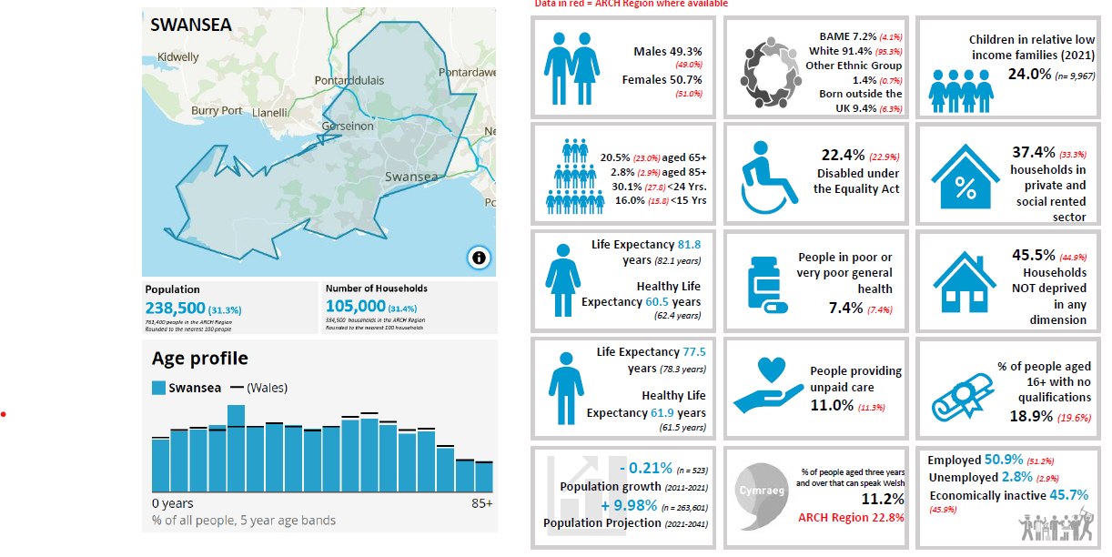
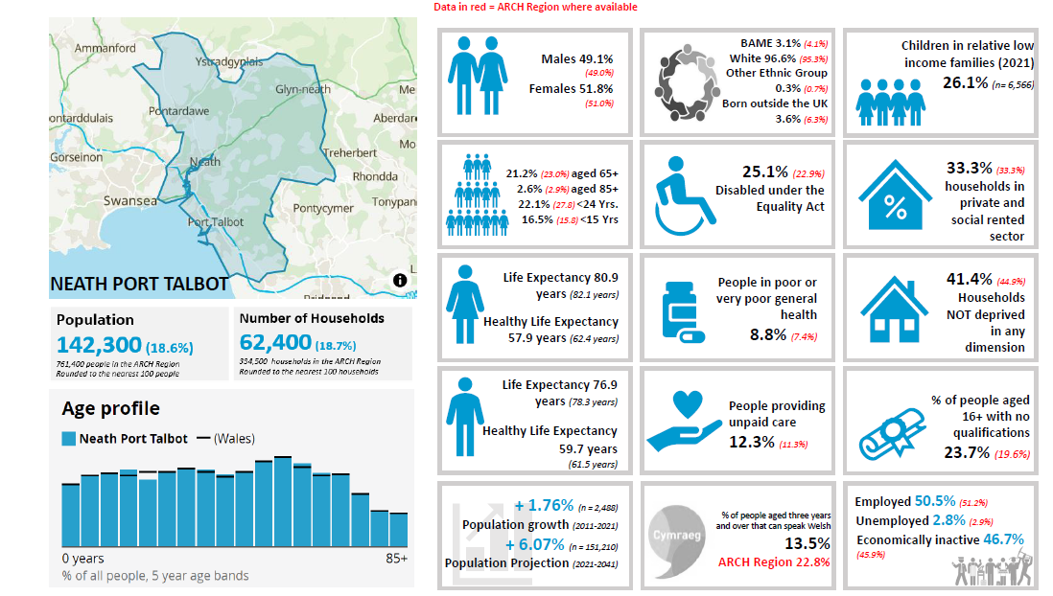

Chronic Disease Prevalence Rate (%), 1st April 2024
Chronic Disease | SBU Health Board % | Wales %
Diabetes mellitus (patients aged 17+) | 7.84 | 8.16
Stroke and transient ischaemic attack | 2.17 | 2.18

Source: Stats Wales
URL:https://statswales.gov.wales/Catalogue/Health-and-Social-Care/NHS-Primary-and-Community-Activity/GMS-Contract/diseaseregisters-by-localhealthboard-cluster-gppractice
Public Health Wales report that regular eye screening reduces the risk of sight loss caused by diabetic retinopathy; a common complication of diabetes that affects the ‘seeing’ part of the eye, the retina (Source: Public Health Wales Diabetic Eye Screening Wales Programme Report,https://phw.nhs.wales/services-and-teams/screening/diabetic-eye-screening-wales/programme-reports/ ). In 2019-20, diabetic eye screening coverage in Swansea Bay University Health Board was recorded as 59%, compared with 60.3% across Wales.
The Royal National Institute of Blind People (RNIB), is the UK’s leading sight loss charity which offers practical and emotional support to blind and partially sighted individuals, their families and carers. This includes information and support regarding assistive aids and technology, money and benefits, education and learning tools for visually impaired children, employment and equality, supporting others, independent living, and also community connection and wellbeing which includes connect Facebook groups and voices network.
RNIB promote awareness of the experiences of blind and partially sighted persons and campaign for change to make the society more accessible for all. Providing and supporting events in our area.
As part of the Swansea Bay University Health Board Eye Health Needs Assessment, RNIB have provided a sight loss briefing specific to the area. Headlines include –
Local area stats
• Total population: 390,949
• Proportion aged 75: 9% - similar to the national average.
• Proportion that are from ethnic minority communities:4.50% - similar to national average.

Eye health stats for local Integrated Care System
• Total outpatient appointments: 30,771.
• Number of Certificates of Vision Impairment in 2019/20: 306.

Sight loss stats
• Number of people estimated to be living with sight loss: 13,470.
• 2032 projection for sight loss population: 15,340.
• Number of registered blind or partially sighted people: 2,317.

UK stats
• One in five people will start to live with sight loss in their lifetime.
• Every day 250 people start to lose their sight.

Source: RNIB Swansea Bay University Health Board Sight Loss briefing (full report at Appendix1).

2.2 Welsh Index Multiple Deprivation
Of the 146 Lower layer Super Output Areas (LSOA’s) in Swansea, 12.8% are in the most deprived 10% LSOA’s in Wales, 25% are in the 20% most deprived LSOAs in Wales, 33.1% are in the 30% most deprived LSOAs in Wales and 50% are in the 50% most deprived LSOA in Wales.
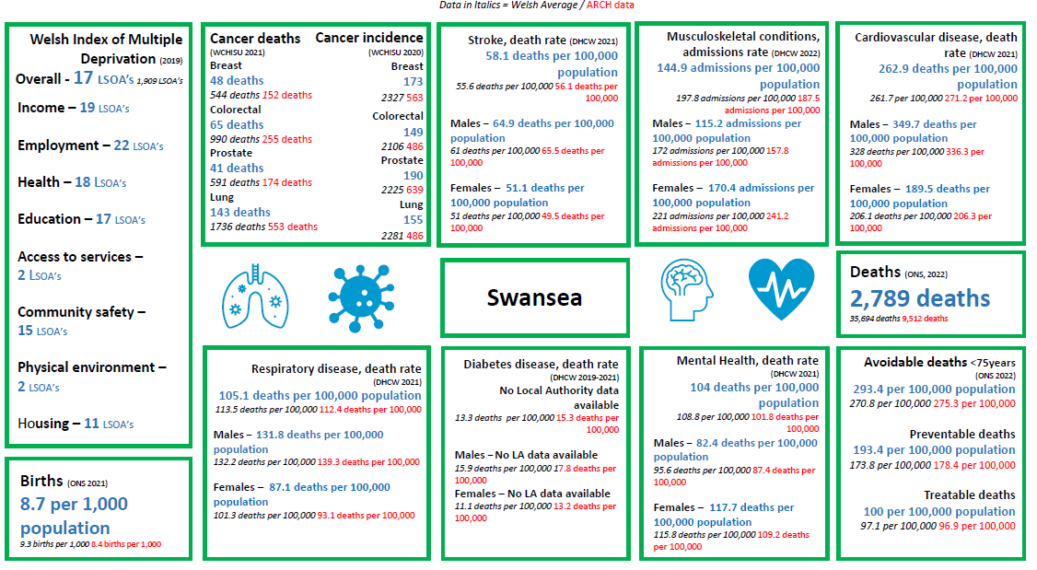
Source ARCH Health Needs Assessment

Of the 91 LSOA’s in Neath Port Talbot 15.4% are in the most deprived 10% in Wales, 28.6% are in the 20% most deprived LSOAs in Wales, 45.1% are in the 30% most deprived LSOAs in Wales and 67% are in the 50% most deprived LSOAs in Wales.
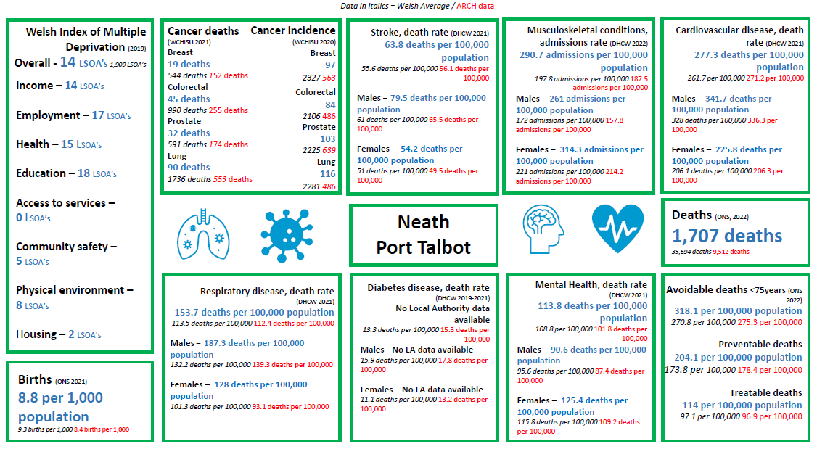
Source ARCH Health Needs Assessment

Swansea and Neath Port Talbot are slightly above the Welsh average for local authorities with LSOAs in the most 10% deprived areas throughout Wales.
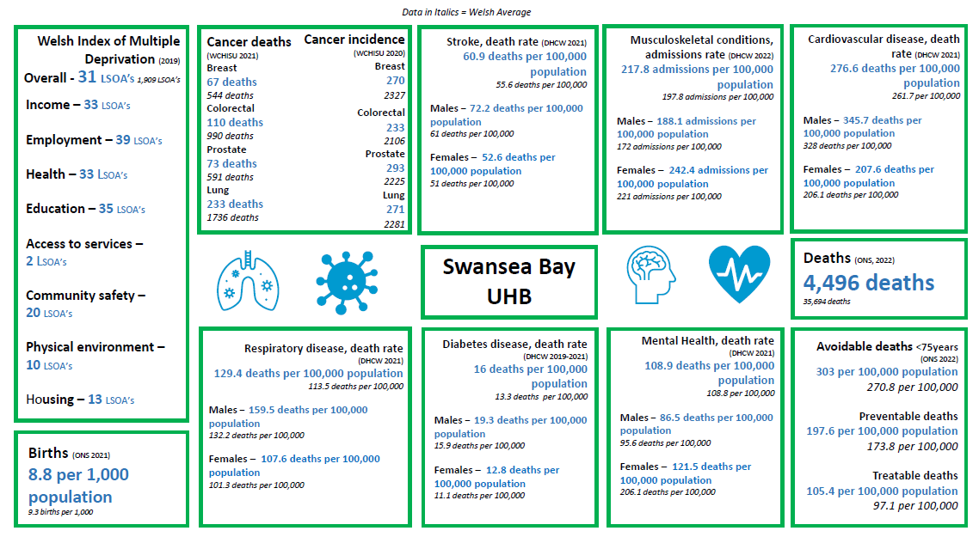
Source ARCH Health Needs Assessment

2.3 WGOS Service Provision
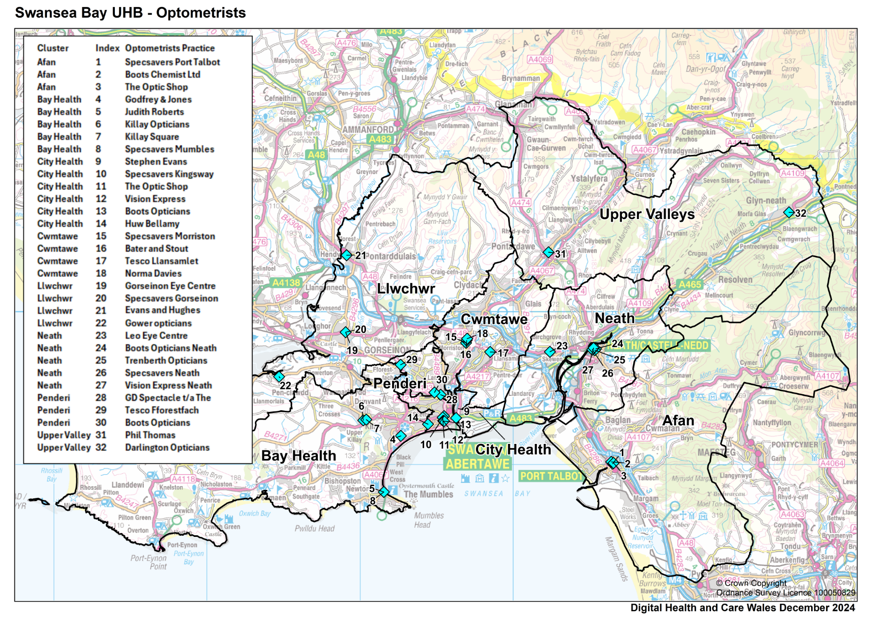
There are a total of 32 optometric practices and 5 domiciliary providers across SBUHB. The map below illustrates the location of our practices within the SBU footprint, with further maps providing a detail breakdown by locality.

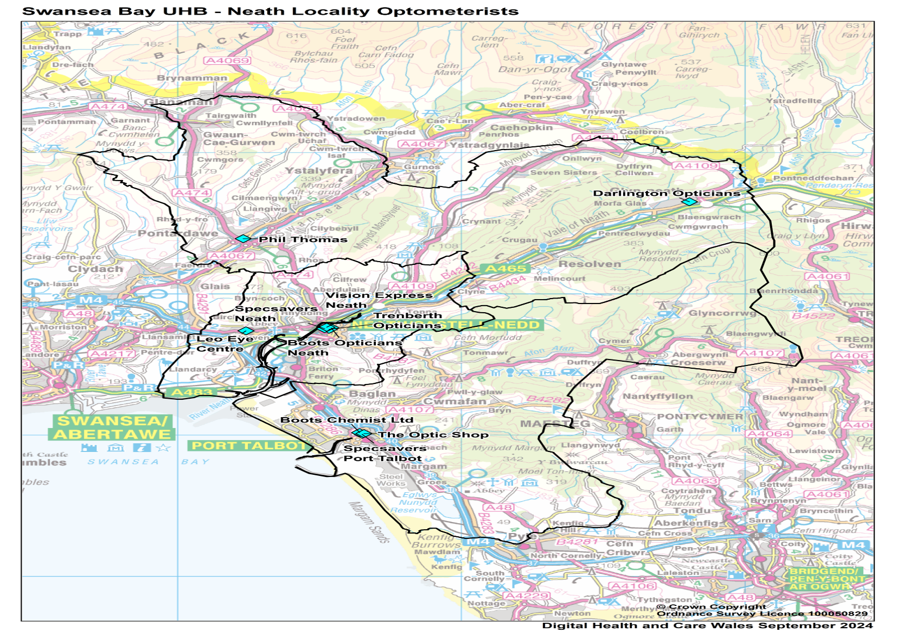
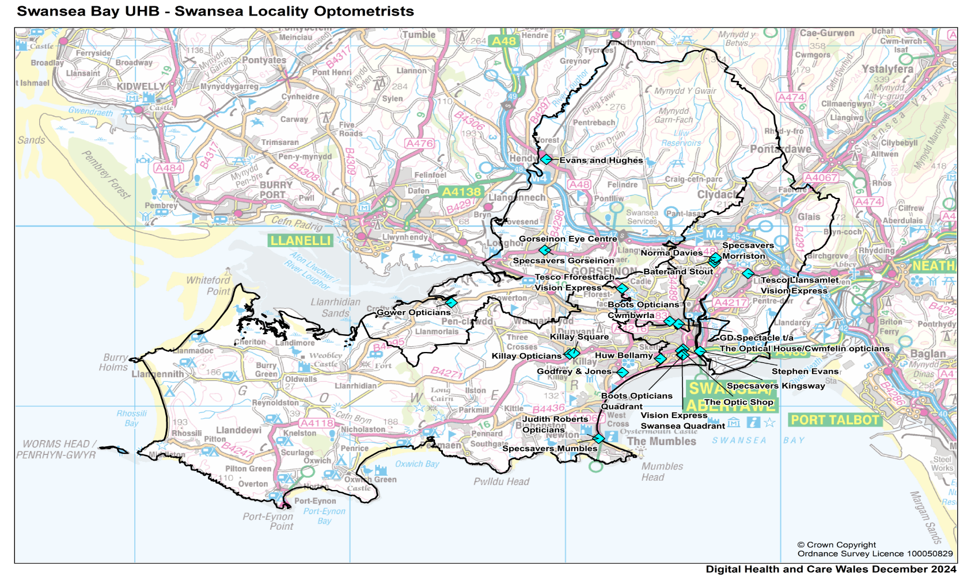
The table below presents a summary of WGOS provision across SBUHB.
 | Heat map highlighting number of WGOS service providers across SBUHB Clusters
Cluster Area | Number of practices | WGOS 1 & 2 | WGOS 3 | WGOS 4 | WGOS 4 | WGOS 5
Cluster Area | Number of practices | [Mandatory] | LVSW | Med Ret | Glaucoma | IP
Afan | 3 | 3 | 0 | 0 | 0 | 0
Neath | 5 | 5 | 2 | 1 | 1 | 0
Upper Valleys | 2 | 2 | 0 | 0 | 0 | 0
Bay | 5 | 5 | 5 | 1 | 0 | 2
City | 6 | 6 | 4 | 3 | 3 | 3
Cwmtawe | 4 | 4 | 3 | 1 | 0 | 0
Llwchwr | 4 | 4 | 4 | 4 | 2 | 3
Penderi | 3 | 3 | 1 | 1 | 0 | 1

Heat map highlighting of WGOS service provision across SBUHB Clusters and opening days
Cluster Area | Number of practices | Monday | Tuesday | Wednesday | Thursday | Friday | Saturday | Sunday
Afan | 3 | 3 | 3 | 3 | 3 | 3 | 3 | 0
Neath | 5 | 5 | 5 | 5 | 5 | 5 | 5 | 2
Upper Valleys | 2 | 2 | 2 | 2 | 2 | 1 | 1 | 0
Bay | 5 | 5 | 5 | 4 | 5 | 4 | 2 | 1
City | 6 | 6 | 6 | 6 | 6 | 6 | 5 | 3
Cwmtawe | 4 | 4 | 4 | 4 | 4 | 4 | 3 | 1
Llwchwr | 4 | 4 | 4 | 4 | 4 | 4 | 3 | 1
Penderi | 3 | 3 | 3 | 3 | 3 | 3 | 2 | 1
The table below presents a summary of days of the week on which WGOS services are delivered.

The table below presents a summary of the domiciliary provisions across the Health Board.
Heat map highlighting of Domiciliary service provision across SBUHB Clusters and opening days
Name | Number of providers | Monday | Tuesday | Wednesday | Thursday | Friday | Saturday | Sunday
@Home health Care (JAMO Group) | 1 | 1 | 1 | 1 | 1 | 1 | 0 | 0
Opticall Healthcare LTD | 1 | 1 | 1 | 1 | 1 | 1 | 0 | 0
OutsideClinic Services LTD | 1 | 1 | 1 | 1 | 1 | 1 | 0 | 0
Specsavers Home Visits (CATVOD LTD) | 1 | 1 | 1 | 1 | 1 | 1 | 0 | 0
Specsavers Home Visits Gwent | 1 | 1 | 1 | 1 | 1 | 1 | 0 | 0

The tables below present a summary of WGOS 4 Medical Retina and Glaucoma capacity (patient appointments) and days of the week on which services are delivered.
Map highlighting WGOS 4 Medical Retina service weekly capacity (appointments) across SBUHB Clusters
Cluster Area | Number of practices providing services as at 24th March 2025 | Monday | Tuesday | Wednesday | Thursday | Friday | Saturday | Sunday
Afan | 0 | 0 | 0 | 0 | 0 | 0 | 0 | 0
Neath | 1 | 1 | 1 | 1 | 1 | 1 | 0 | 0
Upper Valleys | 0 | 0 | 0 | 0 | 0 | 0 | 0 | 0
Bay | 1 | 0 | 0 | 0 | 2 | 2 | 0 | 0
City | 3 | 6 | 6 | 6 | 6 | 6 | 0 | 0
Cwmtawe | 1 | 1 | 1 | 1 | 1 | 1 | 0 | 0
Llwchwr | 4 | 7 | 7 | 7 | 7 | 6 | 2 | 0
Penderi | 1 | 2 | 2 | 2 | 2 | 2 | 2 | 0

Map highlighting WGOS 4 Glaucoma service weekly capacity (appointments) across SBUHB Clusters
Cluster Area | Number of practices | Monday | Tuesday | Wednesday | Thursday | Friday | Saturday | Sunday
Afan | 0 | 0 | 0 | 0 | 0 | 0 | 0 | 0
Neath | 1 | 1 | 1 | 1 | 1 | 1 | 0 | 0
Upper Valleys | 0 | 0 | 0 | 0 | 0 | 0 | 0 | 0
Bay | 0 | 0 | 0 | 0 | 0 | 0 | 0 | 0
City | 3 | 5 | 5 | 5 | 5 | 5 | 0 | 0
Cwmtawe | 0 | 0 | 0 | 0 | 0 | 0 | 0 | 0
Llwchwr | 3 | 6 | 6 | 6 | 6 | 5 | 2 | 0
Penderi | 0 | 2 | 2 | 2 | 2 | 2 | 2 | 0

The transition of WGOS 4 rollout commenced in October 2024, including Medical Retina and Glaucoma Monitoring.
To increase the number of optometrists that complete their higher qualifications and subsequently increase the WGOS provision, a number of key actions are required this includes:
- Distributing a qualification survey to community optometrist to gather insight into their current qualifications, professional aspirations, and any barriers they may face. This will inform targeted approaches for future higher training initiatives.
- Maintaining regular engagement with HEIW to stay informed about available training placements and future funding opportunities.
- To conduct targeted communication efforts Cluster areas with identified service gaps to encourage greater uptake of WGOS 3.

WGOS Activity Summaries
The graph below shows an increase in activity from 2023/24 to 2024/25 (April to February).
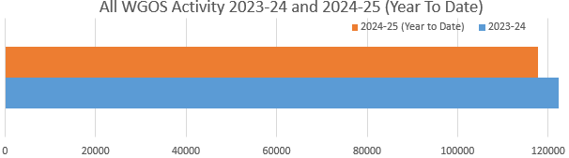
The graphs below show the WGOS 1 and WGOS 2 activity in SBUHB across a range of dates and across clusters.
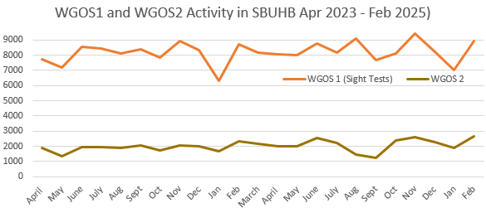
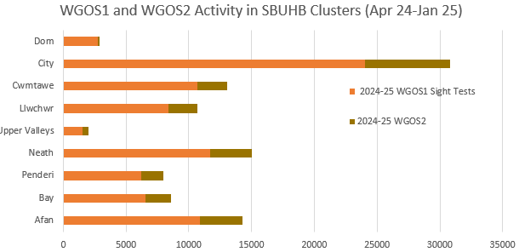

The graphs below show the WGOS 3, WGOS 4 and WGOS 5 activity in SBUHB across a range of dates and across clusters.
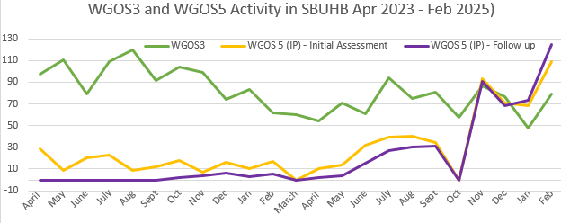
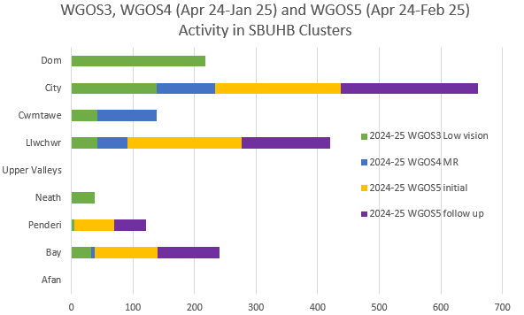

Hospital Eye Services
The main hospital eye service (HES) is located in Singleton Hospital. Opthalmology clinics run from 8:30-5pm Monday to Friday, with an out of hours service where an on-call Ophthalmologist is available.
There are other clinics run on peripheral sites including Neath Port Talbot Hospital, Dyfed Road Hub and the Wellbeing Centre in Swansea University.
The Ophthalmology team is made up of several specialists, including consultants who are supported by a multi-disciplinary team consisting of Orthoptists, Ophthalmic nurse practitioners and an administration team.
Swansea Bay University Health Board also supports Hywel Dda University Health Board’s HES by providing a Glaucoma consultant and a paediatric consultant to assist in timely access to complex Glaucoma services, Cornea and Adult squint services and complex adult motility.
The introduction of Wales General Ophthalmic Services (WGOS) on the 20 October 2023, has enabled close collaboration between Primary Care and HES to ensure that patients are reviewed in the most appropriate setting and where possible, closer to their home, reducing the pressures on HES.
Prison service
A Service Level Agreement is in place to deliver ophthalmic services for men at HMP Swansea, ensuring care is driven by the patient’s needs, their best long-term interests, and minimises risks. The services offered include, but will not be limited to:
- Sight tests and eye health care as defined by the terms of service contract for Wales General Ophthalmic Service (WGOS) or Welsh Government Welsh Health Circulars (WHC)
- Supplying, fitting, repairing and replacement of NHS spectacles and appliances
- Providing eye health care and support advice as appropriate
- Referral out of the services to medical practitioners when appropriate and in line NHS Wales national standards and Health Board local guidelines
- To report changes in eye pathology, e.g. retinopathy, glaucoma, cataract, when diagnosed and refer to specialist hospital eye services when appropriate
- To accept the requirement for a referral from healthcare professionals for diabetic individuals where appropriate
- To accept the requirement for a referral from healthcare professionals to provide service for urgent care.

The Prison service delivers two sessions per month, each accommodating an average of 6 appointments. Currently, the number of monthly referrals has increased, resulting in a 6-week waiting list. Additionally, there has been an increase in Did Not Attends (DNAs). To address this, the Health Board, Prison service and HMP Swansea are collaborating on a targeted initiative to improve attendance rates and reduce the wait for an appointment.
Other Service Developments
Teach and Treat
The South West Wales, Teach and Treat centre is a collaborative initiative with Cardiff University School of Optometry and Vision Sciences, the centre serves a dual purpose: providing patient care and facilitating advanced clinical training placements for optometrists.
Under the supervision of experienced clinical optometrists, practitioners undergo rigorous hands-on training while pursuing higher qualifications in key areas such as glaucoma, independent prescribing, and medical retina. The learning experience ensures that practitioners are not only technically proficient but also confident in delivering high-quality care tailored to individual patient needs.
Upon completing their qualifications, these practitioners are able provide enhanced services directly within the clusters. This significant step reduces the reliance on hospital-based care, allowing patients to access specialised treatments closer to home. The shift to community-based care also alleviates pressure on hospital services, resulting in reduced waiting times and improved overall efficiency in the delivery of eye care.
The centre is based in Neath Port Talbot Hospital for Independent Prescribing and Glaucoma and the Centre based at Singleton Hospital for Medical Retina.

Pilot Pathway

A pilot Pathway Standard Operating Procedure has been developed by the SBUHB Optometric Advisor and Stroke lead consultant for direct referral of Transient Ischemic Attack (TIA) patients. This Pilot went live in December 2025.
The pilot pathway would utilise existing Community and secondary care resources and provide a direct referral route from Optometrists, able to identify visual signs of TIA in at risk patients, to the SBUHB TIA clinic in Singleton and Morriston Hospitals.
At April 2024, Stroke and TIA prevalence rate equated to almost 9,000 patients in the Swansea Bay population.
Evaluation of the effectiveness of this pilot will be undertaken after 6 months, reviewing referral data to assess its effectiveness, informing wider role out of an optimised pathway. This will address any potential disparity to patients living across Localities, with all benefitting from a more timely and effective service response. To date, Community Optometrist have made 7 direct referrals.

2.4 Demand and unmet need for WGOS
An analysis of the WGOS service provision across SBUHB clusters identifies varying levels of availability across the cluster areas. WGOS 4 and WGOS 5 are specialised service provided by Optometrists who have completed advanced training and education, enabling them to deliver these services within community optometry.
 | 2023/24  Number of appointments | 2024/25 Year to date (10 months)  Number of appointments
WGOS 1 | 86,110 | 79,967
WGOS 2 | 21,362 | 20,416
WGOS 3 | 500 | 297
Diabetic Retinopathy and Wet AMD | 1,088 | 914 (April – Oct)
WGOS 4 Med Ret | 0 | 193 (Nov – YTD)
WGOS 4 Glaucoma | 0 | 0
WGOS 5 | 183 | 1,074
Domiciliary | 3,183 | 3,749 (Full year - April to March)

- WGOS 1 and 2 – mandatory services, are universally available at 100% coverage across all cluster areas.
- Diabetic Retinopathy and Wet AMD – this was a local scheme which transitioned to WGOS in October 2024.
- WGOS 3 – is provided at full capacity in Bay and Llwchwr, with a moderate coverage in City, Cwmtawe, Neath and Penderi. No service provision available in Afan and Upper Valleys
- WGOS 4 Medical Retina – is available in Llwchwr, City, Penderi, Cwmtawe and Neath. Other Clusters are not delivering this service.
- WGOS 4 Glaucoma – is available in City and Llwchwr, with limited availability in Neath. Other Cluster are not delivering this service.
- WGOS 5 – is available in Bay, City, Llwchwr and Penderi, with no provision in Afan, Cwmtawe, Neath or Upper Valleys.
- Domiciliary – There are 5 domiciliary providers offering cover from Monday to Friday across Swansea and Neath Port Talbot.
- Digitisation – there is a recognised risk within Secondary and Primary Care that the lack of a shared electronic patient record could impact on roll out of WGOS. In mitigation NHS emails are used for referral, though this does not provide access to patient information.

The current waiting list backlogs for Secondary Care in Glaucoma and Medical Retina are patients requiring hospital eye services. There are currently no suitable patients identified in the Glaucoma backlog to be transferred to WGOS 4. Suitable patients may come from next new of follow up appointment and will be discharged to WGOS 4 if appropriate.
2.5 DDA compliance, loop systems etc
Information not available at time of publication.
2.6 Welsh Language
Welsh language standards apply to NHS Primary Care services that are contracted by the Health Board; these standards currently do not apply to independent contractors. However, independent contractors must comply with Welsh language duties.
Since 30th May 2019, six Welsh language duties have been placed on independent primary care contractors. Under these duties, contractors must:
- Notify the local health board if they provide services through the medium of Welsh
- Provide Welsh language versions of all documents or forms provided to it by the local health board
- Ensure that any new sign or notice provided is bilingual. Contractors can use local health boards translation services for this purpose.
- Encourage staff to wear a badge or lanyard to show that they are able to speak or learning Welsh, if they provide services in Welsh
- Establish and record the language preference of a patient
- Encourage and assist staff to utilise information and/or attend training courses or events provided by the local health board.
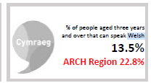
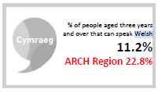
In Swansea, 11.2% of the population aged three years and over are able to speak Welsh, while in Neath Port Talbot, this figure stands at 13%. This data highlights the distribution of Welsh language proficiency across these areas.
Source ARCH Health Needs Assessment
2.7 Workforce data
NHS Wales Shared Services Partnership (NWSSP) maintain the Welsh Performers list, where all Optometrist are required to be part of the Performers list to practice in Wales.
Health Board | Medical Retina Filtering (MRF) | Medical Retina Monitoring (MRM) | HCQ Monitoring | Glaucoma Filtering (GF) | Glaucoma Monitoring (GM)
Swansea Bay ULHB | 42 | 42 | 42 | 5 | 39
Nationally | 317 | 317 | 317 | 50 | 302
The table below provides a summary of those performers qualified to deliver WGOS 4 services, as provided by NWSSP. Contractors are required to submit workforce data as part of the WGOS quality package to enhance understanding of the optometry workforce and support service planning and training. Accurate data was not available at the time of publication.

The following number of performers are delivering services in SBUHB.
- WGOS4 – Medical Retina (Prof Certificate in Medical Retina): 30
- WGOS4 – Glaucoma Monitoring (Professional Certificate): 17
- WGOS5 – IPOS (Independent Prescribing): 11

2.8 Our Clusters
Within Swansea Bay University Health Board there are eight Clusters. The Clusters are made up of groups of GP practices, dentists, community pharmacies, local opticians, community nurses, and allied health professionals who work together to plan and provide services to the local population. The data provided in relation to GMS practice registrations for each cluster gives context to the maps and data. Community Optometry services may be provided to individuals from other Cluster areas unlike GMS services.
Afan Cluster: The Afan Cluster serves a GP registered population of 45,940 and is the 4th smallest Cluster in the Health Board area. (Source – SBUHB Digital Intelligence). There are 5 GP Practices in the area.

Cluster provision: 3 static practices, 5 domiciliary providers.
The Optometric Practices are located mainly in Port Talbot area as set out in the maps below:
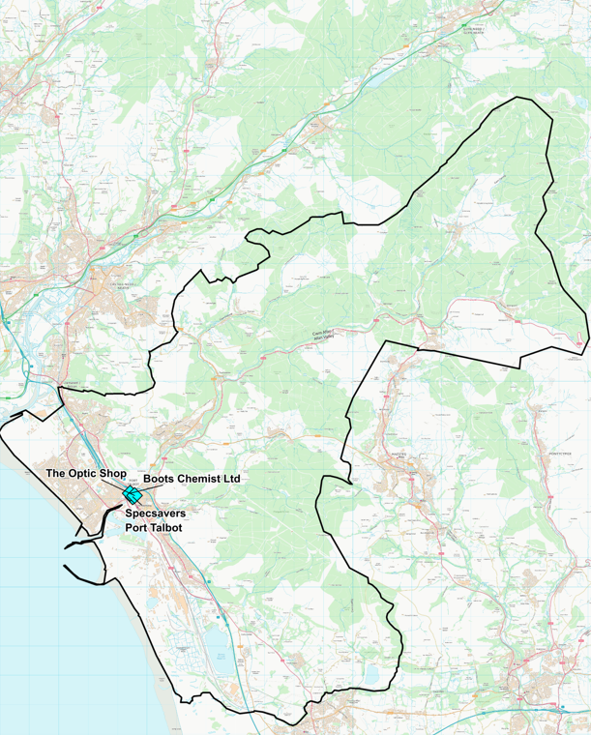
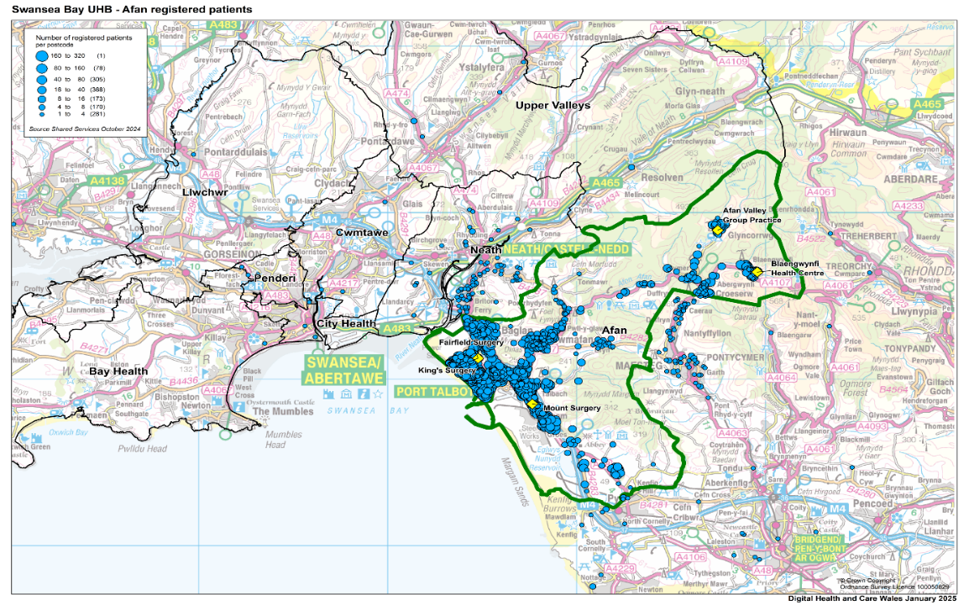

Afan Cluster percentage of population in age band
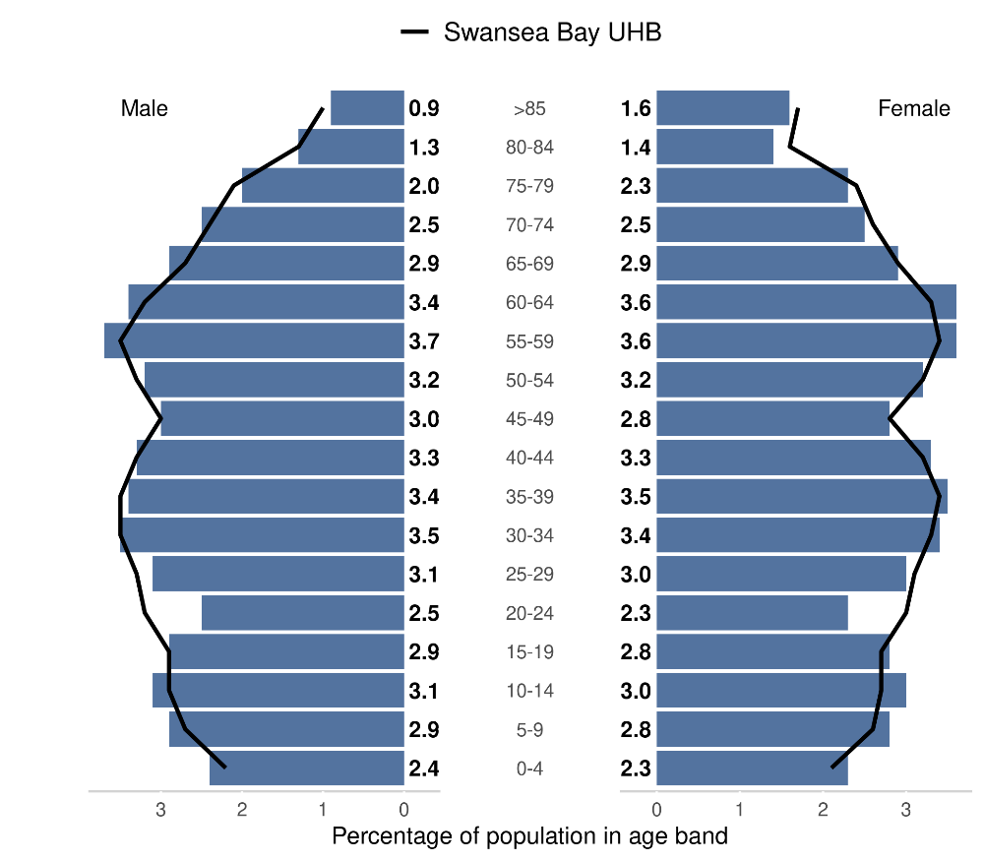
Source: Produced by Public Health Wales using Financial Practitioner Payment Scheme (FPPS) via DHCW URL:https://publichealthwales.shinyapps.io/PCC_Dashboard_Eng_Accessible/

Welsh Index of Multiple deprivation: Of the 20% most deprived LSOAs in Wales, 14 are within Neath Port Talbot and 12 are found within the Afan cluster. 49.7% of Afan Cluster residents live in the most deprived 20% WIMD. Source -https://www.swansea.gov.uk/wimd2019
Afan Cluster Chronic Disease Prevalence % (1st April 2024)
Chronic Disease | Afan % | SBU Health Board % | Wales %
Diabetes mellitus (patients aged 17+) | 9.34 | 7.84 | 8.16
Stroke and transient ischaemic attack | 2.21 | 2.17 | 2.18
Source: Stats Wales
URL: https://statswales.gov.wales/Catalogue/Health-and-Social-Care/NHS-Primary-and-Community-Activity/GMS-Contract/diseaseregisters-by-localhealthboard-cluster-gppractice
Afan Cluster Screening Uptake (%) | Afan % | Wales %
Diabetic Eye Screening (2019/20) | 64 | 60.3
Source: Public Health Wales, Primary Care Clusters Dashboard
URL: https://phw.nhs.wales/services-and-teams/screening/

WGOS Service Provision
The Optometric Practices and Domiciliary Providers (coloured in yellow) that deliver WGOS in Afan Cluster are set out in the table below:
Practice Name | WGOS 1 | WGOS 2 | WGOS 3 | WGOS 3 CVI | WGOS 4  Med Ret | WGOS 4  Glaucoma | WGOS 5
Specsavers Port Talbot | Y | Y
Boots Port Talbot | Y | Y
The Optic Shop | Y | Y
Opticall Healthcare (Neath) | Y | Y
Specsavers Home visits (Neath) (CATVOD LTD) | Y | Y | Y
@home Health Care (Neath) (JAMO group) |  |  | Y
OutsideClinic Services LTD (Neath) | Y | Y | Y
Specsavers Home Visits Gwent (Neath) | Y | Y

The core hours of each Optometric Practice and Domiciliary provider (coloured yellow), as stated in practice declarations, is set out in the table below:

Practice Name | Monday | Tuesday | Wednesday | Thursday | Friday | Saturday | Sunday
Specsavers Port Talbot | 08:00 – 18:00 | 08:00 – 18:00 | 08:00 – 18:00 | 08:00 – 18:00 | 08:00 – 18:00 | 09:00 – 18:00 | Closed
Boots Port Talbot | 09:00 – 17:00 | 09:00 – 17:00 | 09:00 – 17:00 | 09:00 – 17:00 | 09:00 – 17:00 | 09:00 – 17:00 | Closed
The Optic Shop | 09:30 – 16:30 | 09:30 – 16:30 | 09:30 – 16:30 | 09:30 – 16:30 | 09:30 – 16:30 | 09:30 – 12:30 | Closed
Opticall Healthcare (Neath) | 09:00 – 17:00 | 09:00 – 17:00 | 09:00 – 17:00 | 09:00 – 17:00 | 09:00 – 17:00 | Closed | Closed
Specsavers Home visits (Neath) (CATVOD LTD) | 09:00 – 17:00 | 09:00 – 17:00 | 09:00 – 17:00 | 09:00 – 17:00 | 09:00 – 17:00 | Closed | Closed
@home Health Care (Neath) (JAMO group) | 09:00 – 17:00 | 09:00 – 17:00 | 09:00 – 17:00 | 09:00 – 17:00 | 09:00 – 17:00 | Closed | Closed
OutsideClinic Services LTD (Neath) | 09:00-17:30 | 09:00-17:30 | 09:00-17:30 | 09:00-17:30 | 09:00-17:30 | Closed | Closed
Specsavers Home Visits Gwent (Neath) | 09:00-16:00 | 09:00-16:00 | 09:00-16:00 | 09:00-16:00 | 09:00-16:00 | Closed | Closed

In 2023/24 and 2024/25 (year to date), Optometry activity in Afan Cluster included:
 | 2023/24  Number of appointments | 2024/25 Year to date (10 months)  Number of appointments
WGOS 1 | 10,746 | 10,886
WGOS 2 | 2,887 | 3,082

Bay Cluster
The Bay Cluster serves a GP registered population of 75,618 and it the largest cluster in SBUHB area (Source –SBUHB Digital Intelligence). The cluster geographically covers Uplands, Sketty, West Cross, Mumbles, Killay and Gower regions of Swansea. There are 8 GP practices in the Bay Cluster area: whilst Swansea University and its Health Centre sit within the Bay cluster, the City cluster also serve this population based on student residence and/or home address. This is sometimes transient or seasonal but impacts on the age demographic in a unique way compared with other clusters.

Cluster provision: 5 static practices and 5 domiciliary providers.
The Optometric Practices are located mainly in Singleton, Killay and Mumbles area as set out in the map below:

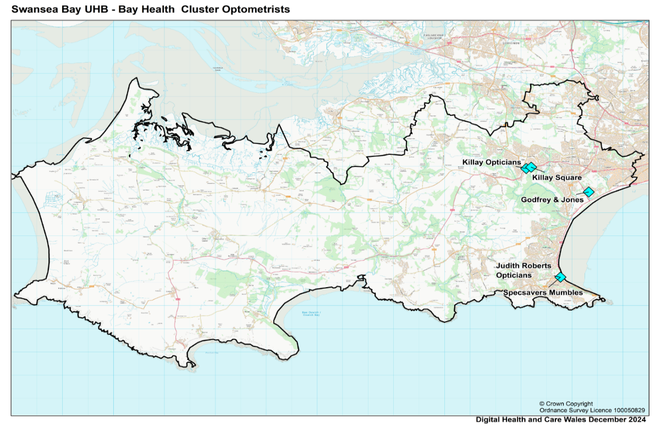
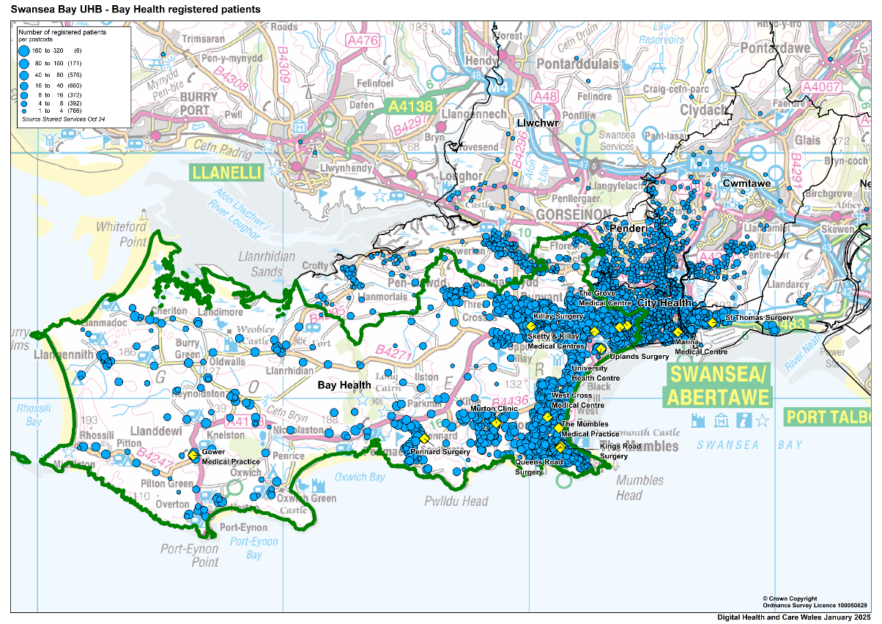

Bay Cluster percentage of population in age band
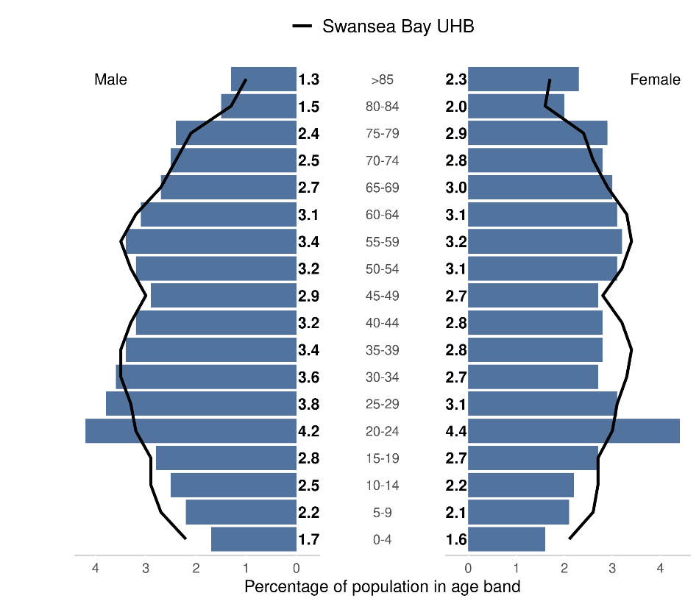
Source: Produced by Public Health Wales using Financial Practitioner Payment Scheme (FPPS) via DHCW (https://publichealthwales.shinyapps.io/PCC_Dashboard_Eng_Accessible/)

Welsh Index of Multiple deprivation: Of the 20% most deprived LSOAs in Wales, 17 are within Swansea. Of the 44 LSOAs in the Bay Cluster 1 is found within the 20% most deprived 8.4% of Bay Cluster residents live in the most deprived 20% WIMD.
Source - https://www.swansea.gov.uk/wimd2019
Bay Cluster Chronic Disease Prevalence % (1st April 2024)
Chronic Disease | Bay % | SBU Health Board % | Wales %
Diabetes mellitus (patients aged 17+) | 5.35 | 7.84 | 8.16
Stroke and transient ischaemic attack | 2.04 | 2.17 | 2.18
Source: Stats Wales
URL: https://statswales.gov.wales/Catalogue/Health-and-Social-Care/NHS-Primary-and-Community-Activity/GMS-Contract/diseaseregisters-by-localhealthboard-cluster-gppractice

Bay Cluster Screening Uptake (%) | Bay % | Wales %
Diabetic Eye Screening (2019/20) | 57.1 | 60.3
Source: Public Health Wales, Primary Care Clusters Dashboard
URL: https://phw.nhs.wales/services-and-teams/screening/

WGOS Service Provision:
The Optometric Practices and Domiciliary Provider (coloured in yellow) that deliver WGOS in Bay Cluster are set out in the table below:

Practice Name | WGOS 1 | WGOS 2 | WGOS 3 | WGOS 4  Med Ret | WGOS 4  Glaucoma | WGOS 5
Godfrey & Jones | Y | Y | Y
Judith Roberts | Y | Y | Y
Killay Opticians | Y | Y | Y
Specsavers Mumbles | Y | Y | Y | Y |  | Y
Killay Square Eyes | Y | Y | Y |  |  | Y
Opticall Healthcare (Swansea) | Y | Y | Y
Specsavers Home visits (Swansea) (CATVOD LTD) | Y | Y | Y
@home Health Care (Swansea) (JAMO group) |  |  | Y
OutsideClinic Services LTD (Swansea) | Y | Y
Specsavers Home Visits Gwent (Swansea) | Y | Y

The core hours of each Optometric Practice and Domiciliary Provider (coloured in yellow), as stated in practice declarations, is set out in the table below:

Practice Name | Monday | Tuesday | Wednesday | Thursday | Friday | Saturday | Sunday
Godfrey & Jones | 09:00 – 12:30 13:30-17:30 | 09:00 – 12:30 13:30-17:30 | 09:00 – 12:30  13:30-17:30 | 09:00 – 12:30 13:30-17:30 | 09:00 – 12:30 13:30-17:30 | Closed | Closed
Judith Roberts | 09:00 – 17:30 | 09:00 – 17:30 | 09:00 – 17:30 | 09:00 – 17:30 | 09:00 – 17:30 | 09:00 – 13:00 | Closed
Killay Opticians | 09:00 – 12:45  14:00 – 17:00 | 09:00 – 12:45  14:00 – 17:00 | Closed | 09:00 – 12:45  14:00 – 16:30 | Closed | Closed | Closed
Specsavers Mumbles | 09:00 – 17:00 | 09:00 – 17:00 | 09:00 – 17:00 | 09:00 – 17:00 | 09:00 – 17:00 | 09:00 – 17:00 | 10:00 – 15:30
Killay Square Eyes | 09:00 – 17:00 | 09:00 – 17:00 | 09:00 – 17:00 | 09:00 – 17:00 | 09:00 – 17:00 | Closed | Closed
Opticall Healthcare (Swansea) | 09:00 – 17:00 | 09:00 – 17:00 | 09:00 – 17:00 | 09:00 – 17:00 | 09:00 – 17:00 | Closed | Closed
Specsavers Home visits (Swansea) (CATVOD LTD) | 09:00 – 17:00 | 09:00 – 17:00 | 09:00 – 17:00 | 09:00 – 17:00 | 09:00 – 17:00 | Closed | Closed
@home Health Care (Swansea) (JAMO group) | 09:00 – 17:00 | 09:00 – 17:00 | 09:00 – 17:00 | 09:00 – 17:00 | 09:00 – 17:00 | Closed | Closed
OutsideClinic Services LTD (Swansea) | 09:00-17:30 | 09:00-17:30 | 09:00-17:30 | 09:00-17:30 | 09:00-17:30 | Closed | Closed
Specsavers Home Visits Gwent (Swansea) | 09:00-16:00 | 09:00-16:00 | 09:00-16:00 | 09:00-16:00 | 09:00-16:00 | Closed | Closed
In 2023/24 and 2024-25 (year to date), Optometry activity in Bay Cluster included:
 | 2023/24  Number of appointments | 2024/25 Year to date (10 months)  Number of appointments
WGOS 1 | 11,101 | 6,564
WGOS 2 | 2,535 | 1,844
WGOS 3 | 32 | 32
Diabetic Retinopathy and Wet AMD | 0 | 18 (Apr – Oct)
WGOS 4 Med Ret | 0 | 24 (Nov – YTD)
WGOS 5 | 0 | 202

City Cluster
The City Cluster serves a GP registered population of 55,618 and has the 2nd largest cluster population in Swansea Bay University Health Board area (Source –SBUHB Digital Intelligence). It geographically covers south east and central Swansea. There are 8 GP Practice in the City Cluster area.
Cluster population: 6 static practices and 5 domiciliary providers.
The Optometric Practices are located mainly in Swansea city centre area as set out in the map below:

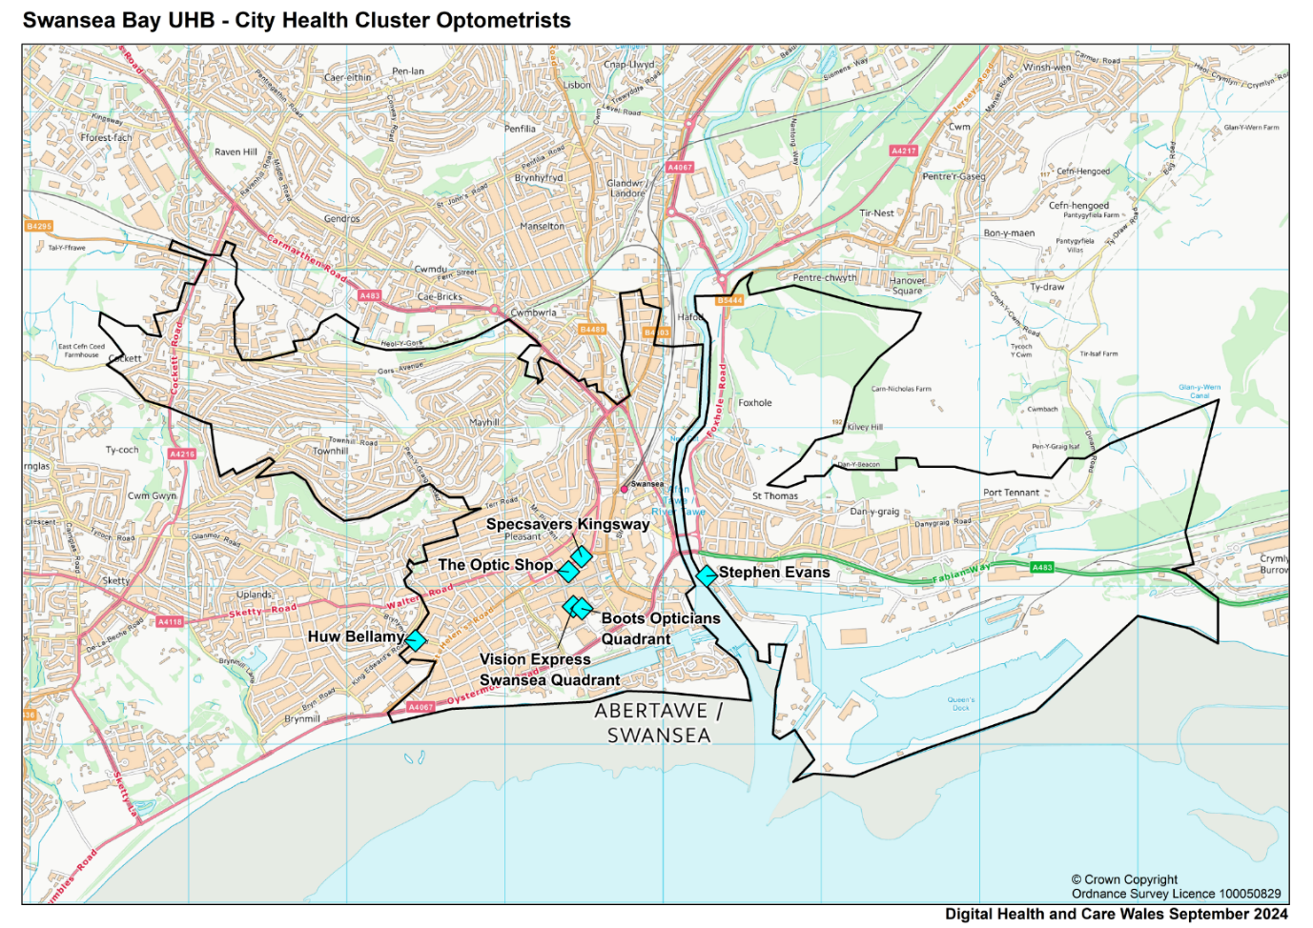

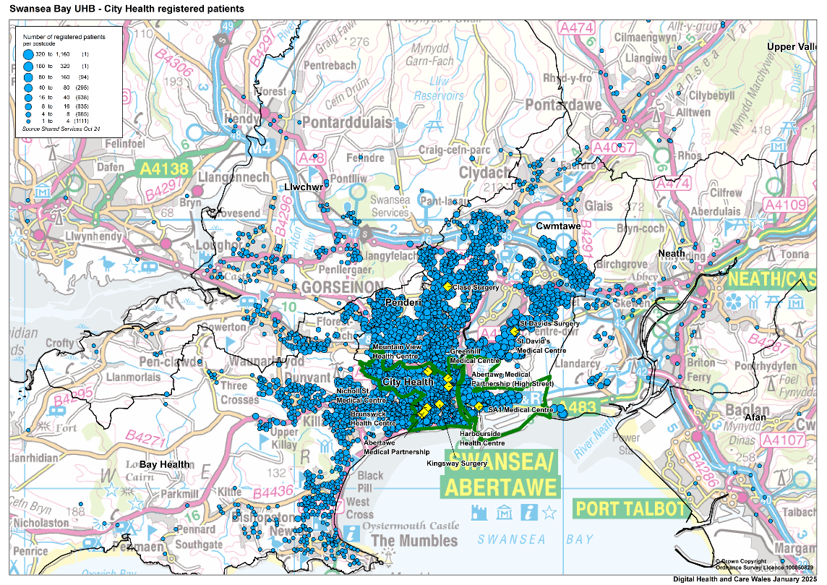

City Cluster percentage of population in age band
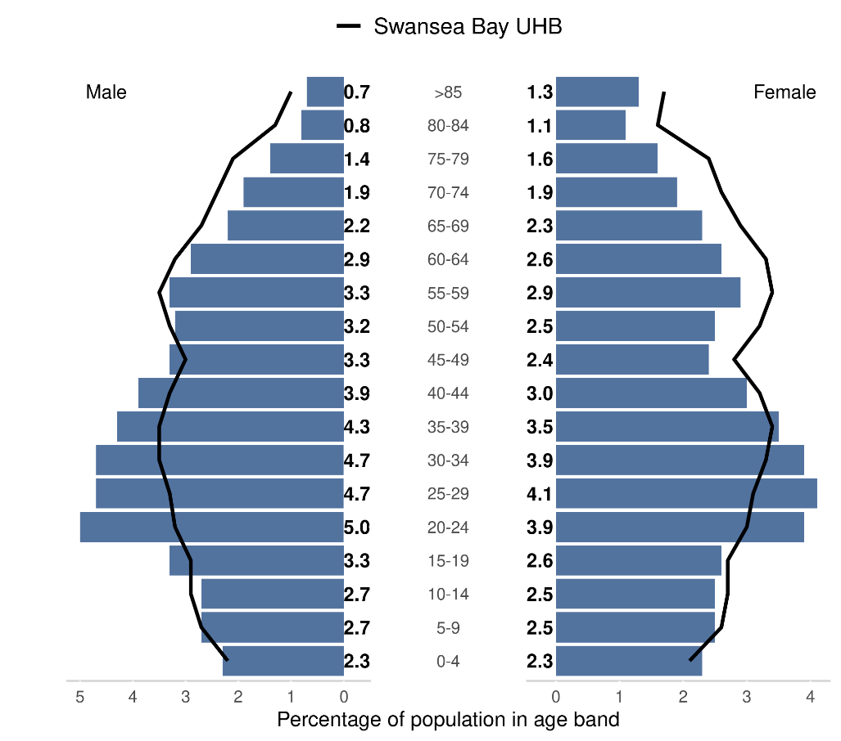

Source: Produced by Public Health Wales using Financial Practitioner Payment Scheme (FPPS) via DHCW (https://publichealthwales.shinyapps.io/PCC_Dashboard_Eng_Accessible/)

Welsh Index of Multiple deprivation: Of the 20% most deprived LSOAs in Wales, 17 are within Swansea, with 12 found within the City Cluster (Source - https://www.swansea.gov.uk/wimd2019). 22.7% of City Cluster residents live in the most deprived 20% WIMD.
City Health Cluster Chronic Disease Prevalence % (1st April 2024)

Chronic Disease | City % | SBU Health Board % | Wales %
Diabetes mellitus (patients aged 17+) | 7.65 | 7.84 | 8.16
Stroke and transient ischaemic attack | 1.93 | 2.17 | 2.18
Source: Stats Wales
URL: https://statswales.gov.wales/Catalogue/Health-and-Social-Care/NHS-Primary-and-Community-Activity/GMS-Contract/diseaseregisters-by-localhealthboard-cluster-gppractice

City Health Cluster Screening Uptake (%) | City % | Wales %
Diabetic Eye Screening (2019/20) | 53.2 | 60.3
Source: Public Health Wales, Primary Care Clusters Dashboard
URL: https://phw.nhs.wales/services-and-teams/screening/

WGOS Service Provision:
The Optometric Practices and Domiciliary provider (coloured in yellow) that deliver WGOS in City Cluster are set out in the table below:

Practice Name | WGOS 1 | WGOS 2 | WGOS 3 | WGOS 4  Med Ret | WGOS 4  Glaucoma | WGOS 5
Stephen Evans | Y | Y | Y | Y | Y | Y
Specsavers Kingsway | Y | Y | Y | Y | Y | Y
The Optic Shop | Y | Y
Vision Express | Y | Y | Y
Boots Opticians | Y | Y
Huw Bellamy | Y | Y | Y | Y | Y | Y
Opticall Healthcare (Swansea) | Y | Y | Y
Specsavers Home visits (Swansea) (CATVOD LTD) | Y | Y | Y
@home Health Care (Swansea) (JAMO group) |  |  | Y
OutsideClinic Services LTD (Swansea) | Y | Y
Specsavers Home Visits Gwent (Swansea) | Y | Y

The core hours of each Optometric Practice and Domiciliary provider (coloured in yellow),
as stated in practice declarations, is set out in the table below:

Practice Name | Monday | Tuesday | Wednesday | Thursday | Friday | Saturday | Sunday
Stephen Evans | 09:00 – 17:30 | 09:00 – 17:30 | 09:00 – 17:30 | 09:00 – 17:30 | 09:00 – 17:30 | 09:00 – 13:00 | Closed
Specsavers Kingsway | 08:40 – 18:00 | 08:40 – 18:00 | 08:40 – 18:00 | 08:40 – 18:00 | 08:40 – 18:00 | 08:45 – 17:15 | 09:45 – 16:00
The Optic Shop | 09:00 – 17:30 | 09:00 – 17:30 | 09:00 – 17:30 | 09:00 – 17:30 | 09:00 – 17:30 | 09:00 – 14:00 | Closed
Vision Express | 09:00 – 17:30 | 09:00 – 17:30 | 09:00 – 17:30 | 09:00 – 17:30 | 09:00 – 17:30 | 09:00 – 17:30 | 10:30 – 16:30
Boots Opticians | 09:00 – 17:00 | 09:00 – 17:00 | 09:00 – 17:00 | 09:00 – 17:00 | 09:00 – 17:00 | 09:00 – 17:00 | 10:30 – 16:00
Huw Bellamy | 09:00 – 17:30 | 09:00 – 17:30 | 09:00 – 17:30 | 09:00 – 17:30 | 09:00 – 17:30 | Closed | Closed
Opticall Healthcare (Swansea) | 09:00 – 17:00 | 09:00 – 17:00 | 09:00 – 17:00 | 09:00 – 17:00 | 09:00 – 17:00 | Closed | Closed
Specsavers Home visits (Swansea) (CATVOD LTD) | 09:00 – 17:00 | 09:00 – 17:00 | 09:00 – 17:00 | 09:00 – 17:00 | 09:00 – 17:00 | Closed | Closed
@home Health Care (Swansea) (JAMO group) | 09:00 – 17:00 | 09:00 – 17:00 | 09:00 – 17:00 | 09:00 – 17:00 | 09:00 – 17:00 | Closed | Closed
OutsideClinic Services LTD (Swansea) | 09:00-17:30 | 09:00-17:30 | 09:00-17:30 | 09:00-17:30 | 09:00-17:30 | Closed | Closed
Specsavers Home Visits Gwent (Swansea) | 09:00-16:00 | 09:00-16:00 | 09:00-16:00 | 09:00-16:00 | 09:00-16:00 | Closed | Closed

In 2023/24 and 2024-25 (year to date), Optometry activity in City Cluster included:
 | 2023/24  Number of appointments | 2024/25 Year to date (10 months)  Number of appointments
WGOS 1 | 27,586 | 24,000
WGOS 2 | 6.963 | 6,138
WGOS 3 | 310 | 138
Diabetic Retinopathy and Wet AMD | 884 | 623 (April – Oct)
WGOS 4 Med Ret | 0 | 24 (Nov – YTD)
WGOS 4 Glaucoma | 0 | 0
WGOS 5 | 0 | 427

Cwmtawe Cluster

The Cwmtawe Cluster serves a GP registered population of 42,945 (Source –SBUHB Digital Intelligence) The Cluster geographically covers south east and central Swansea, which includes the areas of Bonymaen, Clydach, Landore, Llansamlet, Morriston and Mynyddbach. There are 3 GP Practice in the City Cluster area:

Cluster provision: 4 static practices and 5 domiciliary providers.
The Optometric Practices are located mainly in Morriston and Llansamlet area as set out in the map below:
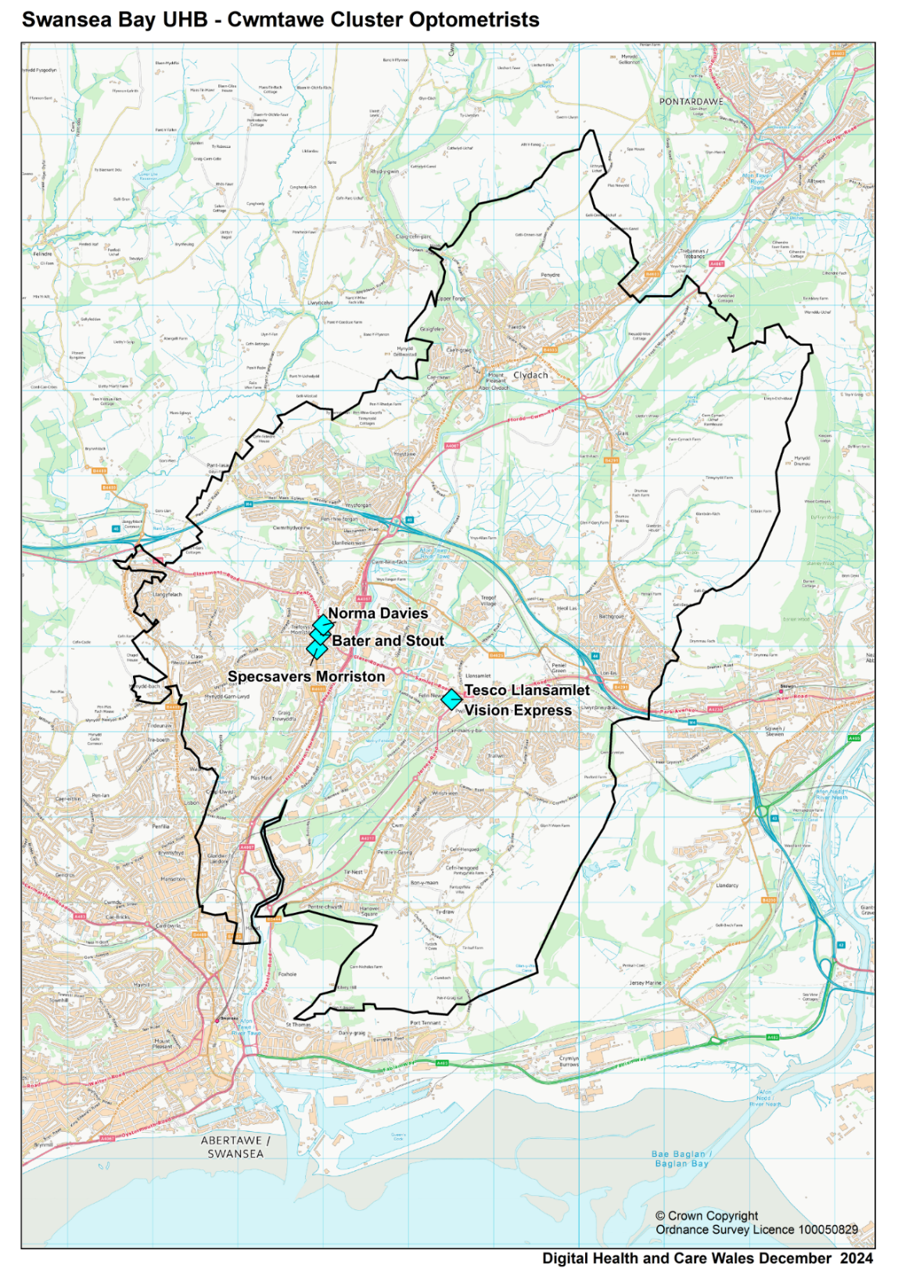

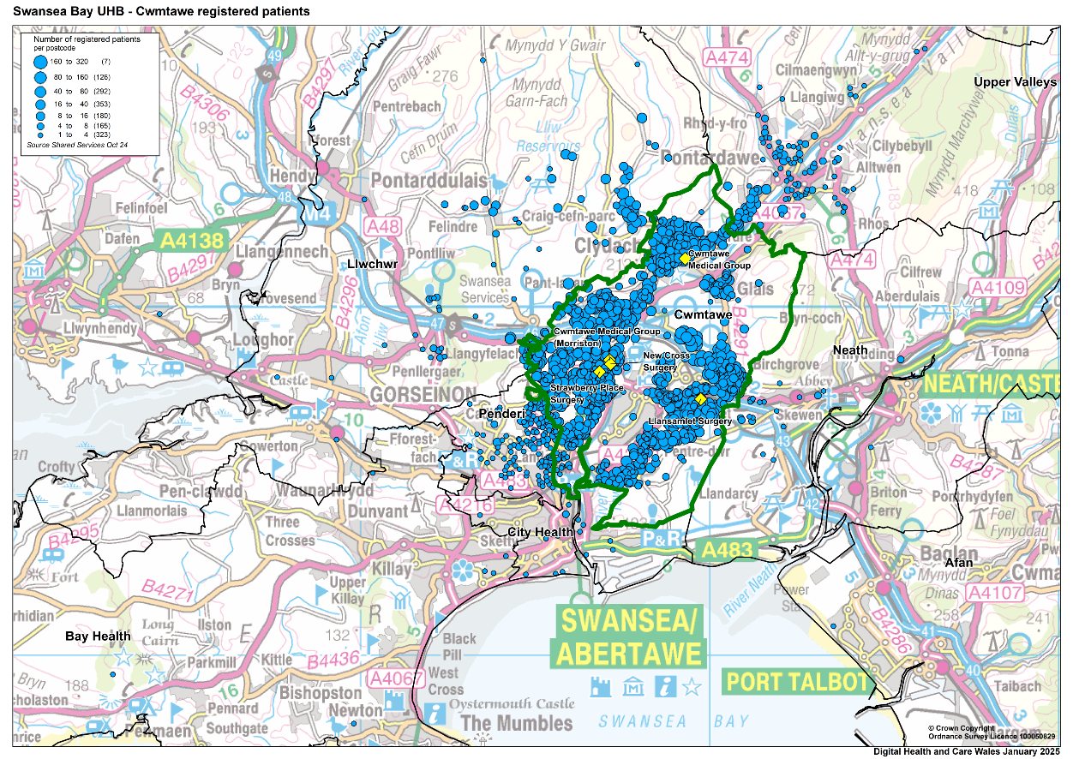

Cwmtawe Cluster percentage of population in age band
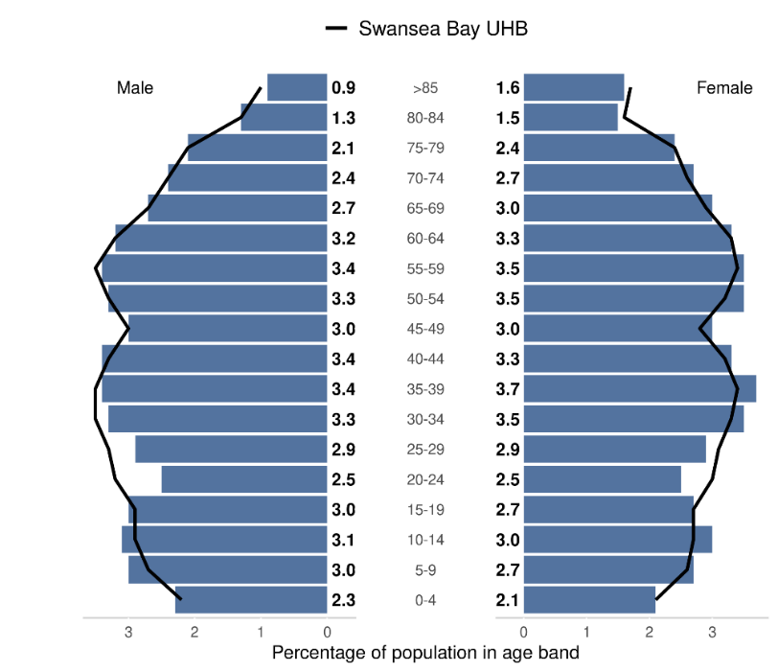

Source: Produced by Public Health Wales using Financial Practitioner Payment Scheme (FPPS) via DHCW (https://publichealthwales.shinyapps.io/PCC_Dashboard_Eng_Accessible/)

Welsh Index of Multiple deprivation: Of the 20% most deprived LSOAs in Wales, 17 are within Swansea, with 9 found within the Cwmtawe SBUHB (Source - https://www.swansea.gov.uk/wimd2019). ). 22.7% of Cwmtawe Cluster residents live in the most deprived 20% WIMD.

Cwmtawe Cluster Chronic Disease Prevalence % (1st April 2024)
Chronic Disease | Cwmtawe % | SBU Health Board % | Wales %
Diabetes mellitus (patients aged 17+) | 8.84 | 7.84 | 8.16
Stroke and transient ischaemic attack | 2.27 | 2.17 | 2.18
Source: Stats Wales
URL: https://statswales.gov.wales/Catalogue/Health-and-Social-Care/NHS-Primary-and-Community-Activity/GMS-Contract/diseaseregisters-by-localhealthboard-cluster-gppractice

Cwmtawe Health Cluster Screening Uptake (%) | Cwmtawe % | Wales %
Diabetic Eye Screening (2019/20) | 57 | 60.3
Source: Public Health Wales, Primary Care Clusters Dashboard
URL: https://phw.nhs.wales/services-and-teams/screening/

WGOS Service Provision:
The Optometric Practices and domiciliary provider (coloured in yellow) that deliver WGOS in Cwmtawe Cluster are set out in the table below:

Practice Name | WGOS 1 | WGOS 2 | WGOS 3 | WGOS 4  Med Ret | WGOS 4  Glaucoma | WGOS 5
Specsavers Morriston | Y | Y | Y
Bater and Stout | Y | Y | Y | Y
Vision Express Llansamlet | Y | Y
Norma Davies | Y | Y | Y
Opticall Healthcare (Swansea) | Y | Y | Y
Specsavers Home visits (Swansea) (CATVOD LTD) | Y | Y | Y
@home Health Care (Swansea) (JAMO group) |  |  | Y
OutsideClinic Services LTD (Swansea) | Y | Y
Specsavers Home Visits Gwent (Swansea) | Y | Y

The core hours of each Optometric Practice and domiciliary provider (coloured in yellow), as stated in practice declarations, is set out in the table below:

Practice Name | Monday | Tuesday | Wednesday | Thursday | Friday | Saturday | Sunday
Specsavers Morriston | 09:00 – 17:30 | 09:00 – 17:30 | 09:00 – 17:30 | 09:00 – 17:30 | 09:00 – 17:30 | 08:30 – 16:00 | 09:00 – 15:00
Bater and Stout | 09:00 – 17:00 | 09:00 – 17:00 | 09:00 – 17:00 | 09:00 – 17:00 | 09:00 – 17:00 | 09:00 – 12:30 | 09:00-12:30 (alt weeks)
Vision Express Llansamlet | 09:00 – 17:30 | 09:00 – 17:30 | 09:00 – 17:30 | 09:00 – 17:30 | 09:00 – 17:30 | 09:00 – 17:30 | Closed
Norma Davies | 10:00 – 16:00 | 10:00 – 16:00 | 10:00 – 16:00 | 10:00 – 16:00 | 10:00 – 16:00 | Closed | Closed
Opticall Healthcare (Swansea) | 09:00 – 17:00 | 09:00 – 17:00 | 09:00 – 17:00 | 09:00 – 17:00 | 09:00 – 17:00 | Closed | Closed
Specsavers Home visits (Swansea) (CATVOD LTD) | 09:00 – 17:00 | 09:00 – 17:00 | 09:00 – 17:00 | 09:00 – 17:00 | 09:00 – 17:00 | Closed | Closed
@home Health Care (Swansea) (JAMO group) | 09:00 – 17:00 | 09:00 – 17:00 | 09:00 – 17:00 | 09:00 – 17:00 | 09:00 – 17:00 | Closed | Closed
OutsideClinic Services LTD (Swansea) | 09:00-17:30 | 09:00-17:30 | 09:00-17:30 | 09:00-17:30 | 09:00-17:30 | Closed | Closed
Specsavers Home Visits Gwent (Swansea) | 09:00-16:00 | 09:00-16:00 | 09:00-16:00 | 09:00-16:00 | 09:00-16:00 | Closed | Closed

In 2023/24 and 2024-25 (year to date), Optometry activity in Cwmtawe Cluster included:
 | 2023/24  Number of appointments | 2024/25 Year to date (10 months)  Number of appointments
WGOS 1 | 4.935 | 10,690
WGOS 2 | 978 | 2,200
WGOS 3 | 59 | 42
Diabetic Retinopathy and Wet AMD | 102 | 172 (April – Oct)
WGOS 4 Med Ret | 0 | 97 (Nov – YTD)
Llwchwr Cluster
The Llwchwr Cluster serves a GP registered population of 49,283 and is the fourth smallest cluster by registered population in the Health Board Area (Source SBUHB Digital Intelligence). It covers the areas of Pontardulais, Gorseinon, Gowerton, Pontlliw, and Penclawdd. There are 4 GP Practice in the Llwchwr Cluster area:
Cluster provision: 4 static practices and 5 domiciliary providers.
The Optometric Practices are located mainly in Gorseinon, with one practice in Pontarddulais and one practice in Penclawdd area as set out in the map below:
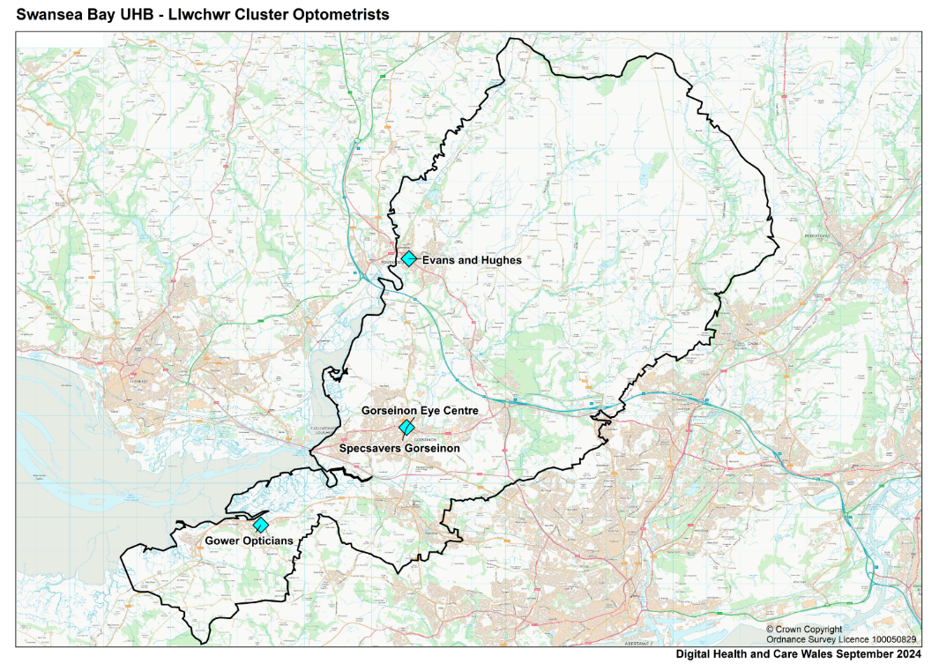

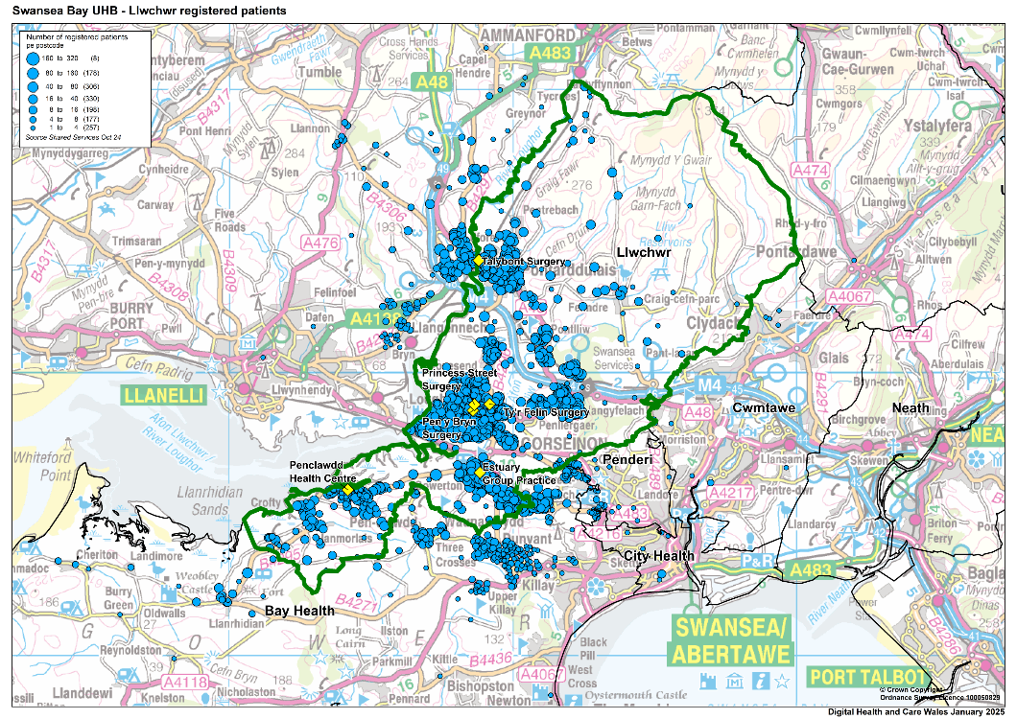

Llwchwr Cluster percentage of population in age band
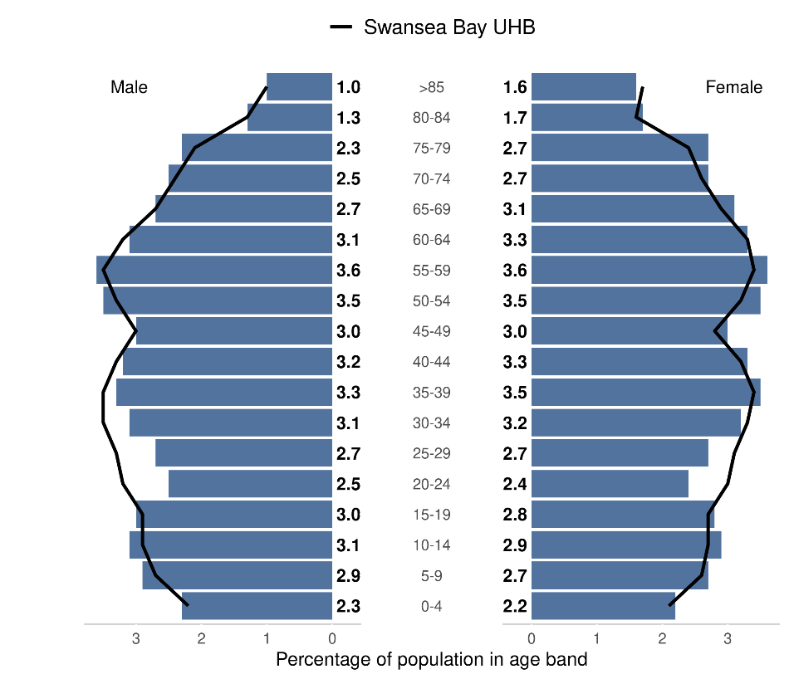

Source: Produced by Public Health Wales using Financial Practitioner Payment Scheme (FPPS) via DHCW (https://publichealthwales.shinyapps.io/PCC_Dashboard_Eng_Accessible/)

Welsh Index of Multiple deprivation: Of the 20% most deprived LSOAs in Wales, 17 are within Swansea, with 2 found within the Llwchwr Cluster (Source - https://www.swansea.gov.uk/wimd2019). ). 8.3% of Llwchwr Cluster residents live in the most deprived 20% WIMD.

Llwchwr Cluster Chronic Disease Prevalence % (1st April 2024)

Chronic Disease | Llwchwr % | SBU Health Board % | Wales %
Diabetes mellitus (patients aged 17+) | 7.88 | 7.84 | 8.16
Stroke and transient ischaemic attack | 2.28 | 2.17 | 2.18
Source: Stats Wales
URL: https://statswales.gov.wales/Catalogue/Health-and-Social-Care/NHS-Primary-and-Community-Activity/GMS-Contract/diseaseregisters-by-localhealthboard-cluster-gppractice

Llwchwr Cluster Screening Uptake (%) | Llwchwr % | Wales %
Diabetic Eye Screening (2019/20) | 51.2 | 60.3
Source: Public Health Wales, Primary Care Clusters Dashboard
URL: https://phw.nhs.wales/services-and-teams/screening/

WGOS Service Provision:
The Optometric Practices and domiciliary providers (coloured in yellow) that deliver WGOS in Llwchwr Cluster are set out in the table below:
Practice Name | WGOS 1 | WGOS 2 | WGOS 3 | WGOS 4  Med Ret | WGOS 4  Glaucoma | WGOS 5
Gorseinon Eye Centre | Y | Y | Y | Y | Y
Specsavers Gorseinon | Y | Y | Y | Y | Y | Y
Evans and Hughes | Y | Y | Y | Y
Gower Opticians | Y | Y | Y | Y |  | Y
Opticall Healthcare (Swansea) | Y | Y | Y
Specsavers Home visits (Swansea) (CATVOD LTD) | Y | Y | Y
@home Health Care (Swansea) (JAMO group) |  |  | Y
OutsideClinic Services LTD (Swansea) | Y | Y
Specsavers Home Visits Gwent (Swansea) | Y | Y

The core hours of each Optometric Practice and domiciliary provider (coloured in yellow), as stated in practice declarations, is set out in the table below:

Practice Name | Monday | Tuesday | Wednesday | Thursday | Friday | Saturday | Sunday
Gorseinon Eye Centre | 08:50 – 16:30 | 08:50 – 16:30 | 08:50 – 16:30 | 08:50 – 16:30 | 08:50 – 16:30 | 09:00 – 12:30 | Closed
Specsavers Gorseinon | 08:00 – 18:30 | 08:00 – 18:30 | 08:00 – 18:30 | 08:00 – 18:30 | 08:00 – 18:30 | 09:00 – 17:00 | 10:00 – 16:00
Evans and Hughes | 09:00 – 17:00 | 09:00 – 17:00 | 09:00 – 17:00 | 09:00 – 17:00 | 09:00 – 17:00 | 09:00 – 12:00 | Closed
Gower Opticians | 09:00 – 13:00  14:00 – 17:00 | 09:00 – 13:00  14:00 – 17:00 | 09:00 – 13:00  14:00 – 17:00 | 09:00 – 13:00  14:00 – 17:00 | 09:00 – 13:00  14:00 – 17:00 | Closed | Closed
Opticall Healthcare (Swansea) | 09:00 – 17:00 | 09:00 – 17:00 | 09:00 – 17:00 | 09:00 – 17:00 | 09:00 – 17:00 | Closed | Closed
Specsavers Home visits (Swansea) (CATVOD LTD) | 09:00 – 17:00 | 09:00 – 17:00 | 09:00 – 17:00 | 09:00 – 17:00 | 09:00 – 17:00 | Closed | Closed
@home Health Care (Swansea) (JAMO group) | 09:00 – 17:00 | 09:00 – 17:00 | 09:00 – 17:00 | 09:00 – 17:00 | 09:00 – 17:00 | Closed | Closed
OutsideClinic Services LTD (Swansea) | 09:00-17:30 | 09:00-17:30 | 09:00-17:30 | 09:00-17:30 | 09:00-17:30 | Closed | Closed
Specsavers Home Visits Gwent (Swansea) | 09:00-16:00 | 09:00-16:00 | 09:00-16:00 | 09:00-16:00 | 09:00-16:00 | Closed | Closed

In 2023/24 and 2024-25 (year to date), Optometry activity in Llwchwr Cluster included:
 | 2023/24  Number of appointments | 2024/25 Year to date (10 months)  Number of appointments
WGOS 1 | 9,407 | 8,353
WGOS 2 | 2,431 | 2,149
WGOS 3 | 56 | 42
Diabetic Retinopathy and Wet AMD | 82 | 101(April – Oct)
WGOS 4 Med Ret | 0 | 48 (Nov – YTD)
WGOS 4 Glaucoma | 0 | 0
WGOS 5 | 183 | 329

Neath Cluster
The Neath Cluster serves a GP registered population of 61,719 and is the second largest cluster by registered population in the Health Board area. (Source – SBUHB Digital Intelligence). The Cluster includes the electoral divisions of Aberdulais, Tonna, Neath North, Neath East, Neath South, Briton Ferry East, Briton Ferry West, Bryncoch. There are 7 GP Practices within the Neath cluster:
Cluster provision: 4 static practices and 5 domiciliary providers.
The Optometric Practices are located mainly in Neath town centre area as set out in the map below:
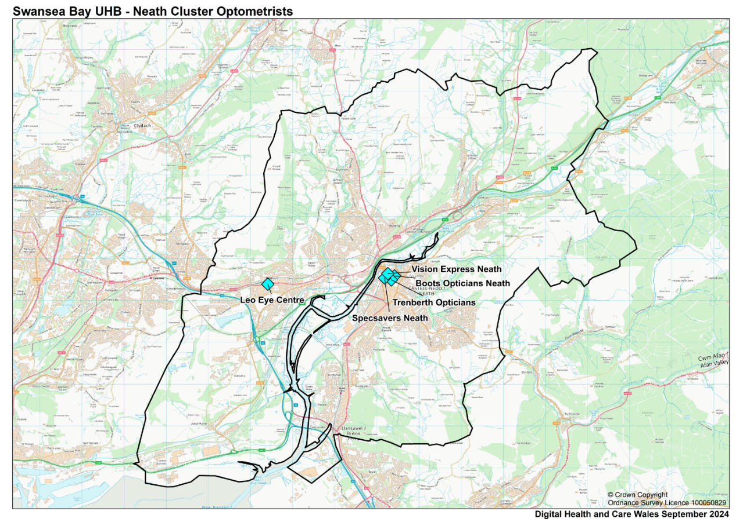

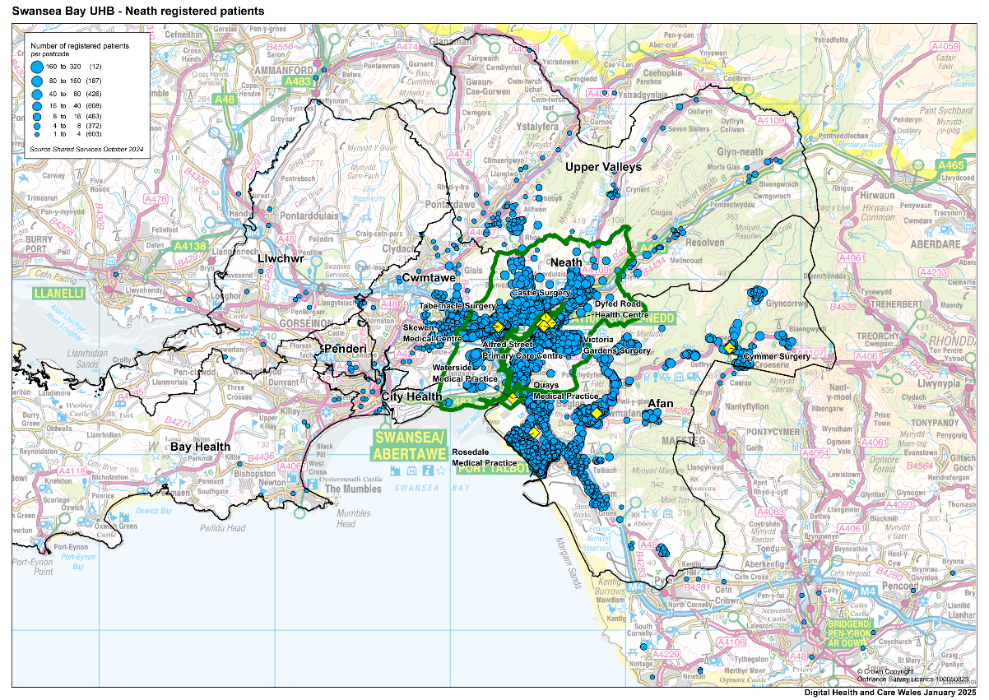

Neath Cluster percentage of population in age band
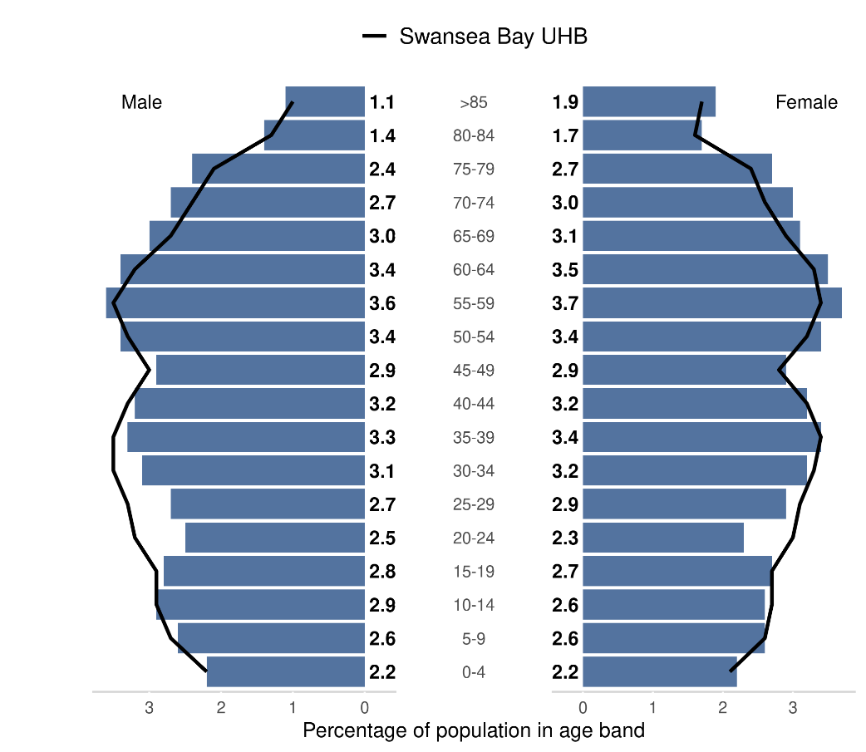

Source: Produced by Public Health Wales using Financial Practitioner Payment Scheme (FPPS) via DHCW https://publichealthwales.shinyapps.io/PCC_Dashboard_Eng_Accessible/)

Welsh Index of Multiple deprivation:
Of the 20% most deprived LSOAs in Wales, 17 are within Swansea. Of the 44 LSOAs in the Neath Cluster 1 is found within the 20% most deprived (Source: https://www.swansea.gov.uk/wimd2019) ). 36.3% of Neath Cluster residents live in the most deprived 20% WIMD.
Neath Cluster Chronic Disease Prevalence % (1st April 2024)
Chronic Disease | Neath % | SBU Health Board % | Wales %
Diabetes mellitus (patients aged 17+) | 8.37 | 7.84 | 8.16
Stroke and transient ischaemic attack | 2.19 | 2.17 | 2.18
Source: Stats Wales
URL: https://statswales.gov.wales/Catalogue/Health-and-Social-Care/NHS-Primary-and-Community-Activity/GMS-Contract/diseaseregisters-by-localhealthboard-cluster-gppractice

Neath Cluster Screening Uptake (%) | Neath % | Wales %
Diabetic Eye Screening (2019/20) | 63.4 | 60.3
Source: Public Health Wales, Primary Care Clusters Dashboard
URL: https://phw.nhs.wales/services-and-teams/screening/

WGOS Service Provision:
The Optometric Practices and domiciliary providers (coloured in yellow) that deliver WGOS in Neath Cluster are set out in the table below:

Practice Name | WGOS 1 | WGOS 2 | WGOS 3 | WGOS 4  Med Ret | WGOS 4  Glaucoma | WGOS 5
Leo Eye Centre | Y | Y | Y | Y | Y
Boots Opticians | Y | Y
Trenberth Opticians | Y | Y
Specsavers Neath | Y | Y
Vision Express Neath | Y | Y | Y
Opticall Healthcare (Neath) | Y | Y | Y
Specsavers Home visits (Neath) (CATVOD LTD) | Y | Y | Y
@home Health Care (Neath) (JAMO group) |  |  | Y
OutsideClinic Services LTD (Neath) | Y | Y | Y
Specsavers Home Visits Gwent (Neath) | Y | Y

The core hours of each Optometric Practice and domiciliary provider (coloured in yellow), as stated in practice declarations, is set out in the table below:

Practice Name | Monday | Tuesday | Wednesday | Thursday | Friday | Saturday | Sunday
Leo Eye Centre | 08:50 – 13:00  14:00 – 17:30 | 08:50 – 13:00  14:00 – 17:30 | Closed | 08:50 – 13:00  14:00 – 17:30 | 08:50 – 13:00  14:00 – 17:30 | Closed | Closed
Boots Opticians | 09:00 – 17:00 | 09:00 – 17:00 | 09:00 – 17:00 | 09:00 – 17:00 | 09:00 – 17:00 | 09:00 – 17:00 | 10:30 – 16:30
Trenberth Opticians | 09:00 – 13:00 | 09:00 – 13:00 | 09:00 – 13:00 | 09:00 – 12:30 | 09:00 – 13:00 | 09:00– 12:30 | Closed
Specsavers Neath | 09:00 – 17:30 | 09:00 – 17:30 | 09:00 – 17:30 | 09:00 – 17:30 | 09:00 – 17:30 | 09:00 – 17:15 | Closed
Vision Express Neath | 09:00 – 17:30 | 09:00 – 17:30 | 09:00 – 17:30 | 09:00 – 17:30 | 09:00 – 17:30 | 09:00 – 17:00 | 10:00-16:00
Opticall Healthcare (Neath) | 09:00 – 17:00 | 09:00 – 17:00 | 09:00 – 17:00 | 09:00 – 17:00 | 09:00 – 17:00 | Closed | Closed
Specsavers Home visits (Neath) (CATVOD LTD) | 09:00 – 17:00 | 09:00 – 17:00 | 09:00 – 17:00 | 09:00 – 17:00 | 09:00 – 17:00 | Closed | Closed
@home Health Care (Neath) (JAMO group) | 09:00 – 17:00 | 09:00 – 17:00 | 09:00 – 17:00 | 09:00 – 17:00 | 09:00 – 17:00 | Closed | Closed
OutsideClinic Services LTD (Neath) | 09:00-17:30 | 09:00-17:30 | 09:00-17:30 | 09:00-17:30 | 09:00-17:30 | Closed | Closed
Specsavers Home Visits Gwent (Neath) | 09:00-16:00 | 09:00-16:00 | 09:00-16:00 | 09:00-16:00 | 09:00-16:00 | Closed | Closed

2023/24 and 2024-25 (year to date), Optometry activity in Neath Cluster included:
 | 2023/24  Number of appointments | 2024/25 Year to date (10 months)  Number of appointments
WGOS 1 | 13,210 | 11,711
WGOS 2 | 3,123 | 2,962
WGOS 3 | 33 | 38
Diabetic Retinopathy and Wet AMD | 0 | 0 (April – Oct)
WGOS 4 Med Ret | 0 | 0 (Nov – YTD)
WGOS 4 Glaucoma | 0 | 0

Penderi Cluster
The Penderi Cluster serves a GP registered population of 37,612 (Source: SBUHB Digital Intelligence) The Cluster geographically covers the wards: Castle (part), Cockett (part), Cwmbwrla, Mynyddbach (part), Penderi. There are 5 GP Practice in the Penderi Cluster.

Cluster provision: 3 static practices and 5 domiciliary providers.
The Optometric Practices are located mainly in Cwmfelin, and one practice in Fforestfach area as set out in the map below:
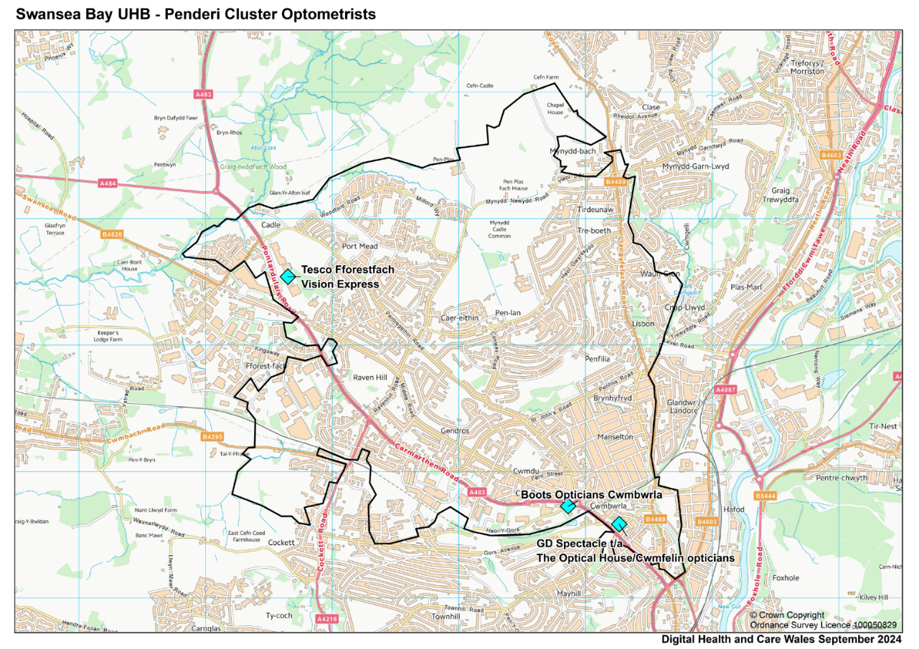

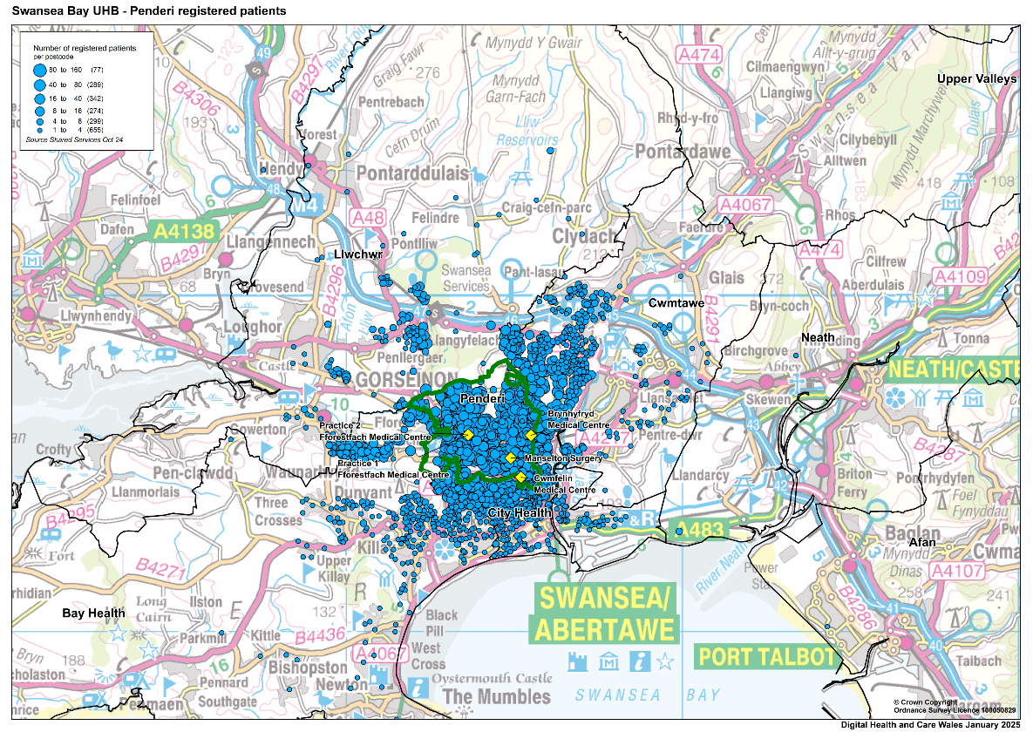

Penderi Cluster percentage of population in age band
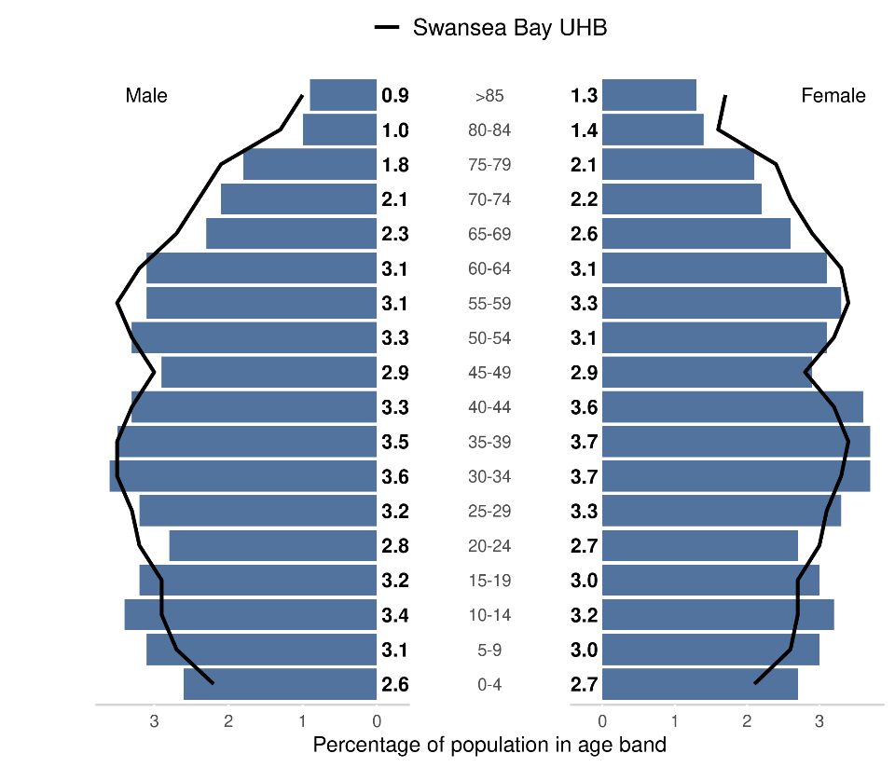

Source: Produced by Public Health Wales using Financial Practitioner Payment Scheme (FPPS) via DHCW (https://publichealthwales.shinyapps.io/PCC_Dashboard_Eng_Accessible/)

Welsh Index of Multiple deprivation:
Of the 20% most deprived LSOAs in Wales, 17 are within Swansea, with 5 found within the Penderi Cluster (Source - https://www.swansea.gov.uk/wimd2019). 49.3% of Penderi Cluster residents live in the most deprived 20% WIMD.
Penderi Cluster Chronic Disease Prevalence % (1st April 2024)
Chronic Disease | Penderi % | SBU Health Board % | Wales %
Diabetes mellitus (patients aged 17+) | 8.69 | 7.84 | 8.16
Stroke and transient ischaemic attack | 2.33 | 2.17 | 2.18
Source: Stats Wales
URL: https://statswales.gov.wales/Catalogue/Health-and-Social-Care/NHS-Primary-and-Community-Activity/GMS-Contract/diseaseregisters-by-localhealthboard-cluster-gppractice

Penderi Cluster Screening Uptake % | Penderi % | Wales %
Diabetic Eye Screening (2019/20) | 57.7 | 60.3
Source: Public Health Wales, Primary Care Clusters Dashboard
URL: https://phw.nhs.wales/services-and-teams/screening/

WGOS Service Provision:
The Optometric Practices and domiciliary providers (coloured in yellow) that deliver WGOS in Penderi Cluster are set out in the table below:

Practice Name | WGOS 1 | WGOS 2 | WGOS 3 | WGOS 4  Med Ret | WGOS 4  Glaucoma | WGOS 5
Cwmfelin Opticians | Y | Y
Vision Express Fforestfach | Y | Y
Boots Opticians | Y | Y | Y | Y |  | Y
Opticall Healthcare (Swansea) | Y | Y | Y
Specsavers Home visits (Swansea) (CATVOD LTD) | Y | Y | Y
@home Health Care (Swansea) (JAMO group) |  |  | Y
OutsideClinic Services LTD (Swansea) | Y | Y
Specsavers Home Visits Gwent (Swansea) | Y | Y

The opening times of each Optometric Practice and domiciliary providers (coloured in yellow), as stated in practice declarations, is set out in the table below:

Practice Name | Monday | Tuesday | Wednesday | Thursday | Friday | Saturday | Sunday
Cwmfelin Opticians | 09:30 – 17:30 | 09:30 – 17:30 | 09:30 – 17:30 | 09:30 – 17:30 | 09:30 – 17:30 | Closed | Closed
Vision Express Fforestfach | 09:00 – 17:30 | 09:00 – 17:30 | 09:00 – 17:30 | 09:00 – 17:30 | 09:00 – 17:30 | 09:00 – 17:30 | Closed
Boots Opticians | 09:00 – 17:00 | 09:00 – 17:00 | 09:00 – 17:00 | 09:00 – 17:00 | 09:00 – 17:00 | 09:00 – 17:00 | 10:00 – 16:00
Opticall Healthcare (Swansea) | 09:00 – 17:00 | 09:00 – 17:00 | 09:00 – 17:00 | 09:00 – 17:00 | 09:00 – 17:00 | Closed | Closed
Specsavers Home visits (Swansea) (CATVOD LTD) | 09:00 – 17:00 | 09:00 – 17:00 | 09:00 – 17:00 | 09:00 – 17:00 | 09:00 – 17:00 | Closed | Closed
@home Health Care (Swansea) (JAMO group) | 09:00 – 17:00 | 09:00 – 17:00 | 09:00 – 17:00 | 09:00 – 17:00 | 09:00 – 17:00 | Closed | Closed
OutsideClinic Services LTD (Swansea) | 09:00-17:30 | 09:00-17:30 | 09:00-17:30 | 09:00-17:30 | 09:00-17:30 | Closed | Closed
Specsavers Home Visits Gwent (Swansea) | 09:00-16:00 | 09:00-16:00 | 09:00-16:00 | 09:00-16:00 | 09:00-16:00 | Closed | Closed
In 2023/24 and 2024-25 (year to date), Optometry activity in Penderi Cluster included:
 | 2023/24  Number of appointments | 2024/25 Year to date (10 months)  Number of appointments
WGOS 1 | 7,284 | 6,236
WGOS 2 | 1,889 | 1,610
WGOS 3 | 10 | 5
Diabetic Retinopathy and Wet AMD | 0 | 0 (April – Oct)
WGOS 4 Med Ret | 0 | 0 (Nov – YTD)
WGOS 5 | 0 | 116

Upper Valley Cluster
The Upper Valleys Cluster serves a GP registered population of 32, and is the smallest cluster by registered population in the Health Board area. (Source – SBUHB Digital Intelligence). The Upper Valleys Cluster geographically covers the northern wards of Neath Port Talbot County Borough Council. The Cluster shares boundaries with both Afan and Neath Clusters and with the City and County of Swansea, Bridgend, Carmarthenshire, and Powys County Borough Council. There are 4 GP Practices in the Upper Valley Cluster:
Cluster provision: 2 static practices and 5 domiciliary providers.
One Optometric Practice is located in Glynneath and one practice is located in Pontardawe as set out in the map below:
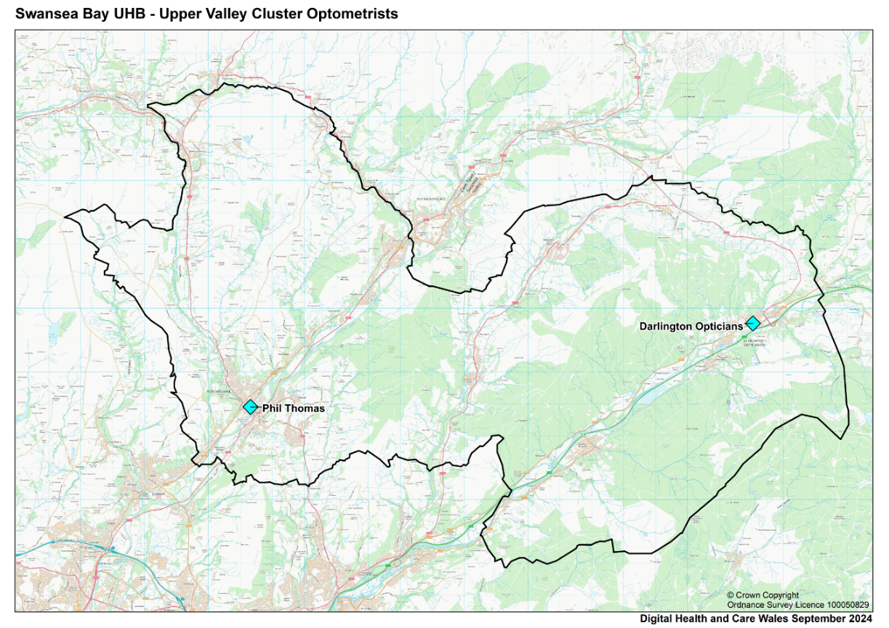

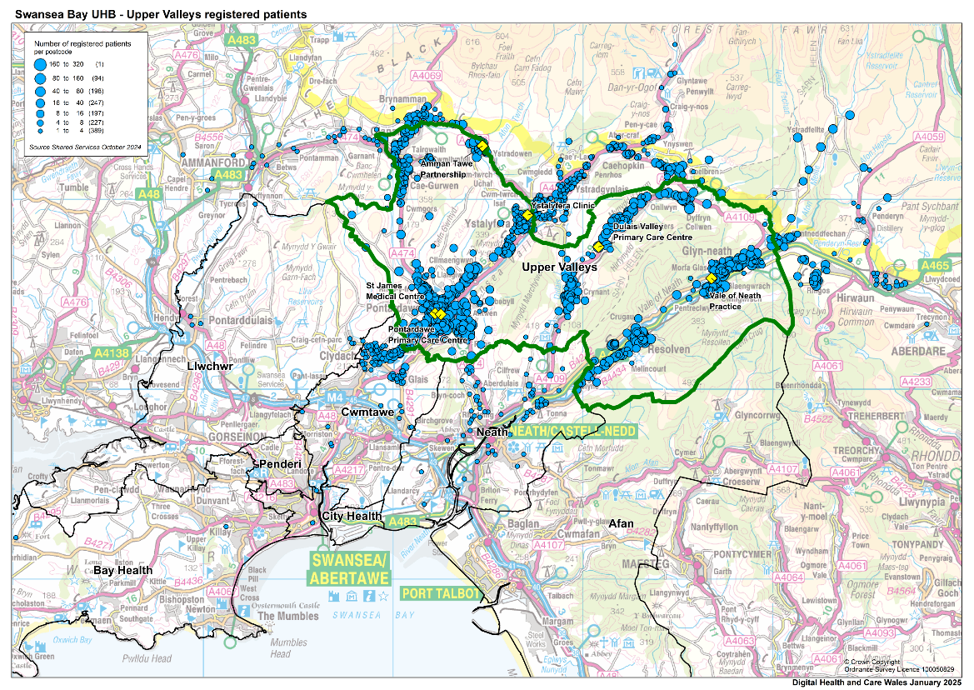

Upper Valleys Cluster percentage of population in age band
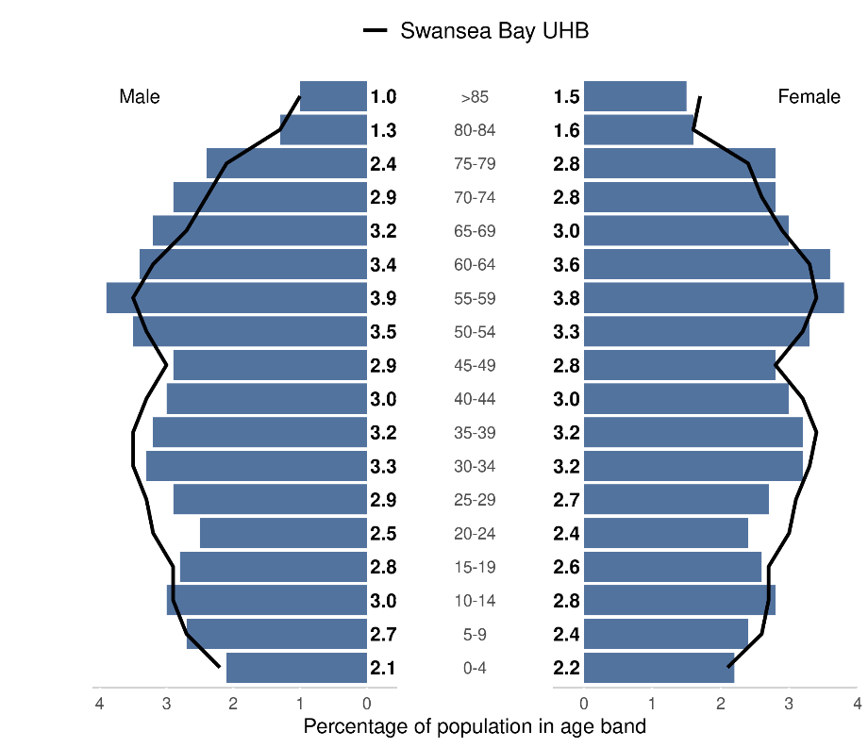
Source: Produced by Public Health Wales using Financial Practitioner Payment Scheme (FPPS) via DHCW (https://publichealthwales.shinyapps.io/PCC_Dashboard_Eng_Accessible/)

Welsh Index of Multiple deprivation: Of the 20% most deprived LSOAs in Wales, 14 are within Neath Port Talbot, with 3 found within the Upper Valleys Cluster (Source - https://www.swansea.gov.uk/wimd2019). 5.6%).of Upper Valley Cluster residents live in the most deprived 20% WIMD.

Upper Valleys Cluster Chronic Disease Prevalence % (1st April 2024)

Chronic Disease | Upper Valleys % | SBU Health Board % | Wales %
Diabetes mellitus (patients aged 17+) | 8.75 | 7.84 | 8.16
Stroke and transient ischaemic attack | 2.33 | 2.17 | 2.18
Source: Stats Wales
URL: https://statswales.gov.wales/Catalogue/Health-and-Social-Care/NHS-Primary-and-Community-Activity/GMS-Contract/diseaseregisters-by-localhealthboard-cluster-gppractice

Upper Valleys Cluster Screening Uptake % | Upper Valleys % | Wales %
Diabetic Eye Screening (2019/20) | 67.5 | 60.3
Source: Public Health Wales, Primary Care Clusters Dashboard
URL: https://phw.nhs.wales/services-and-teams/screening/

WGOS Service Provision:
The Optometric Practices and domiciliary providers (coloured in yellow) that deliver WGOS in Upper Valleys Cluster are set out in the table below:

Practice Name | WGOS 1 | WGOS 2 | WGOS 3 | WGOS 4  Med Ret | WGOS 4  Glaucoma | WGOS 5
Phil Thomas Opticians | Y | Y
Darlington Opticians | Y | Y
Opticall Healthcare (Neath) | Y | Y
Specsavers Home visits (Neath) (CATVOD LTD) | Y | Y | Y
@home Health Care (Neath) (JAMO group) |  |  | Y
OutsideClinic Services LTD (Neath) | Y | Y | Y
Specsavers Home Visits Gwent (Neath) | Y | Y

The opening times of each Optometric Practice and domiciliary providers, as stated in practice declarations, is set out in the table below:

Practice Name | Monday | Tuesday | Wednesday | Thursday | Friday | Saturday | Sunday
Phil Thomas Opticians | 09:00 – 15:00 | 09:00 – 17:00 | 09:00 – 17:00 | 09:00 – 17:00 | 09:00 – 17:00 | 09:00 – 12:00 | Closed
Darlington Opticians | 09:30 – 13:00  14:00 – 17:00 | 09:30 – 13:00  14:00 – 17:00 | 09:30 – 13:00  14:00 – 17:00 | 09:30 – 13:00  14:00 – 17:00 | Closed | Closed | Closed
Opticall Healthcare (Neath) | 09:00 – 17:00 | 09:00 – 17:00 | 09:00 – 17:00 | 09:00 – 17:00 | 09:00 – 17:00 | Closed | Closed
Specsavers Home visits (Neath) (CATVOD LTD) | 09:00 – 17:00 | 09:00 – 17:00 | 09:00 – 17:00 | 09:00 – 17:00 | 09:00 – 17:00 | Closed | Closed
@home Health Care (Neath) (JAMO group) | 09:00 – 17:00 | 09:00 – 17:00 | 09:00 – 17:00 | 09:00 – 17:00 | 09:00 – 17:00 | Closed | Closed
OutsideClinic Services LTD (Neath) | 09:00-17:30 | 09:00-17:30 | 09:00-17:30 | 09:00-17:30 | 09:00-17:30 | Closed | Closed
Specsavers Home Visits Gwent (Neath) | 09:00-16:00 | 09:00-16:00 | 09:00-16:00 | 09:00-16:00 | 09:00-16:00 | Closed | Closed
In 2023/24 and 2024-25 (year to date), Optometry activity in Upper Valleys Cluster included:
 | 2023/24  Number of appointments | 2024/25 Year to date (10 months)  Number of appointments
WGOS 1 | 1,841 | 1,527
WGOS 2 | 556 | 431

Conclusions
The Eye Health Needs Assessment (EHNA) has considered the current provision of optometric services across the Health Board and specifically the demography and health needs of the population.
The EHNA has highlighted strong levels of WGOS provision across City and Penderi Cluster. However, it has also identified gaps in WGOS provision within the Health Board area, requiring careful consideration of workforce capacity and training to ensure future provisions are bolstered.
The table below identifies gaps in service provision across SBU. Each ‘X’ marks an area where no service provision is available in respective cluster.
 | WGOS 3 | WGOS 4 Glaucoma | WGOS 4 Medical Retina | WGOS 5
Afan | X | X | X | X
Bay |  | X
City
Cwmtawe |  | X |  | X
Llwchwr
Neath |  |  |  | X
Penderi |  | X
Upper Valleys | X | X | X | X

Patients requiring Low Vision, Glaucoma or Medical Retina monitoring, as well as those needing prescriptions for eye health conditions, may need to travel outside of their local cluster area. This may pose challenges, particularly for individuals rely on public transport or have limited mobility.
In response to this the Health Board has designed a workforce development plan and survey which has been shared with our community optometrists. This survey aims to identify potential barriers faced, and assess the willingness of practitioners to undertake the additional training and qualifications required to provide specific elements of WGOS services. It is anticipated that the collated results will inform future workforce and capacity planning. A full review of domiciliary provisions will also be undertaken.
Future developments to support the expansion of an upskilled optometric workforce and consequently the provision of WGOS services, include the SBUHB Independent Prescribing Teach and Treat Centre which launched at Neath Port Talbot Hospital in March 2025.

References
1. The National Health Service (Wales) Act 2006 The National Health Service (Wales Eye Care Services) (Wales) (No. 2) Directions 2024 (Welsh Government) (2024).
2. ONS. Population estimates for the UK, England, Wales, Scotland and Northern Ireland: mid-2023. 2023.
3. Pezzullo L, Streatfeild J, Simkiss P, Shickle D. The economic impact of sight loss and blindness in the UK adult population. Bmc Health Services Research. Jan 2018;1863. doi:10.1186/s12913-018-2836-0
4. Walker ER, McGee RE, Druss BG. Mortality in mental disorders and global disease burden implications: a systematic review and meta-analysis. JAMA Psychiatry. Apr 2015;72(4):334-41. doi:10.1001/jamapsychiatry.2014.2502
5. West SK, Rubin GS, Broman AT, Munoz B, Bandeen-Roche K, Turano K. How does visual impairment affect performance on tasks of everyday life? The SEE Project. Salisbury Eye Evaluation. Arch Ophthalmol. Jun 2002;120(6):774-80. doi:10.1001/archopht.120.6.774
6. Lamoureux EL, Hassell JB, Keeffe JE. The determinants of participation in activities of daily living in people with impaired vision. Am J Ophthalmol. Feb 2004;137(2):265-70. doi:10.1016/j.ajo.2003.08.003
7. Ogedengbe TO, Sukhai M, Wittich W. Towards identifying gaps in employment integration of people living with vision impairment: A scoping review. Work. 2024;78(2):317-330. doi:10.3233/WOR-230018
8. Chai YX, Gan ATL, Fenwick EK, et al. Relationship between vision impairment and employment. Br J Ophthalmol. Mar 2023;107(3):361-366. doi:10.1136/bjophthalmol-2021-319655
9. Schakel W, van der Aa HPA, Bode C, Hulshof CTJ, van Rens G, van Nispen RMA. The Economic Burden of Visual Impairment and Comorbid Fatigue: A Cost-of-Illness Study (From a Societal Perspective). Investigative Ophthalmology & Visual Science. Apr 2018;59(5):1916-1923. doi:10.1167/iovs.17-23224
10. WG. National Clinical Strategy for Ophthalmology. NHS; 2024.
11. NWSSP. Values and Standards of Behaviour Framework. NWSSP. Accessed 26/12/2014, 2024. https://nwssp.nhs.wales/a-wp/governance-e-manual/living-public-service-values/values-and-standards-of-behaviour-framework/
12. WG. Well-being of Future Generations (Wales) Act 2015. Welsh Government; 2015.
13. WG. A Healthier Wales: our Plan for Health and Social Care. Welsh Government; 2021.
14. NHS Wales Eye Health Care Future Approach for Optometry Services (Welsh Government) (2021).
15. WG. Welsh Index Multiple Deprivation. WG. Accessed 25/11/24, 2024. https://statswales.gov.wales/Catalogue/Community-Safety-and-Social-Inclusion/Welsh-Index-of-Multiple-Deprivation

Appendices
Appendix 1 - RNIB

Swansea Bay University Health Board sight loss briefing
Source: RNIB Sight Loss Data Tool Version 5.2
Date created: March 2023
Geography level: Health Board

Headline summary

Local area stats
- Total population: 390,949
- Proportion aged 75: 9% - similar to the national average.
- Proportion that are from ethnic minority communities: 4.50% - similar to the national average.

Eye health stats for local Integrated Care System
- Total outpatient appointments: 30,771.
- Number of Certificates of Vision Impairment in 2019/20: 306.

Sight loss stats
- Number of people estimated to be living with sight loss: 13,470.
- 2032 projection for sight loss population: 15,340.
- Number of registered blind or partially sighted people: 2,317.

UK stats
- One in five people will start to live with sight loss in their lifetime.
- Every day 250 people start to lose their sight.

Contents
1. Introduction 2
2. General population 3
3. Eye health and social care landscape 6
4. Sight threatening eye conditions 10
5. People living with sight loss 12
6. Additional health problems and disabilities 16
Additional information 18
References 18

1. Introduction

Background
This report has been generated using RNIB’s Sight Loss Data Tool. It provides a range of indicators relevant to blind and partially sighted people and those at risk of sight loss in Swansea Bay University Health Board.

The aim of this report is to bring together relevant data at a local level to help supplement knowledge about the different factors that can influence provision on the ground. Much of the data in this report requires local interpretation.

Impact of sight loss
Around two million people live with sight loss in the UK today. And it can be tough. From difficulty accessing treatment and services, to a lack of emotional and practical support, blind and partially sighted people each face their own set of challenges every day.

RNIB’s vision is for a world where blind and partially sighted people participate equally and our purpose in helping to achieve that is to break down the barriers for people with sight loss.

Definitions
This report includes information about the general population, people with a potentially sight threatening eye condition or additional health problems linked to higher prevalence of sight loss, and also people living with sight loss.

The number of people living with sight loss has been taken from a systematic review of available evidence to help understand how commonly vision problems were occurring in the population. The basis for these estimates is the World Health Organisation’s definition of blindness and partial sight, which equates to the point at which someone should stop driving in the UK.

Further information
There is a comprehensive set of guidance notes to accompany this report. These notes provide further information on the data used, including notes on terminology and limitations. Further information can be found at www.rnib.org.uk/datatool.

Whilst every effort has been made to ensure the accuracy of the information in this report, sometimes mistakes do happen or information has changed. If you notice anything that doesn’t look right, please let us know.

If you have any questions, please contact us at research@rnib.org.uk.

2. General population
This section provides an overview of the general population in Swansea Bay University Health Board, including information on demographics and public health metrics that are linked to increased risk of sight loss.

Public attitudes have also been identified as a key barrier for blind and partially sighted people. The general public can have a key impact on independence and inclusion.
- 60 per cent of the UK population think that there is a lot or a fair amount of discrimination against blind and partially sighted people.
- More than one-third of blind and partially sighted people say that they sometimes or frequently experience negative attitudes from the general public because of their sight loss.
- People of working age are more likely to say that they have been treated unfairly because of their sight loss.
- Four out of every 10 blind and partially sighted people were not able to make all the journeys that they want or need to make.

2.1 Local area summary
Swansea Bay University Health Board covers the 2 local authorities of Swansea and Neath Port Talbot; and the Swansea Bay University Health Board.

2.2 Demographics
There are 390,949 people living in the Swansea Bay University Health Board. Of the total population:
- 19% are aged 17 or under.
- 61% are aged 18-64.
- 20% are aged over 65.

The older you are, the greater your risk of sight loss. The proportion of people aged 75 years and over in the Swansea Bay University Health Board is similar to the average for Wales - 9% of the population are aged 75 plus, compared to 10% in Wales.

Table: Population by age band
Age band | Population | Percentage
0-4 | 19,218 | 5%
5-17 | 55,712 | 14%
18-29 | 66,629 | 17%
30-49 | 94,670 | 24%
50-64 | 75,508 | 19%
65-74 | 42,713 | 11%
75-84 | 26,296 | 7%
85+ | 10,203 | 3%
Note: Percentages may not sum to 100 due to rounding.

2.3 Ethnicity
People from different ethnic communities are at greater risk of some of the leading causes of sight loss.

The proportion of people from minority ethnic groups is similar to the average for Wales, 4.50% of the population are from minority ethnic groups, compared to 4.30% across Wales.

Table: Total population by ethnicity
Ethnicity | Population | Percentage
White | 361,784 | 96%
Mixed ethnicity | 3,070 | 1%
Asian / Asian British | 6,840 | 2%
Black / Black British | 2,282 | 1%
Other ethnic groups | 4,859 | 1%
Note: Percentages may not sum to 100 due to rounding.

2.4 Impact of societal attitudes and inclusion
Public attitudes towards sight loss are rooted in stereotypes and a lack of knowledge about blindness and partial sight. The majority of the UK general population agrees that blind and partially sighted people are not treated the same as everyone else.

One of the main influences that drives greater feelings of positivity towards blind and partially sighted people is exposure. A greater familiarity results in more positive associations, a greater understanding as well as an increased sense of confidence in one’s ability to provide appropriate support.

Despite legislation that aims to protect the rights of blind and partially sighted people, the accessibility of products, information and services is still not an area where people with sight loss have equality of experience. Whether this is being able to independently read instructions on grocery packaging, being able to enjoy favourite TV shows with audio description or getting information from health services in accessible formats, blind and partially sighted people experience a significant information and inclusion gap because of their vision impairment.

Transport systems, pavements and built environments are often not designed to be fully inclusive of people with a vision impairment. People with sight loss are unable to drive so, for journeys that cannot be made by walking, rely on public transport, taxis and lifts from friends or relatives. Navigating streets, public spaces and buildings can be a challenge for people with sight loss, particularly if the environment is unfamiliar, changeable or not designed in an accessible way.

3. Eye health and social care landscape
This section provides an overview of eye health and social care landscape from the perspective of pre-hospital, in hospital, and post-hospital services in Swansea Bay University Health Board.

In the future we plan to develop and expand this section to be more focused on patient experiences, but currently the data (where is exists) is more focused on service outputs.

No one should experience sight loss without the appropriate support. Despite advancements in clinical treatments over the last decade, less attention has been paid to the patient pathway as a whole, from pre- to post-diagnosis, and the support mechanisms within this. As a result, many individuals find themselves ill equipped to live with their sight loss and the increased risk of poor wellbeing, low confidence and the impact this has on daily life.
- Only 17 per cent of people experiencing sight loss were offered emotional support in relation to their deteriorating vision.
- People with sight loss were more than twice as likely to have experienced difficulties with unhappiness or depression than the UK average.
- More than 40 per cent of blind and partially sighted people feel moderately or completely cut off from the people and things around them.

3.1 Pre-hospital

Eye tests
In Swansea Bay University Health Board there were 27,225 NHS-funded eye tests carried out in 2018/19. This is a rate of 20,600 per 100,000 people.

Diabetic eye screening
Across Wales, 136,088 eligible patients were invited for diabetic eye screening in 2019/20, this was 60% of the total number of eligible patients. A total of 110,087 attended their screening appointment, a take up rate of 81%.

Performance of local Diabetic Eye Screening Programmes can vary considerably. Local screening data can be accessed on the Public Health Wales website Diabetic Eye Screening pages.

3.2 In hospital
Information in this section has been provided at NHS Health Board level.

Outpatient appointments
The attendance rate for ophthalmology outpatient appointments in 2019/20 was 7,871 per 100,000 people.

In the most recent year, 2020/21, a total of 30,771 attendances were recorded. Note: attendance figures for 2020/21 are typically lower than previous years due to the pandemic – we will add some more trend data in a future update.

Inpatient procedures
Some eye conditions, such as lens removal for cataract or laser treatment for diabetic retinopathy, require a patient to have a surgical procedure.

Broad local inpatient data was not available at the time this report was created. However, cataract admissions data is available. There were 985 admissions for cataract procedures in 2019/20.

Waiting times
Since the pandemic, the backlog in patients requiring eye care has resulted in an increase to appointment waiting times with more urgent cases are prioritised.

Since 2018 eye care in Wales has taken a risk-based approach by introducing Eye Care Measures which assign patients a Health Risk Factor (HRF) based on the severity of their condition and also a target date which they need to be treated by, in order to reduce the risk of irreversible sight loss.

Performance data for eye care attendances are monitored monthly. Numbers waiting within target date or within 25% beyond target date at the end of each month are recorded for the priority at risk groups. If then target data is missed, patients are at risk of irreversible harm or significant patient adverse outcome.

In the Swansea Bay University Health Board, as of November 2024, 78,272 out of 160,389 patient pathways assessed as Health Risk Factor R1 were waiting more than 25% beyond target for an outpatient appointment.

Eye Care Liaison Officers
Eye Care Liaison Officers or ECLOs, providing a sight loss advice service, are based within eye clinics or hospitals. They play an important role in helping patients recently diagnosed with an eye condition or who are experiences changes in their vision to understand the impact of their diagnosis and provide patients with emotional and practical support.

ECLO support is not available in every NHS Trust or Health Board in the UK. RNIB has collected information about where support is available. This only includes qualified ECLOs, trained by RNIB, and there may be other support services available locally.

All NHS Boards in Wales have access to ECLO services.

3.3 Post hospital

Vision rehabilitation
See “Appendix 1: Vision rehabilitation services in Swansea Bay UHB area”.

Voluntary sector
See “Appendix 2: Third sector support available in Swansea Bay UHB area”.

The Wales Council for the Blind provide an information portal focused on services available in Wales. Please visit the Perspectif search tool http://wcb-ccd.org.uk/perspectif for more details.

The Sightline Directory also provides more information on services aimed at helping blind and partially sighted people, providing information on both national and local services. Please visit www.sightlinedirectory.org.uk for more details.

3.4 Impact of the lack of essential support and poor wellbeing
Being told you are losing your sight can be difficult to come to terms with, with common effects being depression and reduced wellbeing. But many people do not receive essential support in relation to their sight loss.

Having to re-learn how to do everyday things is the reality of losing your sight. This can include everything from re-learning how to make a cup of tea to moving safely around your local area. But provision of specialist rehabilitation services varies across the country, and most people do not receive practical support with mobility or practical tasks such as preparing food.

Overall, feelings of wellbeing are lower among blind and partially sighted people compared to the UK average. This includes feelings of unhappiness or depression, worthlessness and lack of confidence.

Blind and partially sighted people can feel cut off from the people and things around them. This is compounded by inaccessible information, difficulty with everyday tasks such as shopping for groceries and problems navigating pavements or using public transport.

4. Sight threatening eye conditions
The figures presented in this section highlight estimates for all people living with certain eye conditions in the Swansea Bay University Health Board.

This includes people who have experienced sight loss as a result of these eye conditions, people who have been diagnosed but have not experienced any sight loss yet, and also those people who are undiagnosed.

If you need more information about specific eye conditions, or eye health basics, RNIB’s website has a comprehensive range of Eye Health information.

4.1 Age-related macular degeneration (AMD)
AMD causes changes to the macula, which leads to problems with your central vision. Your central vision is the vision you use when you’re looking straight at something, for example when you’re reading or watching television.

AMD is the leading cause of blindness and severe sight loss in the UK. There are two main types:
- Wet AMD can develop quickly affecting central vision in a short period of time. Early identification and treatment of wet AMD is vital. Treatment can halt the further development of scarring but lost sight cannot be restored.
- Dry AMD can develop slowly and take a long time to progress. There is currently no treatment for dry AMD. People with early and moderate stages of dry AMD are not eligible for registration, but it does have an impact upon daily life, for example a person may have to stop driving.

In the Swansea Bay University Health Board, we estimate that:
- 18,250 people are living with the early stages of AMD;
- 1,390 are living with late-stage dry AMD;
- 2,830 are living with late-stage wet AMD.
- 4,000 combined late-stage AMD.

Between 2022 and 2032 there is estimated to be an increase of 18% in the number of people living with late-stage AMD.

4.2 Cataract
Cataract is a common eye condition that is prevalent in older people. The lens becomes less transparent and turns misty or cloudy. Cataracts often get worse over time and the impact upon vision may be difficult to notice. The usual treatment is an operation to replace the lens with an artificial one.

In the Swansea Bay University Health Board, we estimate that 4,420 people are living with cataract.

Between 2022 and 2032 there is estimated to be an increase of 18% in the number of people living with cataract.

4.3 Glaucoma
This is a group of eye conditions in which the optic nerve can be damaged due to changes in eye pressure. Damage to sight
can usually be minimised by early diagnosis in conjunction with careful regular observation and treatment. Many glaucoma patients will attend regular appointments and take eye drops for the rest of their lives to prevent deterioration of vision. Some forms of glaucoma can be treated with laser surgery and surgery.

In the Swansea Bay University Health Board, we estimate that 8,060 people are living with ocular hypertension. A further 4,330 people are living with glaucoma.

Between 2022 and 2032 there is estimated to be an increase of 12% in the number of people living with glaucoma.

4.4 Diabetic eye disease
People with diabetes are at risk of diabetic eye disease, which can affect the blood vessels in the eye. This can lead to permanent sight loss. Screening and early diagnosis with appropriate intervention is essential.

In the Swansea Bay University Health Board, we estimate that:
- 25,700 adults have diagnosed diabetes.
- 7,890 people are living with diabetic retinopathy.
- Of these, 730 have severe diabetic retinopathy, a later stage of the disease that is likely to result in significant and potentially certifiable sight loss.

Between 2022 and 2032 there is estimated to be an increase of 3% in the number of people living with diabetic retinopathy.

5. People living with sight loss
This section provides an overview of the number of people impacted by sight loss in Swansea Bay University Health Board and the impact that this has on their daily life.
- Only one in four registered blind and partially sighted people of working age is in employment.
- Half of blind and partially sighted people are always or frequently limited in the activities that they would like to take part in.
- 36% of blind and partially sighted people never use the internet or don’t have access to it. This is significantly higher than the UK average of 10%.

5.1 UK overview
More than two million people are estimated to be living with sight loss in the UK today. This sight loss is severe enough to have a significant impact on their daily lives. This figure includes:
- people who are registered blind or partially sighted;
- people whose vision is better than the levels that qualify for registration, but that still has a significant impact on their daily life (for example, not being able to drive);
- people who are awaiting or having treatment such as eye injections or surgery that may improve their sight;
- people whose sight loss could be improved by wearing correctly prescribed glasses or contact lenses.

The main causes of sight loss are:
- Uncorrected refracted error – 39 per cent
- AMD – 23 per cent
- Cataract – 19 per cent
- Glaucoma – 7 per cent
- Diabetic eye disease – 5 per cent

5.2 Swansea Bay University Health Board
In the Swansea Bay University Health Board there are an estimated 13,470 people living with sight loss. This includes around:
- 8,660 people living with mild sight loss.
- 3,010 people living with moderate sight loss
- 1,800 people living with severe sight loss.

Note: these figures include people whose vision is better than the levels that qualify for registration, but that still has a significant impact on their daily life (for example, not being able to drive).

The estimated prevalence of sight loss in the Swansea Bay University Health Board is 3.40% which is lower the average for Wales of 3.8%. This estimate is based on age and gender. A range of other factors could potentially impact on the prevalence of sight loss in the local area including higher proportions of people from ethnic minority communities, the number of people in low-income households and access to healthcare services.

Age profile
In terms of the age profile of the people living with sight loss in the Swansea Bay University Health Board, we estimate that:
- 140 are aged 0 to 17 years
- 2,460 are aged 18 to 64 years
- 2,700 are aged 65 to 74 years
- 3,970 are aged 75 to 84 years
- 4,210 are aged 85 years and over

*Figures may not sum due to rounding and different prevalence estimates for vision impairment in children.

Future projections
By 2032 there are expected to be 15,340 people in the Swansea Bay University Health Board living with sight loss, an estimated increase of 14% over the next decade.

Table: Estimated prevalence of sight loss over time, by severity
Severity of sight loss | 2022 | 2032
Mild sight loss | 8,660 | 9,850
Moderate sight loss | 3,010 | 3,410
Severe sight loss | 1,800 | 2,090
Total | 13,470 | 15,340

5.3 Certification of Vision Impairment
Each CVI form is signed by a consultant ophthalmologist in an eye clinic and a copy is sent to the person's local adult social care service. Upon receipt of the CVI, the adult social care service should offer registration and other relevant advice and services.

Welsh Government is currently exploring proposals for qualified primary care optometrists based in community practices to issue a CVI to individuals with dry AMD, as part of Optometry Contract Reform.

Number of CVIs
In 2019/20, 306 Certificates of Vision Impairment were issued in Swansea Bay University Health Board.

5.4 Registration
Upon receipt of a completed CVI form, the adult social care service should offer registration as blind or partially sighted and other relevant advice and support. Registers of blind and partially sighted people should be maintained by all local authorities to help them plan and deliver services.

In the Swansea Bay University Health Board, there are 2,317 people registered as blind or partially sighted. Roughly half are registered as blind and half as partially sighted.

Table: Registered blind or partially sighted by age band
Age band | Registered blind | Registered partially slighted | Total
0-17 | 24 | 35 | 59
18-64 | 330 | 292 | 622
65+ | 823 | 813 | 1,636
Total | 1,177 | 1,140 | 2,317

Rate of registration
In the Swansea Bay University Health Board there are 594 registered blind or partially sighted people per 100,000 population. This compares to an overall rate of 417 for Wales.

Note on registration data
Registration data is submitted by local authorities to the Welsh Government. Sometimes there can be data quality issues or data can be missing. If you have any questions regarding the accuracy of these numbers, contact the relevant local authority with responsibility for holding the register.

5.5 Impact of sight loss
The majority of visually impaired children are educated in inclusive (mainstream) education, but many children are being deprived of specialist support due to variation in service provision, and learning materials and exams are not consistently made available in alternative formats. This results in lower educational attainment compared to children without a special educational need. Around half of children with a vision impairment will have additional disabilities and additional special educational needs.

People with sight loss have a lower employment rate compared to the UK average. The majority of blind and partially sighted say that they feel that their sight loss has stopped them reaching their full potential at work.

Many blind and partially sighted people have reduced opportunities to do the things they would like to take part in. This includes general leisure pursuits, and things like sports and fitness, civic and cultural engagement and access to volunteering opportunities.

We know that technology is a key enabler for people to feel more connected and more independent. But there is a significant generational divide in its use. Younger blind and partially sighted people are much more likely to be using the internet, a computer or a smartphone compared to older people.

6. Additional health problems and disabilities
Many blind and partially sighted people are also living with other health problems or disabilities. Sight loss is linked to age, and as we get older we are more likely to be living with many health conditions at the same time.

6.1 Stroke
Around 60% of people who experience strokes will also experience some form of visual impairment immediately after their stroke. There are national guidelines recommending specialist vision assessment for stroke survivors who have a suspected visual problem.

In the area we estimate that 2,090 people have a long-standing health condition after experiencing a stroke.

6.2 Dementia
Prevalence estimates suggest that over 1 million people in the UK have some form of dementia. Prevalence of sight loss is higher among people with dementia, especially those living in care homes.

In the Swansea Bay University Health Board we estimate that 6660 people are living with dementia. Within this group it is estimated that 2360 people have dementia and vision impairment.

6.3 Learning disabilities
People with learning disabilities are 10 times more likely to experience sight loss than the general population.

In the Swansea Bay University Health Board we estimate that 490 adults have a learning disability and partial sight. A further 140 adults have a learning disability and blindness.

6.4 Hearing impairment
In the Swansea Bay University Health Board we estimate that 43,500 people have a moderate or severe hearing impairment, and 960 people have a profound hearing impairment.

6.5 Dual sensory loss
An estimated 2,550 people are living with some degree of dual sensory loss in the Swansea Bay University Health Board. Of these people, it is estimated that 1,000 are living with severe dual sensory loss.

6.6 Falls
Falls are more common, and are more likely to have serious outcomes, amongst older people. In some cases, falls can lead to serious medical problems and a range of adverse outcomes for health and wellbeing.

In the Swansea Bay University Health Board we estimated that:
- 1,710 people with sight loss aged over 65 experience a fall per year.
- Of these falls, 800 are directly attributable to sight loss.
- 135 people aged over 65 with sight loss experience a severe fall per year (here, a severe fall is defined as a fall that results in hospital admission through A&E).
- Of these severe falls, 65 are directly attributable to sight loss.

Additional information
RNIB is a leading source of information on sight loss and the issues affecting blind and partially sighted people.

Our Research and Knowledge Hub contains key information and statistics about blind and partially sighted people including our Sight Loss Data Tool, which provides information about sight loss at a local level throughout the UK. You’ll also find research reports on a range of topics including employment, education, technology, accessibility and more.

Visit our Knowledge and Research Hub at: www.rnib.org.uk/research.

References
This section provides a brief overview of the sources of evidence used in this report.

There is a separate, more comprehensive, set of guidance notes also available to accompany this report. These guidance notes provide further information on the data and evidence sources, including full references, notes on terminology and limitations. Further information can be found at www.rnib.org.uk/datatool.

Further information on the impact of sight loss can be found in RNIB’s Key statistics about sight loss.

General population
Demographic data come from the most recent estimates and projections available from the relevant national statistics agency.

Public health, socio-economic and labour market data also come from the most recent national statistics.

Some benchmarking is available in the original source material, but where this isn’t published we have developed our own benchmarking tool in order to provide these insights. Further details can be found in the SLDT guidance notes.

Eye health and social care landscape
As health and social care is devolved across the four UK nations, the range of sources in this section varies considerably depending on the geography of the report.

The latest publications available from the relevant health bodies covering primary and secondary care have been used.

Further details on the indicators and sources used in this section by UK nation can be found in the SLDT guidance notes.

Sight threatening eye conditions
Most of the prevalence estimates for sight threatening eye conditions come from the National Eye Health Epidemiological Model. The base prevalence rates are then applied to the most recent estimates and projections available from the relevant national statistics agency

People living with sight loss
Prevalence estimates for the number of people living with sight loss come from the Deloitte Access Economics report The economic impact of sight loss and blindness in the UK adult population. The base prevalence rates are then applied to the most recent estimates and projections available from the relevant national statistics agency.

Certification of Vision Impairment and registration data come from the most recent publication in each nation.

Additional health problems and disabilities
We have combined the latest underlying prevalence estimates for stroke, dementia. learning disabilities, hearing impairment, dual sensory loss and falls, with population estimates from the relevant national statistics agency.

