# New Picture

# Annual

# Equality Report

# 2018/2019

**Contents**

|  |  |  |
| --- | --- | --- |
| **Introduction** | | **1** |
| **Background** | | **1** |
| **Looking back over the last year:** | | **2** |
|  | * **Equality Objective 1 - Reduce health inequalities** | **2** |
|  | * **Equality Objective 2 - Accessible advice and information** | **4** |
|  | * **Equality Objective 3 - Communicate according to individual needs** | **5** |
|  | * **Equality Objective 4 - Mental wellbeing** | **6** |
|  | * **Equality Objective 5 - Mental health services for children and young people** | **8** |
|  | * **Equality Objective 6 - Staff wellbeing and experience** | **9** |
|  | * **Equality Objective 7 - Pay differences** | **14** |
|  | **Looking forward to the next year** | **16** |

**Introduction**

This Annual Equality Report describes what we did to progress equality across the Health Board during 2018/2019. Equality is about making sure people are treated fairly and given fair chances. It is not about treating everyone the same, but seeing people as individuals and being sensitive, thoughtful and flexible about how to meet the needs of each person.

The report is not designed to cover everything but is an overview highlighting some of our key work. It should be read alongside our Annual Report 2018/2019, Annual Quality Statement and Accountability Report 2018/2019.

**Background**

The Equality Act 2010 is about treating everyone in a fair way. This law protects people from being treating less favourably than other people because they are:

* men and women
* disabled people
* young people and older people
* people from different races – who may speak another language
* people who follow a religion or who have no religious beliefs
* people who are gay, lesbian or bisexual
* people who are considering, undergoing or have undergone gender reassignment
* people who are in a civil partnership or married
* women who are pregnant or have recently had a baby.

We have to tell you how we collect and use information to ensure that we are treating people fairly. It is important that our services are meeting the needs of all groups of people who we serve and we treat people fairly at work.

**Looking back over the last year:**

**Taking forward our Equality Objectives**

We have a plan of the work to help ensure that everyone is treated fairly. This is known as our Strategic Equality Plan. Equality objectives are set out within our plan to support the delivery of our strategic aims.

We want to be always improving and review progress every year against our equality objectives. Our Annual Report describes our work towards implementing the objectives during 2018/2019. This includes highlighting achievements and identifying areas where further work needs to be done.

**Equality Objective 1**

**Reduce health inequalities through ensuring access to services for people according to their individual needs**

Our Annual Quality Statement looks back over 2018/2019 at ABMU’s work programmes to promote good health. This includes:

* the uptake of the flu vaccination
* raising awareness of the importance of nutrition and hydration for patients while they are in hospital
* the education programme for children and young people diagnosed with Diabetes
* the promotion of World Mental Health Day and World Suicide Prevention Day.

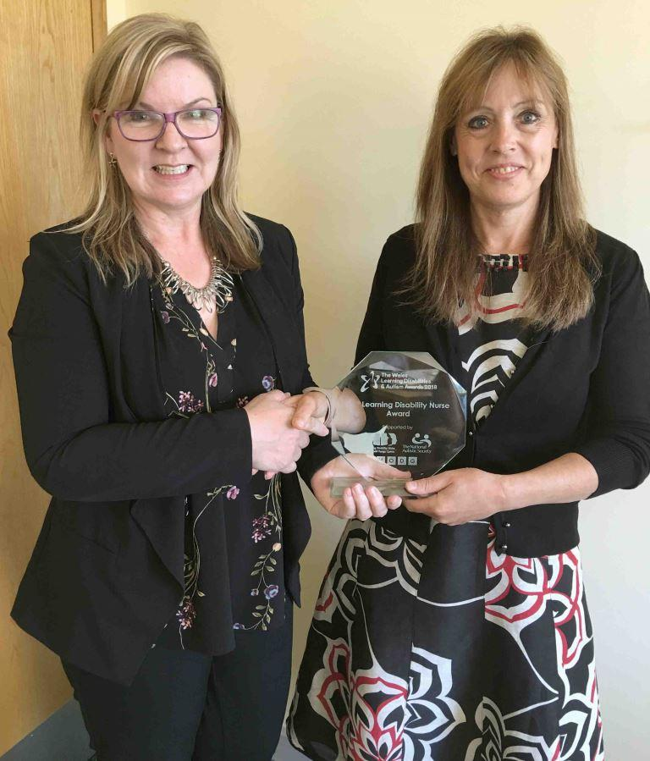Three of our nurses were nominated at the inaugural Learning Disability and Autism Awards held in Cardiff on 28 September 2018. All three were nominated for the learning disability nurse award which was won by Denise Bromfield. Denise began her career in Learning Disabilities 38 years ago. Her continued dedication and commitment is second to none. She currently manages the Acute Admissions Unit in Hafod y Wennol.

**Denise Bromfield (right) pictured with**

**Unit Nurse Director Hazel Powell**

In her Acute Liaison Nurse role, Joanne Edwards has developed a comprehensive hospital based Learning Disability Champion initiative. The ward champions have gained confidence in supporting people with learning disabilities. This has increased the confidence of ward staff as they know there is someone at ward level to support and advise them.

The role of the Learning Disability Acute Liaison Nurse is to support hospital staff in the provision of effective person centred care and treatment of people with learning disabilities. Claire Jenkins has worked in partnership with the family carers to deliver a set of training sessions. The carers have increased confidence in their ability and knowledge.

**Equality Objective 2**

**Provide accessible advice and information to enable people to understand and make informed choices**

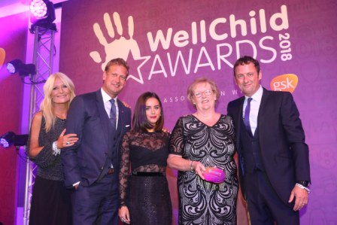A paediatric nurse was named a winner at the 2018 WellChild Awards in London.

Geraldine Phillips was chosen from hundreds of nominations across the UK as the Most Inspirational Nurse.

**Geraldine collecting her award in London**

Geraldine has worked as a paediatric diabetes specialist nurse within the department of child health at Morriston Hospital for more than two decades. Geraldine began in post as a single-handed nurse covering a large clinic population. She quickly helped establish a support group for families, including organising and participating in an annual activities weekend at an outdoor pursuits centre.

The residential weekend is an innovative service in Wales that helps children meet other young people with diabetes, learn new skills and develop confidence and independence.

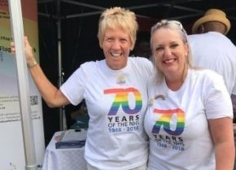The Wales Fertility Institute worked on the Pride Cymru stall to promote awareness of IVF services to the LGBT+ community. This was an important message to get across on the year marking the 40th anniversary of the first baby born through IVF.

**Equality Objective 3**

**Communicate with patients, families and carers according to their individual needs**

The Health Board recognises the importance of patients, service users and families being able to receive safe and responsive quality services in a language of their choice.

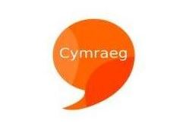Attention has largely been focused on the new Welsh Language Standards during 2018 as described in our 2018/2019 Annual Report. An action plan has been produced to facilitate delivery and compliance with the standards.

The Health Board has continued to improve its existing offer as demonstrated by the achievements below:

* ABMUHB ensure that Welsh language considerations are included in the commissioning and contracting of services;
* The language preferences of all inpatients is collected on admission;
* Whilst the staff handbook has always included a section on the Welsh language, it was reviewed in 2018/2019 to reflect the importance of language awareness.

We have a Group overseeing the implementation of the All Wales Standards for Communication and Information for People with Sensory Loss across the Health Board. The Standards set out the level of service delivery that people with sensory loss should expect when they access healthcare.

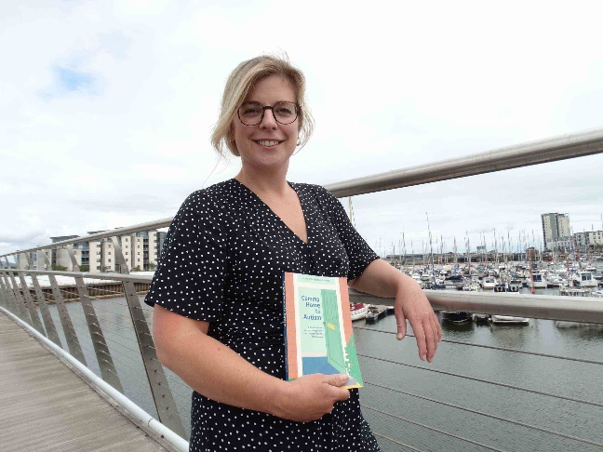A speech and language therapist from Swansea has teamed up with a mum to offer advice and coping strategies based on their years of first-hand experience. The book called ‘Coming Home to Autism’ provides a down-to-earth guide for parents who need support to communicate with their child and help them take part in and complete the daily tasks most people take for granted. Rhian Grounds, pictured above, explained that ‘A lot of books were from a professional or parental approach, we wanted both voices to offer practical advice.’

**Equality Objective 4**

**Work with partners to promote mental wellbeing and improve access to mental health services for people who are most in need of support**

The Strategic Framework for Adult Mental Health was developed with stakeholders and service users. During 2018, the Strategic Framework has been further revised to include the findings of a report commissioned by Western Bay on unmet mental health needs in our area.

The Strategic Framework gives a clear direction for enhancing the services available across health and social care in order to meet the needs of a wide range of individuals. The new model of care will provide a range of services available to everyone experiencing mental health problems regardless of the severity. The aim is prevention and earlier intervention.

The new model should help stop problems occurring or getting worse and provide earlier support for people whose mental health is deteriorating. This will include options to help people be confident to deal with problems themselves as much as possible and more complex interventions and approaches reserved for addressing more complex needs.

Staff from mental health and learning disability services worked together to help promote World Suicide Prevention Day. Inspirational messages were collected from staff, visitors and people who use mental health and learning disabilities services. These messages were anonymised, presented on heart shapes and hung on three decorative trees placed in Ward F, Neath Port Talbot Hospital, Coity Clinic, Princess of Wales Hospital and Cefn Coed Education Centre. Staff at Coity Clinic organised a sponsored 24 hour static cycle challenge to mark the day. The challenge raised £1,200 which was donated to Hafal, Wales’ leading charity for people with serious mental illness and their carers.

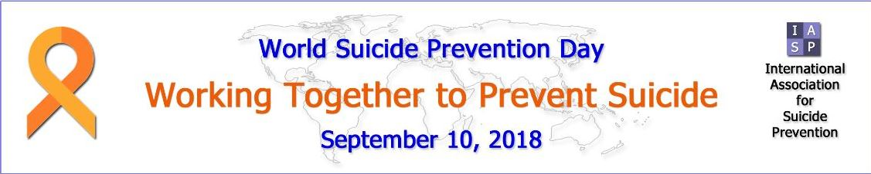

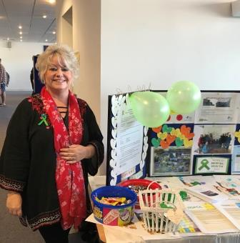To mark World Mental Health Day on 10 October 2018, ABMU organised a special public event at the Grand Theatre in Swansea. It focused on the World Federation for Mental Health’s 2018 awareness day theme of young people and Mental Health in a changing world. This was developed to reflect the increased amount of time young people spend on the internet and the rise of cyber-crimes, cyber-bullying and violent online games. A variety of guest speakers addressed themes such as the eating disorders service, substance misuse and cyber bullying.

Forty stallholders from across a wide range of organisations were at the event to provide information and support to more than 300 people.

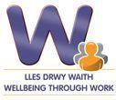The Health Board has been successful in securing an extension of funding to deliver the Welsh Government/ESF ‘In Work Support Service’ until December 2022. The service is open to anyone who is struggling in work or on sickness absence due to mild or moderate mental health issues – such as stress, anxiety or low mood. The initiative provides rapid access to a team of locally-based NHS occupational therapists, who specialise in emotional health issues, and physiotherapists. They provide tailored support to help people manage their health condition in work, or to successfully return to work. The confidential service is open to people who are employed or self-employed, and live or work in the Bridgend, Neath Port Talbot or Swansea areas.

**Equality Objective 5**

**Work in partnership to improve emotional and mental health services for children and young people**

Our Annual Report 2018/2019 explains that Child and Adolescent Mental Health Services (CAMHS) for the population of Bridgend, Neath Port Talbot and Swansea are provided by Cwm Taf University Health Board. The CAMHS provision has traditionally suffered from significant waiting time and variation challenges. This is in part because the service is relatively small so where there is staff absence for any reason there is disproportionate impact.

The existing service is split between Primary CAMHS (P_CAMHS) and Secondary CAMHS (S-CAMHS). The P_CAMHS sees patients with lower acuity needs. The S-CAMHS sees and treats patients with more complex and persistent mental health disorders.

ABM UHB (now Swansea Bay University Health Board) is working with Cwm Taf University Health Board to develop an integrated service model with a single team working across the whole of Swansea and Neath Port Talbot area. The integrated service will provide a single point of referral to all primary and secondary CAMHS. This approach is strongly supported by GPs and Local Authorities.

Some, but not all, of the benefit of integration includes a larger, more resilient team working across the whole Health Board area, reduced variation in service and shorter waiting times.

Our Annual Report 2018/2019 explains how the Health Board measures CAMHS performance against local targets. In all but one of the six areas of measurement, the organisation is improving its performance demonstrating that the service is improving. For the first time ever, during February 2019, ABMUHB achieved the target of 80% of S-CAMHS patients being assessed within 28 days.

**Equality Objective 6**

**Improve the wellbeing and experience of our staff**

Staff wellbeing was a continued priority over the past year with a focus on early intervention to increase resilience and emotional health. The Wellbeing Champions network has been developed and expanded. Over 340 Wellbeing Champions are now trained across the Health Board to signpost colleagues to staff support services. They are supporting our approach to early intervention and raising awareness of national health promotion campaigns.

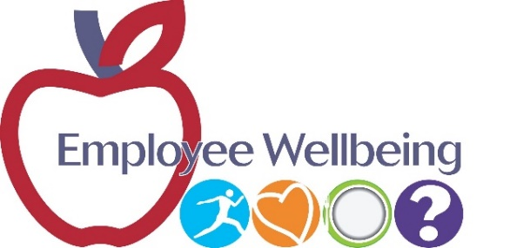The new Staff Wellbeing Service launched in June 2018 providing early intervention for staff support with over 900 referrals in the first 10 months. Waiting lists reduced for the initial contact for mental health support from 6 weeks to 7 days. The service is 2018/2010 Bevan Commission Exemplar.

‘Mindful Menopause’ workshops for staff were rolled out across the Health Board with 60 staff attending todate. 267 managers have attended the Work Related Stress Workshops equipping themselves with the tools to manage employee stress at work. 209 managers have attended the Mental Health Awareness Workshops to recognise and manage mental health conditions in the workplace.

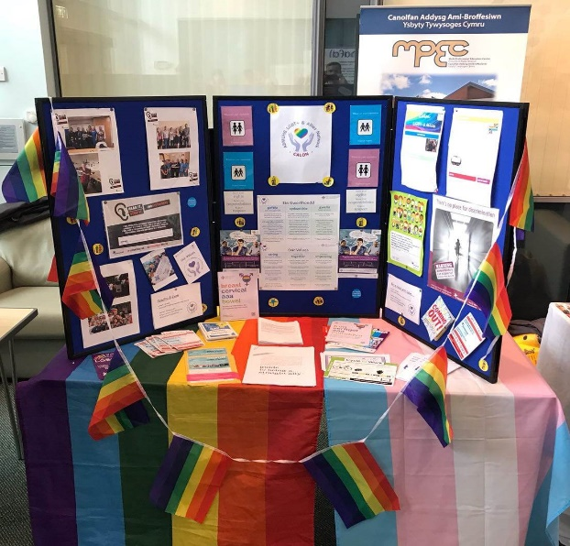A successful ‘Wellbeing Week’ was held across the Health Board in September 2018 promoting internal and local services that support staff health and wellbeing.

A large number of staff attended, including 450 who booked on special wellbeing-related sessions held at the four main hospital sites. The sessions were aimed at promoting physical and emotional health including topics such as mindfulness, meditation, menopause and positive psychology.

We have continued to embed the ‘Living our Values’ programme through celebration of the inspirational work of many staff and volunteers across the Health Board. This included the ABMU Long Service Awards programme, the Patient Choice Awards, the Volunteer celebration event and the celebrations to mark the 70th birthday of the NHS. The ABMU Chairman’s Values into Practice (VIP) Awards coincided with the 70th anniversary of the NHS.

|  |
| --- |
| http://abm.cymru.nhs.uk/imagebase/13776-EID.JPG |

Muslim staff hosted the Eid ul-Fitr celebration in the Multi-Faith Centre at Morriston Hospital on 26 June 2018. This free event was open to staff and friends from the wider community with food and drink provided. It was organised by the hospital’s Muslim Chaplain and Muslim staff. The event celebrated the end of Ramandam and helped people learn and understand Islam.

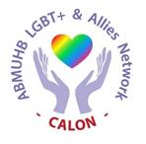ABMU’s Lesbian, Gay, Bi and Trans (LGBT+) & Allies Staff Network, Calon, is going from strength to strength with an increased profile. The network provides networking opportunities and peer support between staff. It is open to LGBT+ employees and allies. Calon’s membership is continually increasing and new members are always welcome. Just drop an e-mail to [Calon.LGBTStaffNetwork@wales.nhs.uk](mailto:Calon.LGBTStaffNetwork@wales.nhs.uk) if you want to find out more.

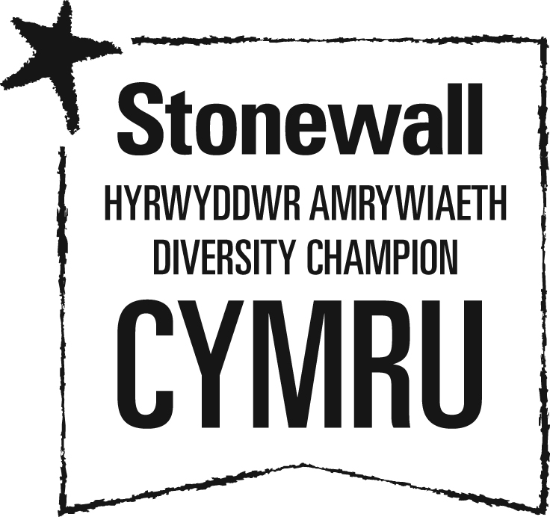

ABMU is a proud member of Stonewall Cymru’s Diversity Champions Programme. Stonewall is Europe’s largest lesbian, gay, bi and trans (LGBT) charity. Diversity Champions is the leading employers’ programme for ensuring all LGBT staff are accepted without exception.

We were one of the 445 organisations that took part in Stonewall’s Workplace Equality Index (WEI) 2019. This is a bench marking tool for employers to measure their progress on lesbian, gay, bi and trans inclusion in the workplace. ABMU moved up 4 places in the Stonewall WEI to be ranked number 150 in 2019.

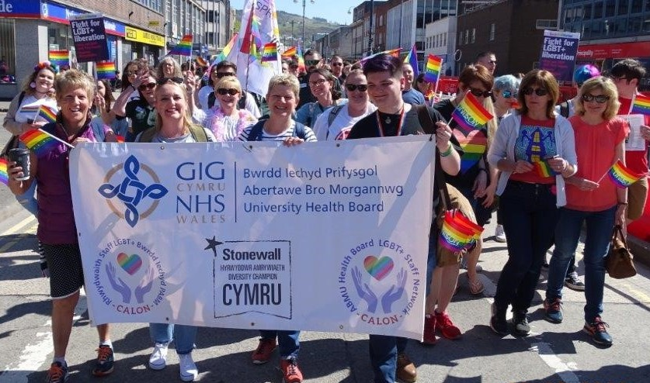

Emma Walters, Calon Co-Founder, and Tracy Myhill, Chief Executive, lead ABMU staff in the parade

Calon Members were proud to come together with local businesses and organisations and show their solidarity with all members of the LGBT+ community at Swansea Spring Pride on 5 May 2018. They gathered with family, friends and colleagues in Castle Square and joined the parade through the city centre to Swansea Waterfront Museum.

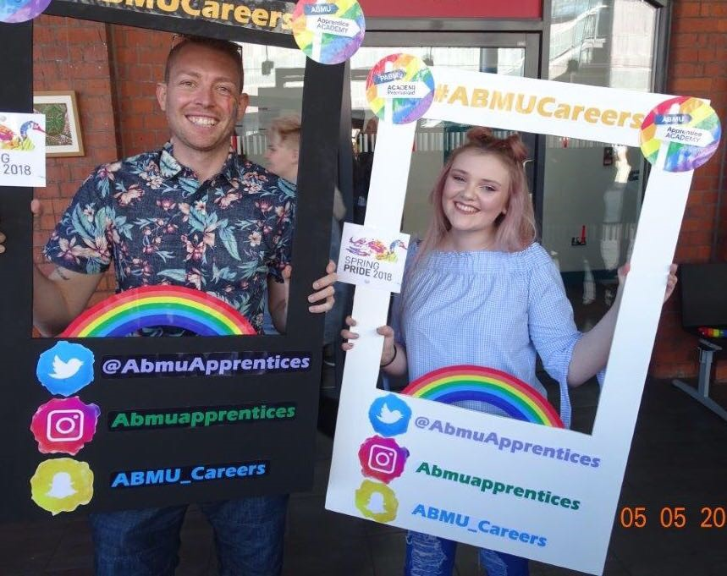There were stalls, information and entertainment at the Museum. Staff from Calon, the Apprentice Academy, and the Strategy Team supported the ABMU stalls. They engaged with the public gathering feedback around the experience of service users and speaking to those interested in applying to work or volunteer at ABMU.

Mitchell Jones and Giorgia-May Towns at the Museum

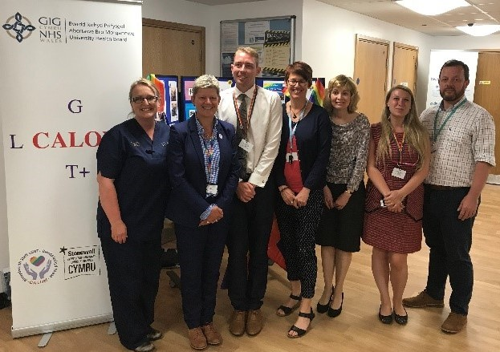A special event gave staff the chance to hear inspirational stories from Tracy Myhill and members of Calon, ABMU’s LGBT+ and Allies Staff Network. The event took place on Monday, 4 June 2018. It gave an opportunity for Tracy and Calon Members to share personal stories about their lives.

Tracy Myhill, Chief Executive, with Calon Members

Calon hosted an event on 6 September 2018 at Neath Port Talbot Hospital to discuss why allies, friends and champions are important to LGBT+ employees in the workplace. The speakers talked about what it means to be an ally and shared their personal stories of being an ally as a colleague, friend and health professional. They offered practical ways to step up as an ally and help create an inclusive working environment for everyone.

Calon, ABMU’s LGBT+ & Allies Network joined around 50,000 people at the annual Pride Cymru Big Weekend in Cardiff to celebrate equality and diversity. Calon was proud to march with NHS Wales colleagues, friends and family and enjoy the carnival atmosphere of the parade. This year, NHS Wales pulled out all the stops to celebrate the 70th Anniversary of the NHS with a bed push and a choreographed dance through the streets of Cardiff. Thousands of people took to the streets along the route of the colourful parade.

After the parade, Calon joined NHS colleagues at the Pride Cymru event in the Civic Centre where they supported the health information stand. People were encouraged to visit the stand to describe their experiences of using NHS services in Wales. They told stories of good care as well as how services could be improved.

**Equality Objective 7**

**Develop a fuller understanding of the reasons for any pay differences**

We have produced pay reports and these are available on our website.

We recognise that there is more work to be done to analyse pay differences. This includes improving the collection of equality data for staff and raising awareness of the reasons why the information is collected. We will be researching the best practice work of other organisations to learn how improvements can be made to the workforce and pay data analysis.

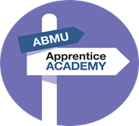

Our Apprenticeship Academy grows from strength to strength with 185 apprentices enrolled to date on level 2, 3, 4 programmes. Approximately ¾ of all apprentices secure substantive employment with the Health Board following their apprenticeship programme. A further 450 staff are currently enrolled on apprenticeship frameworks.

The Apprenticeship Academy promote apprenticeships and NHS careers at job fairs, careers and community events to encourage people from diverse backgrounds to apply to work for us. This included the Swansea Pride on 5 May 2018 and the Neath Port Talbot BAME event on 2 August 2018. We monitor the protected characteristics of people through the recruitment process.

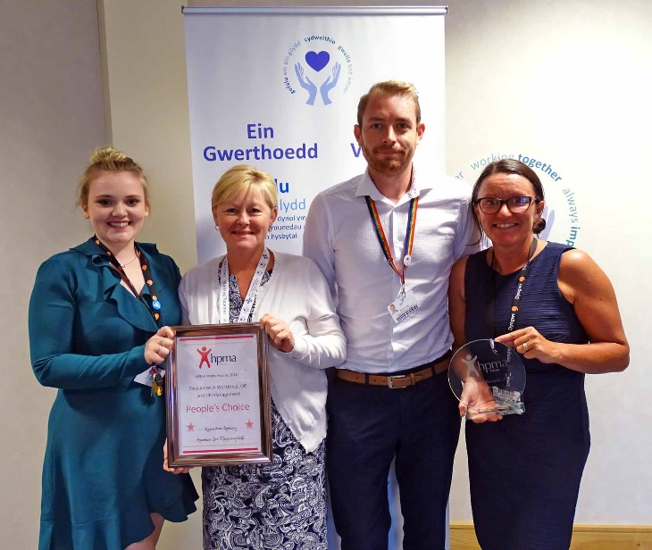ABMU Apprentice Academy received the People’s Choice Award for Excellence in Workforce, OD (Organisational Development) and HR (Human Resources) at the HPMA (Healthcare People Management Association) Wales Awards 2018.

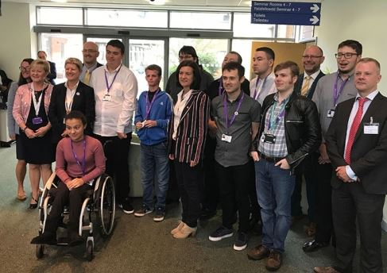We launched Project SEARCH with Bridgend College and Elite Supported Employment Agency on 13 September 2018. This enabled nine young people with additional learning needs and disabilities to secure a supported internship at the Princess of Wales Hospital.

Through our Vocational Training Team, we offer a range of work-based training opportunities for unemployed people. These include Employability Skills Programme for adults and Engagement programmes for 16 – 19 year olds.

Junior doctors arranged a practical leadership skills event at Morriston Hospital on 19 April 2018. The event included talks and workshops to help women develop their skills in daily practice giving them useful hints and tips. The event received very positive feedback.

**Looking forward to the next year**

Our Strategic Equality Plan is published on our website. The objectives help us to continue to make equality and diversity an integral part of all our work and focus on the areas of inequality. We will be tackling the inequalities through actions to take forward our equality objectives.

Over the next year, we will be engaging and consulting on what should be our equality objectives for 2020-2024. We will have the health board’s full backing going forward as they are committed to ensuring that we continue to shape the future of equality and human rights within the Health Board.