Swansea Bay
University Health Board
Annual Equality Report 2024 – 25



Introduction
Swansea Bay University Health Board (SBUHB) is committed to advancing equality, diversity, inclusion and human rights in everything we do, as both a provider of health services and a major employer within the Swansea Bay region. This Annual Equality Report outlines our progress during 2024–25 in delivering our equality objectives.

Our equality work is shaped by the Health Board’s wider ambition to reduce health inequalities, improve population health outcomes, and ensure that people can access services and information in ways that meet their individual needs. This report should be read alongside the Health Board’s Annual Report and Accounts 2024–25, which provides broader organisational context and performance information.

During 2024–25, we have continued to prioritise two core equality objectives: reducing health inequalities across our population, and communicating in ways that are inclusive, accessible and responsive to individual need. Progress against our wider equality objectives is set out later in this report.

This report is an overview highlighting some of our key work and should be read alongside our Annual Report 2024/25. sbuhb.nhs.wales/about-us/swansea-bay-uhb/our-board-business/board-meetings-and-papers/board-november-2025/7-3ii-sbu-annual-report-and-accounts-2024-25/

Background
About Swansea Bay University Health Board
Swansea Bay University Health Board plans, commissions and delivers healthcare services for the populations of Swansea and Neath Port Talbot, serving around 390,000 people. We employ over 14,000 staff and deliver services across acute, community, primary care, mental health and learning disability settings, as well as hosting several specialist and all-Wales services.
Our values underpin all that we do and guide how we work with patients, communities, partners and staff.
- Caring for each other
In every human contact, in all our communities and in each of our hospitals.
- Working together
As patients, families, carers, staff and communities – always putting patients first.
- Always improving
So that we are at our best for every patient and for each other.

Equality, dignity, compassion and respect are fundamental to delivering high-quality, person-centred care.

Our Population
The Swansea Bay area is diverse, with significant variation in health outcomes linked to deprivation, disability, age, ethnicity, and other social determinants of health. Levels of child poverty, long-term unemployment, unhealthy behaviours and unequal life expectancy continue to present challenges. These inequalities shape our approach to service planning and delivery and reinforce the importance of targeted, preventative, and inclusive action.
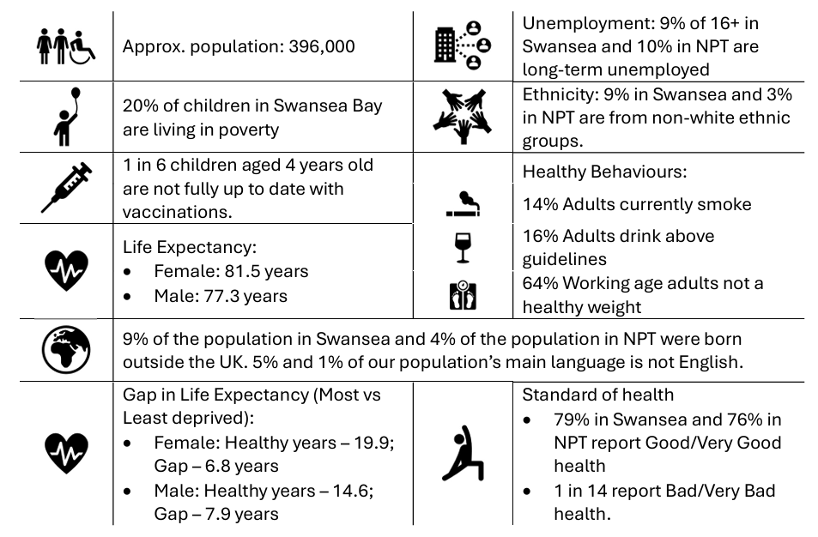
The Health Board has responsibility for assessing the health needs of our population to inform commissioning, planning and delivery of healthcare for those people we serve, while recognising the responsibility for improving the health and wellbeing of our diverse communities. As an anchor organisation, part of the broader social, economic, environmental and health economy in the region we have a role in addressing and responding to the wider determinants of health that impact on the health and lives of people in our communities.

Our workforce
Our workforce is one of our greatest assets, and as a Health Board we have a diverse workforce. There is more to do to ensure that our workforce reflects the diversity of our local communities and to ensure everyone feels valued, safe and able to thrive at work.
Much of our workforce live in our area, and their families and friends are patients and service users of the services we provide. We work closely with our partners in Swansea University and local colleges to train the next generation as well as a contributing to finding solutions to the healthcare challenges we face.
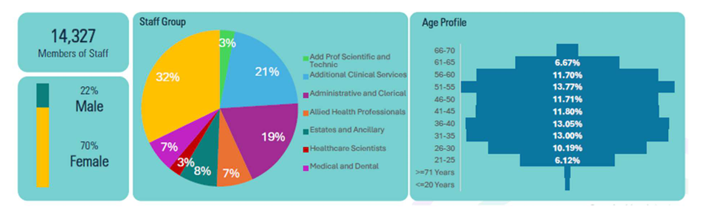
Service Delivery
The Health Board has responsibility for assessing, commissioning, planning and delivering the health needs of our population in collaboration with Swansea and Neath Port Talbot Local Authorities. This joint responsibility extends to improving the health and wellbeing of our diverse communities. As an anchor institution, we have a role in addressing and responding to the broader social, economic, environmental and health economy in the Swansea Bay region where we can look to address the wider determinants of health that impact on the lives and health of people in our communities.
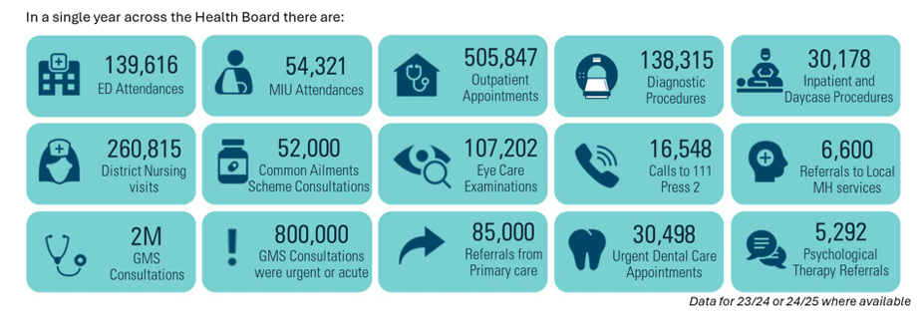
The Health Board provides a range of specialist and tertiary services including Major Trauma and Spinal Networks, Emergency Medical Retrieval Service (EMRTS) for partner HBs in Wales. The Burns and Plastics Service delivered from Morriston Hospital goes further covering the breadth as far as South-West England. Regional working with Hywel Dda University Health Board, and the establishment of the Joint Commissioning Committee provides us with the opportunity to plan and deliver services together for a total population of nearly 1 million people.

Legal and Strategic Context
The Public Sector Equality Duty, means public bodies must have due regard to the need to
- Eliminate discrimination, harassment and victimisation
This includes conduct that is prohibited under the Equality Act 2010.
- Advance equality of opportunity between people who share a protected characteristic and those who do not
This involves:
- Removing or minimising disadvantages
- Taking steps to meet different needs
- Encouraging participation where it is disproportionately low
- Foster good relations between people who share a protected characteristic and those who do not. This includes tackling prejudice and promoting understanding.
We must tell people how we collect and use information to ensure that we are treating people fairly. It is important that our services are meeting the needs of all groups of people who we serve and we treat people fairly at work
The Equality Act 2010 which is the main piece of UK legislation that protects people from discrimination, harassment and victimisation in work and in the delivery of services. It brought together and replaced previous equality laws into a single Act, creating a consistent legal framework across Great Britain.
For NHS bodies, the Act applies both:
- as an employer, and
- as a provider and commissioner of health services.
The Act protects people who share one or more of the following nine protected characteristics:
- Age
- Disability
- Gender reassignment
- Marriage and civil partnership
- Pregnancy and maternity
- Race
- Religion or belief
- Sex
- Sexual orientation
The Anti‑Racist Wales Action Plan (ARWAP) is a Welsh Government plan first published in June 2022, setting out a national commitment to make Wales an anti‑racist nation by 2030. It is based on the explicit recognition that institutional and structural racism exists and that incremental or “colour‑blind” approaches are insufficient. A refreshed version of the plan was published in November 2024, following review and feedback on early implementation. The update strengthens leadership expectations, clarifies delivery responsibilities, and places greater emphasis on measurable impact rather than activity alone
The Workforce Race Equality Standard for Wales (WRES) is a national, data‑driven framework introduced by Welsh Government and NHS Wales to identify, measure and address racial inequality in the health and social care workforce. This is embedded into NHS Wales accountability and governance arrangements.
Our equality work aligns with wider acts including the Well-being of Future Generations (Wales) Act 2015.

3. Looking back over the last year – taking forward our equality objectives
The Health Board is one of the largest public bodies in the UK responsible for population health as well as for delivering health services. The Board makes major decisions every year, both around shaping the future and on how to spend a significant amount of public money-£1.741bn in 2024/25.
There are many achievements, across the breadth of services and we appreciate our staff across the organisation who have worked so hard to deliver those achievements.
We acknowledge the challenges that we faced last year, we spent some considerable time focussing on services where we know we need to do better, for patients, service users and their families, and for staff who have found themselves working in pressurised environments. Maternity and Neonatal services, Mental Health and Learning Disability services and Unscheduled Care have all been important items on the Board agenda.
As Board members, we apologise to patients, service users and their families for whom our services were not as they should be and give you our commitment to continue working our hardest to secure continuous improvements.
Our Equality Objectives Our Strategic Equality Plan 2020 – 2024 sets out our equality objectives to support the delivery of our strategic aims. We want to be always improving, and review progress every year against our equality objectives. Our Annual Report describes our work towards implementing the objectives during 2024/2025. This includes highlighting achievements and identifying areas where further work needs to be done.

3.1 Equality Objective 1:
Reduce Health Inequalities
Reducing health inequalities means tackling the unfair and avoidable differences in health outcomes, access to services, and experiences of care that exist between different groups of people and communities. It is important to acknowledge that
not everyone starts from the same place, and some people will need more tailored support to achieve the same health outcomes.
To tackle health inequalities, action is needed around:
- Targeting resources where need is greatest
- Designing services around people’s lived experience
- Removing structural and systemic barriers to access
- Improving outcomes for groups who experience poorer health
Examples of services and programmes of work supporting the achievement of this objective include:
The Diabetes prevention programme targets people who are pre-diabetic, or at high risk of becoming diabetic to support people make the necessary lifestyle changes to avoid developing the disease. Approx 3,400 people had an initial appointment with the imitative following a GP referral and a year later 30% were no longer prediabetic.
Waiting Well is a national initiative supporting patients to better manage their symptoms whilst waiting in secondary care by promoting healthy lifestyles, preventing deterioration and preparing patients for their treatment or surgery. It offers a holistic approach providing tailored advice, self-management resources and signposting to community-based services
We have been Improving access to healthcare for people who are homeless through a partnership approach where a dedicated nurse led service works with The Wallich to provide a service for the Neath Port Talbot area. The team supports vulnerable people to access GP services, dentists, smoking cessation and sexual health services among others. This is part of the wider work by the primary care clusters to develop primary care health inclusion services that are designed and adapted for those most in need.
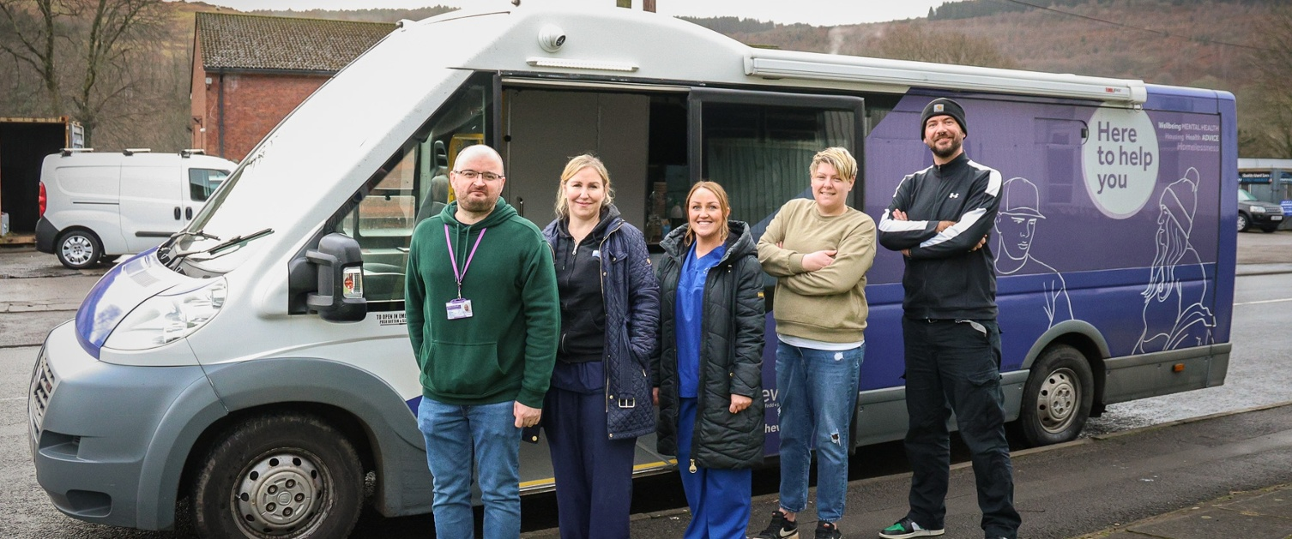
The Health Board had a centralised dialysis service, with patients travelling long distances multiple times a week to receive life-sustaining treatment. Recognising the need for a more patient-centred approach, strategic partnerships were formed to expand and improve service delivery. This included collaboration with Fresenius Medical Care, a global leader in renal services. This partnership has enabled development of independent satellite dialysis units in areas including Bridgend, with a planned expansion to Neath Port Talbot. These satellite units allow care closer to home, significantly improving patient experience by reducing travel times and improving accessibility.
The Penderi Local Cluster Collaborative has worked with Your Voice Advocacy, which provides support to people with learning disabilities across Swansea and Neath Port Talbot and other community organisations to host a free wellbeing event to promote annual health checks for people with learning disabilities. Annual health checks play a crucial role in identifying and addressing health issues early, ensuring that individuals receive the support and treatment they need. These checks help to detect a range of health conditions as well as providing an opportunity to review medications, discuss lifestyle factors, and support carers in managing overall health and wellbeing.
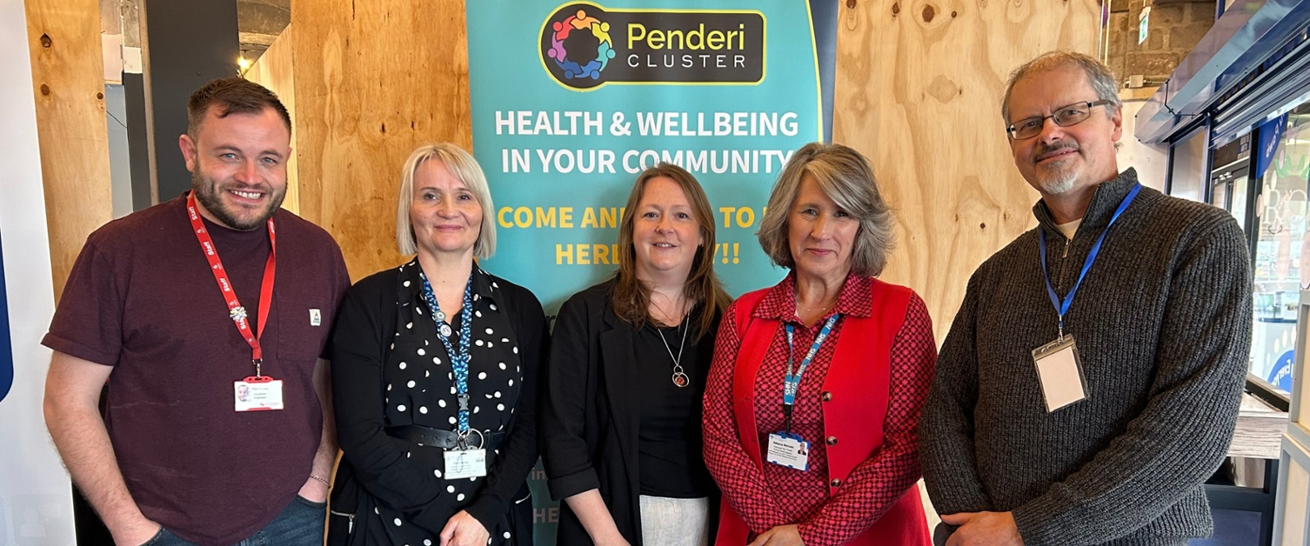
The Persistent Pain Service has worked with some of Swansea Bay’s Local Cluster Collaboratives to provide education sessions in the community, avoiding a long wait. Previously, the pain service would have offered one-to-one sessions to patients where they could learn about pain management and the support available to them, these new group sessions allow more patients to be seen in a timelier manner, closer to home.
The Health Board commissions a Diverse Outreach Team, where officers are based at Neath Port Talbot Council for Voluntary Services and Swansea Council for Voluntary Services build trusted relationships with individuals, communities and organisations. This provides the opportunity to share appropriate messaging around vaccinations, screening programmes, specific health conditions advice and prevention information on conditions including stroke, diabetes, cancer and improvement messaging in safe environments such as Chai and Chat sessions. Integral to this work is the capacity building element where advice guidance and support is provided to enable people to build confidence and access education, volunteering opportunities and employment. Some members have / are training as Mental Health Facilitators or Education Programmes for Patients Facilitators.
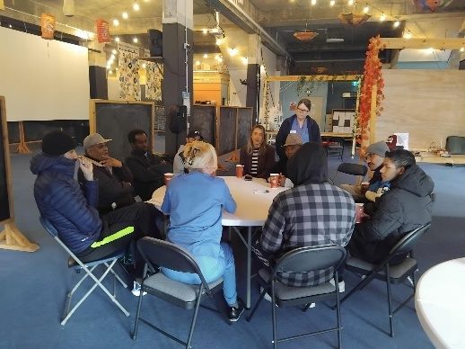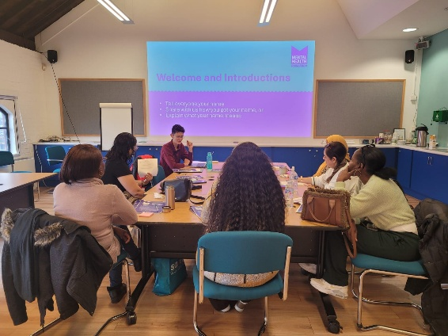
A new screening project has been helping to identify and support people at risk of developing diabetes. Over the last year staff from the City Health Local Cluster Collaborative have been working closely with Swansea Mosque to help identify people who are either pre-diabetic or have undiagnosed diabetes. Swansea Mosque is one of the largest in the UK with around 10,000 members and worked with team to deliver screening days to bridge health inequalities.
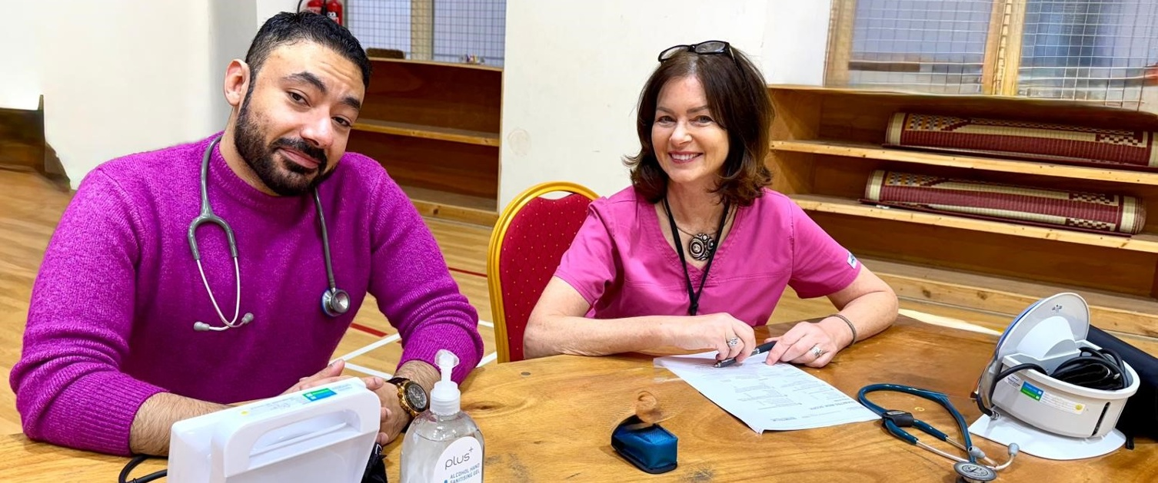
Sexual health testing in the community - Sexual health and blood borne virus testing kits are available in community pharmacies, making it easier for people to get tested. Two types of free test kits are available, with or without blood testing facilities, for those aged 16 and over. Under 16s can see their school nurse or visit the sexual health clinic. The packs offer testing for chlamydia, gonorrhoea, HIV, syphilis, hepatitis B and hepatitis C and people can choose which tests they wish to do. The tests can be done privately in the comfort of their own home, before being posted for free so it can be analysed.
Neath Port Talbot Children’s Centre has been collaborating with the local authority to help school children navigate their educational experiences, improving experiences for young people.

  - Equality Objective 2:
Communicate According to Individual Need
As a Health Board we recognise the importance of patients, service users and families being able to receive services in the language of their choice.
As a Health Board, the vital part that the Welsh language and culture has to play in the provision of health and social care services to our resident population is recognised. Many people choose to receive services in Welsh because that is what they prefer. For others, however, it is more than a matter of choice – it is a matter of need. It is especially important for many vulnerable people and their families who need to access services in their first language, such as older people with dementia or stroke who may lose their second language and children who speak only Welsh. In addition, when discussing mental health, being able to communicate in your first language to express feelings, thoughts and emotions is important. The annual report for our Welsh language service is now available on our website.
In recognition of the link between language and high-quality care, we have developed a five-year plan to increase access to clinical consultations through the Welsh language. This work is being commenced within the priority areas in the More Than Just Words framework, namely Stroke, Care of the Elderly, Speech and Language Therapy, Children’s Services and Mental Health Services. Successes within these areas will then be spread to other areas.
The Swansea Bay Patient Portal (powered by Patients Know Best) helps patients better manage their overall care and be more in control. Patients can receive information regarding blood tests, clinical document and appointments to their phone, tablet or PC. This is part of the hybrid mail service meaning registered patients receive their digital letter, with a hard copy posted only if the electronic version isn’t opened and read within 48 hours. Patients who don’t register will continue to receive paper copy letters.
In June 2025 a new Children’s Therapy Sensory Room at Neath Port Talbot Children’s Centre was opened providing support for children and young people with additional needs across the Swansea Bay area. The Sensory Room has made a difference, providing a calming, interactive environment for therapy and development and is a safe space where children can play, process emotions, and build confidence through sensory exploration.
Staff have been completing the Paul Ridd Learning Disability Awareness Training. One of the issues identified in his death was a communications breakdown which meant his clinical needs were not being properly met before his death. Paul’s family actively supported the development of awareness training for all staff caring for patients with a learning disability in all wards and services.
Deconditioning is a risk for all hospital patients, especially those who are older.
It can lead to longer hospital stays and to patients needing additional support to leave hospital. Encouraging patients to move around more while in hospital is key. The communications team worked with the occupational therapy team to design a leaflet/poster specifically for the carers and family members of older patients which sets out in brief and clear terms why mobility and patients getting to dress every day is important. Families and carers were asked to ensure patients had daytime clothes, their glasses, dentures and hearing aid.

The Diverse Outreach Team works in the community, building trusted relationships with individuals, communities and organisations. This provides the opportunity to tailor and share accessible, appropriate information with members of diverse communities.
The Team works with communities and services to tailor messaging around vaccinations, screening programmes, specific health conditions advice and prevention information on conditions including stroke, diabetes, cancer and improvement messaging in ‘safe’ environments where people feel comfortable and confident such as Chai and Chat sessions. Integral to this work is the capacity building element where advice guidance and support is provided to enable people to build confidence and access education, volunteering opportunities and employment. Some members have / are training as Mental Health Facilitators or Education Programmes for Patients Facilitators.
We have been working with LGBTQ+ communities to understand the issues they are facing and identify priorities for action; these have included the importance of appropriate and sensitive communication.
  - Equality Objective 3
Emotional and Mental Wellbeing
A focus on emotional and mental wellbeing is important as it underpins how people feel, cope and function in everyday life and has a significant influence on resilience, relationships, learning, work and overall health. When emotional wellbeing is supported, people are better able to manage stress and change, regulate emotions, make decisions and cope with challenges before they escalate into crisis. It is closely linked to physical health outcomes, recovery and self‑management, and plays a key role in preventing anxiety, burnout and longer‑term mental health problems. Prioritising emotional and mental wellbeing supports performance, inclusion and positive relationships, reduces harm and inequality.
The modernisation of services across both Mental Health and Learning Disabilities has been an important priority for 2024-25, with ongoing reviews of our current processes and pathways including outpatients, CDAT, and inpatient models. The Service Group has worked closely with NHS Executive to review services and work commenced on a specific Mental Health and Learning Disabilities Service Group transformation programme. Short term plans to improve the inpatient estates have been developed whilst interim and long-term plans are being developed to address the inadequate inpatient provision for adult mental health treatment.
A new initiative, Messages of Hope has bene launched by a former patient. People are invited to compose hopeful messages, or videos, for those struggling with their mental health at a challenging time in their lives. Messages are shared with the patients who arrive at hospitals for psychiatric-related admission. Some patients might not have family support, or people might be reluctant to visit psychiatric wards, so a supportive message, even from someone they don’t know, can give them a lift and offer them some hope. This is supplemented by a community interest company provides gift bags, Bags of Hope for patients, which contain items such as books, toiletries, feminine hygiene products, socks and pants, phone chargers, puzzles and snacks.
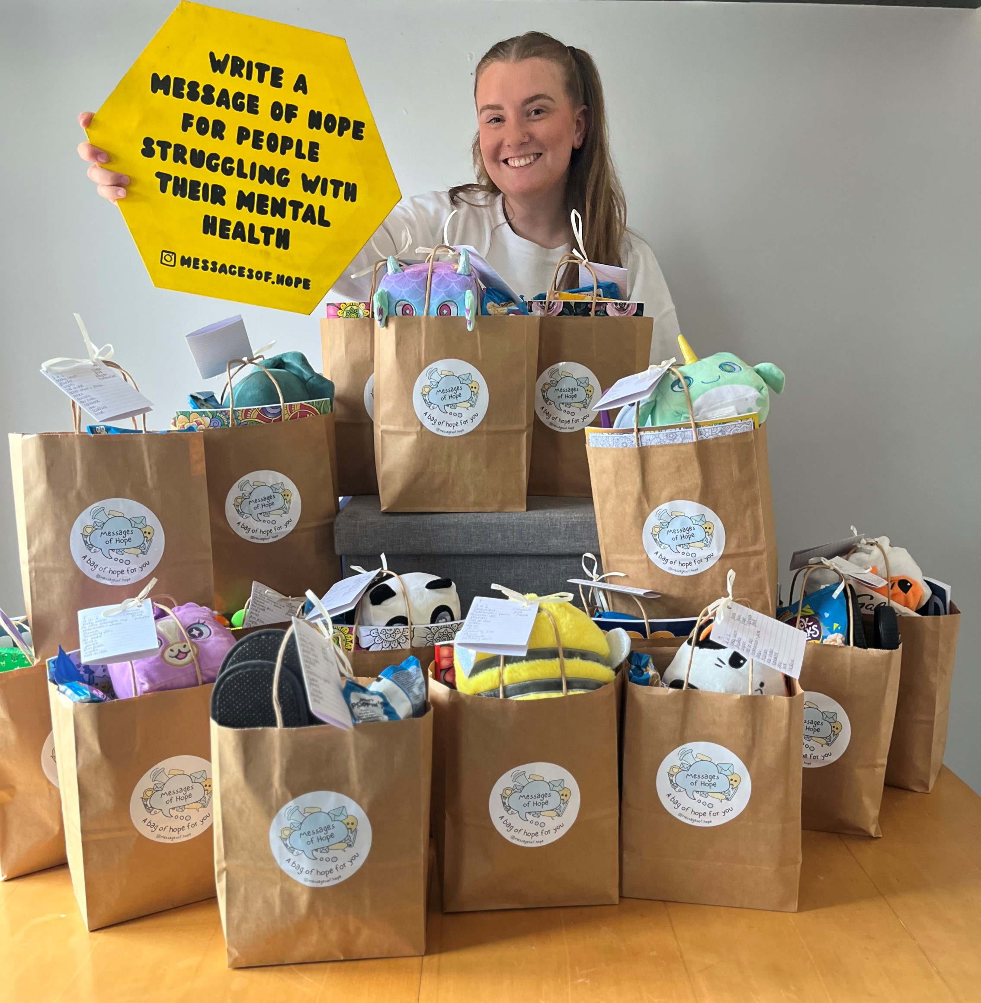

The Gwelfor Occupational Therapy Team have established a litter picking group in mental health rehabilitation services to promoted patients’ wellbeing. The team have been working with the Environment Centre to take patients into green spaces to undertake regular litter picks. This helps patients engage in therapeutic activity, develop social networks and a greater understanding of the environment. Engaging in meaningful activities improves recovery times, reducing hospital stays while providing physical benefits for patients.
The Neath Port Talbot Sanctuary Service, which is an extension of the current service provided in Swansea and is located at The Forge Centre, Port Talbot. The service is for anyone who is suffering a mental health crisis. There does not have to be a mental health diagnosis, just a situational crisis they are experiencing such as finance, loneliness, relationship breakdown. People can come for an informal chat and be signposted to further help and support as appropriate
At a Cluster level, we have seen a range of local projects with Wellbeing Events for our public being delivered, all eight Clusters supporting the domestic violence agenda with better identification and pathways into appropriate support. There has been development of a bespoke dental antimicrobial prescribing guidance and a continued focus on improving the mental health of our population. There are Cluster specific projects in all eight clusters, including the NHS Award winning Cwmtawe Mental Health model.
The Dementia and Carer Project supports people living with dementia and their carers. It is run in partnership with Swansea Council for Voluntary Service (SCVS) and the health board’s Swansea-based Local Cluster Collaboratives. The project provides people living with dementia, and their carers, an opportunity to engage in the community and access community resources. It also helps reduce isolation for carers by providing a safe space for them to talk about their experiences.
Some pregnant women were struggling with overwhelming emotions, low mood and anxiety when going through this big change in their lives, A Pregnancy Wellbeing Clinic was established to address this gap. The service has helped reduce anxiety and stress by introducing learning and coping techniques and support for mums-to-be has been established.
Our Arts in Health team have supported a range of exciting projects, improving the experience of patients, staff and communities. This includes providing regular music events in Neath Port Talbot Hospital to reduce boredom amongst patients, improve their wellbeing, which makes a positive difference to their outcomes.
  - Equality Objective 4
Mental Health Services for Children and Young People
Mental Health Services for children and young people in Wales are delivered through a tiered system, with CAMHS providing specialist NHS support up to age 18 for moderate to severe mental health needs.

In Swansea Bay University Health Board, this is complemented by a Single Point of Access, school in‑reach, community‑based services, crisis teams and non‑clinical sanctuaries, alongside a wider range of child and family psychology support. National evidence highlights the importance of early intervention, school and community support, and partnership working, to ensure children and young people receive timely, accessible help before needs escalate.

Child and Adolescent Mental Health Services (CAMHS) have returned to Swansea Bay this year, with performance against the national targets steadily improving. Working with Neath Port Talbot Local Authority, we provide an In-reach CAMHS service into the Young Offenders Unit at Hillside.

A new Sanctuary for Children and Young People in emotional and mental health crisis, intended as an alternative to turning up at emergency departments, opened in July 2024. This Sanctuary Service is a partnership between Swansea Bay University Health Board’s Child and Adolescent Mental Health Service (CAMHS) and the mental health charity, Adferiad (formerly Hafal). The project is funded by Welsh Government as part of an admission avoidance pilot which considered how young people can be better supported when in crisis. The service, designed for 12 - 18-year-olds, is currently accessed through referral by CAMHS’s crisis team.

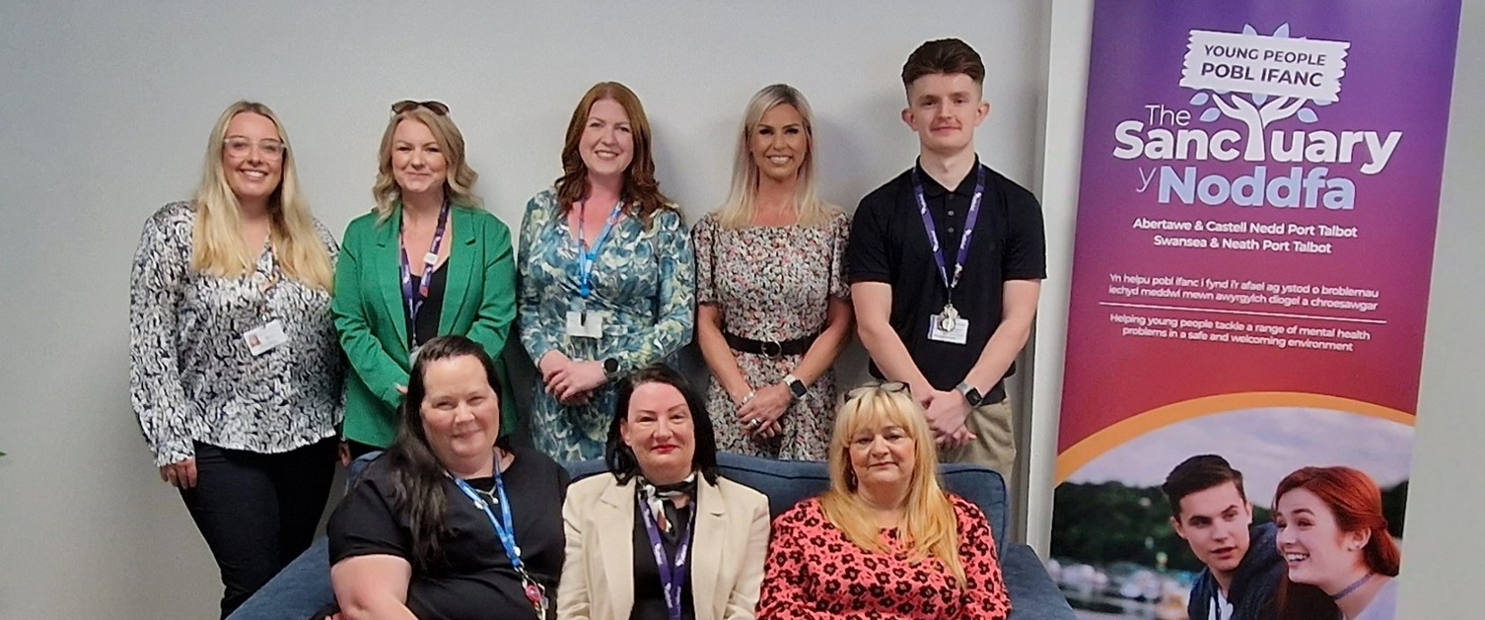
We have submitted the Welsh Government NEST self-assessment, assessing how well services are implementing the NEST framework principles, aiding in action planning and improving support services. We have received good feedback from Welsh Government on our progress.
The tidyMinds website was launched on World Mental Health Day 2024 during an event hosted at the Waterfront Museum, Swansea. tidyMinds is a dedicated mental health and wellbeing website for young people in Swansea and Neath Port Talbot
The West Glamorgan Regional Partnership Board established a delivery group in May 2024 to operationalise the Regional Emotional Wellbeing and Mental Health No Wrong Door. The aim is to deliver a multi-agency, multi-disciplined single point of access for Children and Young People to support their emotional health and wellbeing, and this is an on-going piece of work.
The Arts in Health team are developing an Arts Council Wales programme aimed at improving young people’s emotional wellbeing, through creative input. This will be delivered through our Schools In-reach Service.
  - Equality Objective 5
Staff and Wellbeing Experience
Staff wellbeing and experience are important because they directly influence the quality and safety of care, the sustainability of the workforce and how valued and supported staff feel at work. When staff are healthy, engaged and supported, they are better able to deliver safe, compassionate care, are more likely to stay in their roles, experience lower levels of stress and burnout, and feel motivated and connected to the organisation. This creates a positive cycle where looking after staff enables them to better look after patients and the wider community.
The Health Board has a workforce of over 13,000 staff members and there is increasing pressure on the workforce and staff. A network of staff, our Staff Wellbeing Champions, has been established and there are over 700 champions from various services. Monthly meetings are held to welcome new champions, with informal meetings to connect and share ideas. Within teams, wellbeing champions discuss wellbeing goals, engage with staff to assist them face challenges more positively, examples of activities include the creation of a wellbeing tree, monthly wellbeing newsletters and encouraging staff to go outside for lunchtime walks.
Staff wellbeing checks commenced in 2024 to promote healthy behaviours and signpost staff to relevant support and advice. These checks include cholesterol screening, height and weight measurements, waist to hip ration, diabetes risk assessment, cardiovascular risk assessment and health promotion advice.
During June 2024 we turned our attention to We Belong. One of the areas we focused on was Staff Networks. The Health Board has three established staff networks, CALON, our LGBTQ+ network, BAME, our Black Asian and Minority Ethnic network and our Neurodiversity network. We participated in Swansea Pride, participating in the march with our colleagues from other health organisations and had stands at the Guild Hall, for our Sexual Health Services and Calon. 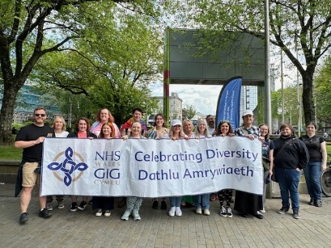 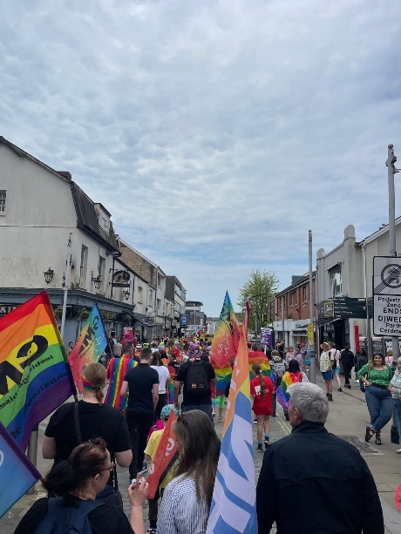 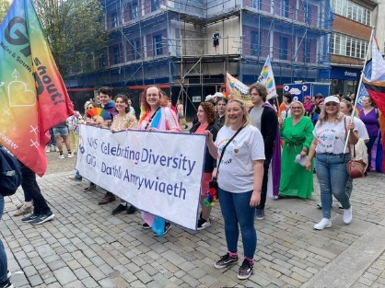
Sharing Hope is an arts project available to all Health Board staff groups. Through arts and creative activities, we can find ways of expressing what we can’t put into works, connect with colleagues and share stories. The project works with experienced artists to establish safe spaces and activities where staff can heal and recover.
During 2024 the Health Board’s Occupational Health and Staff Wellbeing Service launched a dedicated Men’s Health Group. This was developed following feedback from services there was a need for additional proactive support for diverse groups of men working across the organisation. The group aims to ensure that men are not excluded from health conversations with an emphasis on reaching out for help being seen as a sign of strength instead of weakness. Several digital and in-person sessions have been held to raise awareness of the help available.
The Ophthalmology Team at Singleton Hospital inherited a small garden which was initially used for staff to sit during their breaks. Over time, this has developed into a Wellness Garden, staff have dedicated time to planting flowers and installing seats and provides a calming environment for staff.
  - Equality Objective 6
Identify and Take Action to Address Gender, Ethnicity and Disability Pay Differences
Tackling pay differences in the NHS is important because unequal pay can undermine fairness, staff morale and trust in the organisation and may indicate wider structural inequalities affecting groups such as women, disabled staff and staff from ethnic minority backgrounds.
Addressing pay gaps helps the Health Board meet its legal duties under the Equality Act 2010 and the Public Sector Equality Duty, supports workforce equality objectives and demonstrates a commitment to valuing staff fairly for their contribution.
Reducing unjustified pay differences also supports recruitment and retention, improves staff engagement and wellbeing, and helps create an inclusive culture where people feel respected and motivated, which in turn contributes to better patient care and organisational performance.
The average full-time basic pay at Swansea Bay University Health Board is higher for male than female staff across all staff groups. As part of our commitment to equality for all, the Health Board signalled its ongoing commitment to create a culture of openness, honesty, civility and compassion which promotes an inclusive working environment to support every staff member to bring their whole self to work. Recognising both the need and demand within the organisation for a development programme aimed at women, a suite of in-house programmes was developed by a colleague in Widening Access, Equality & Careers (WAEC), known locally as ‘Optimise’.
These programmes provide women with time to focus on themselves, to explore issues that are important to them in the company of other women; hearing their stories, learning about what they have done to get where they are, the setbacks they have faced and how they overcame them. Participants explore topics including ‘imposter syndrome’, challenging limiting beliefs, and the power of networking, mentoring and coaching. Practical tools and techniques help participants identify clear, realistic steps to challenge the ‘second generation’ bias, which may be limiting their professional and personal progress.
A continual evaluation process has ensured the programme is tailored to the needs of the attendees and maximises the benefits for the organisation. Recognising pay gaps are not limited to gender, colleagues in WAEC are triangulating data to broaden the offering across other protected characteristics.

  - Equality Objective 7
Workforce Diversity
Having a diverse workforce is important because it helps the Health Board better reflect, understand and meet the needs of the communities it serves. A workforce made up of people with different backgrounds, experiences and perspectives supports more inclusive decision‑making, improves cultural awareness, and helps reduce inequalities in both employment and patient care.
NHS equality and diversity guidance highlights that valuing difference and promoting inclusion helps staff feel respected and supported, which in turn improves wellbeing, engagement and retention. This approach underpins equality objectives set out in NHS equality reporting and staff network activity, which emphasise creating a sense of belonging and using diversity as a strength to improve services for patients and the public.
During 2024/25 activities to attract and recruit staff included:
- Widening access to careers in healthcare
- A work experience framework to support local communities to access healthcare careers and increase diversity
- Vocational team DWP and LA provided work placements for long term unemployed people in our communities
- Promotion of compassionate leadership – Speak Up Month and Anti-bullying week
- Expansion of cultural conversations to other staff groups to promote an inclusive culture where staff feel they belong
- Delivery of the Anti-racist Workforce Action Plan

- Looking ahead to 2025-26

During 2025-26 we will develop our Strategic Equality Plan and base it on what people tell us, whether they are the public, patients, families or staff. We want to ensure that every single person feels that they belong in our service.
The development of our priorities for the next three years will be shaped by our long-term vision, values and engagement and our approach is to make sure our commitment to equality, diversity and belonging is at the heart of everything we do and this will be reflected across our organisations, plans and strategy development.
We will utilise and inclusive approach to developing the plan to ensure we have a wide range of issues to be addressed and prioritise actions for each year that will make a real difference.

