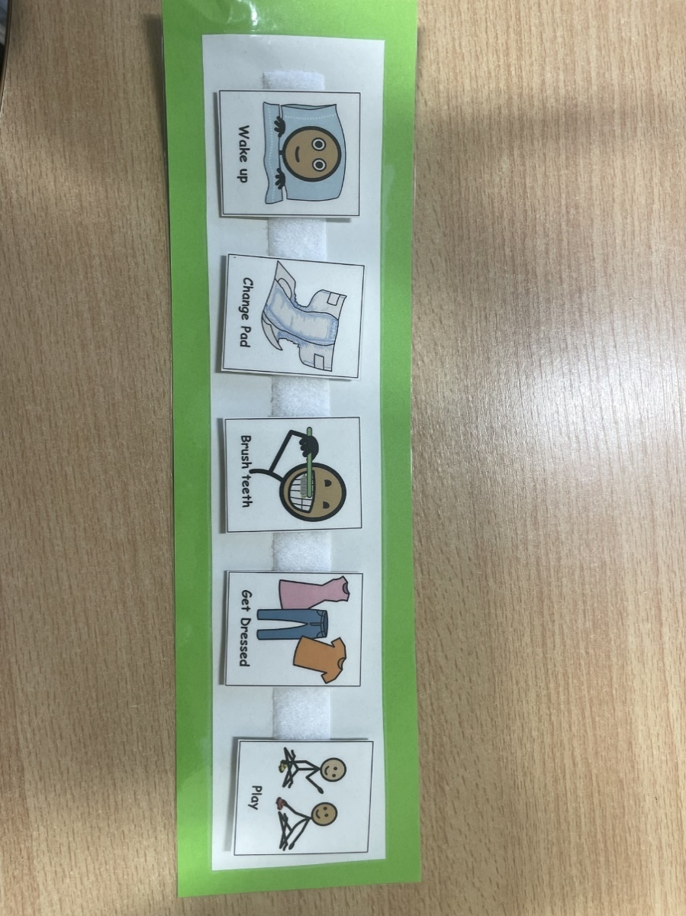

Using Visuals
Visuals are used to give clear visual instructions of the activities children are going to do and the order in which they will do them. This can help reduce children’s anxiety levels and help them learn new routines.
Visual timelines can be very simple (Now/ Next) and others can be longer (such as a morning routine).

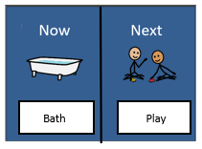

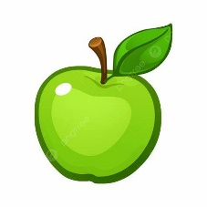

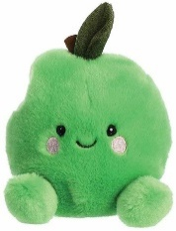
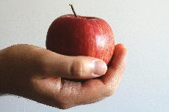
Understanding Your Child’s Level of Comprehension
Before creating visuals, it’s important to think about what type of visual your child can understand. Children may have different levels of understanding, including:

Understanding your child’s comprehension level will help you choose the best way to present visuals.
Real objects: Some children may only understand by seeing or holding the actual object. For example, showing them an actual apple if it’s time to eat.

Objects of reference: Some children associate a specific object with an activity. For instance, a child may indicate they want a snack by displaying a toy apple.

Photographs: Others may understand using a photo of the object, such as a picture of an apple.

Symbols: Some children understand using simplified symbols or illustrations, like a symbol of an apple to represent snack time.

Creating Visuals

Now/ Next
A Now/Next board is a great starting point for introducing visuals to your child. It shows the current activity (Now) and what will happen next (Next).
- Now/ Next boards can easily be created by taking a piece of paper or card and dividing it into two sections, (1) Now, (2) Next.
- Depending on your child’s level of understanding, decide on what type of visual’s you would like to use. For example, you may need to take pictures of the objects/ activities you want to use and print them out, or you could use symbols.
- You can use Velcro or Blue Tac to stick the visuals on to the board.
How to use it:
- Show the board to your child and explain: “Now we are doing [Activity 1], and next we will do [Activity 2]”.
- Update the board throughout the day as activities change.
- Keep it simple and positive to help your child transition between activities.

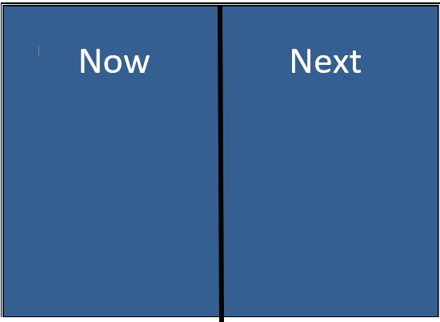

Timelines
Visual timelines are more detailed visuals and can be created for a specific routine, like the morning routine.
- Timelines can easily be created by taking a piece of paper or card cutting it into a long strip.
- Think about the steps of the routine as this will guide what visuals you need to create (e.g. Wake up, change pad, brush teeth etc)
- Depending on your child’s level of understanding, decide on what type of visual you need for each step. For example, you may need to take pictures of the items/activities you want to use and print them out, or you could use symbols.
- Stick the visuals on the timeline in the order they occur. You can use Velcro or blue tac to stick the visuals onto the board.
How to use it:
- Place the timeline somewhere your child can easily see it, but out of reach if they might try to change it.
- Walk through the timeline with your child every morning, pointing to each step as you do it.
- Remove the step from the timeline once it is completed.
- Celebrate progress to keep your child motivated.
