The Hand Rule
When talking to children, we often use a lot of questions. But sometimes, too many questions can feel a bit overwhelming. Instead, it's often more helpful to simply talk about what they're doing or seeing. This shows them how to use words and build sentences. A great way to remember this is by using the 'hand rule’

The hand rule is a simple way to remember, that to help the child’s language development, we need to use more comments than questions.

Each finger stands for one sentence:
- 4 fingers = 4 comments
Talk about what your child is doing, seeing, or feeling.
For example: “You are building a big tower”. “This is fun”
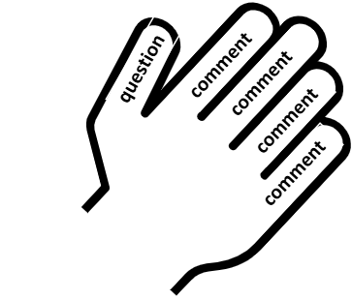
- 1 thumb = 1 question
Keep questions short and simple.
For example: “What colour next?” or “Do you want more?”

