Rydym yn croesawu gohebiaeth yn y Gymraeg neu'r Saesneg. Atebir gohebiaeth Gymraeg yn y Gymraeg, ac ni fydd hyn yn arwain at oedi. We welcome correspondence in Welsh or English. Welsh language correspondence will be replied to in Welsh, and this will not lead to a delay.
Cais Rhyddid Gwybodaeth / Freedom of Information request
Ein Cyf / Our Ref: 23-I-038

You asked:

- Please can you provide the product names with start and finish dates of all your agreed primary care rebates?

Please can you provide this information at Health Board level
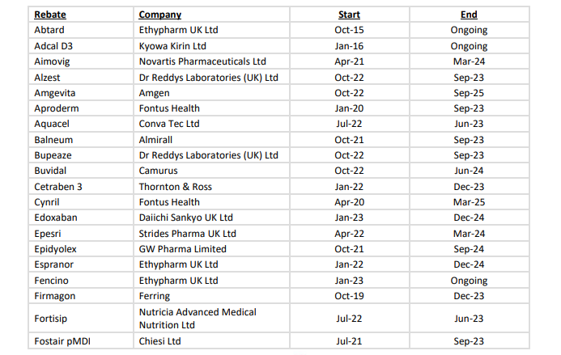
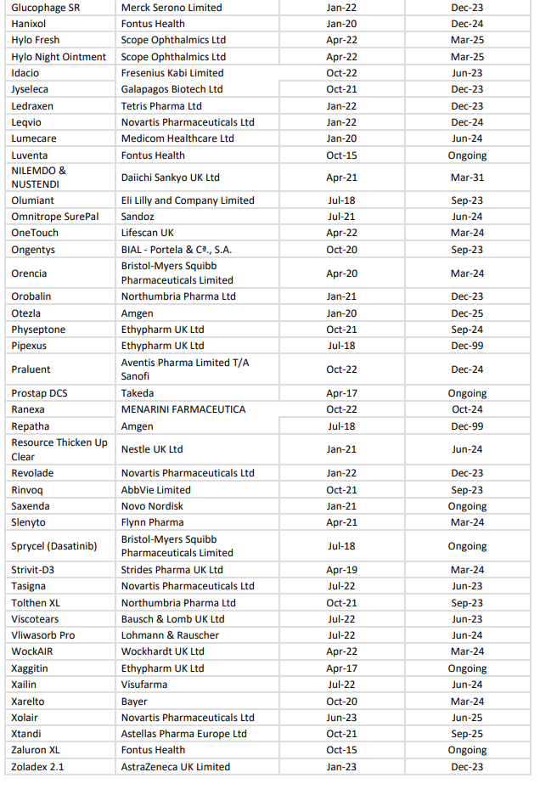

- Please can you advise if any of your agreed rebates are conditional on achieving increased volumes/ market shares?

We do not approve any rebate which is linked to achieving increased volumes/market sale conditions. This goes against our principles of the rebates and committee as stated in the policy – All Wales Pharmaceutical Rebate Scheme Policy – which is attached.

- Please can you also provide a copy of your Health Board primary care rebate policy.
Please see attachment – All Wales Pharmaceutical Rebate Scheme Policy.

