Rydym yn croesawu gohebiaeth yn y Gymraeg neu'r Saesneg. Atebir gohebiaeth Gymraeg yn y Gymraeg, ac ni fydd hyn yn arwain at oedi. We welcome correspondence in Welsh or English. Welsh language correspondence will be replied to in Welsh, and this will not lead to a delay.
Cais Rhyddid Gwybodaeth / Freedom of Information request
Ein Cyf / Our Ref: 24-B-050

You asked:
Please provide the Health Boards Information Technology (IT) Spend, and your current HIMSS EMRAM and INFRAM scores for:

Financial Year 2021-2022: £20,137,790
Financial Year 2022-2023: £18,535,628

Which HIMSS EMRAM ( Electronic Medial Record Adoption Model score has your Health Board currently achieved (0-7):
HIMMS EMRAM scored at 1.
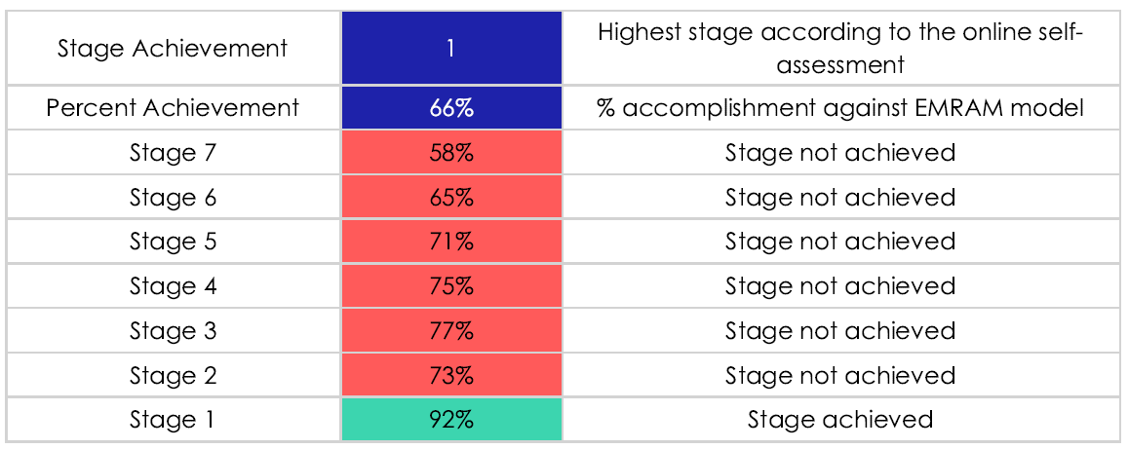

Which HIMSS INFRAM (Infrastructure Adoption Model) score has your Health Board currently achieved (0-7):
Not assessed
If your Health Board are working towards achieving a new HIMSS EMRAM or INFRAM level, what level is this, and when will it be achieved?
We aim to be at EMRAM stage 4 in 5 years time and 7 in 10 years time.
INFRAM has not been assessed and there are currently no plans to assess.
_____________________________________________________________

