HEAD INJURY

Pre-emptive CT Scanning

Sports concussion advice
Hypotension is very rarely due to a head injury except as a terminal event. Look for other causes.
Always carefully palpate scalp wound for skull fractures.

Glasgow Coma Scale
Eye Opening
- Spontaneous 4
- To voice 3
- To pain 2
- None 1

Verbalisation Children < 4 years
- Orientated 5 Responds appropriately/interacts
- Confused 4 Cries but consolable
- Inappropriate words 3 Cries, intermittently consolable
- Incomprehensible sounds 2 Inconsolable, irritable
- None 1 None

Motor Response
- Obeys commands 6
- Localises pain 5
- Abnormal flexion 4
- Decorticate response 3
- Decerebrate response 2
- None 1

CT for adult head injury- NICE 2014
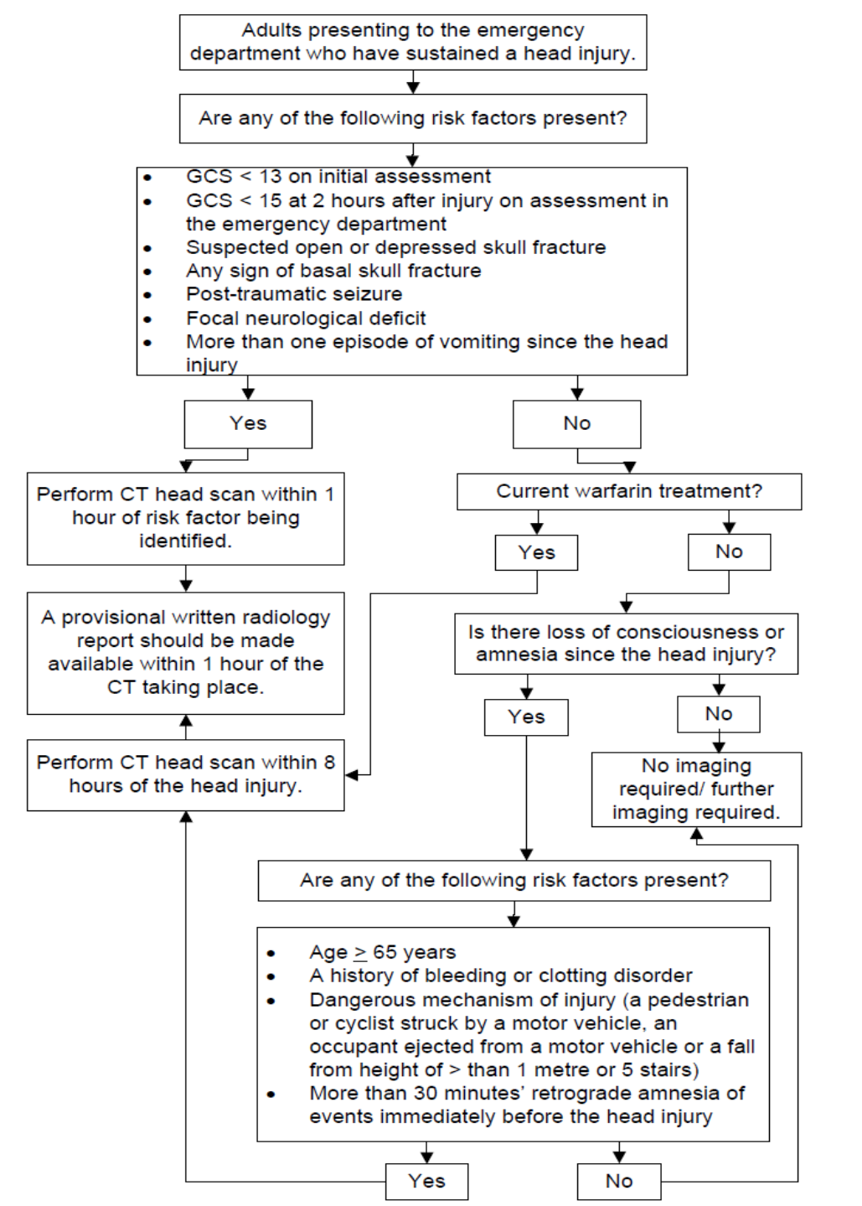

Requesting CT head scans
Printable pathway: CT head- radiographer proforma
REFERRALS FOR CT CAN ONLY BE MADE FROM MIDDLE GRADE LEVEL OR ABOVE. If the ED Consultant is in the department, then discuss with them first.
CT for Children Head Injury- NICE 2014
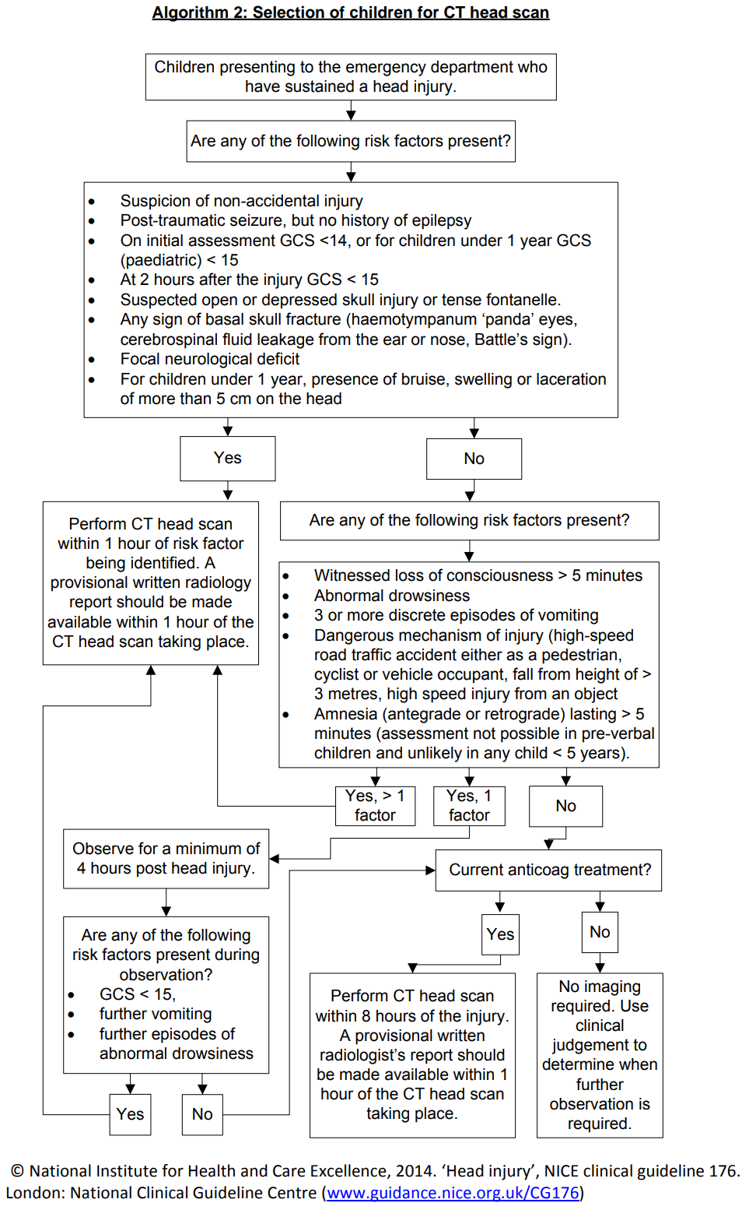
Minor head injury

Presentation
Often associated with assaults / trauma. Note mechanism carefully and any loss of consciousness / amnesia / fits. Patients often state they have lost consciousness but have in reality amnesia for the event. Try to confirm unconsciousness with an independent witness. Establish if the amnesia is retrograde (events leading up to the injury) or post-grade (unable to recall events after the injury).

Investigations
X-ray of the skull – once the mainstay investigation in the past – is seldom used now. Make sure you adequately explore scalp wounds prior to closure. Your finger is the most sensitive tool you have for detecting skull fractures!

X-rays may be requested if:
- Suspected penetrating injury
- Suspect foreign body

In addition, x-rays may be requested in children after consultation with senior if:
- Suspected NAI
- Inadequate history

Management
Most patients can be discharged home but guidelines for admission are (see flow charts above regarding referral and CT):
- Prolonged post traumatic amnesia e.g. > 10 minutes
- Decreased conscious level / irritability / abnormal behaviour
- Clinical / radiological evidence of fracture
- Neurological signs
- Severe headache or repeated vomiting
- Special risk, eg, coagulation disorder/ warfarin
- Difficult to assess, eg, intoxicated
- Poor home circumstances - not supervised
- If any patient has a GCS < 15 or neurological signs discuss with a senior. A GCS of 8 or less has an unprotected airway and needs senior or anaesthetic assessment.
Discharge and concussion advice

Printable pathway: Sports concussion advice

Always ensure there is a sensible person at home to care/ observe. Give written head injury advice and always explain this advice and ensure full understanding.
Be very clear that the patient should return to ED if any concern (NOT GP).
A useful departing phrase is:
“GPs are not always experienced with head injuries, so if you lose the head injury advice card or aren’t sure, just remember that if there is any change or any concern in the next week to return to the ED immediately- we are open 24hours a day”.
Warn about symptoms of concussion. These include- headache, nausea, irritability, ‘not feeling right’, difficulty concentrating, feeling exhausted or ‘washed out’, sensitive to light or noise, forgetfulness.
All symptoms typically get worse if the patient tries to return to normal activities- especially trying to concentrate or exert.
Advise the patient to rest, keep well hydrated and avoid activities that make symptoms worse. Paracetamol or ibuprofen is best (avoid codeine if possible).
If there are any symptoms of concussion the patient should refrain from sports for at least 2 weeks after resolution of all symptoms and be free of needing regular analgesia. They should exercise a ‘graduated return to play’ by increasing activity in increments.
Specific concussion advice for sports via link above (or via ED intranet page).
Ensure that the cascard is coded +/- write a discharge letter to the GP so they understand this too.

Admission
Patients not requiring neurosurgery should be admitted to an orthopaedic ward if requiring more than 24 hours observation.

Major head injury

Presentation
May be isolated / part of multiple injury. Time and mechanism of injury, initial condition (GCS if possible, pupil size and reactivity) and progress are vital.

Investigations
X-rays are usually unhelpful. CT scan is usually required. Refer to flow chart previous page and discuss with senior.

Management
Get help early. Always give 100% O2 as hypoxia is devastating. Establish a clear airway and control it (anaesthetist may be required). Protect the cervical spine as co-existing injury is common. Fits need immediate control as ICP rises quickly.
If any patient has a GCS < 15 or neurological signs discuss with a senior. A GCS of 8 or less has an unprotected airway and needs senior or anaesthetic assessment.
Antibiotics are not indicated for open or basal skull fractures.
LINKS
NICE Head injury
Scottish Intercollegiate Guidelines Network 2000 (www.sign.ac.uk)

Devastating Head Injury

Traumatic Brain Injury Service
Printable pathway: Traumatic Brain Injury referral form
The Traumatic Brain Injury Service offers rehabilitation and support (psychologist, physio, SALT etc) for people with severe brain injury (abnormal CT, GCS<8, >24hrs amnesia). Usually they get referrals from neurosurgery, but they can help us with follow up in the following cases:
- Late presentation with CT+ve lesion that does not then require admission
- Severely debilitating symptoms with a normal CT (unable to return to work, loss of independence etc)- senior to discuss with service first
- Severe post concussion syndrome not settling with time/ rest/ analgesia- senior to discuss with service first

