Cais Rhyddid Gwybodaeth / Freedom of Information request
Ein Cyf / Our Ref: 25-L-035

You asked:

- The number of employees within Swansea Bay University Health Board currently (17th December 2025) employed on temporary or fixed-term contracts
585
- The number of employees on temporary or fixed-term contracts whose employment has been terminated within the last three months (Sept-Nov 2025)
37
- The total expenditure incurred by SDEC on locum staff, agency staff, and overtime over the past six months (Jun-Nov 2025)
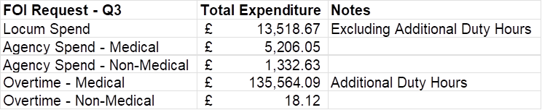

- Details of any Physician Associate posts that are currently advertised or due to be advertised (17th December 2025)
On the date requested, 17th December 2025, there were no Physician Associate posts advertised or confirmed as planned for advertisement.

_____________________________________________________________

