Cais Rhyddid Gwybodaeth / Freedom of Information request
Ein Cyf / Our Ref:

You asked:
For each of the last 5 financial years (2019-2020, 2020-2021, 2021-2022, 2022-2023, 2023-24) please provide the following:

Commissioning Process:
A description of the care and support commissioning process for people living with MND, including key stages and decision-making criteria.

The South Wales MND Care and Research Network is run by 5 specialist, locally based care coordinators who provide a single point of access in each of the Local Health Boards (LHB’s), liaising and working within a localized and pre – existing Multi-Disciplinary Team (MDT) model. This MDT looks after people living with and affected by MND in both a clinic and community setting from diagnosis to death. Primary and secondary care are also involved in caring for this patient group and other charities most notable the MND Association.

The average duration of the commissioning process from initial proposal to the awarding of contracts for care and support people living with MND.

The contracts between the 5 LHB’s and the MND Association usually take anywhere between one to two years to gain confirmation. The current contract submitted in Nov 2022, was confirmed in Nov 2024 from all 5 LHB’s. These contracts are ending in 2027 when the LHB’s take over full funding of the MND Network
Commissioned Services:
A list of all care and support services commissioned for people living with MND, including the name of the service provider, the location of the service provider, the type of service provided, and the duration of the contract.
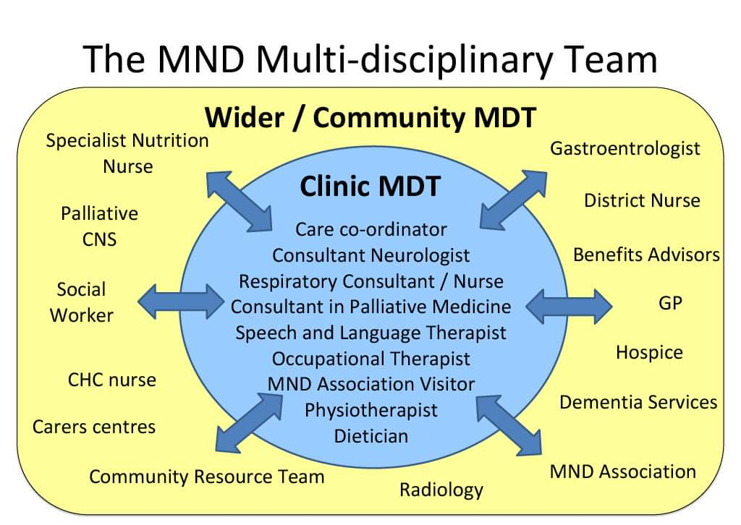

The total number of new contracts awarded and the number of contracts renewed for people living with MND.

Between 2019 and currently, we have had 3 contracts awarded. 2019-2023- 4 year contract between the 5 health boards and the MND Association, a one year emergency extension contract in 2023-24, and the current new contract between the 5 LHB’s and the MND Association which will take us to 2028. From that time on there will be no contracts with the MND Association for care coordination as the 5 LHB’s have agreed to take on 100% core funding of the Network.
Budget and Expenditure:
The total budget allocated for care and support commissioning for people living with MND.

The Network has received funding from the MND Association since 2007 when it was originally a Care Centre service based in Cardiff and the Vale of Glamorgan. Continued funding from the MND Association alongside investment from the five LHBs saw the development and implementation of a Care Network of MDT clinics from 2012. The funding between 2019 -2023 followed a tapering arrangement, with the MND Association contributing 52% of the running costs and the remaining 48% being split between the LHBs – this reduced by 2% for the Association and increased by 2% for the LHBs each financial year.
The partnership agreement for 22/23 was 50% MNDA and 50% LHBs which amounted to £15,857 from each of the LHBs and totalled at £70,829 for the four-year period.
2024-2028 follows a period of adjusted tapering during the 2024-28 grant cycle where the LHBs’ contribution rises to full funding for the core service at an estimated contribution of £40,309 per year, per health board.

Dec 23 – Nov 24 60% £24,185
Dec 24- Nov 25 70% £28,217
Dec 25- Nov26 80% £32,248
Dec 26-Nov 27 90% £36,279
Dec 27 onwards 100% £40,309
Alongside this the MND Network will look for a further long-term service level agreement from the MND Association for investment in non-core elements to offer additional value with opportunities to innovate and improve standards of care delivery. In the 2024-2028 contract between the MND Association and the MND Network, the MND Association have agreed to fund a 0.6WTE Band 8a psychologist for three years estimating £157,335.

The actual expenditure on commissioned care and support services for people living with MND, broken down by service type.

 | 2019/20 | 2020/21 | 2021/22 | 2022/23 | 2023/24
Administration | £6,172.00 | £6,415.00 | Nil* | £3,428.00 | £6,109.00
Allied Health Professionals | £71,181.00 | £74,083.00 | £70,282.00 | £78,273.00 | £124,799.00
Qualified Nursing | £77,427.00 | £80,805.00 | £97,587.00 | £78,279.00 | £81,261.00
Non Pay | £10,002.00 | £10,000.00 | £5,767.00 | £4,475.00 | £30,437.00
TOTAL | £164,782.00 | £171,303.00 | £173,636.00 | £164,455.00 | £181,732.00

*Vacant Post
MND Diagnosis:
How many people have been diagnosed with a neurological condition.

Please note this information is for Swansea Bay University Health Board only. This is the number of patients who were admitted to main Swansea Bay University Health Board hospitals between 1st April 2019 and 31st March 2024 inclusive, who had a “disease of the nervous system” diagnosis during the admission.

Diagnosis | 2019/20 | 2020/21 | 2021/22 | 2022/23 | 2023/24
G00-G99: Diseases Of The Nervous System | 6569 | 4898 | 6172 | 6189 | 6166

How many people have been diagnosed with MND.
Health Board | 2013 |  | 2014 | 2015 | 2016 | 2017 | 2018 | 2019 | 2020 | 2021 | 2022 | 2023 | 2024 up to September only
ABUHB |  | 44 | 45 | 52 | 59 | 44 | 48 | 42 | 43 | 50 | 49 | 62 | 23
CAV |  | 29 | 30 | 33 | 32 | 29 | 38 | 37 | 33 | 31 | 38 | 40 | 15
CTUHB |  | 23 | 20 | 20 | 27 | 26 | 26 | 18 | 30 | 29 | 22 | 17 | 18
SBUHB |  | 49 | 51 | 39 | 37 | 40 | 39 | 41 | 26 | 28 | 35 | 31 | 12
HDUHB |  | 37 | 30 | 35 | 34 | 39 | 32 | 47 | 38 | 36 | 27 | 36 | 15

Average length from initial presentation to formal diagnosis of MND.
Very variable between LHB’s with an estimate 4 - 6 months average. This is dependent on the additional tests e.g. EMG’s results coming back in a timely fashion.
Average length of time from formal diagnosis to registration of death for people with MND.

Swansea Bay University Health Board does not hold this information.

The Health Board’s information systems do not code the cause of death; such information could only be obtained by reference to the individual’s death certificate. Death certificates are not held by the Health Board, but by the Registrar of Deaths (in the local authority), please contact them for this information

How many hospital admissions have you had for someone living with MND.

Please see number of admissions to Swansea Bay University Health Board only between 1st April 2019 and 31st March 2024 inclusive for patients with a diagnosis of Motor Neurone Disease during the admission (by financial year)

2019/20 | 2020/21 | 2021/22 | 2022/23 | 2023/24
42 | 28 | 46 | 17 | 24

Neurological support:
How much money has been spent on neurological support for people living with MND.
2019/20 | 2020/21 | 2021/22 | 2022/23 | 2023/24
£164,782.00 | £171.303.00 | £173,636.00 | £164,454.00 | £181,732.00

How many consultant neurologists have you employed that support people living with MND.

There are 3 neurologists at all times to support living people with Motor Neurone Disease.

Psychological support:
How much money has been spent on psychological support for people living with MND.

Prior to 2021 this information would be held by the Motor Neurone Disease Association.
From November 2025 – to November 2028 the total will be £157,335

How many psychologists have you employed that support people living with MND.

A 0.2 WTE clinical psychologist was employed to cover the five health boards between Nov 2018-Nov 2021. Although some direct patient contact was carried out, the role was mainly for service development of a psychological model of care for people living with and affected by MND. From 2025-2028 we are hoping to have a 0.6 WTE clinical psychologist working in the Network focusing on Acceptance and Commitment Therapy for people living with and affected by MND.
Genetic testing:
How many people with an MND diagnosis have received genetic testing.

Hywel Dda <5**
Aneurin Bevan University Health Board 11
Swansea Bay University Health Board <5**
Cardiff and Vale University Health Board 5
Cwm Taf Morgannwg University Health Board <5**

How many family members of people with MND have received genetic testing.

Across all five health boards there have been <5** family members of people with MND who have received genetic testing.

What is the average length of time between requesting genetic testing and receiving the results.
This varies but it has been taking up to a year. This is being looked at by genetics and the process has changed so all tests are outsourced to Germany. We have been assured that this will cut down the wait time substantially to 4-6 weeks.

** Where fewer than 5 has been indicated we are unable to provide you with the exact number of patients as due to the low numbers, there is a potential risk of identifying individuals if this was disclosed. We are therefore withholding this detail under Section 40(2) of the Freedom of Information Act 2000. This information is protected by the General Data Protection Regulation (GDPR) and Data Protection Act 2018 and its disclosure would be contrary to the data protection principles and constitute as unfair and unlawful processing in regard to Articles 5, 6, and 9 of GDPR. This exemption is absolute and therefore there is no requirement to apply the public interest test.
_____________________________________________________________

