Cais Rhyddid Gwybodaeth / Freedom of Information request
Ein Cyf / Our Ref: 25-G-053

You asked:
I would like to know about the employment of Occupational Therapists (OTs) in the Swansea Bay University Health Board broken down by Band and age.

Data provided in this response relates to Swansea Bay University Health Board Occupational Therapy Service, including the core OT service; Swansea Integrated Community Service (ICS); Neath Port Talbot Community Reablement Team (NPT CRT) and is accurate as of 1st August 2025.

Please can you provide the following information:

How many HCPC-registered Occupational Therapists are employed by Swansea Bay University Health Board in total, broken down by Band and the following age brackets: 21-25, 26-35, 36-45, 46-55, 56+
I can confirm that the total number of HCPC registered Occupational Therapists employed by Swansea Bay University Health Board is 257.
Please see below for a breakdown by Band:
Band | Core OT service | Swansea ICS | NPT CRT | Non-OT role
5 | 38 | 5 | 3 | 0
6 | 90 | 8 | 6 | 0
7 | 70 | 3 | 2 | 5
8a | 14 | 0 | 0 | 5
8b | 2 | 0 | 0 | 2
8c | 1 | 0 | 0 | 0
8d | 1 | 0 | 0 | 2
Total | 216 | 16 | 11 | 14
It is not possible to break down further to banding or registration service. This information is not held centrally. To obtain this information would involve a manual trawl and search of records which we have estimated would significantly exceed the 18 hours limit set down by the FOI Act as the reasonable limit. Section 12 of the FOI Act and The Freedom of Information and Data Protection (Appropriate Limit and Fees) Regulation 2004 provides that we are not obliged to spend in excess of 18 hours in any sixty-day period locating, retrieving and identifying information in order to deal with a request for information and therefore we are withholding this information at this time.

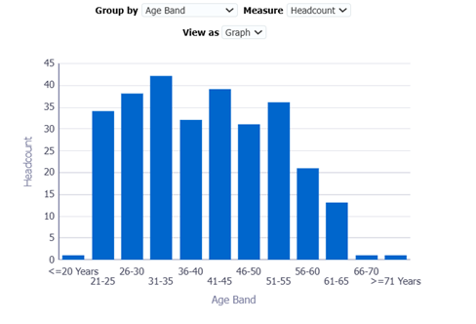
Below is the breakdown of registered Occupational Therapy staff in Swansea ICS and CRT broken down by band and age group:
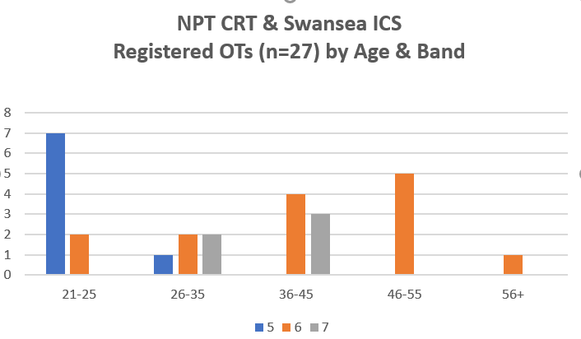

How many HCPC-registered Occupational Therapists are employed by the Health Board in non-OT roles?
I can confirm that 14 HCPC-registered Occupational Therapists are employed by our Health Board in non-OT roles.
NB: some of these are part-time secondment roles

How many non-HCPC registered support staff are employed supporting OT services?
I can confirm that 111 non-HCPC registered support staff are employed supporting OT services.
NB: approximately 10% work in shared therapy support roles.

How many FTE vacancies for Occupational Therapists positions are there across the Swansea Bay University Health Board broken down by band and time the position has been vacant?
I can confirm that the total vacancies (FTE) is 15.46:
Vacancies - Core OT Service
Band | FTE | Time vacant
3 | 2.3 | Average vacancy time is 3 months due to timescale of vacancy process
4 | 1.05
5 (static) | 1.51
6 | 0.7
7 | 4.9
5 (rotational) | 25 | Early recruitment of new graduates
Total | 10.46 | Rotational band 5s excluded as posts not yet vacant
Vacancies – NPT CRT
Band | FTE | Time vacant
6 | 2.0 | >18 months
7 | 1.2 | Newly funded post
Total | 3.2
Vacancies – Swansea ICS
Band | FTE | Time vacant
6 | 1.8 | 2 months
Total | 1.8

_____________________________________________________________

