Cais Rhyddid Gwybodaeth / Freedom of Information request
Ein Cyf / Our Ref: 25-G-058

You asked:
The request relates to home enteral tube feeding, which is a way of providing nutrition to people who can't eat and drink normally.
- Does your organisation provide care to individuals aged 0-25 who may use home enteral feeding tubes?
Yes.

- How many patients has your organisation provided dietetic care for home enteral tube feeding between 01-01-2023-31-12-2024?

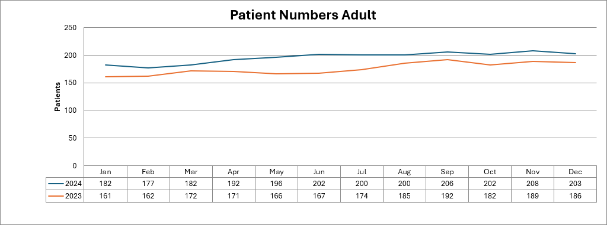
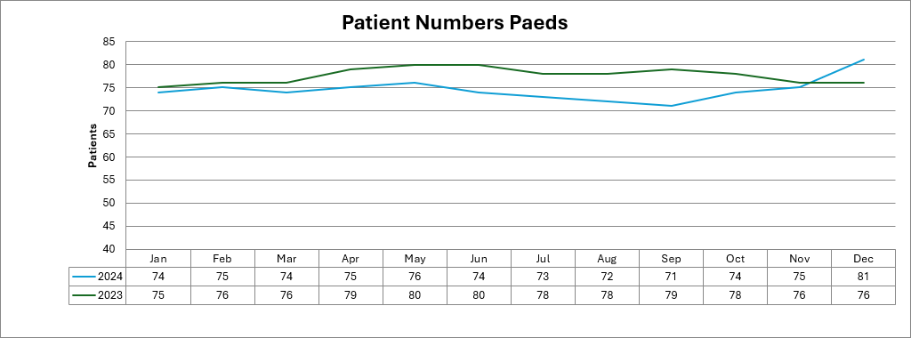
- Divided into the following age categories: 0-18, 18-25, 25+ (age when they joined the caseload or age on 01-01-23 if they were on the caseload throughout this period).
0-18 years 40
18-25 years <5**
25+ 240

- If possible, please provide caseload numbers by age (e.g. <1, 1-2, 2-3... years etc.)
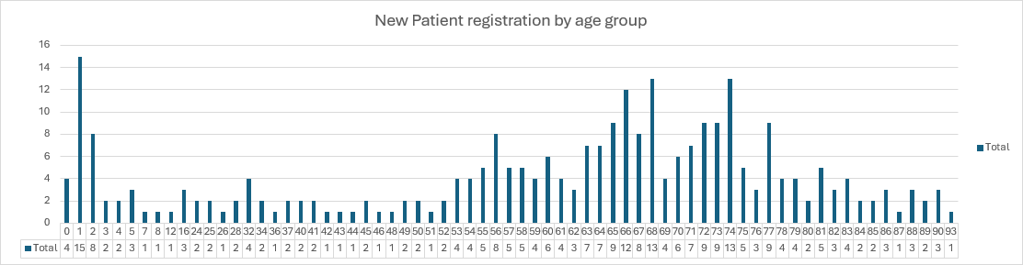

- Of these, how many individuals use a blended diet*?
18

- Divided in the following age categories: 0-18, 18-25, 25+
0-18 years 12
18-25 years 5
25+ <5**

- If possible, please provide caseload numbers by age (e.g. <1, 1-2, 2-3... years etc.)
Age range | Numbers on blended diet
0-1 | 0
1-2 | 0
2-3 | <5*
3-4 | 0
4-5 | <5*
5-6 | 0
6-7 | <5*
7-8 | <5*
8-9 | <5*
9-10 | <5*
10-11 | 0
11-12 | 0
12-13 | <5*
13-14 | 0
14-15 | 0
15-16 | 0
16-17 | <5*
17-18 | 0
19-20 | <5*
21 -22 | <5*
23- 24 | <5*
28-29 | <5*

- Does your organisation have the following:
- Local blended diet policy – Acute setting (Yes/No)
No.

- Local blended diet policy – Community setting (Yes/No)
No.

- Blended diet guideline (Yes/No)
Yes, please see attached SBUHB Protocol Admin of Liquid Food via Gastrostomy 2023.

- Blended diet standard operating guideline or procedure (Yes/No)
No

- Blended diet training package (Yes/No)
Partly – please see attached further training package in development – Training guideline.

- If yes to 4a-4e, please provide a copy.
Attachments are provided as referenced in questions 4c and 4e.

- Are any staff employed by your organisation in roles funded by income provided by an enteral feeding provider (e.g. Nutricia, Abbott)?
Yes.

- If yes, please state number of posts (whole time equivalent) and Agenda for Change banding.
Band 7 1.56WTE
Band 3 1 WTE
Band 2 0.4 WTE

*A blended diet is the use of everyday foods blended to a puree and given via an enteral feeding tube. This may be used exclusively or in combination with commercial formula.

** Where fewer than 5 has been indicated we are unable to provide you with the exact number of patients as due to the low numbers, there is a potential risk of identifying individuals if this was disclosed. We are therefore withholding this detail under Section 40(2) of the Freedom of Information Act 2000. This information is protected by the General Data Protection Regulation (GDPR) and Data Protection Act 2018 and its disclosure would be contrary to the data protection principles and constitute as unfair and unlawful processing in regard to Articles 5, 6, and 9 of GDPR. This exemption is absolute and therefore there is no requirement to apply the public interest test.
_____________________________________________________________

