Delirium management guidelines for patients on Cardiac ITU and Cardiac HDU
Introduction and who this document applies to:
Postoperative delirium (POD) after cardiac surgery is a well-known phenomenon which carries a higher risk of morbidity and mortality. Multiple patient-specific risk factors and pathophysiologic mechanisms have been identified and therapies have been proposed to mitigate risk of delirium development postoperatively.
This guidance is primarily intended for use by medical and nursing staff caring for elderly, critically ill and surgical patients postoperatively in cardiac ITU, cardiac HDU. This also applies to and PACU patients.

- What is delirium?
- An acute state of confusion (NICE, 2010), disturbance of consciousness, fluctuating confusion, inattention and disordered thinking
- Delirium is often triggered by an acute illness, surgery, injuries or adverse effects of medications.

- Types of delirium
- Hyperactive delirium:
restlessness, agitation, aggression.
- Hypoactive delirium: (Most Common)
sleepy, withdrawn and quiet, difficult to recognise.
- Mixed! Hypo-Hyperactive Delirium

- Think delirium:
Specially in hospitalised patients who have had recent major surgery including cardiac and thoracic surgery.

- Risk factor assessment:
- Regular CAM-ICU assessment for all patients admitted to cardiac ITU and Cardiac HDU (at least once per nursing shift).
- Please use the CAM-ICU score to differentiate between Delirium and acute psychosis.
Delirium or Psychosis?
Symptom | Delirium | Psychosis due to Psychiatric disorder
Orientation | Confused about current time, date, place, or identity | Usually, aware of time, date, place, and identity
Attention | Greatly impaired | Unaffected
Memory for recent events | Lost | Retained
Ability to calculate | Unable to do simple calculations | Retained
Hallucinations | If present, mostly visual or involving touch | If present, mostly auditory
Other disorders | Often present and may be serious | History of previous psychiatric disturbances
Drug use | Often, evidence of recent drug use | Not necessarily involved

- Preventing delirium
- Patients at risk of delirium should be cared for by healthcare professionals that are familiar to them.
- Avoid moving people within and between wards or rooms unless absolutely.
- Address cognitive impairment and/or disorientation by:
- providing appropriate lighting and clear signage.
- a clock and a calendar should also be easily visible to the person at risk.
- talking to the person to reorientation them by explaining where they are, who they are and what is your role.
- introducing cognitively stimulating activities (for example, reminiscence).
  - Facilitating regular visits from family and friends.
  - Address nutrition, dehydration and/or constipation:
- Adequate fluid intake to prevent dehydration.
- Ensure drinks if food intake is poor.
- consider intravenous fluids if necessary.
  - Assess for hypoxia and optimise oxygen saturation.
  - Address infection by:
- looking for and treating infection.
- avoiding unnecessary catheterisation.
- implementing infection control procedures in line with the NICE guideline on healthcare-associated infections.
- Address immobility or limited mobility by:
  - Encourage people to mobilise soon after surgery
  - Encourage all people, including those unable to walk, to carry out active range of motion exercises.
- Address pain by:
- Regular pain score + non-verbal signs of pain (learning difficulties, dementia, ventilated patients).
- Appropriate pain management.
- Regular medication review for people taking multiple drugs.
- Address sensory impairment by:
  - resolving any reversible cause of the impairment
  - ensuring hearing and visual aids are available to and used correctly
- Use verbal and non-verbal techniques to de-escalate the situation
- Promote good sleep patterns and sleep hygiene by:
  - avoiding nursing or medical procedures during sleeping hours, if possible
  - scheduling medication rounds to avoid disturbing sleep
  - reducing noise to a minimum during sleep periods.

- Assessment and diagnosis in ICU
- CAM-ICU (Confusion Assessment Method for intensive care unit).
- The final CAM-ICU-7 score ranges from 0-7 with 7 being most severe. CAM-ICU-7 scores were further categorized as:
- 0-2: no delirium
- 3-5: mild to moderate delirium
- 6-7: severe delirium.
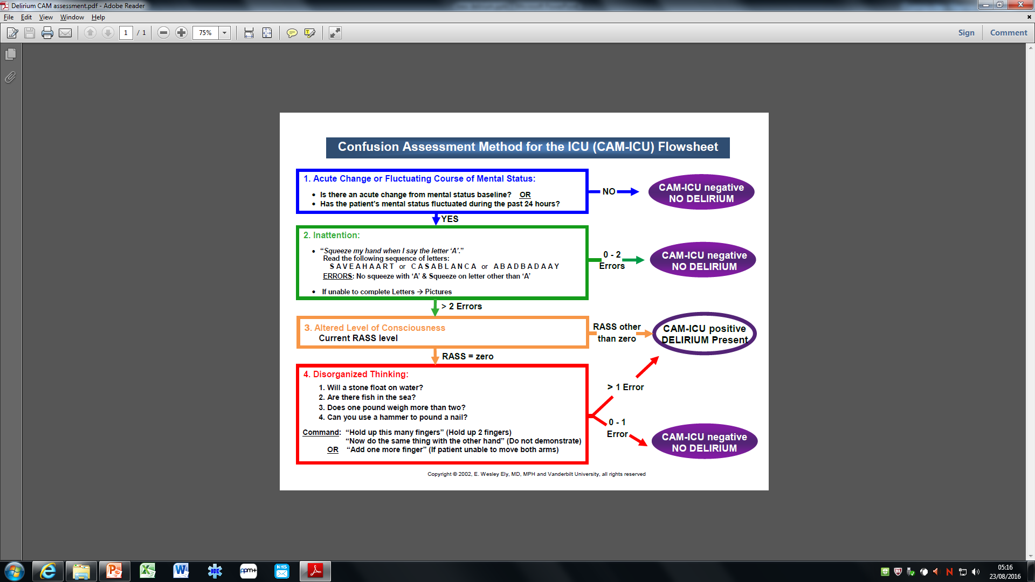

7) Treatment of delirium
- Identify and treat the underlying cause.
- Effective communication and re-orientation, engage family/ friends/ carers known to patient.
- Try to de-escalate the situation using verbal and non-verbal technique (please refer to NICE guidelines on violence and aggression.
  - Note: Hypoactive delirium might show less evident signs of distress
- Only use pharmacological methods to keep patient and staff safe. Discuss the medications with anaesthetist (Rota C) before commencing treatment. The anaesthetist should review the patient prior to prescription the choose the appropriate medication.

Medication | Recommended Dosage | Side Effects | Contraindications
Haloperidol | IV (haloperidol lactate only): 0.5 to 10 mg q15 to 30 min until response achieved, then give 25% of last bolus dose Q6H | QTC prolongation, large potential for extrapyramidal effects | Prolonged QTC, Parkinson’s disease
Quetiapine | 100 to 200 mg orally per d in 2 divided doses | QTC prolongation, less extrapyramidal effects than haloperidol | Prolonged QTC
Dexmedetomidine infusion (only for cardiac surgery patients) | 400micrograms in 100mls to run at 0.2 -0.7microg/kg/h maintenance dose | Bradycardia, hypotension | -Bradycardia,  -High degree AV block,  - hypotension
Clonidine infusion | 750microgram in 50mls (15micrograms/ml) at 0.5mcg-4mcg/kg/hr | - Hypotension  -Bradycardia  -Impaired left ventricular function  -Concurrent use with haloperidol may produce QT prolongation. | -Skin rash  -Coronary insufficiency  -Conduction disturbances,  -Chronic renal failure
Risperidone | 0.25 mg per day and further increased to 0.5 mg over two days; it can be utilized on an as needed basis with 0.25 mg every one hour to a maximum of 0.75 mg for agitation | QTC prolongation, dystonias, neuroleptic malignant syndrome, seizures, and possible elevated prolactin | Discontinuation of risperidone should gradually be tapered by 0.25 mg every two days and discontinued over one week

- Treatment of Acute Psychosis:
- Acute psychosis with agitation = 1st step maintains the safety of the patient and those around them
- Antipsychotic medications are mainstay of treatment for acute psychosis.
- Use if there are positive symptoms of psychosis (eg, hallucinations, delusions, and agitation)
- 1st generation antipsychotics (haloperidol, most common used agents).
- 2nd generation antipsychotics (risperidone, olanzapine).

References:
Young, J., Murthy, L., Westby, M., Akunne, A. and O’Mahony, R., 2010. Diagnosis, prevention, and management of delirium: summary of NICE guidance. Bmj, 341.
Cheraghi, M. A., Hazaryan, M., Bahramnezhad, F., Mirzaeipour, F., & Haghani, H. (2017). A Multifactorial Intervention Based on the NICE-Adjusted Guideline in the Prevention of Delirium in Patients Hospitalized for Cardiac Surgery. International Journal of Medical Research & Health Sciences, 6(5), 96-101.
Lamond, E., S. Murray, and C. E. Gibson. "Delirium screening in intensive care: A life saving opportunity." Intensive and Critical Care Nursing 44 (2018): 105-109.
Boot, Rebecca. "Delirium: a review of the nurses’ role in the intensive care unit." Intensive and Critical Care Nursing 28, no. 3 (2012): 185-189.

Chen, H., Mo, L., Hu, H. et al. Risk factors of postoperative delirium after cardiac surgery: a meta-analysis. J Cardiothorac Surg 16, 113 (2021). https://doi.org/10.1186/s13019-021-01496-w
Deininger, M.M., Schnitzler, S., Benstoem, C. et al. Standardized pharmacological management of delirium after on-pump cardiac surgery reduces ICU stay and ventilation in a retrospective pre-post study. Sci Rep 13, 3741 (2023). https://doi.org/10.1038/s41598-023-30781-y
Marina Pieri, Alessia De Simone, et al. Trials Focusing on Prevention and Treatment of Delirium After Cardiac Surgery: A systematic Review of Randomized Evidence, J Cardiothoracic and Vascular Anaesthesia, Volume 34, Issue 6, 2020, 1641-1654, ISSN 1053-0770, https://doi.org/10.1053/j.jvca.2019.09.028.
Mu, Jing Lan MMed; Lee, Anna PhD, MPH; Joynt, Gavin M. MBBCh, FCICM. Pharmacologic Agents for the Prevention and Treatment of Delirium in Patients Undergoing Cardiac Surgery: Systematic Review and Meta-analysis*. Critical Care Medicine 43(1):p 194-204, January 2015. | DOI: 10.1097/CCM.0000000000000673
Wang G, Niu J, Li Z, Lv H, Cai H (2018) The efficacy and safety of dexmedetomidine in cardiac surgery patients: A systematic review and meta-analysis. PLoS ONE 13(9): e0202620. https://doi.org/10.1371/journal.pone.0202620
Peng, K., Shen, Y.P., Ying, Y.Y., et al 2021. Perioperative dexmedetomidine and 5-year survival in patients undergoing cardiac surgery. British journal of anaesthesia, 127(2), pp.215-223.
Likhvantsev, V.V., Landoni, G., Grebenchikov, O.A., et al, 2021. Perioperative dexmedetomidine supplement decreases delirium incidence after adult cardiac surgery: a randomized, double-blind, controlled study. Journal of cardiothoracic and vascular anesthesia, 35(2), pp.449-457.
Peng, Ke, et al. "Effects of perioperative dexmedetomidine on postoperative mortality and morbidity: a systematic review and meta-analysis." Clinical Therapeutics 41.1 (2019): 138-154.
Shokri, H. and Ali, I., 2020. A randomized control trial comparing prophylactic dexmedetomidine versus clonidine on rates and duration of delirium in older adult patients undergoing coronary artery bypass grafting. Journal of clinical anesthesia, 61, p.109622.

