Cais Rhyddid Gwybodaeth / Freedom of Information request
Ein Cyf / Our Ref: 25-F-041

You asked:
Please provide the below information for the Chemotherapy Day Unit
- The current waiting time from referral to first appointment/treatment
Within Oncology the quality performance indicator is the number of days from the date the patient agreed to the treatment plan (decision to treat or DTT) and the treatment start date. This is divided into 3 priorities as below;
 | Patient Group | Target for Treatment
Priority 1 | Emergency - patients with cancer types that tend to rapidly clinically decompensate and respond well to systemic anti-cancer therapy (SACT) including small cell lung cancer, germ cell tumours, lymphoma and small subsets of ovarian and breast cancer. | Within 48 hours of DTT
Priority 2 | Curative – patients receiving SACT as first definitive treatment and so include primary chemotherapy patients and chemo-RT patients with radical intent. | Within 14 days of DTT
Priority 2 | Neo-adjuvant – those receiving SACT prior to definitive treatment. | Within 14 days of DTT
Priority 2 | Palliative - those receiving treatments that are not curative but can prolong life and reduce symptoms. | Within 14 days of DTT
Priority 3 | Adjuvant - all patients receiving systemic chemotherapy post definite treatment. | Within 21 days of DTT

In FY 2024/25 our performance against these priorities has been as follows;
Average wait (in days)
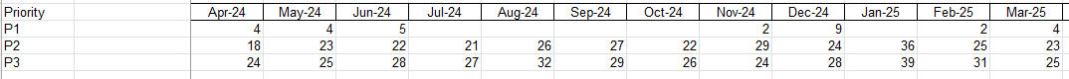

- The number of appointments in 2024 to date vs the same period in 2023
2023 - 15,158 patient attendances for systemic anti-cancer therapy
2024 - 16,137 patient attendances for systemic anti-cancer therapy
___________________________________________________________________________________________

