Cais Rhyddid Gwybodaeth / Freedom of Information request
Ein Cyf / Our Ref: 25-C-052

Please note that the Health Board is carrying out significant work around recruitment generally and has a dedicated area on its website for recruitment: https://sbuhb.nhs.wales/jobs/jobs-and-volunteering. Within this area of the website the Health Board has details of vacancies, up-coming recruitment days, contact information and short videos (developed in-house) advertising the benefits of working for SBU and interviews with staff. As well as emphasising the career and learning opportunities offered by being part of such a large NHS organisation, we actively promote the great work-life balance that living in Swansea and South West Wales offers, including affordable housing, our beaches, countryside, etc.
Please note, we do everything possible to cover rotas with Swansea Bay staff and bank staff. It is only after exhausting these options, do we look to agencies for cover.
You asked:
- Please can you confirm the cost the Health Board incurred on temporary medical and AHP staffing from Agency so far this financial year
The cost incurred by the Health Board on temporary medical and AHP staffing from Agency for financial year 2024/25 was £9,294,287.65.
- Please can you confirm the % of agency workers the Health Board directly engaged i.e. on Health Board contracts, thereby avoiding VAT on their pay in the financial year ending April 2024.
If the Health Board does not use any Direct Engagement to avoid VAT on medical agency staffing, a confirmation of this will suffice.
Please see below the breakdown by month.
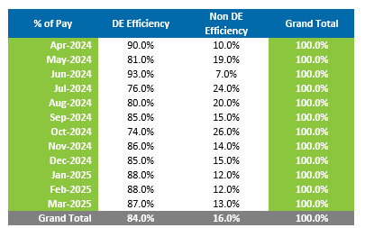
- Please can you confirm how many Resident Doctors the Health Board paid at BMA full-time trainee pay band 3, and for how many months in the financial year so far. A single value for these higher payments on band 3 would be acceptable if that is easier.
Nil.
_____________________________________________________________

